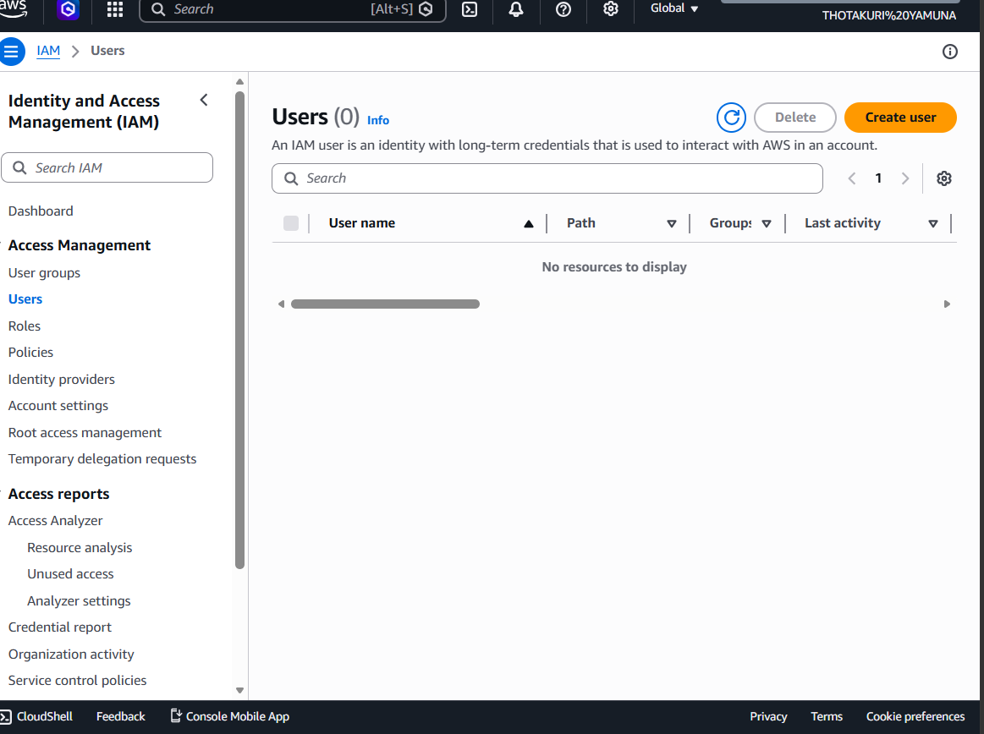
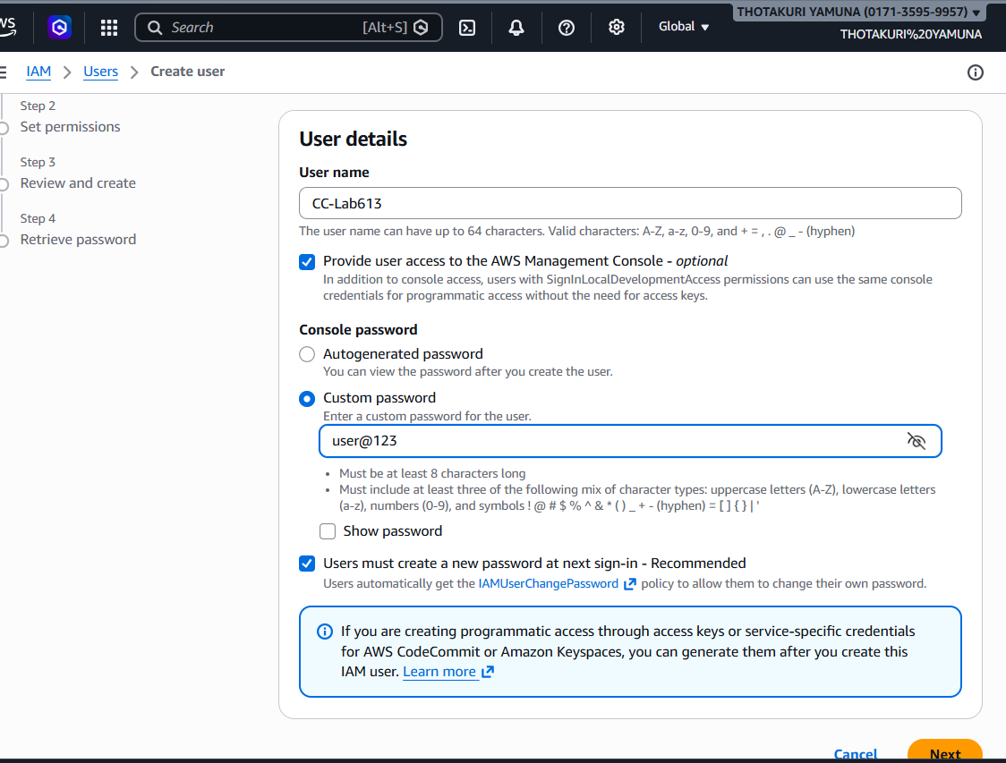
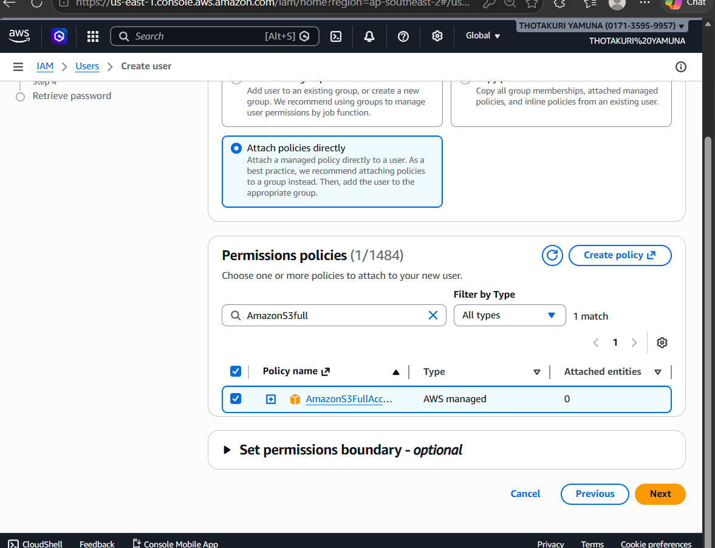
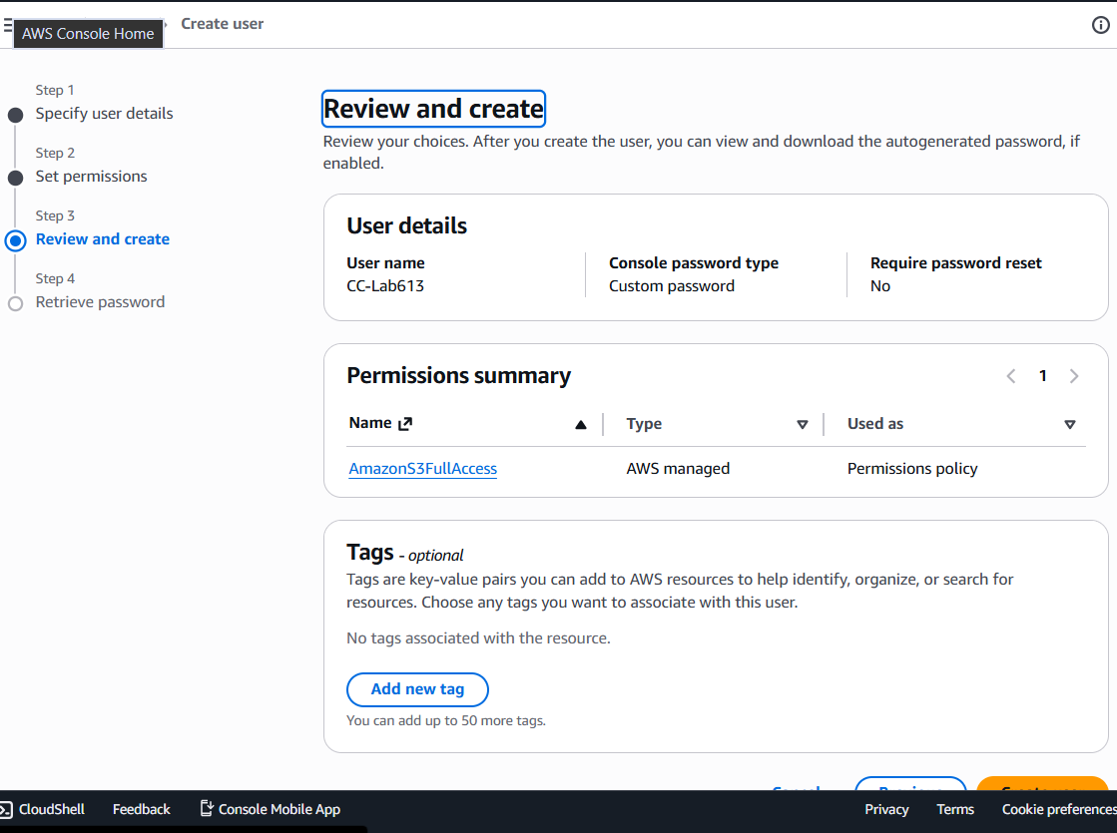
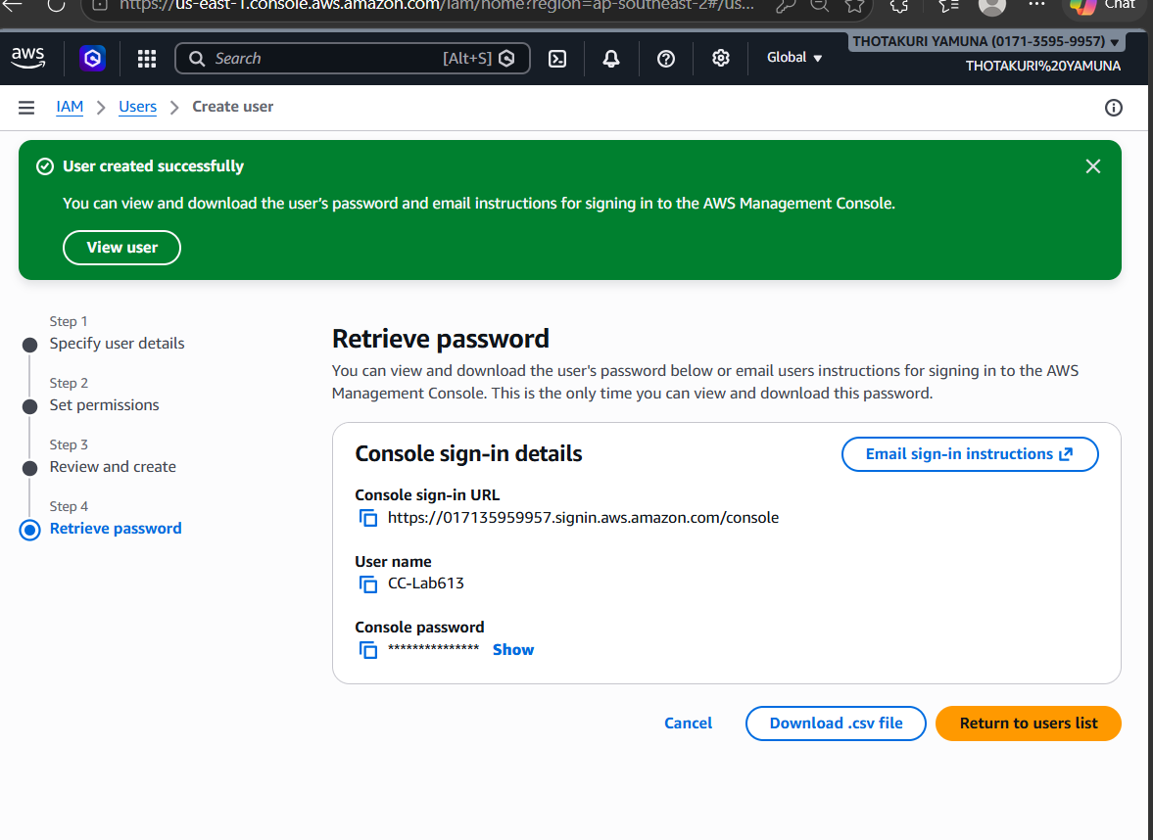
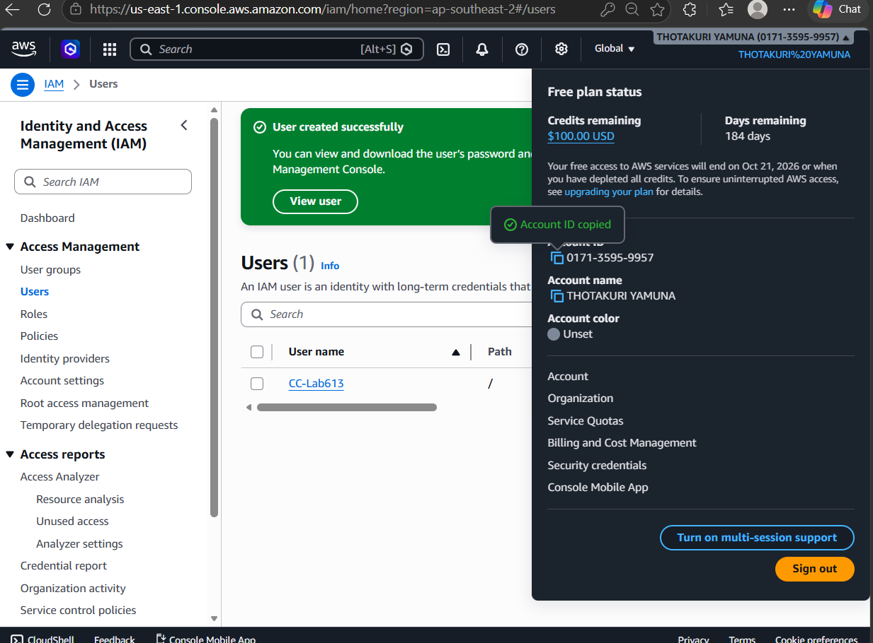
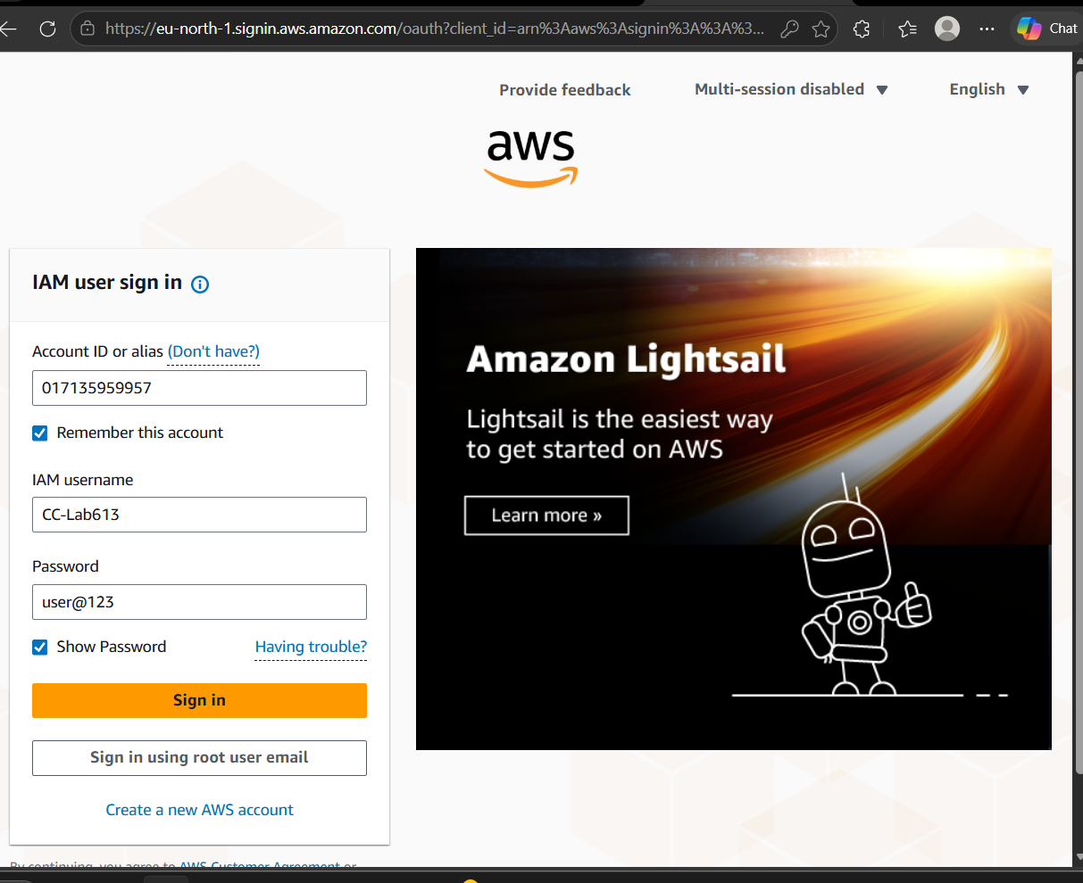
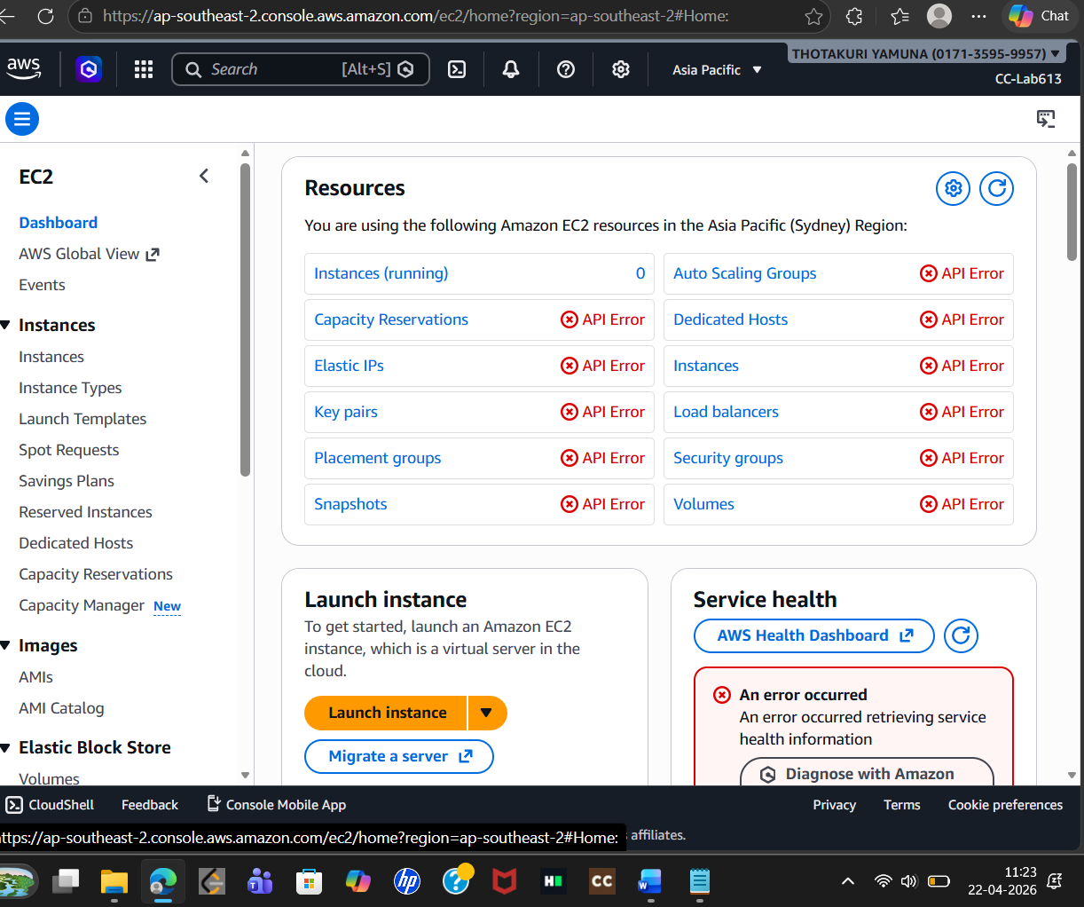
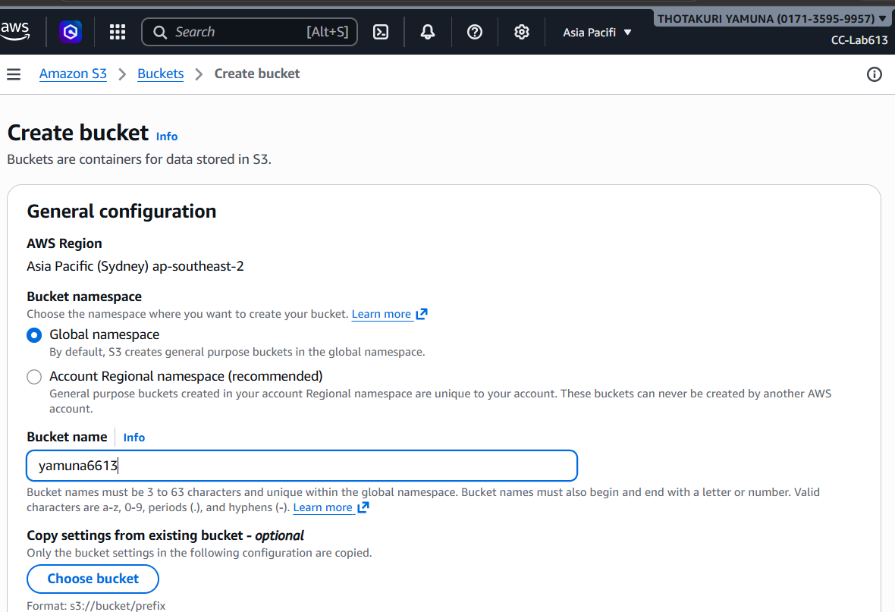
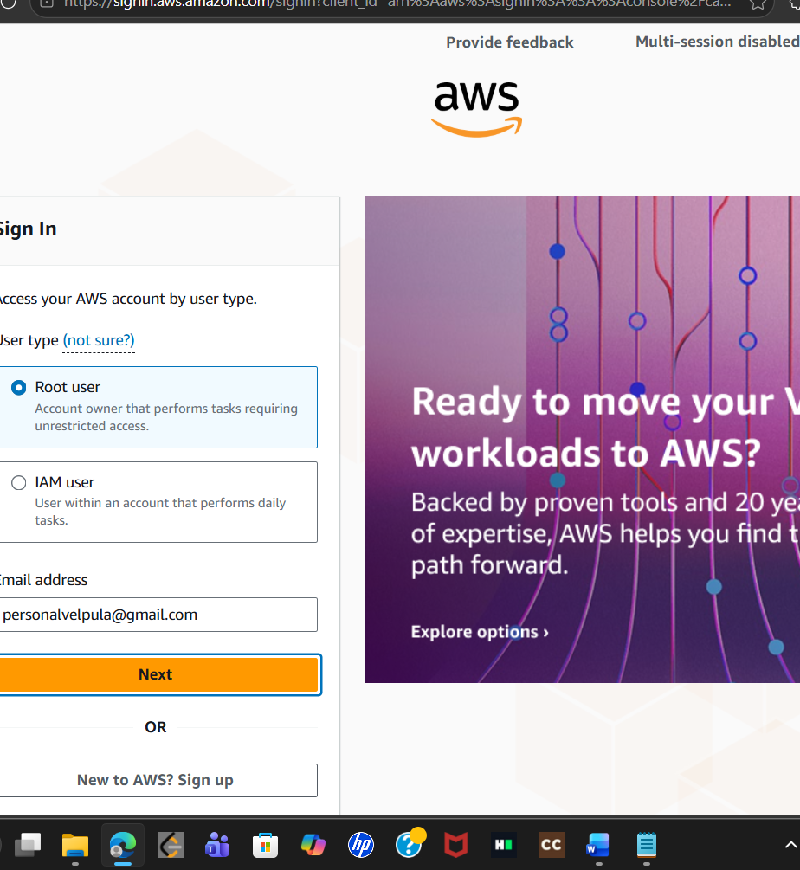
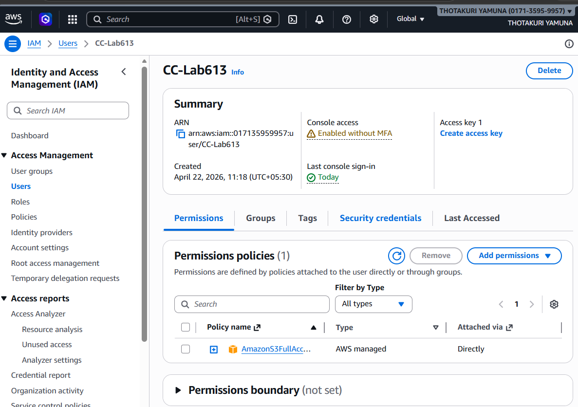
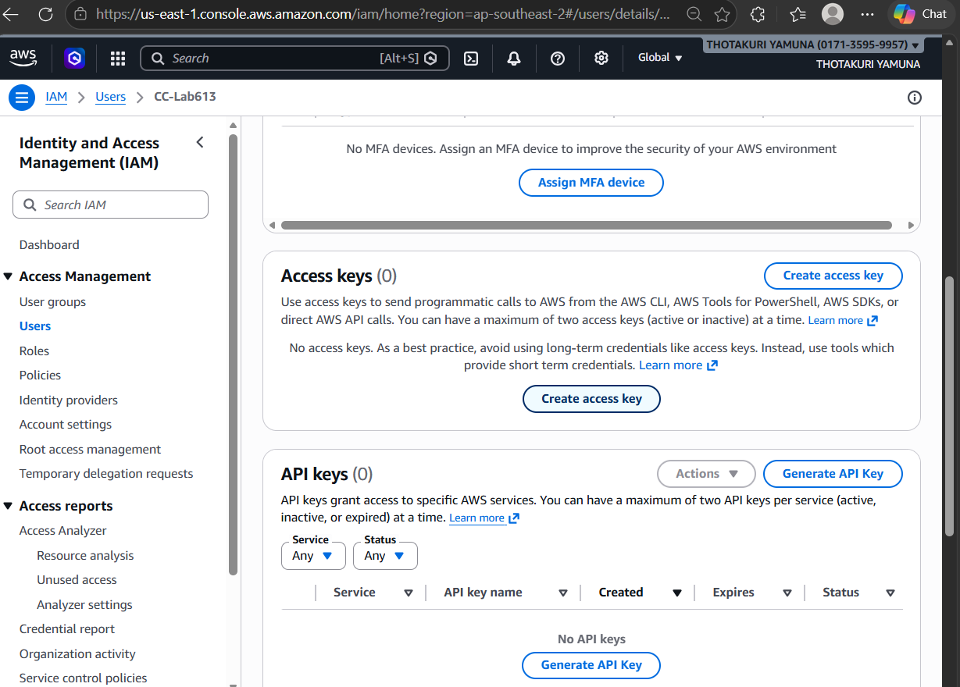
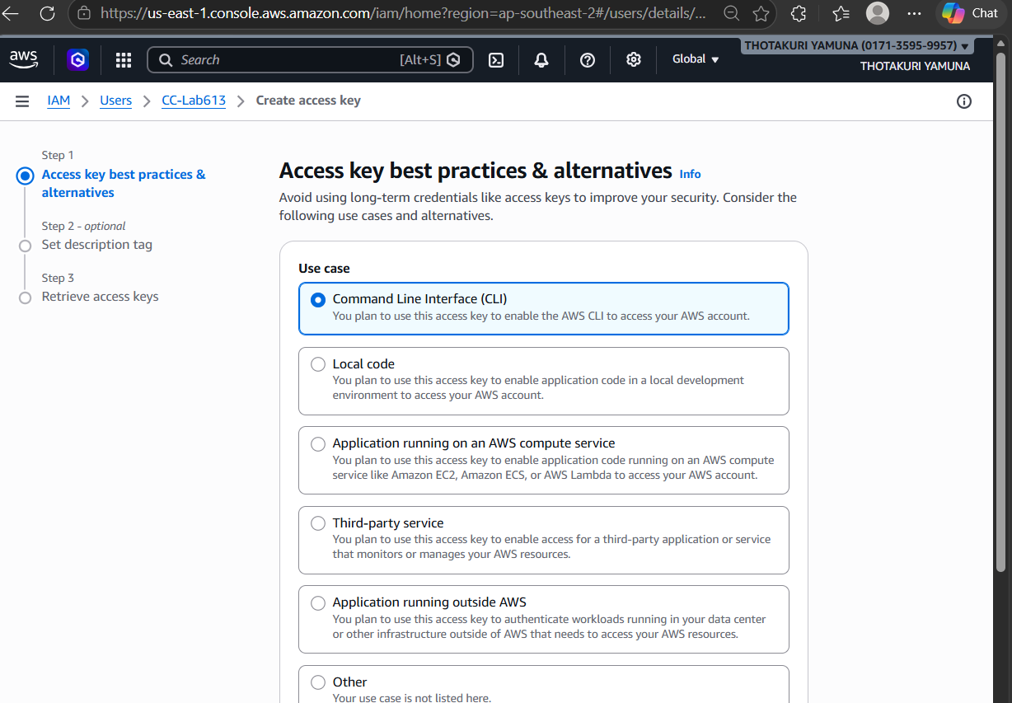
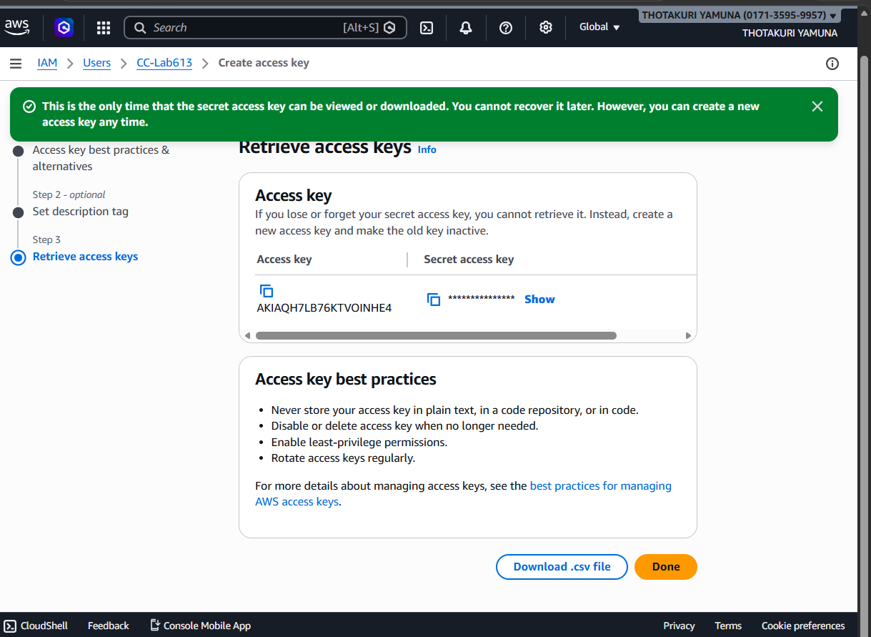
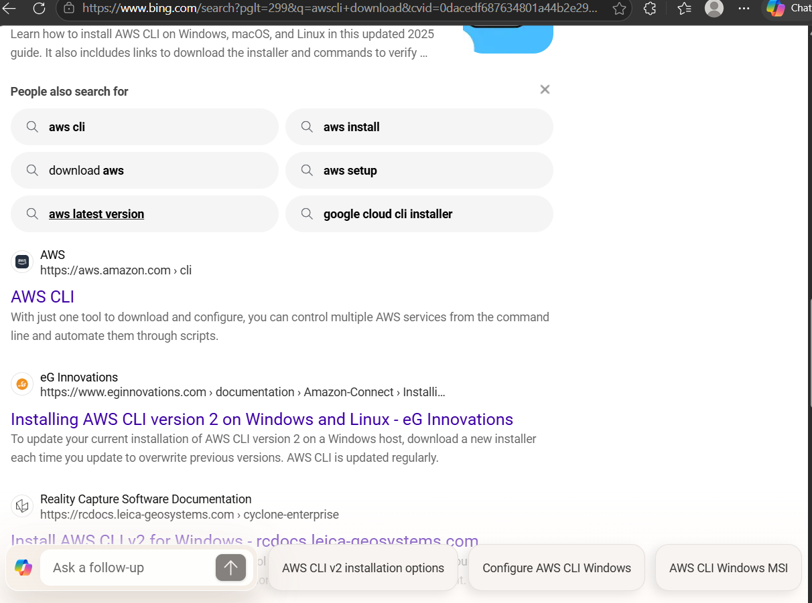
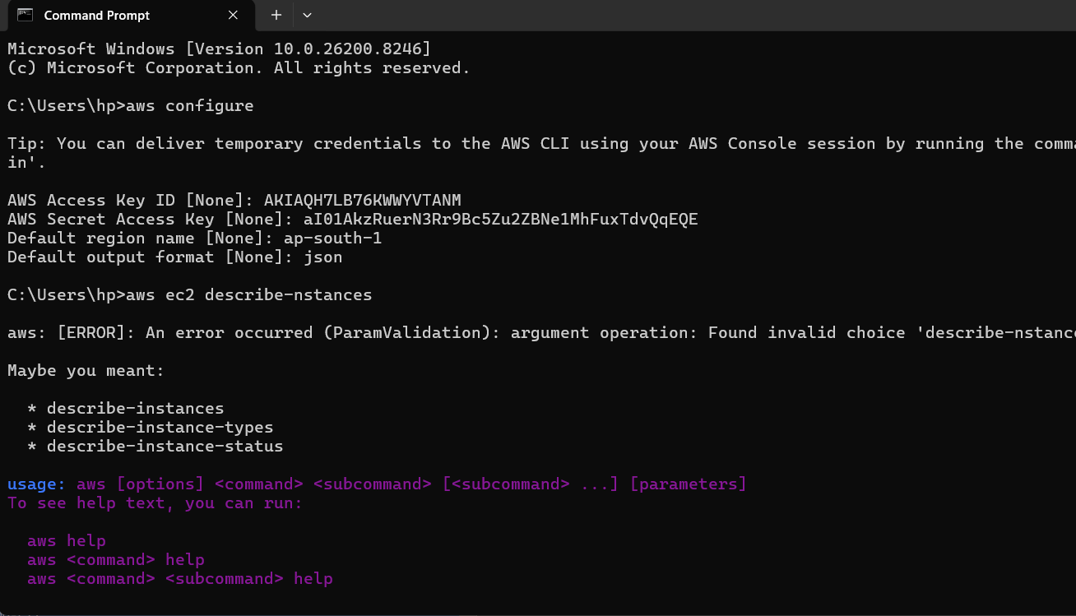
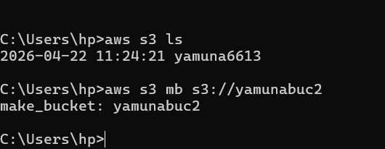
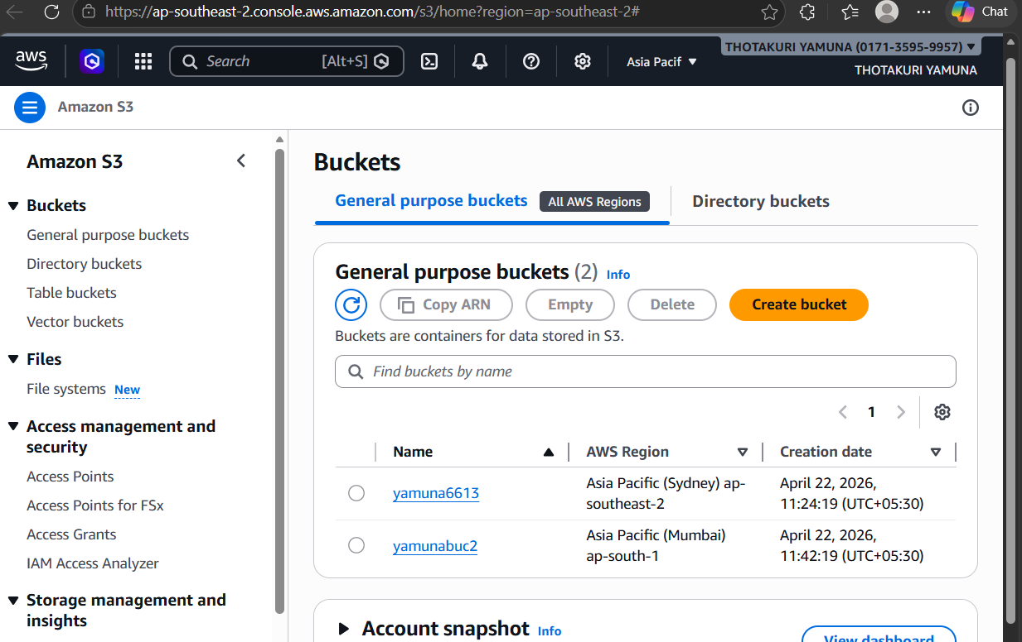
SBQ’s:
Scenario 1: Security Risk
Q: You logged into AWS using the root user for daily work. What’s wrong here?
Answer:
Using the root user for daily tasks is dangerous because:
• It has full unrestricted access to all AWS services
• Any mistake can cause major damage (delete resources, security breach)
• It increases risk if credentials are compromised
Best Practice:
• Use root only for initial setup
• Create IAM users and use them instead
• Enable MFA (Multi-Factor Authentication) for root
________________________________________ Scenario 2: Account Compromise
Q: AWS bill suddenly increases (possible root compromise). Steps?
Answer:
1. Immediately log in to root account
2. Change root password
3. Delete/rotate access keys
4. Enable MFA
5. Check:
o Billing dashboard
o Running EC2 instances
o Unusual services (crypto mining etc.)
6. Stop/terminate suspicious resources
7. Review CloudTrail logs
8. Contact AWS Support
________________________________________ Scenario 3: Root Credentials Lost
Q: Forgot root password?
Answer:
• Go to AWS login page → click “Forgot Password”
• Use registered email ID to reset password
• Verify via email
________________________________________
Scenario 4: Root Access Keys
Q: Why avoid root access keys?
Answer:
• Root keys give programmatic full access
• No restriction → high security risk
• Cannot limit permissions
Best Practice:
• Never create root access keys
• Use IAM users/roles instead
________________________________________Scenario 5: New Developer Joining
Q: How to give access?
Answer:
1. Create IAM user
2. Assign to a group (e.g., Developers)
3. Attach required policies
4. Enable MFA
5. Share login credentials securely
________________________________________Scenario 6: Least Privilege
Q: User needs only S3 read access
Answer:
• Attach policy: AmazonS3ReadOnlyAccess
OR
• Create custom policy allowing:
{
"Effect": "Allow",
"Action": ["s3:GetObject", "s3:ListBucket"],
"Resource": "*"
}

Scenario 7: Temporary Access
Q: Contractor needs access for 2 weeks
Answer:
• Use IAM Role with temporary credentials
OR
• Create IAM user + set:
o Access expiration (manual or automation)
• Remove access after 2 weeks
Best Practice: Use STS (Security Token Service)
________________________________________ Scenario 8: Access Denied Error
Q: User gets “Access Denied” for EC2
Answer:
Possible reasons:
• No IAM permission
• Explicit Deny policy
• Resource-level restriction
• Wrong region
• Missing role attachment
Fix:
• Check IAM policies
• Use IAM Policy Simulator
________________________________________ Scenario 9: Multiple Users Same Permissions
Q: 50 users need same access
Answer:
• Create an IAM Group
• Attach policy to group
• Add all users to group
Efficient & scalable

Scenario 10: Configure CLI
Q: Configure AWS CLI
Command:
aws configure
• Access Key ID
• Secret Access Key
• Region (e.g., ap-south-1)
• Output format (json)
________________________________________Scenario 11: Create IAM User via CLI
aws iam create-user --user-name dev-user
________________________________________Scenario 12: Attach Policy via CLI (S3 Read Access)**
aws iam attach-user-policy \
--user-name dev-user \
--policy-arn arn:aws:iam::aws:policy/AmazonS3ReadOnlyAccess
________________________________________Scenario 13: Create Access Keys via CLI
aws iam create-access-key --user-name dev-user
________________________________________ Scenario 14: List IAM Users
aws iam list-users
________________________________________Scenario 15: Delete IAM User via CLI (Safe Way)**
Steps:
aws iam delete-access-key --user-name dev-user --access-key-id KEY_ID
aws iam detach-user-policy --user-name dev-user --policy-arn POLICY_ARN
aws iam delete-user --user-name dev-user
________________________________________Q: CLI command fails with AccessDenied. What to check?
Answer:
• IAM permissions (Do you have required policy?)
• Correct AWS profile
• Region configuration
• Resource-level restrictions
• Explicit Deny policies
• Role/session permissions

