Week-2
- a) Create and attach an EBS volume to an EC2 instance, and
- scale the instance by increasing CPU and RAM by changing the instance type.
2.Attach and permanently mount an EBS volume to a Linux EC2 instance to ensure data persistence across reboots.
3. Create a snapshot of the attached EBS volume and use it to create and attach a new volume to an EC2 instance in another AWS region.

- a) Create and attach an EBS volume to an EC2 instance, and
- scale the instance by increasing CPU and RAM by changing the instance type.
Q1. what is ebs
EBS, most commonly Amazon Elastic Block Store, is a high-performance, scalable, block-level cloud storage service from AWS that acts like a virtual hard drive for Amazon EC2 instances, offering persistent storage for databases, file systems, and applications, with features like snapshots for backups and various volume types for different needs. It's durable, independent of instance lifecycle, and crucial for robust cloud data storage.
Key Characteristics:
- Block-Level Storage: Stores data in fixed-size blocks, similar to traditional hard drives.
- Persistence: Data remains even if the EC2 instance it's attached to is stopped or terminated
.
- Scalability: Volumes can be resized dynamically.
- High Performance: Offers various volume types (SSD, HDD) to match application needs, from general purpose to intensive I/O.
- Snapshots: Incremental backups for easy disaster recovery and data migration.
- Availability Zone Specific: Volumes are tied to a specific Availability Zone for high availability.
Common Uses:
- Boot volumes for EC2 instances.
- Databases (SQL, NoSQL).
- File systems.
- Transactional data, applications, and containers.
In Simple Terms: Think of an EBS volume as a separate, expandable hard drive you can plug into your virtual server (EC2 instance) in the cloud, ensuring your critical data stays safe and accessible even if .

IOPS, or Input/Output Operations Per Second, measures how many data reads or writes a storage device (like an SSD or HDD) can perform in one second. A higher IOPS number generally means faster data access and better system performance.

GP3is the newer, more cost-effective AWS EBS volume type, offering independent scaling of IOPS/throughput from storage size, lower base cost, and higher maximum performance than GP2, where performance scales with size and small volumes burst. GP3 provides consistent performance with a 3,000 IOPS baseline and 1,000 MiB/s throughput, making it ideal for most modern workloads, while GP2's performance depends on volume size and burst credits, making it suitable for low-intensity tasks or where bursting is beneficial.

- Creating and attaching an EBS volume to an EC2 instance
Note: First Create one ES2 instance say ubuntupemINSTANCEyogita

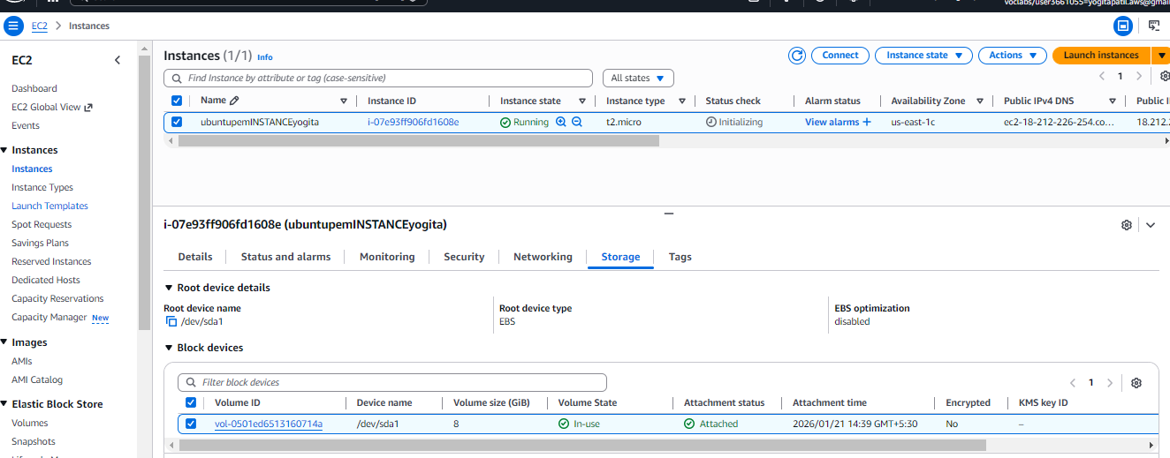

Here, above if u click on checkbox of instance u get instance details down, also if u click on storage u get information of volume, its size, status,…. Down page

Step 1: Create a New EBS Volume
Open the EC2 Dashboard.
From the left-hand menu, select Volumes under Elastic Block Store (EBS).
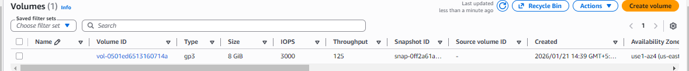
The volume here above is default volume of instance. Now to create new volume do as below

Click Create Volume.
Choose:
Volume type (gp3/gp2) = gp3
Size of the volume = 2
Availability Zone (must be the same as the EC2 instance)
Click Create Volume. (Down ,all other are default setting)

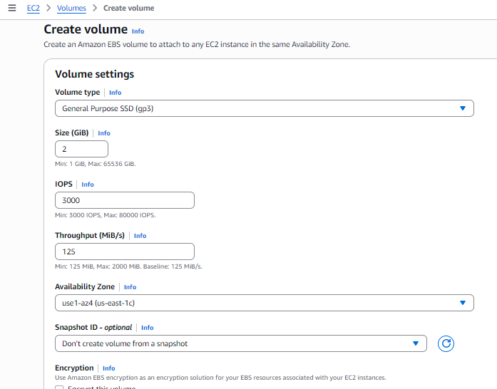

Note: Steps to check Availability Zone -> Goto dashboard -> Instance-> open this in new tab ->
Click on instance checkbox, then down page click on Networking to see Availability Zone ( this use1-az4) must be same as in EBS volume Availability Zone.
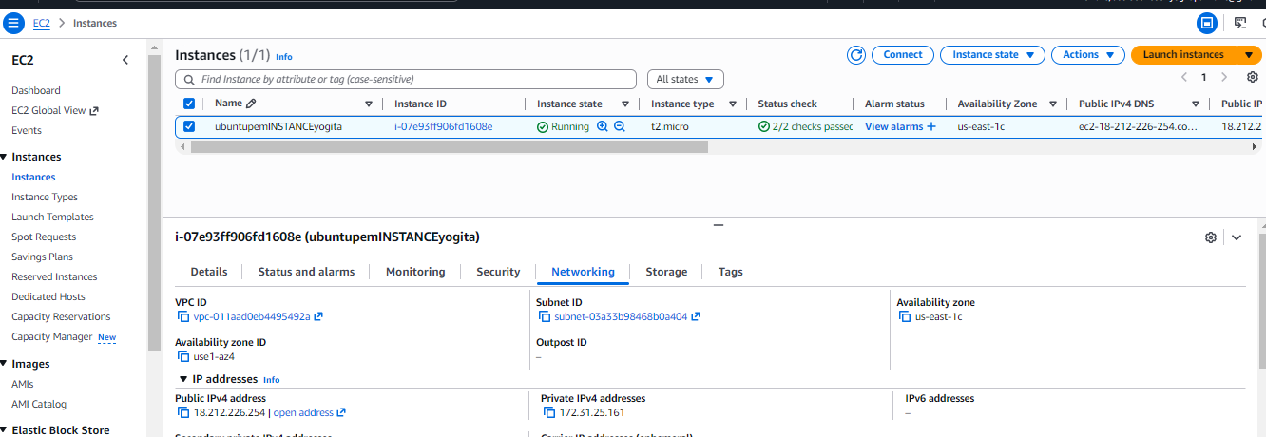

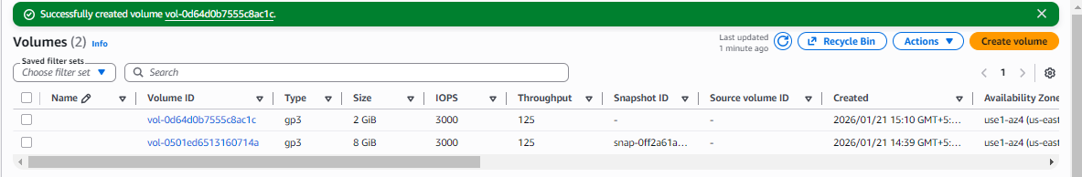
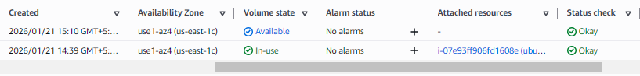
Thus new volume created with type gp3, size 2GB, status Available …. But not attached still…

Step 2: Attach the EBS Volume to the Existing EC2 Instance
- In the Volumes section, select the newly created volume.

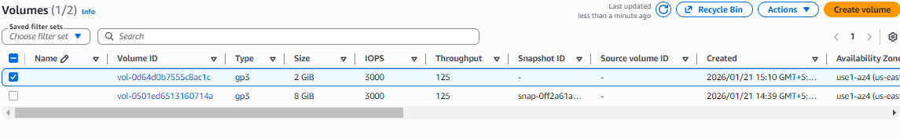

- Click Actions → Attach Volume.
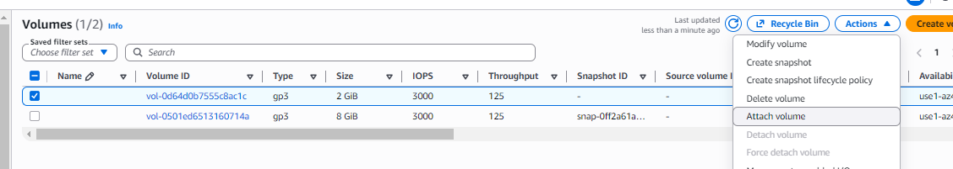
- Select the target EC2 instance from the list.
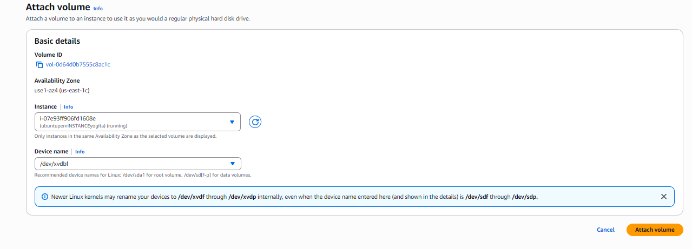
- Specify the device name (example: /dev/xvdf).
- Click Attach.( it shows In-use)
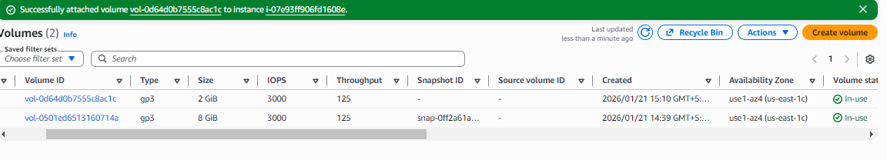
Now goto Instance -> select it->click Storage-> then u see two volume
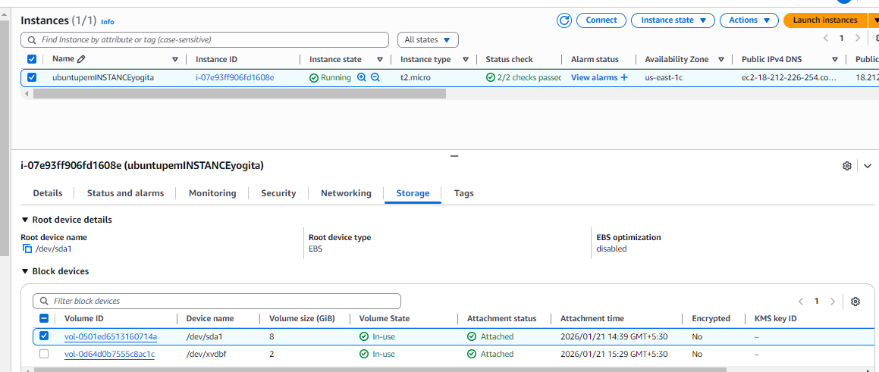

Default volume has for “Delete on terminated” is Yes and No for new Volume. So it’s permanent volume.
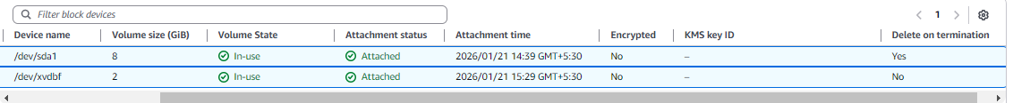

Step 3: Verify the Volume on the EC2 Instance
Connect to the EC2 instance using SSH.
Check the attached disks:
lsblk
Identify the new volume (e.g., /dev/xvdbf).

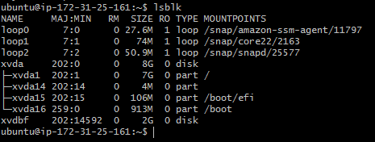

Note: Ensure that the EBS volume and the EC2 instance belong to the same Availability Zone, as cross-AZ attachment is not supported.

b)Procedure: increasing/decreasing of CPU and RAM
Step 1. - Navigate to the EC2 dashboard.
Step 2. - Stop the EC2 instance associated with the EBS volume.

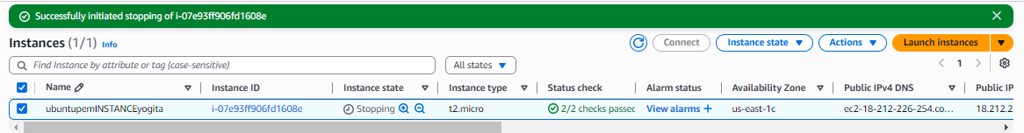

Step 3. - Click "Actions" and then—instance settings—change the instance type . below is with t2.micro

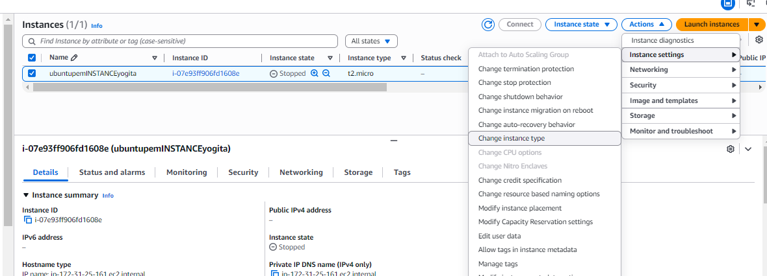
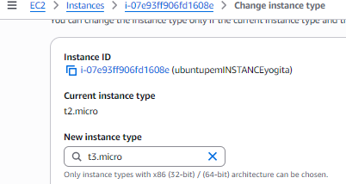
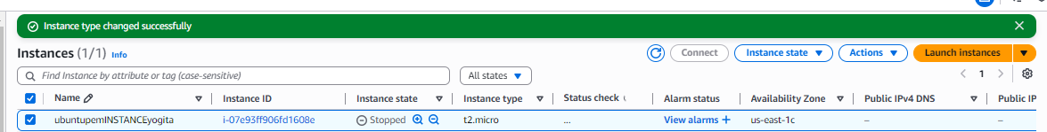

After changing to type t3.micro we get

Step 4. -Increase/ decrease the size or change the volume type to a higher performance specification.

- Goto Volumes under Elastic Block Store
- Volumes -> select volume to change
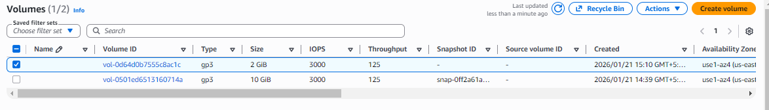
- Actions -> Modify
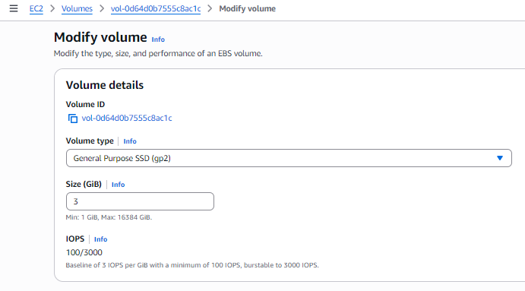
Step 5. - Click "Modify" to apply the changes.
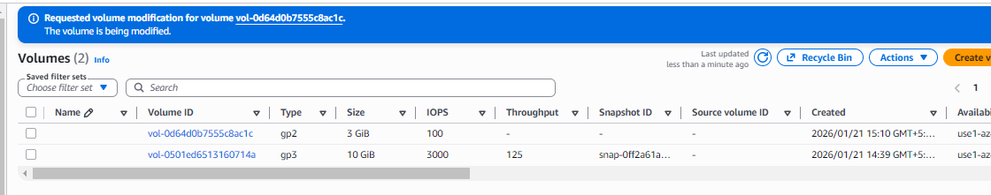

Step 6: Now the start the machine you see with increase /decrease of size and performance

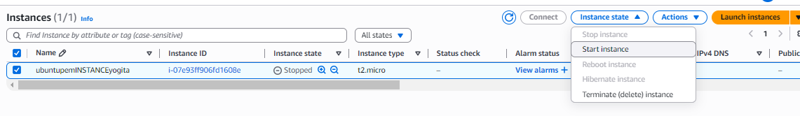
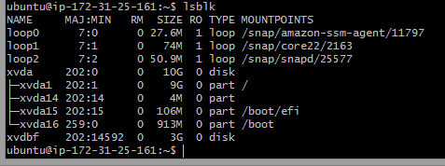

- Attach and permanently mount an EBS volume to a Linux EC2 instance to ensure data persistence across reboots.
Note:
- lsblk : list block devices/volumes that are available. Display information about all available block devices, such as hard drives, SSDs, and their partitions
- file -s /dev/xvdbf or lsblk -fs
to check is file system is on new EBS volume
In output, if u see data means you need to setup file system for new
Volume.
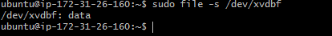
- mkfs -t xfs /dev/xvdbf Create file system on volume to mount it to EC2
- mkdir /mnt/yogita create directory
- mount /dev/xvdbf /mnt/yogita

Step 1: Create an EBS Volume
- Log in to AWS Management Console
- Go to EC2 → Volumes
- Click Create Volume
- Choose:
  - Volume Type: gp3 (recommended)
  - Size: (e.g., 20 GB)
  - Availability Zone: Same AZ as EC2 instance
- Click Create Volume
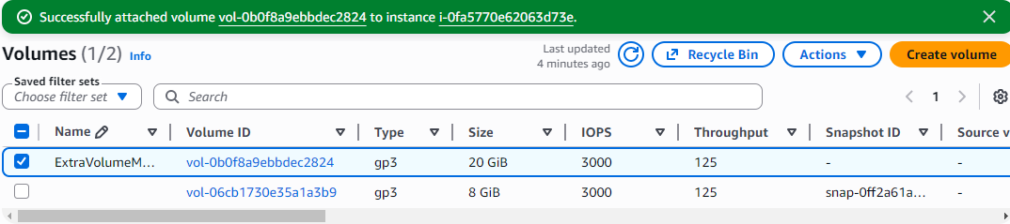

Step 2: Attach the EBS Volume to EC2
- Select the newly created EBS volume
- Click Actions → Attach Volume
- Choose:
  - Instance: Select your Linux EC2 instance
  - Device name: /dev/xvdf
- Click Attach
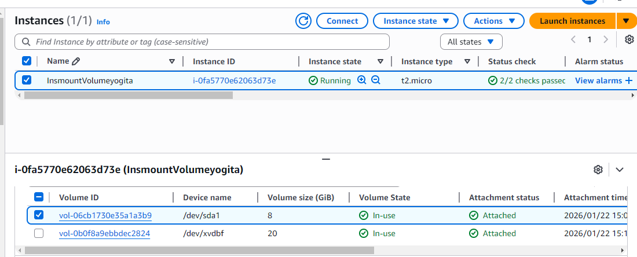

Step 3: Connect to the EC2 Instance
Connect using SSH:
ssh -i key.pem ec2-user@<public-ip>

Step 4: Verify the Attached Disk
Check all available disks:
lsblk
You will see:
- Root volume: /dev/xvda
- New volume: /dev/xvdbf (no partition yet)
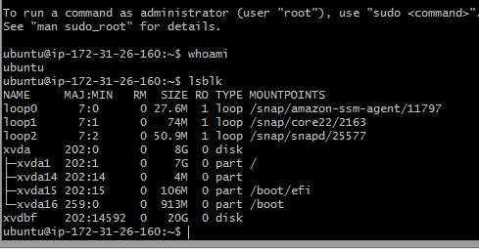
Here above last line shows new volume xvdbf of 20G
Check filesystem:
lsblk -fs
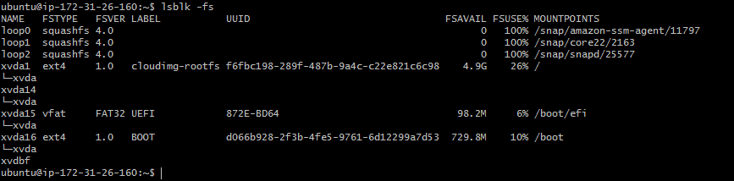

Step 5: Create a Partition
Create a partition on the new volume:
sudo fdisk /dev/xvdbf
Inside fdisk:
- Press m → Help menu
- Press n → New partition
- Press p → Primary partition
- Enter default value and Press Enter → Default partition number
- Enter default value and Press Enter → Default first sector
- Enter default value and Press Enter → Default last sector (use full disk)
- Press w → Write changes and exit
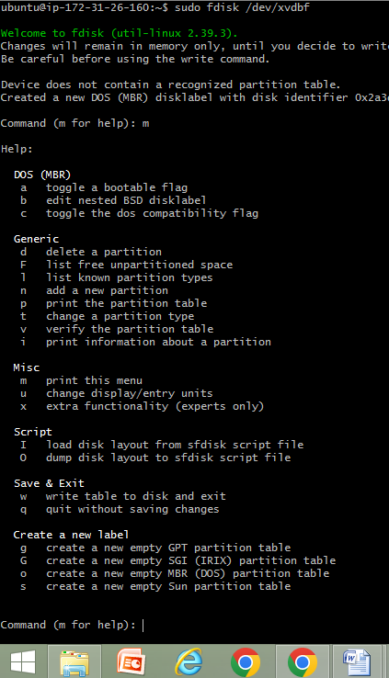
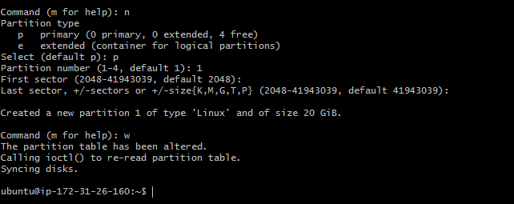
Notify kernel:
partprobe
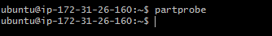

Step 6: Verify the New Partition
lsblk -fs
You should now see:
/dev/xvdf1
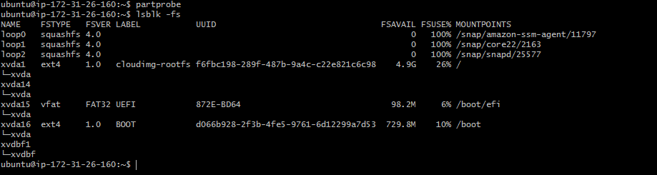
File system xvdbf1 without UUID for disk block/volume xvdbf

Step 7: Format the Partition
Format with XFS filesystem:
sudo mkfs.xfs /dev/xvdbf1
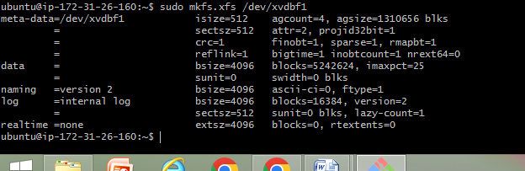
Verify:
lsblk -fs
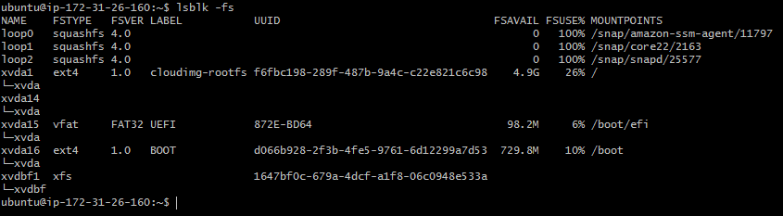
File system xvdbf1 has UUID for disk block/volume xvdbf

Step 8: Create a Mount Directory
mkdir /mnt/yogita

Step 9: Mount the Volume
sudo mount /dev/xvdbf1 /mnt/yogita
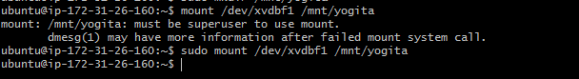
Verify:
df -h
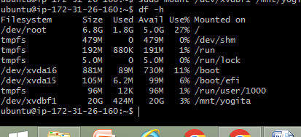

Step 10: Make the Mount Persistent ( Write UUID in fstab ie file system table)
Get the UUID of the volume:
sudo blkid /dev/xvdbf1
Edit fstab:
sudo nano /etc/fstab
This put now
Add this line at the end:
Syntax : UUID=<UUID-value> /mnt/yogita xfs defaults,nofail 0 0
example
UUID =f97b4832-90b6-4b31-a18b-34a6a2e39b75 /mnt/yogita xfs defaults,nofail 0 0
Save and exit. ( Press ^o Enter then ^x Enter)
Next cd /mnt/yogita // means move to directory yogita
sudo nano f1.txt (… write your name in file f1.txt and save)
cd ..
cd ..
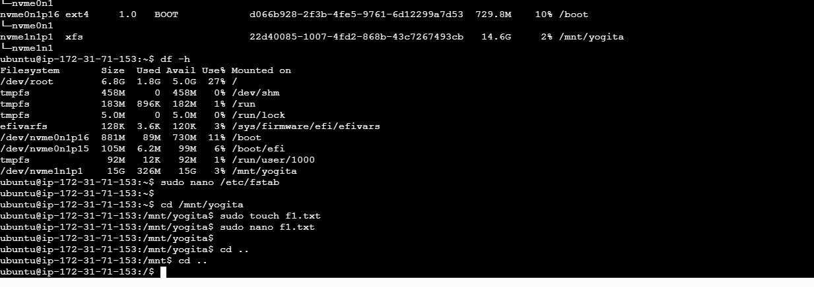
Now Test fstab:
mount –a
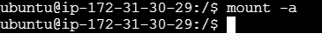

Step 11: Verify Persistence
- Reboot the instance:
Reboot instance
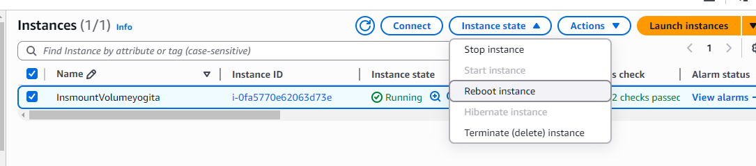
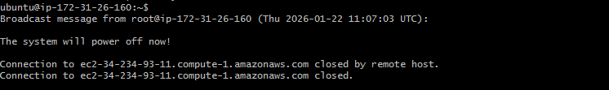
- Reconnect and check:
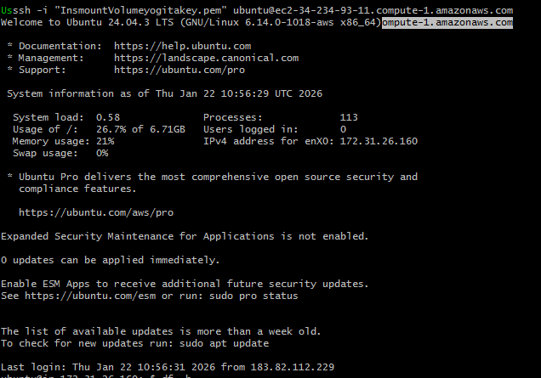
df -h
➡️ Volume should be mounted automatically.
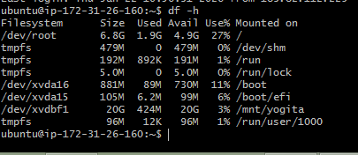

Step 12: Detach and Reattach Volume (Data Recovery Scenario)
Detach:
- EC2 → Volumes → Select volume
- Actions → Detach volume
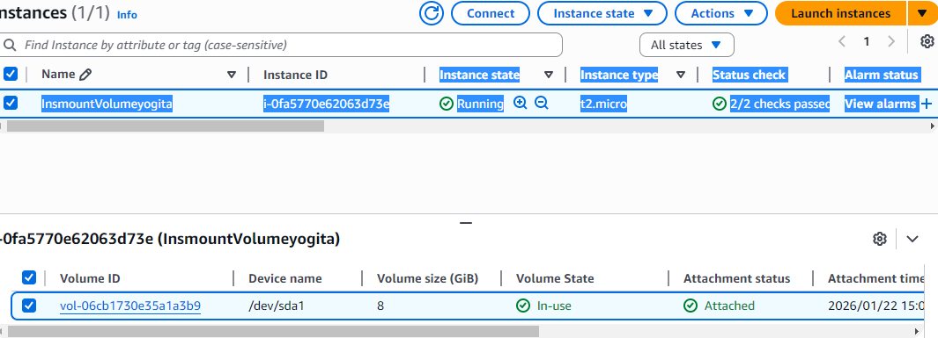
Attach to another EC2 instance:
- Attach to new instance (Name anotherINS) (same AZ)
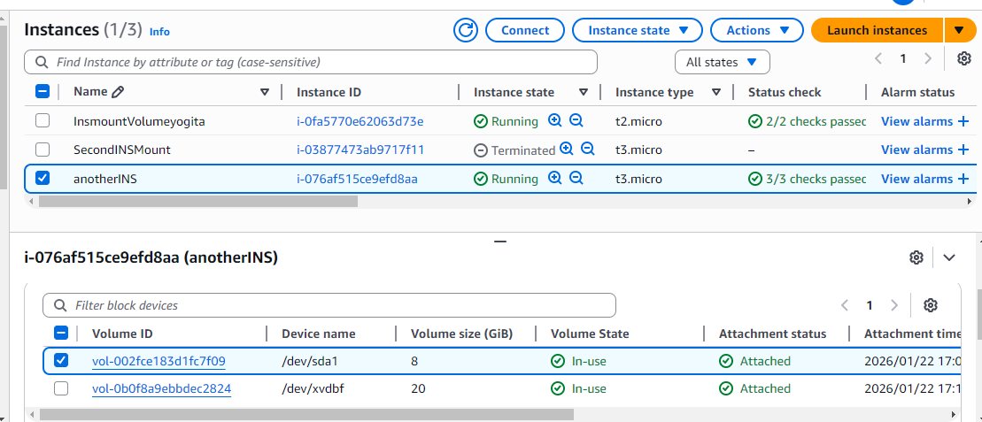
- Login to new instance

- Create mount directory:
mkdir /mnt/yogita

- Mount the volume:
mount /dev/xvdf1 /mnt/yogita
All previous data will be available
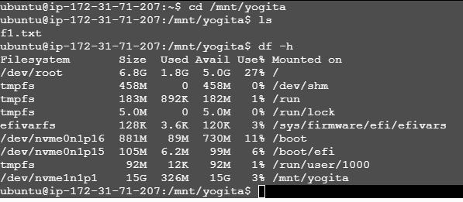
cd /mnt/yogita
ls
output is f1.txt
cd ..

Summary Flow
Create Volume → Attach → lsblk → fdisk → mkfs → mkdir → mount → fstab → reboot

3. Create a snapshot of the attached EBS volume and use it to create and attach a new volume to an EC2 instance in another AWS region.
Attaching Volumes across regions of EC2 using the snapshot
To create a snapshot of an EBS volume and attach it to an instance in another region in AWS, you'll need to follow these steps:

Step 1. Create a Snapshot:
a. Sign in to the AWS Management Console.
b. Navigate to the EC2 Dashboard.
c. Click on "Volumes" in the left-hand navigation pane.
d. Select the EBS volume you want to create a snapshot of.
e. Click on the "Actions" dropdown menu above the volume list and select "Create Snapshot."
f. Provide a name and description for the snapshot.
g. Click on the "Create Snapshot" button to initiate the snapshot creation process.

Step 2. Copy the Snapshot to Another Region:
a. Once the snapshot is created, go to the "Snapshots" section in the EC2 Dashboard.
b. Select the snapshot you just created.
c. Click on the "Actions" dropdown menu above the snapshot list and select "Copy Snapshot."
d. Choose the destination region where you want to copy the snapshot.
e. Click on the "Copy Snapshot" button to initiate the copy process. This may take some time depending on the size of the snapshot and the network speed.

Step 3. Monitor the Snapshot Copy Progress:
a. You can monitor the progress of the snapshot copy by navigating to the "Snapshots" section in the EC2 Dashboard of the source region.
b. Look for the snapshot you copied and check its status. It will change from "pending" to "completed" once the copy process is finished.

Step 4. Switch to the Destination Region:
- Use the region selector in the top-right corner of the AWS Management Console to switch to the destination region where you copied the snapshot.

Step 5. Create a Volume from the Snapshot:
a. In the EC2 Dashboard of the destination region, go to the "Snapshots" section.
b. Find the snapshot you copied from the source region.
c. Click on the snapshot, then click on the "Actions" dropdown menu and select "Create Volume."
d. Configure the volume settings, such as volume type, size, and availability zone.
e. Click on the "Create Volume" button to create the volume from the snapshot.

Step 6. Create the ec2 instance & Attach the Volume to an Instance:
a. Once the volume is created, navigate to the "Volumes" section in the EC2 Dashboard.
b. Find the newly created volume and select it.
c. Click on the "Actions" dropdown menu and select "Attach Volume."
D the EC2 instance to which you want to attach the volume and specify the device name.
e. Click on the "Attach" button to attach the volume to the instance.

We have created a snapshot of an EBS volume, copied it to another region, created a volume from the snapshot, and attached it to an instance in the destination region.
sudo mount /dev/xvdbf1 /mnt/yogita
