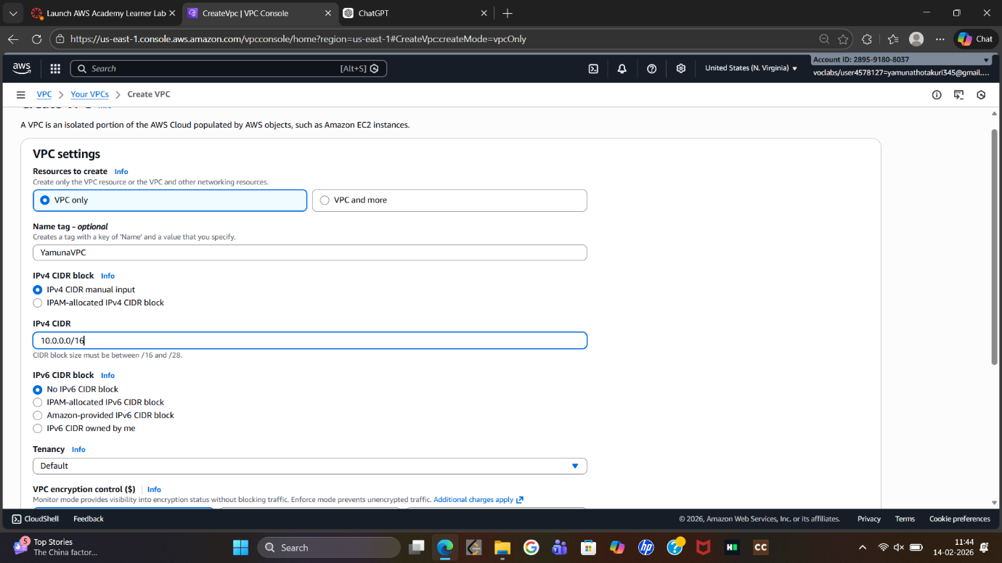
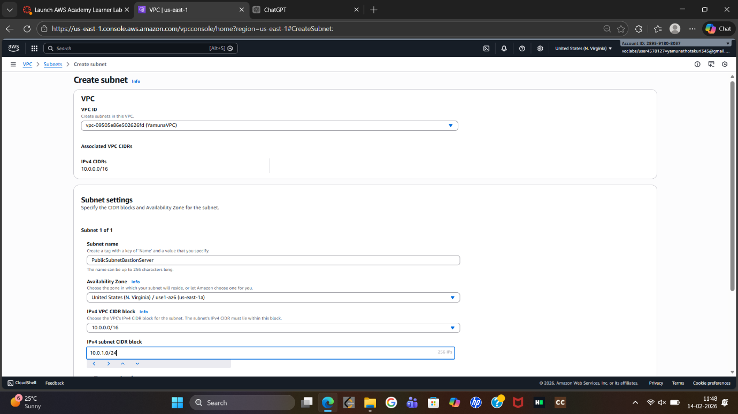
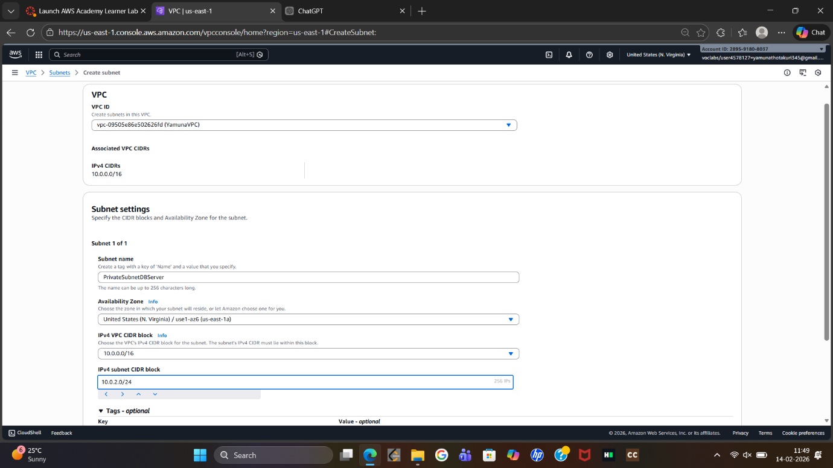
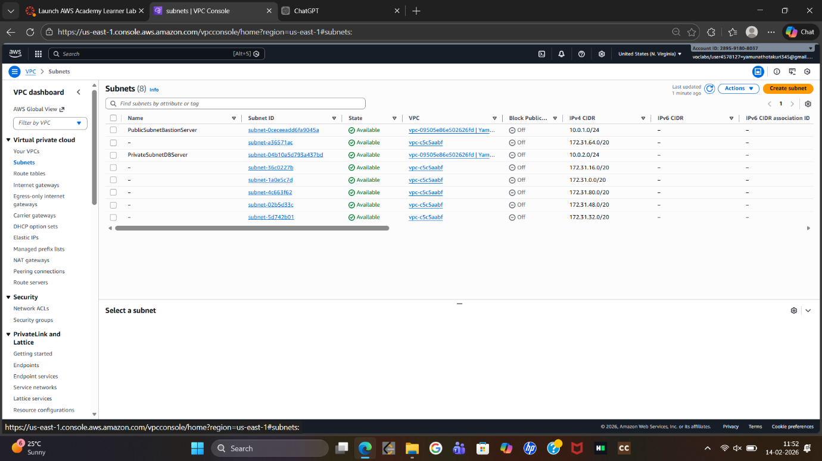
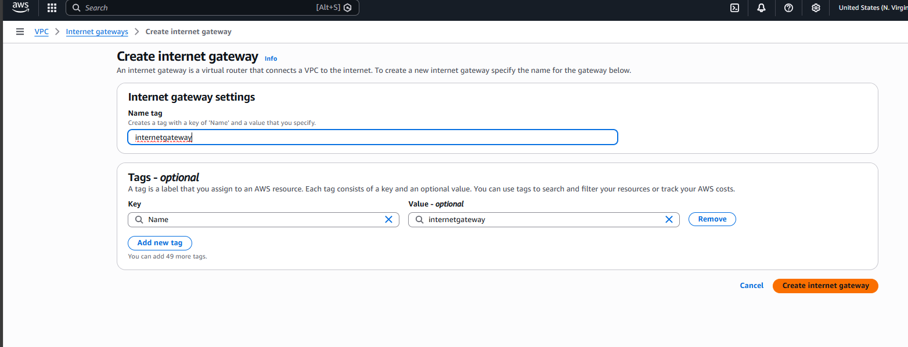
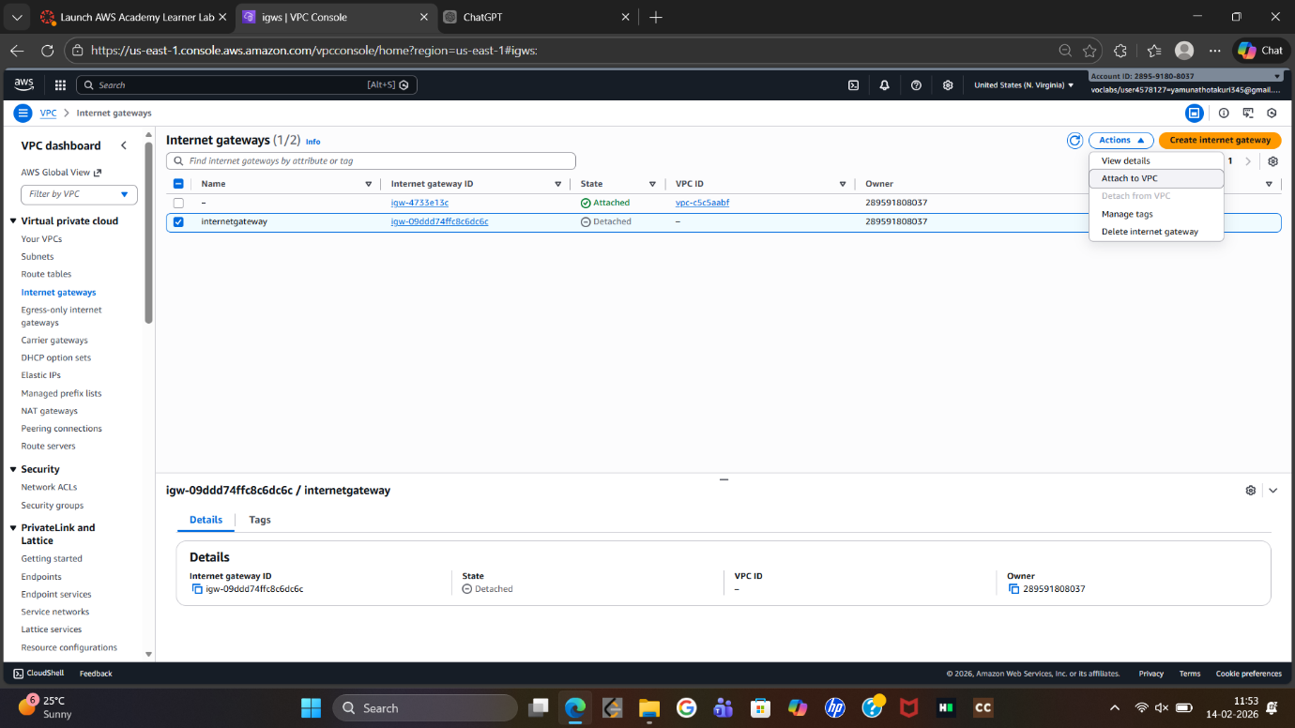
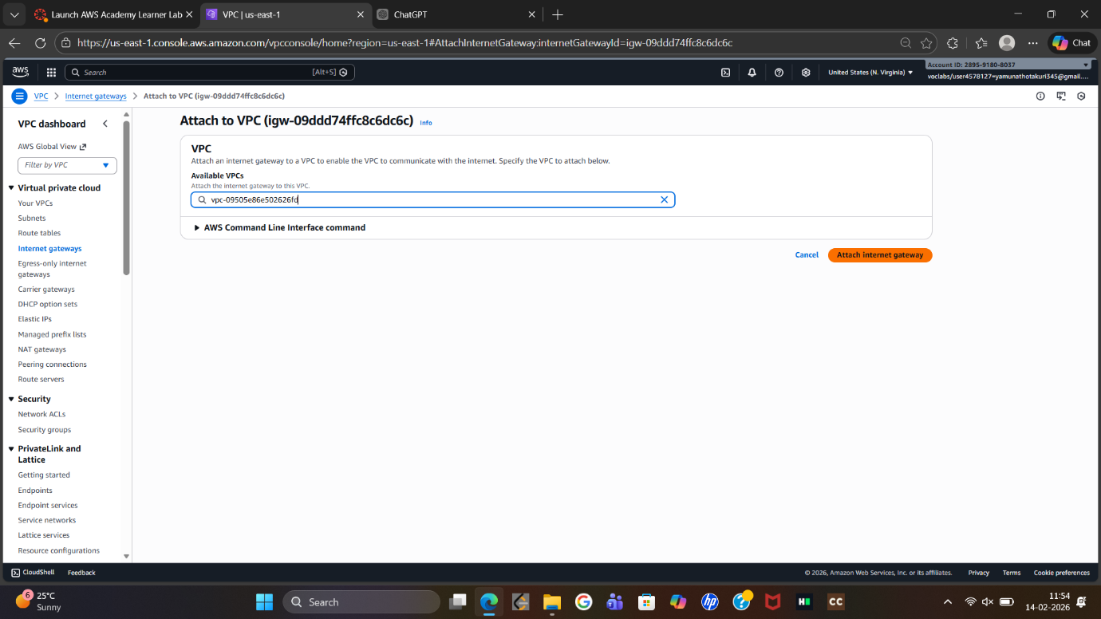
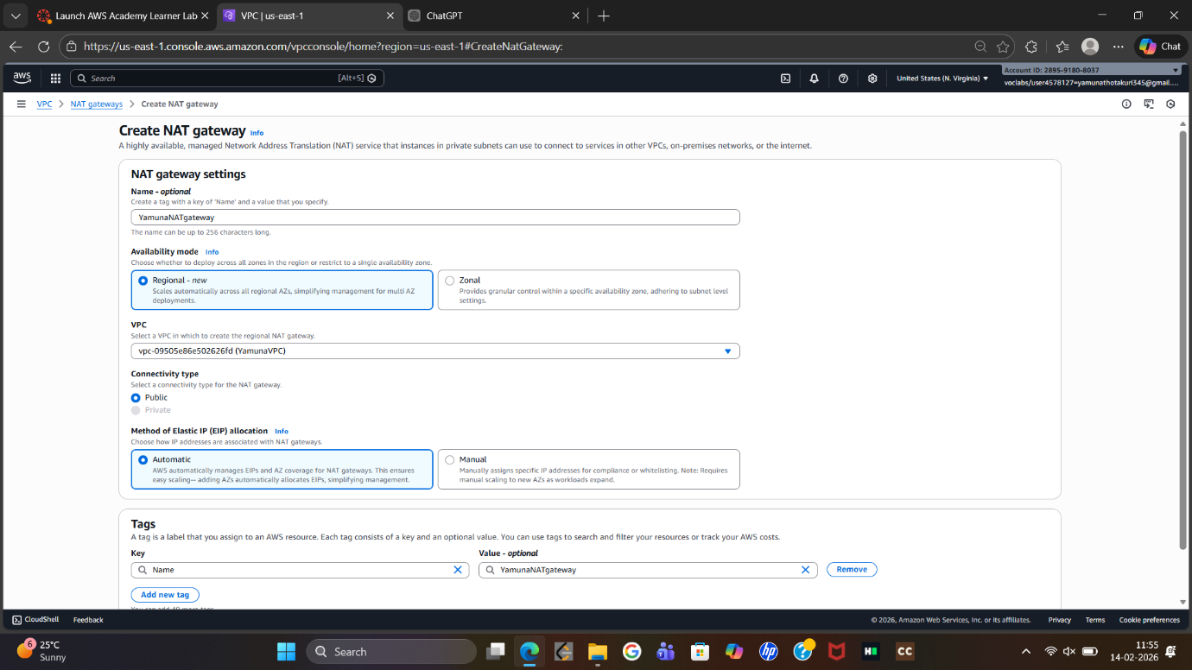
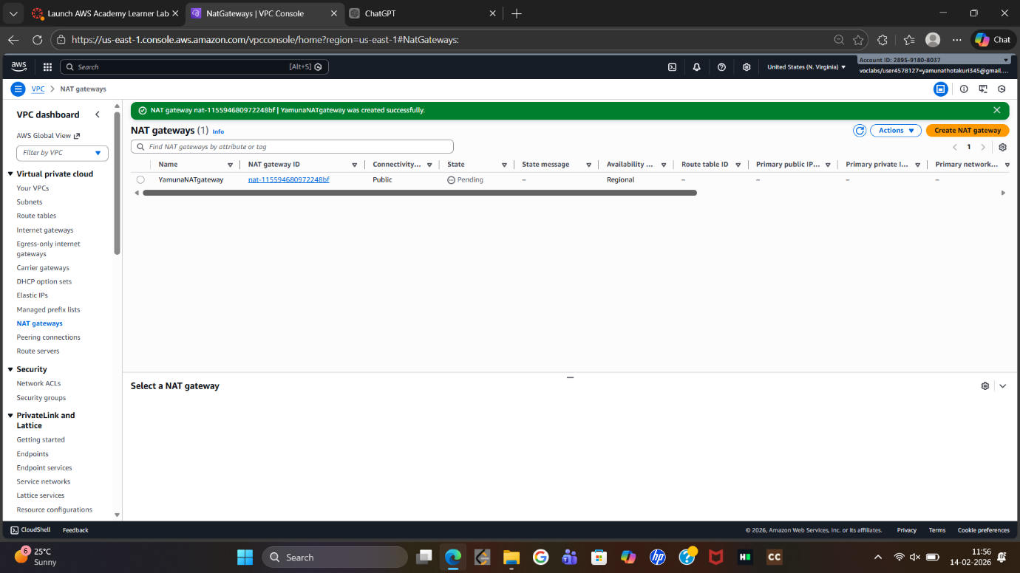
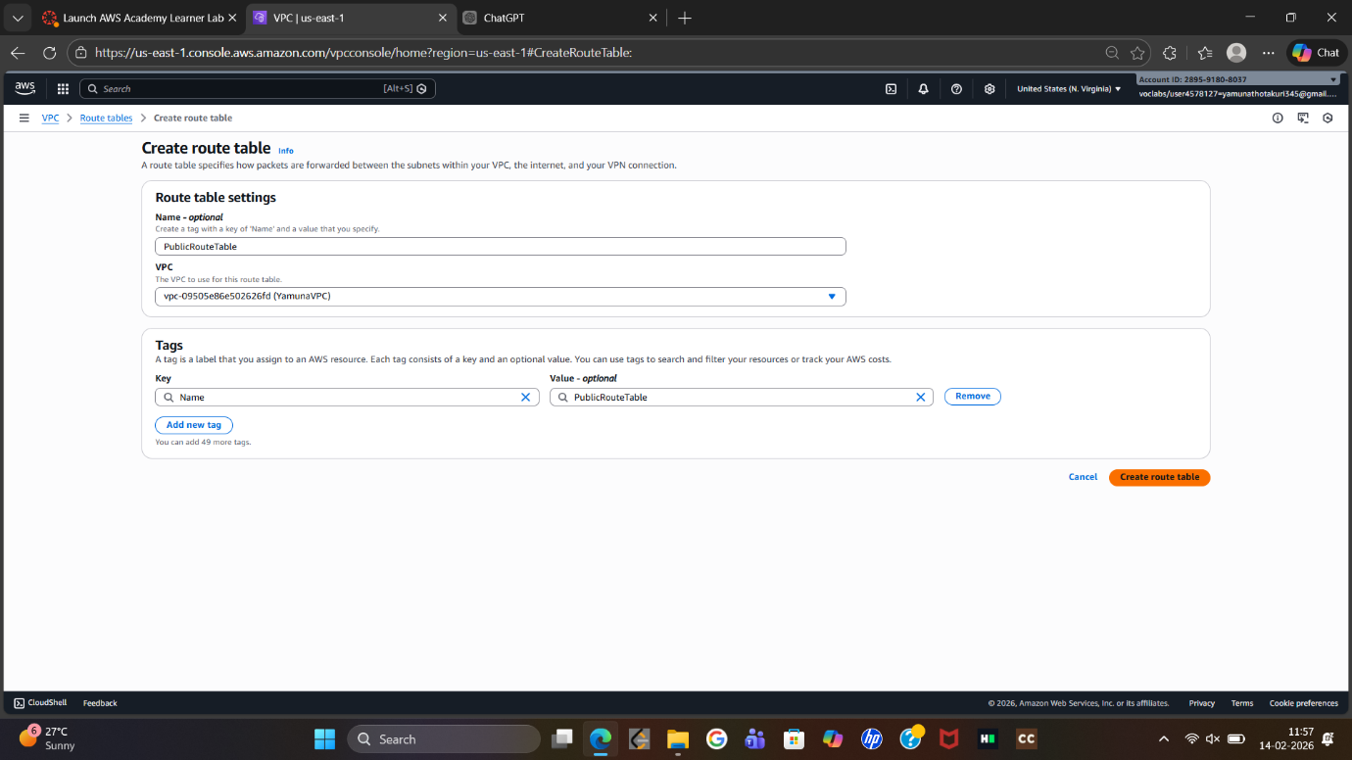
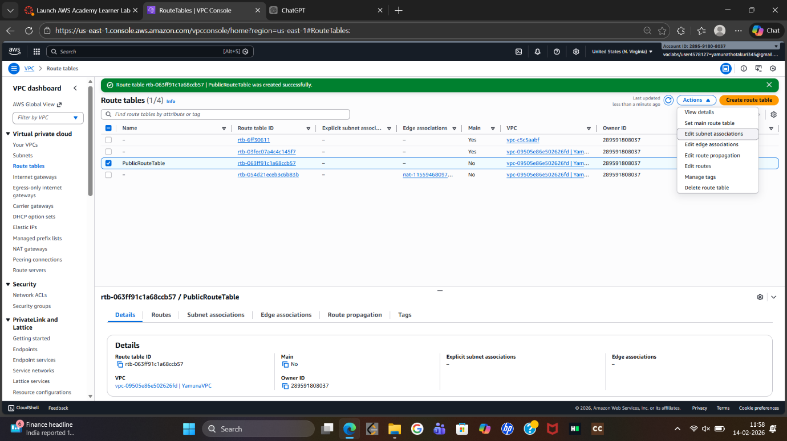
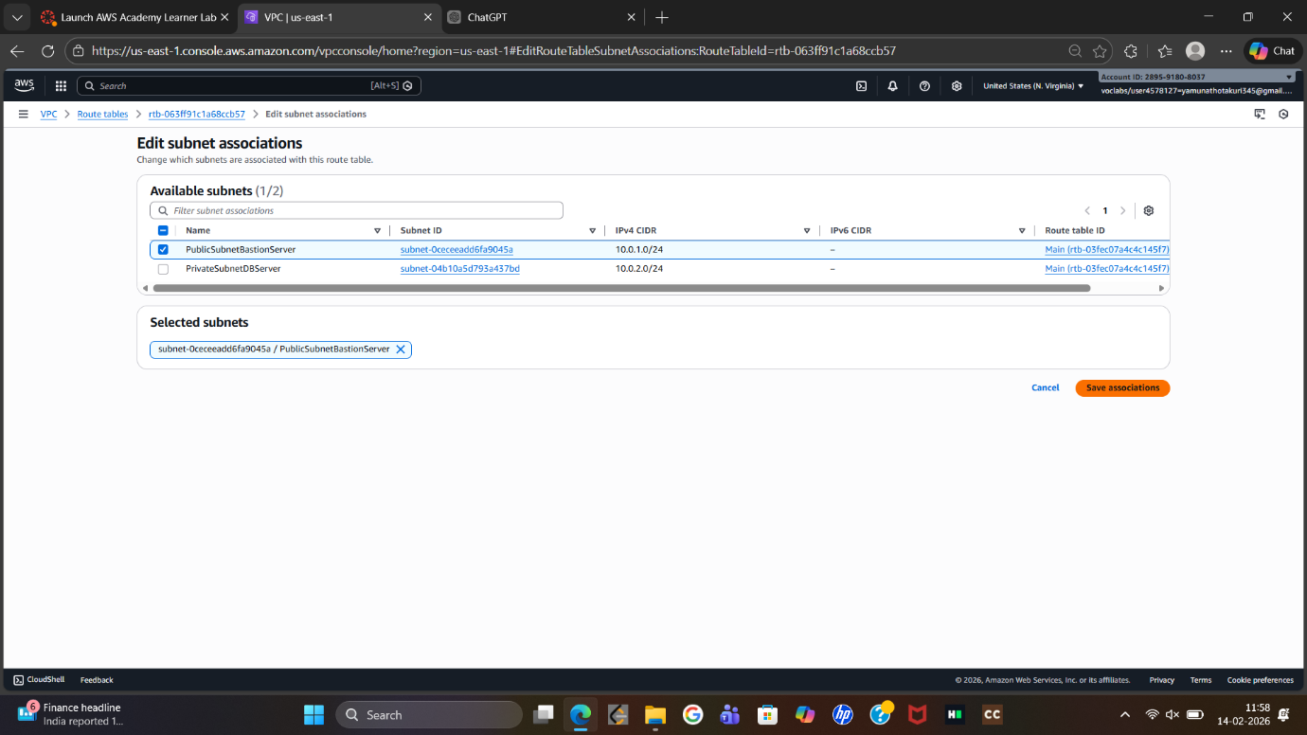

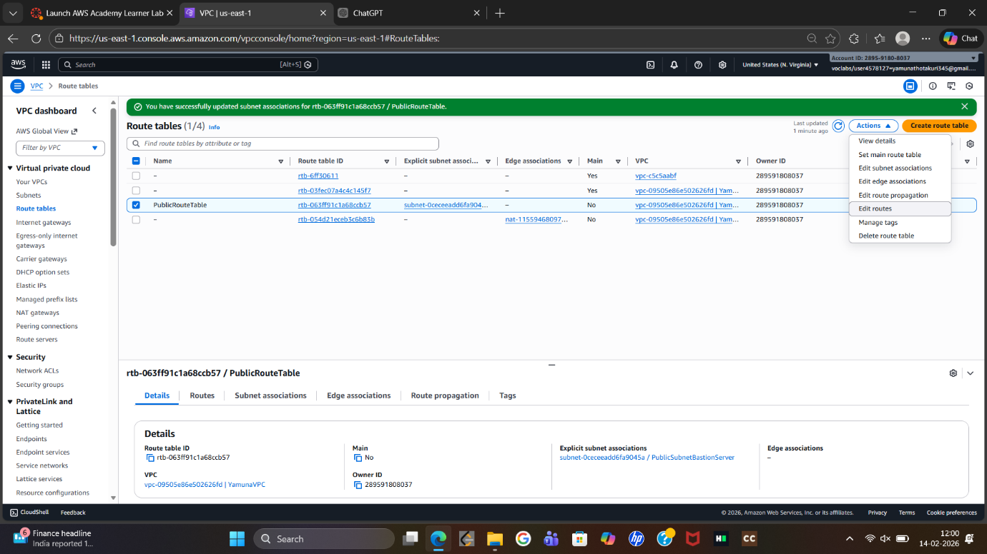
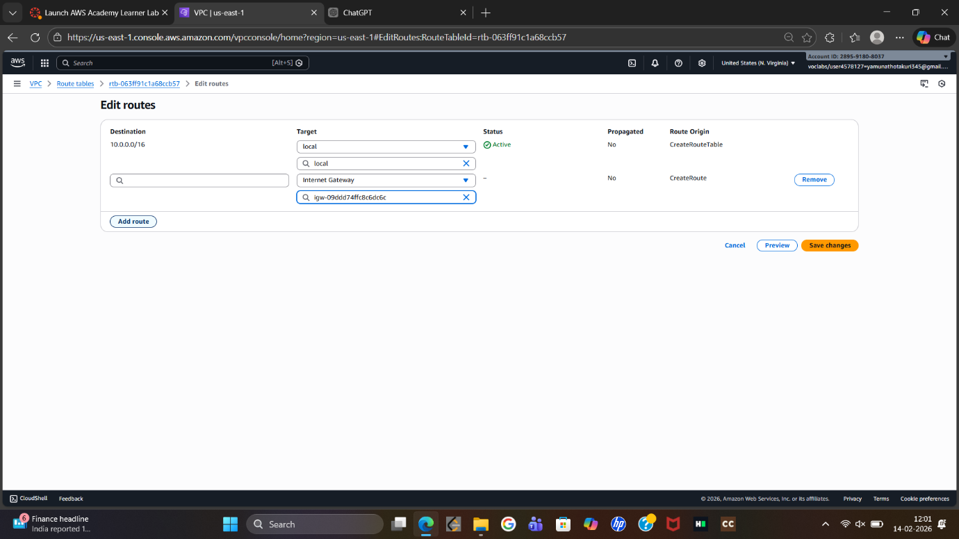
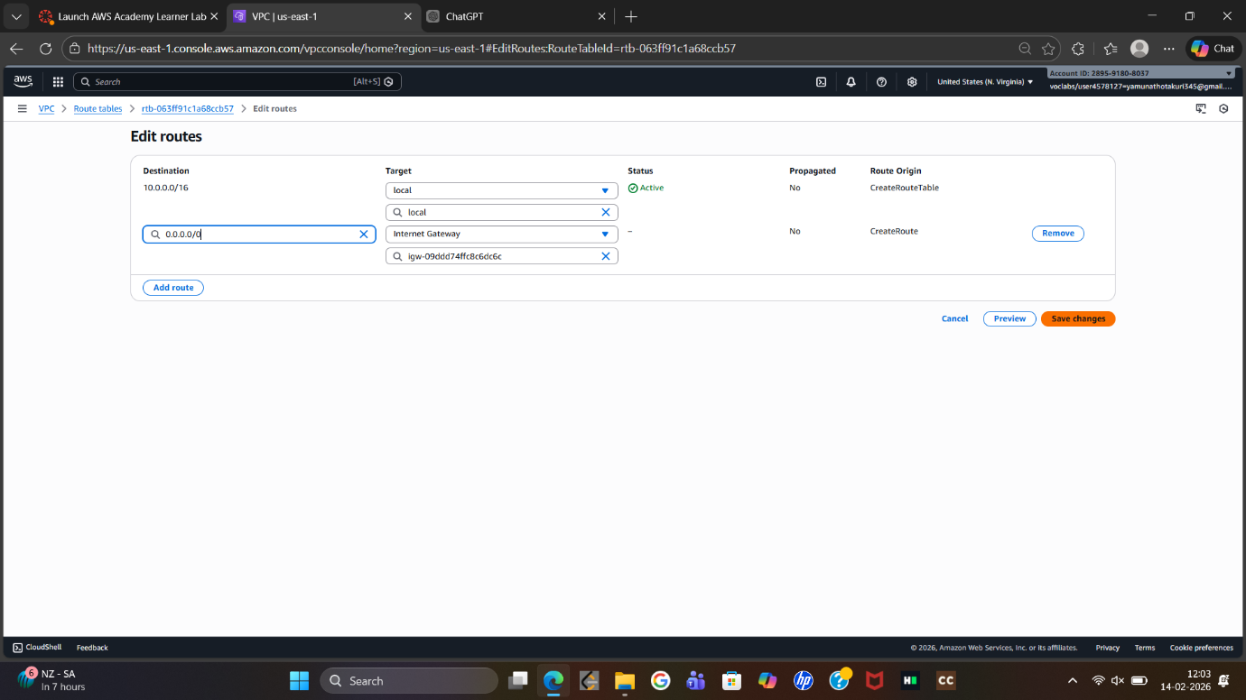
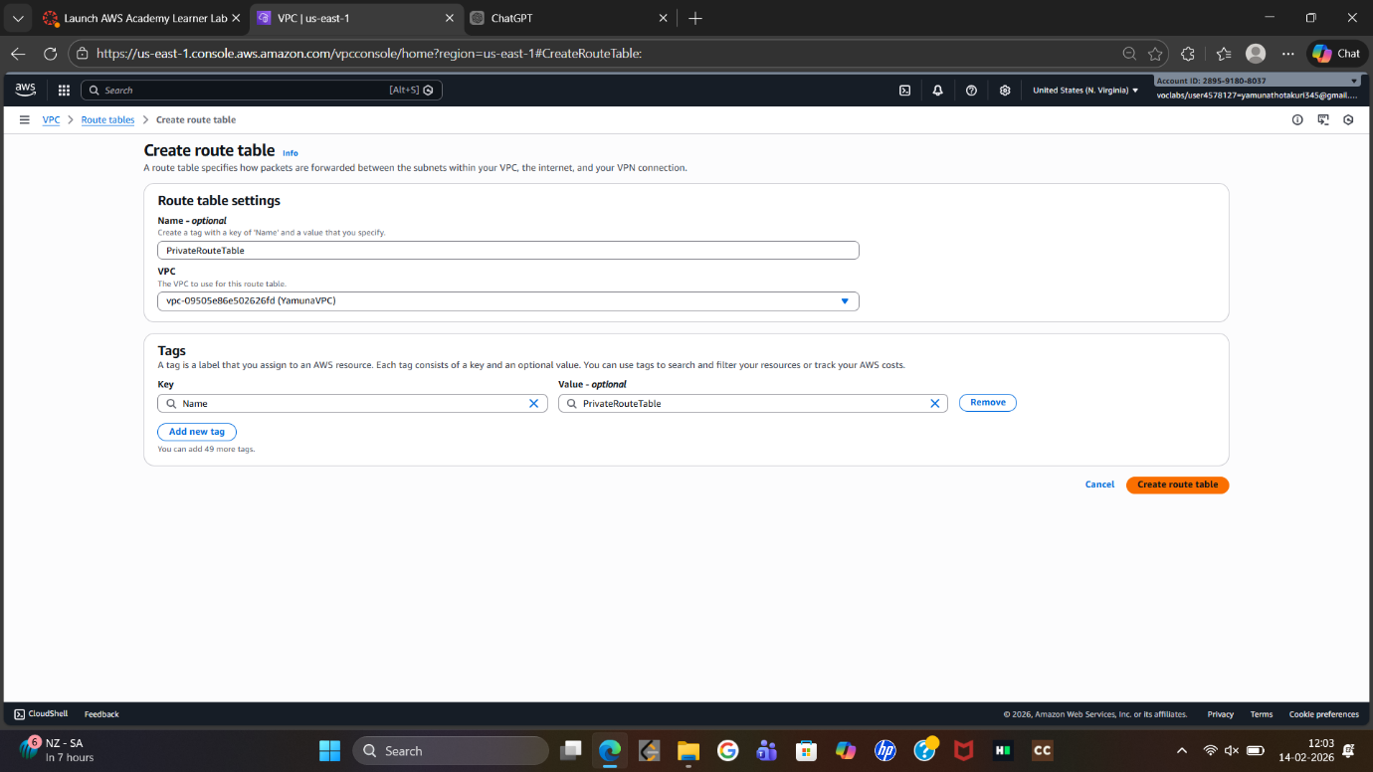
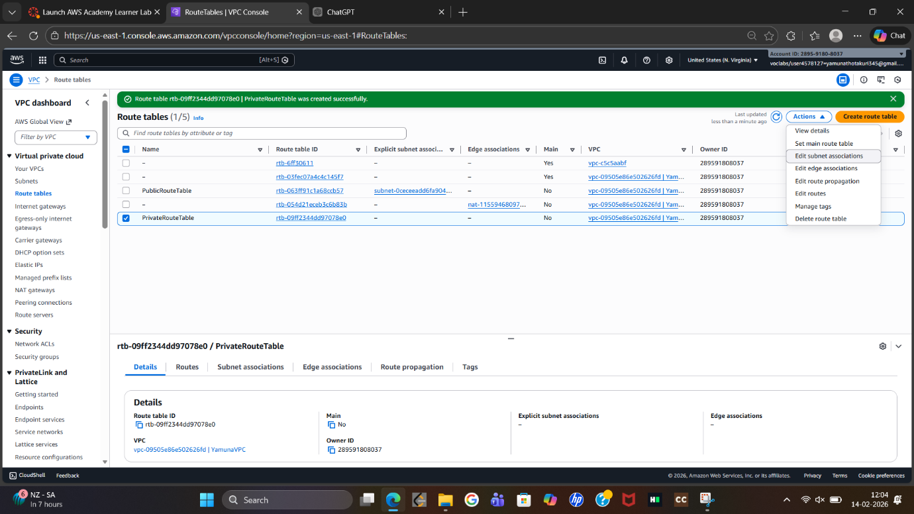
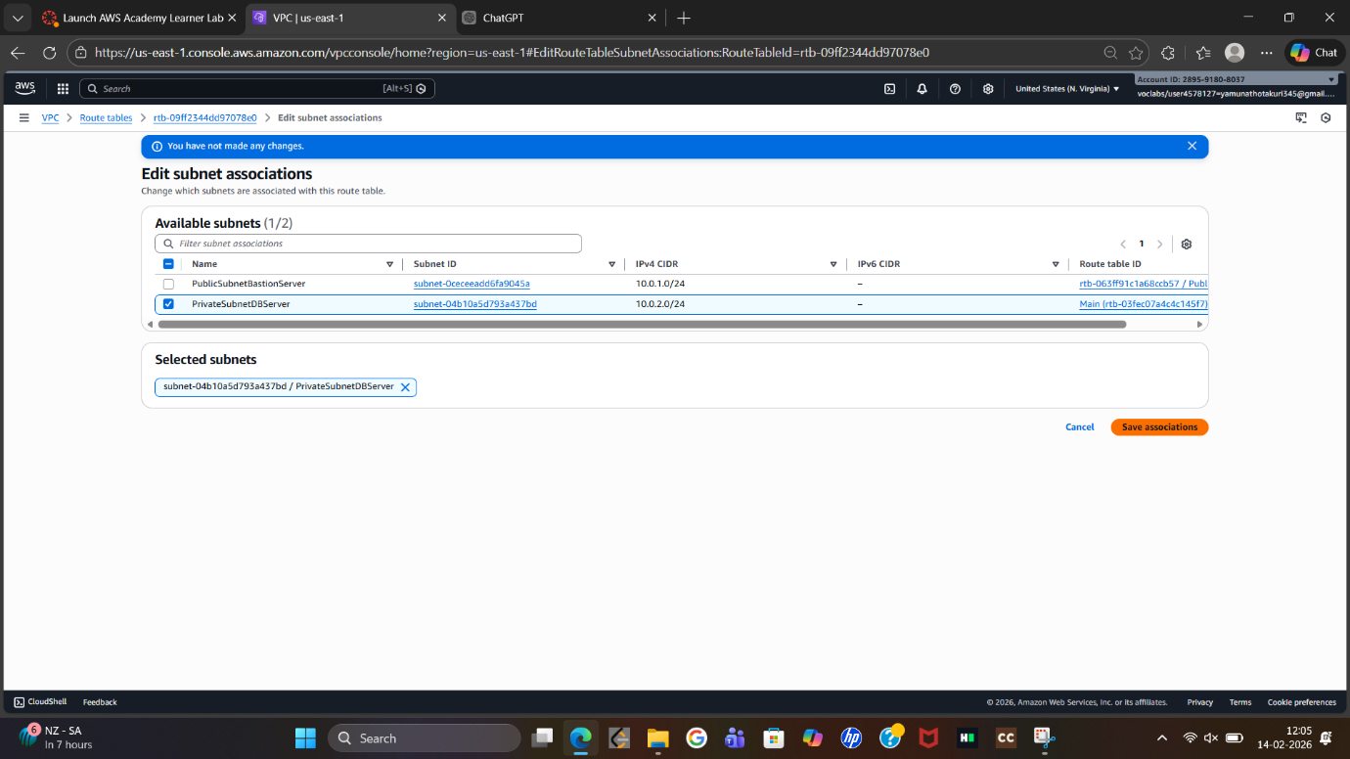
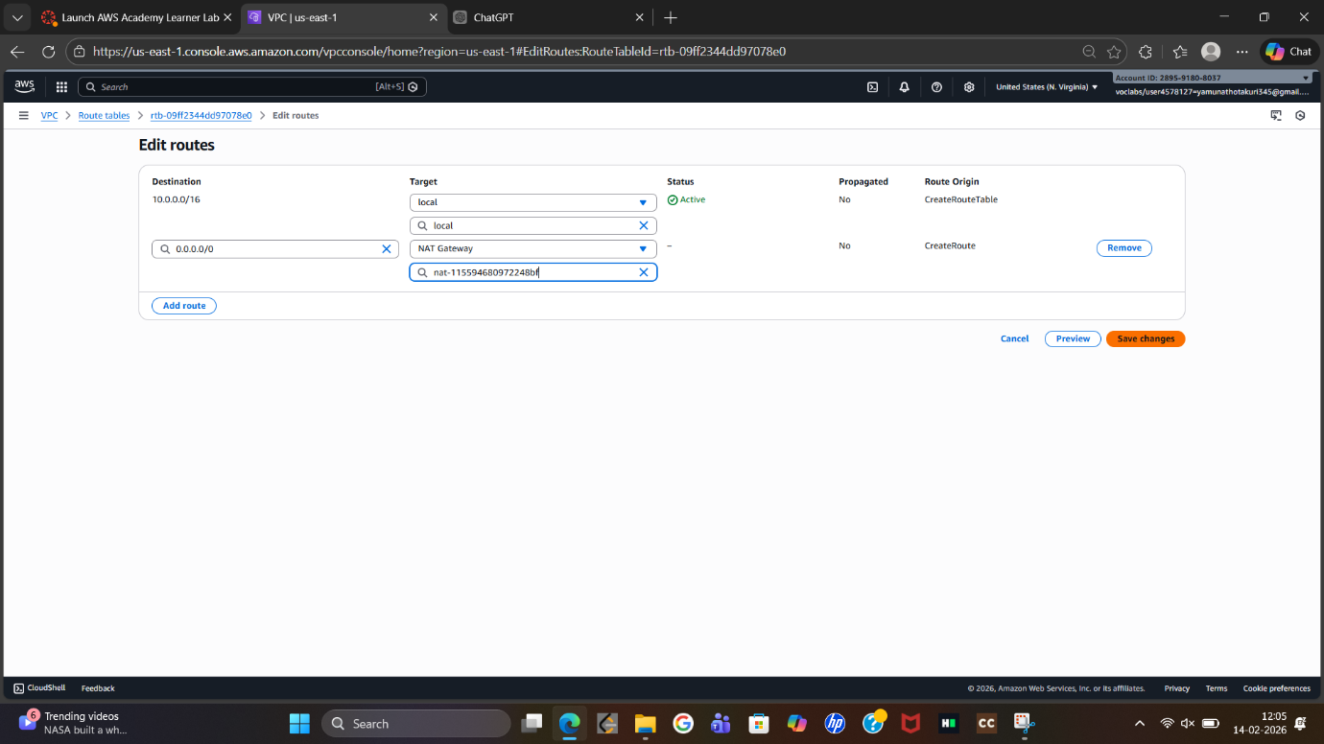
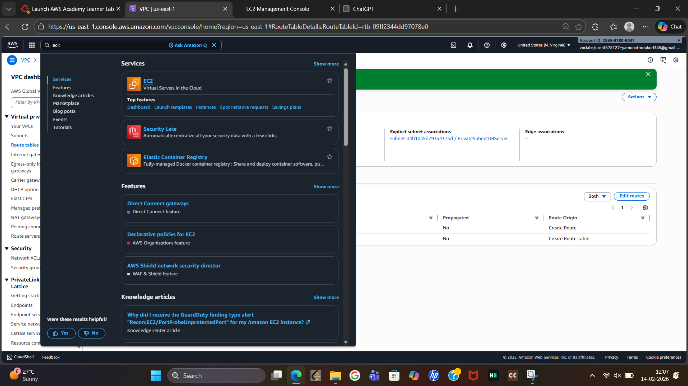
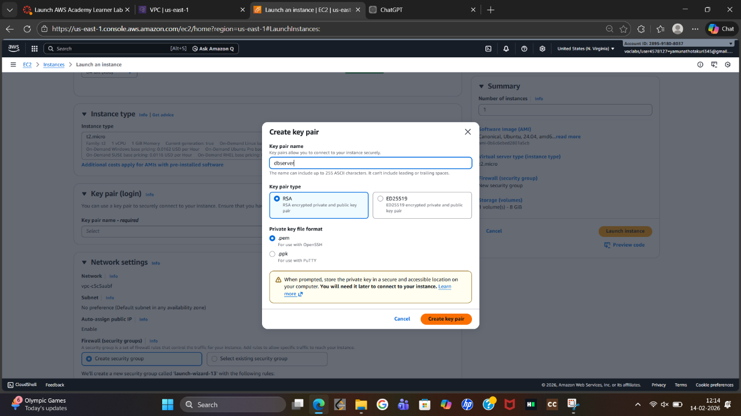
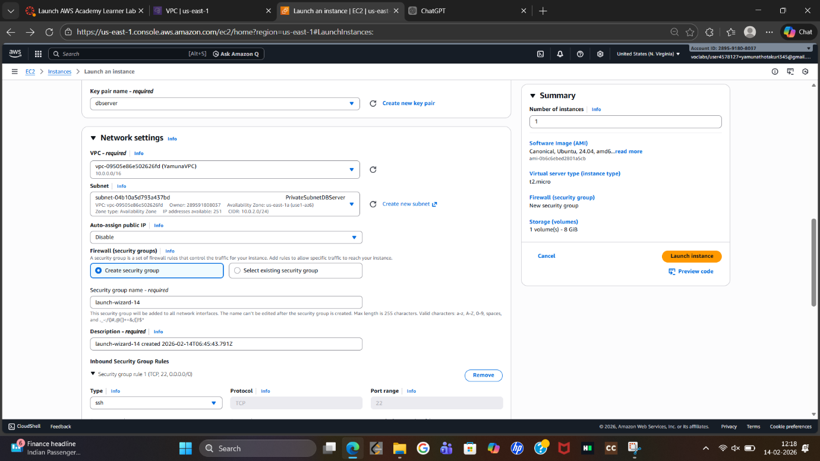
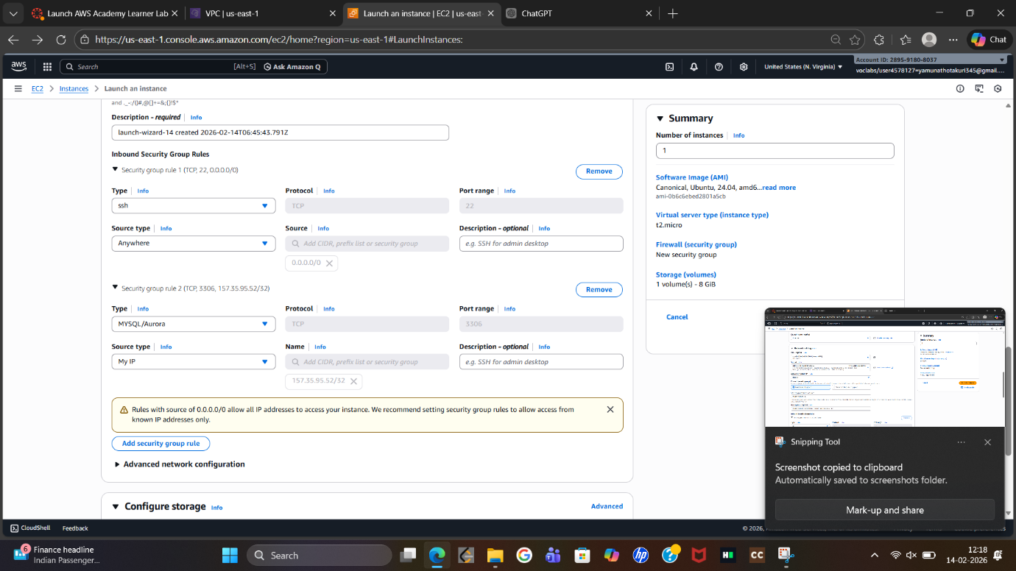
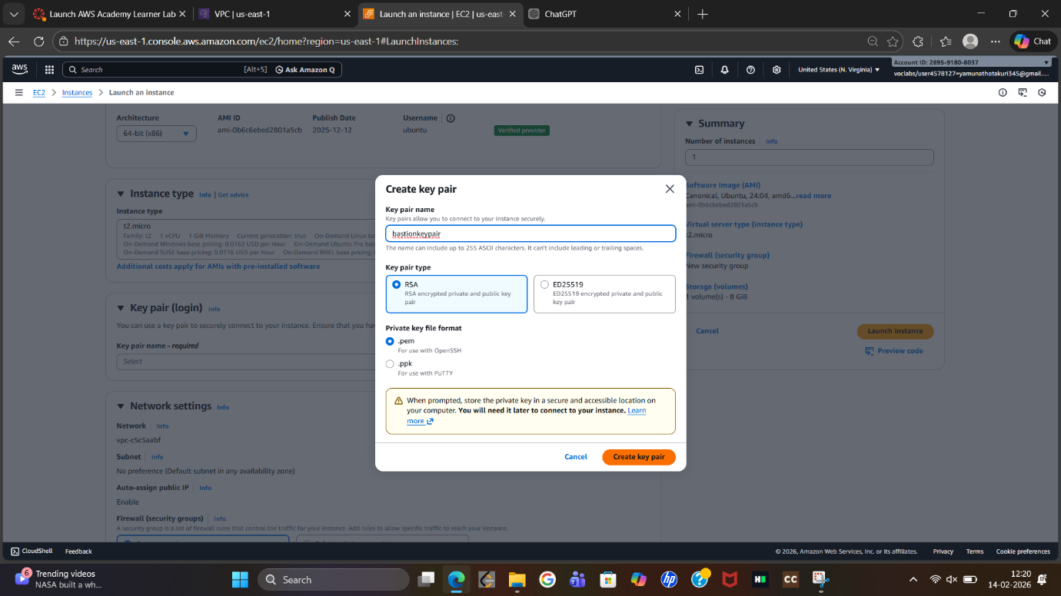
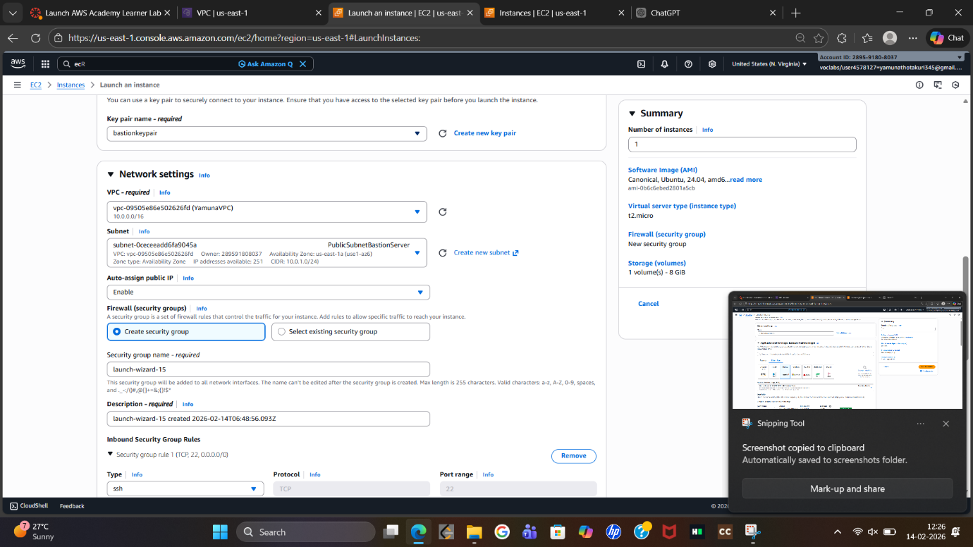
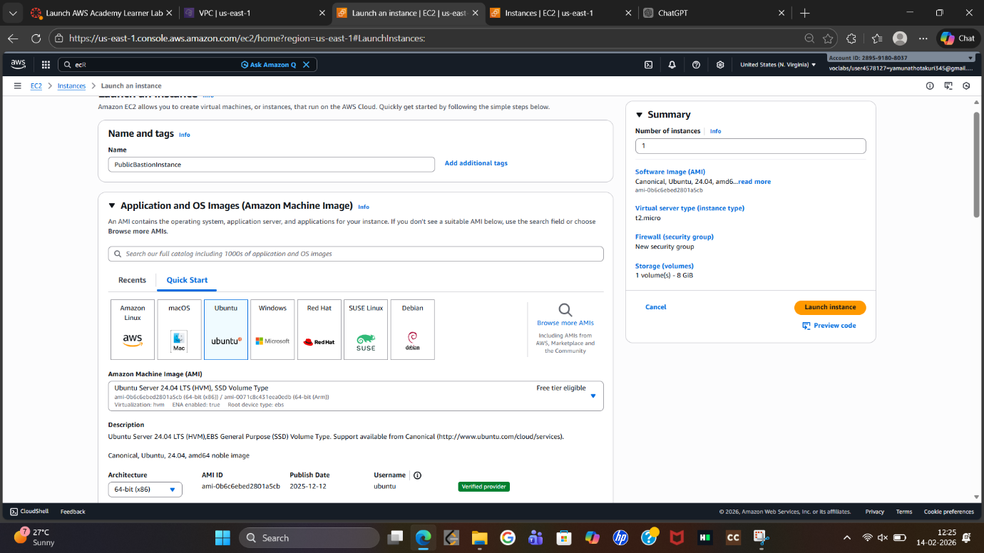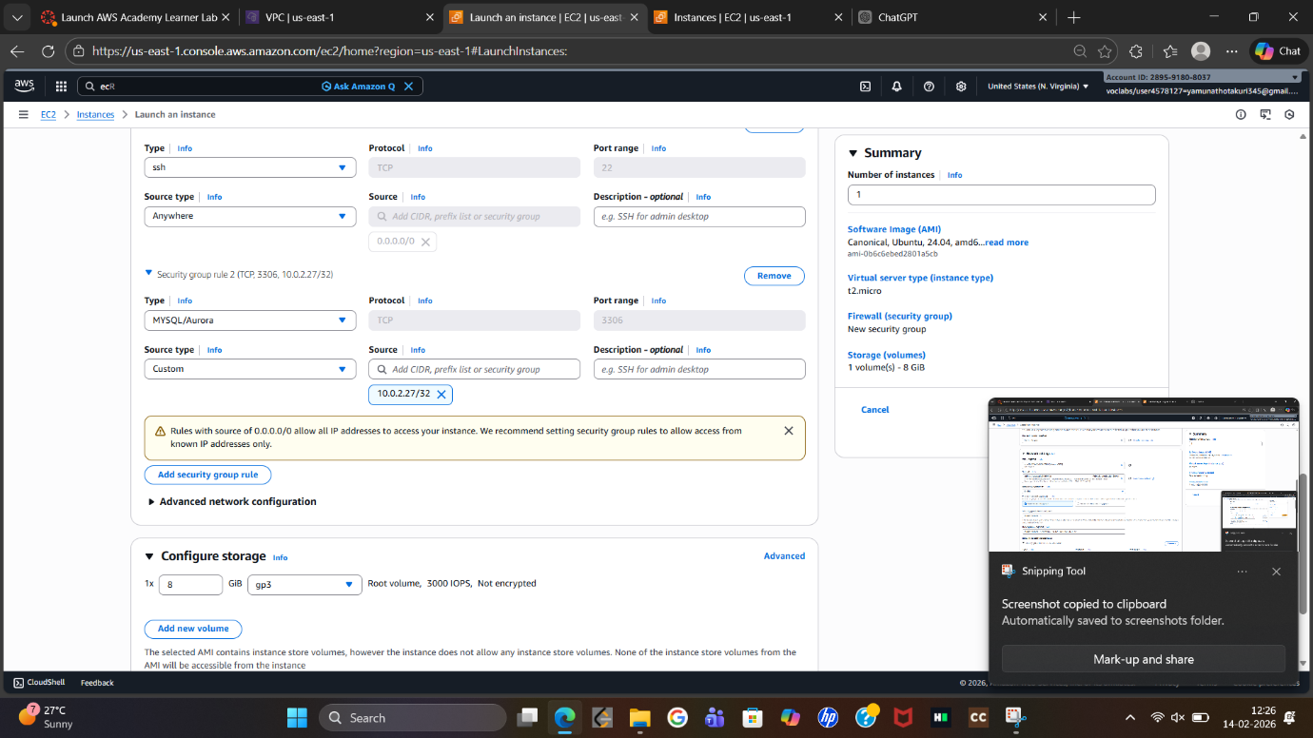
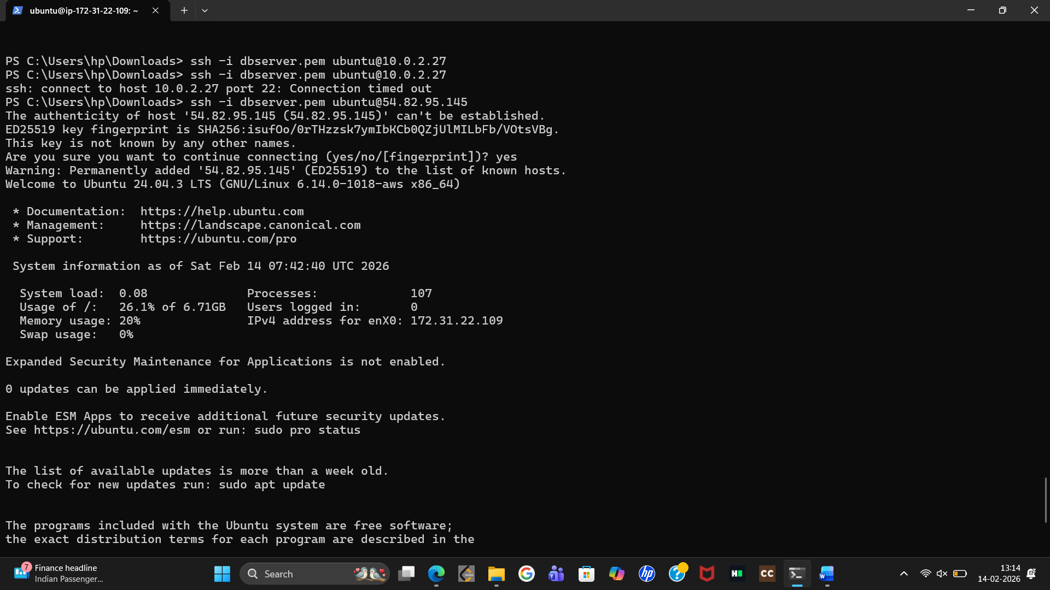
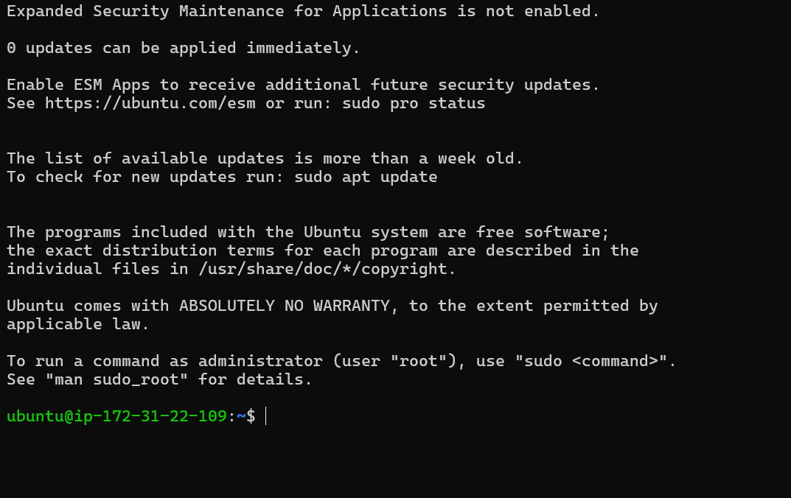
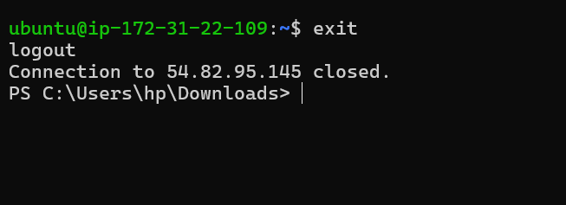

SBQ’s
SCENARIO BASED QUESTIONS
1. Multiple private subnets across AZs — one or multiple NAT Gateways?
Best practice: Use one NAT Gateway per AZ.
• High Availability – NAT Gateway is AZ-specific. If one AZ fails, other AZs still work.
• Avoid cross-AZ traffic charges – Routing traffic from another AZ adds latency + cost.
• Scalability – Traffic load is distributed.
Design Choice:
Each private subnet → Route → NAT Gateway in same AZ________________________________________
2. Priate instances have internet, but NAT Gateway shows no traffic — why?
Possible reasons:
• Wrong Route Table Association – Instances using another NAT Gateway.
• Traffic via Internet Gateway (misconfiguration).
• Using VPC Endpoints (traffic bypasses NAT).
• Cached connections / minimal traffic
• Wrong subnet monitoring selected
________________________________________
3. NAT Gateway created in private subnet — problem & fix
Problem:
NAT Gateway won’t work because:
• Needs Internet Gateway access
• Private subnet has no direct internet route
Impact:
Private instances lose internet access.
Fix:
1. Delete incorrect NAT Gateway
2. Create NAT Gateway in public subnet
3. Ensure:
Public Subnet Route → Internet Gateway
Private Subnet Route → NAT Gateway

4. Restrict outbound access to trusted services only
Use:
Security Groups / NACLs
Firewall / Proxy / AWS Network Firewall
Route via NAT + filtering
Example controls:
• Allow only specific IP ranges
• Allow only ports (443, etc.)
• Use Squid proxy / inspection layer
________________________________________
5. One team’s traffic affecting others — redesign
Use traffic isolation strategy: Multiple NAT Gateways
Options:
• Per-team NAT Gateway
• Per-environment NAT Gateway (Dev/Test/Prod)
• Separate route tables
Benefits:
• Cost tracking
• Bandwidth isolation
• Fault isolation
________________________________________
6. SSH works, but yum/apt update fails — why?
Common causes:
• DNS resolution failure
• No outbound HTTPS (443) allowed
• Missing NAT Gateway route
• Wrong Security Group rules
• Repository access blocked
SSH uses port 22, updates use 443 / 80

7. Internet works via NAT, but SSH via Bastion fails
Possible reasons:
• Security Group blocking port 22
• Bastion SG not allowed in Private Instance SG
• NACL blocking SSH
• Wrong key pair / username
• Private IP mismatch
Correct rule:
Private Instance SG → Allow SSH from Bastion SG
________________________________________
8. Bastion + NAT Gateway both in private subnet — impact
Major failure:
Bastion unreachable from internet
NAT Gateway unusable (no IGW access)
Result:
• No admin access
• No outbound internet
Fix:
Move both to public subnet
________________________________________
9. SSH to Bastion works, but Bastion → Private EC2 fails
Likely issues:
• Private EC2 SG blocking SSH from Bastion
• NACL blocking traffic
• Wrong private IP
• OS firewall blocking SSH
Correct SG rule:
Allow SSH FROM Bastion Security Group

10. Why Bastion ≠ NAT Gateway
Bastion Server:
Used for administrative access (SSH/RDP)
Manual login only
Not designed for scalable outbound internet
NAT Gateway (from Amazon Web Services):
Handles automatic outbound internet traffic
Scalable + managed
No inbound access allowed
________________________________________

