Week5

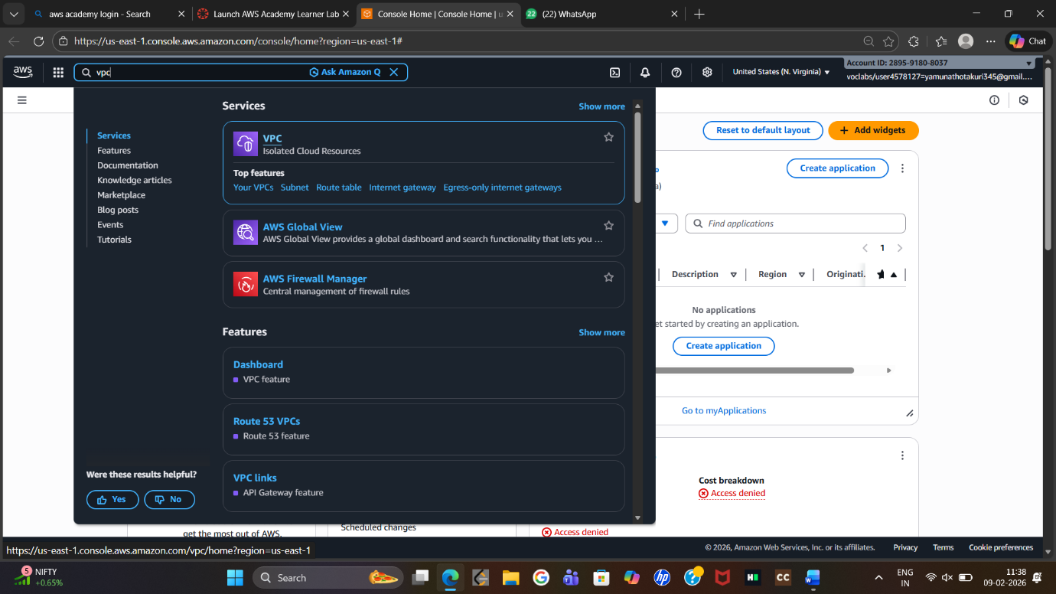
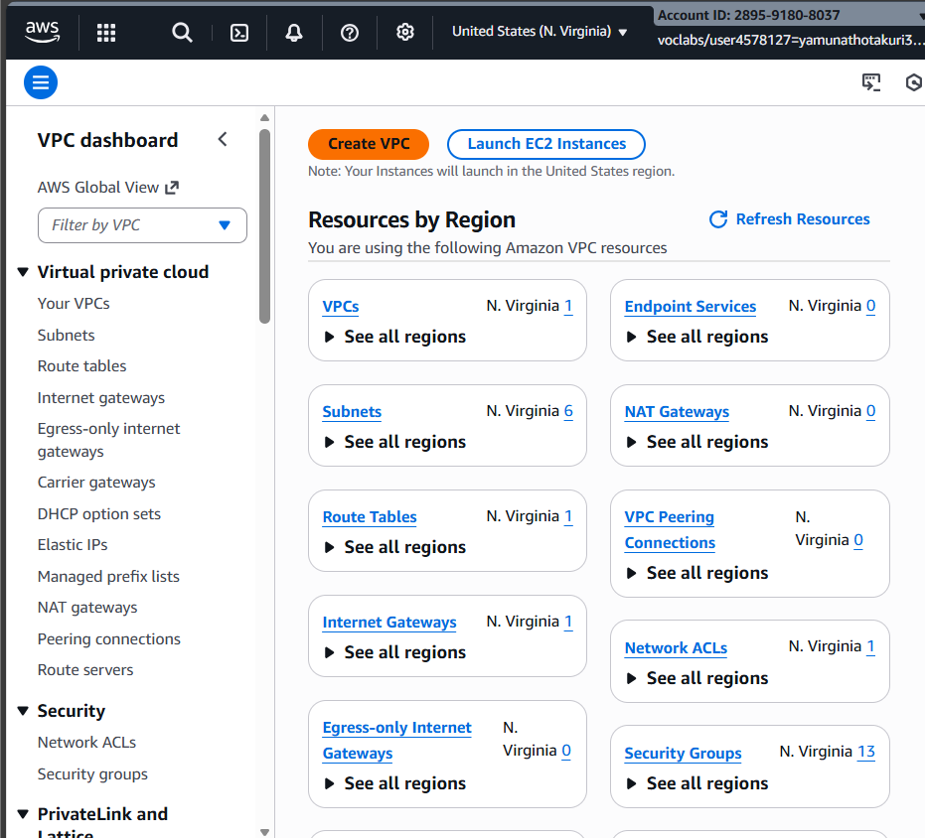
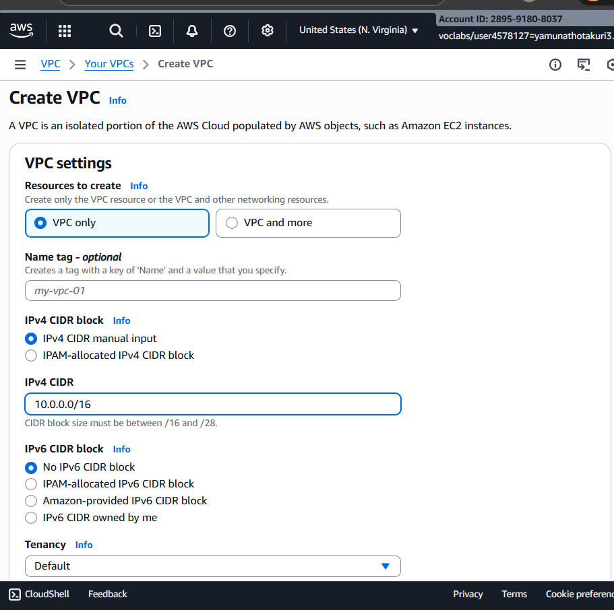
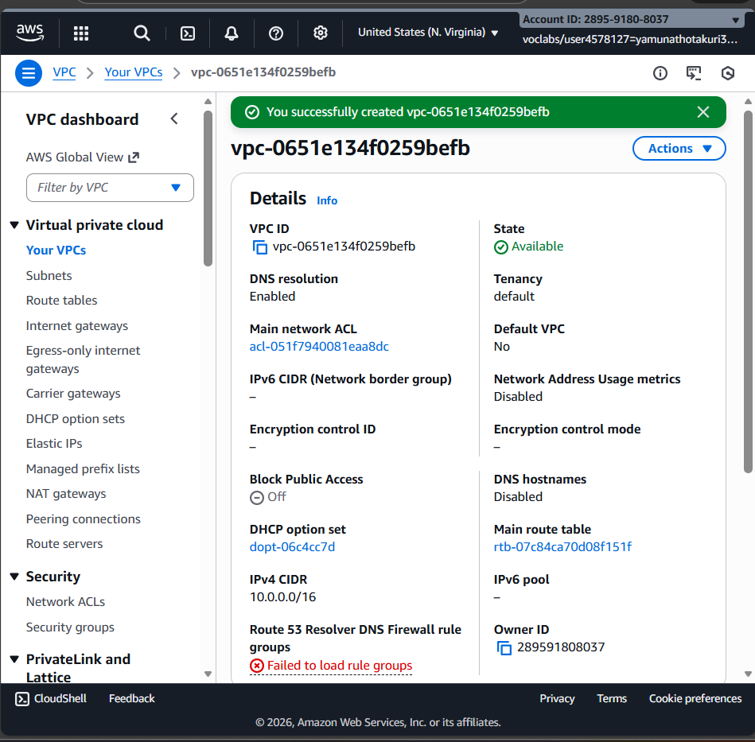
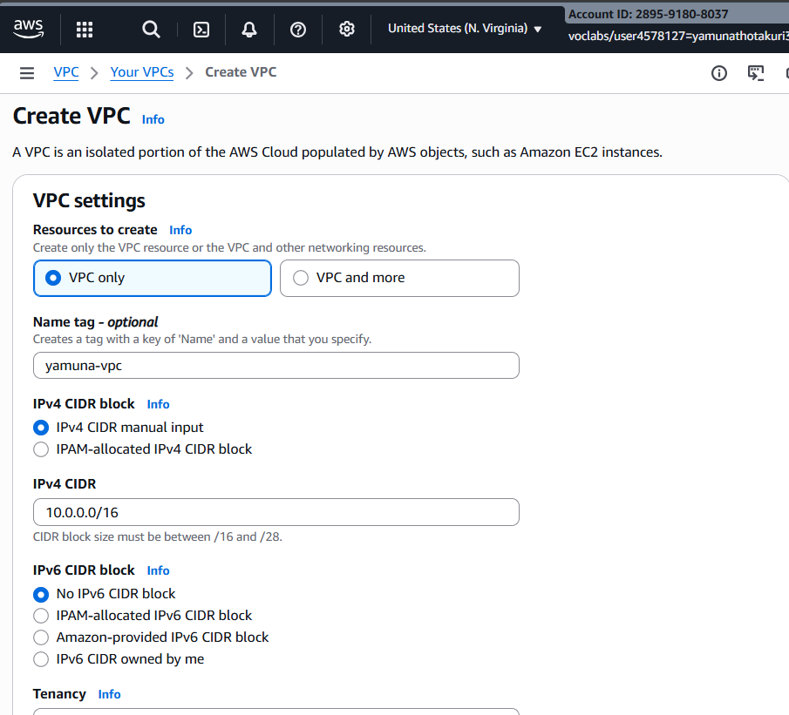
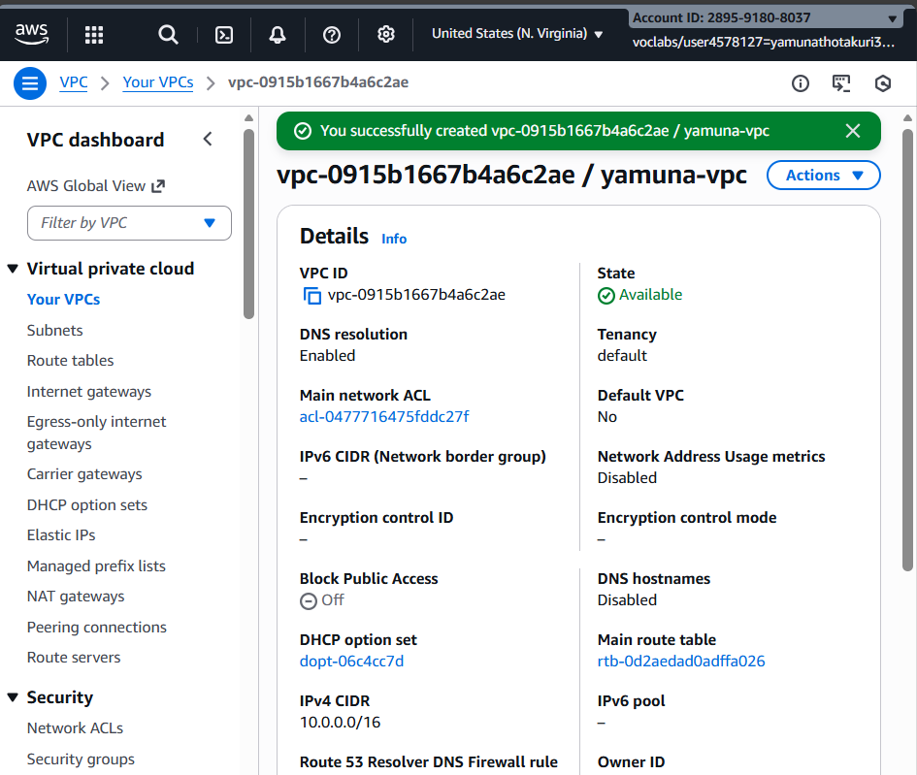
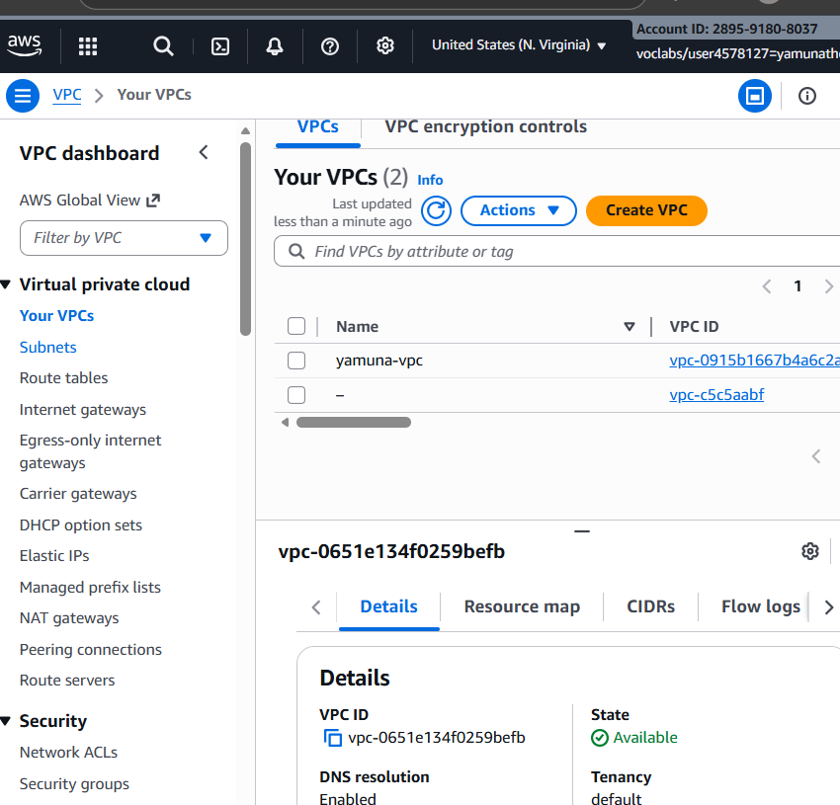
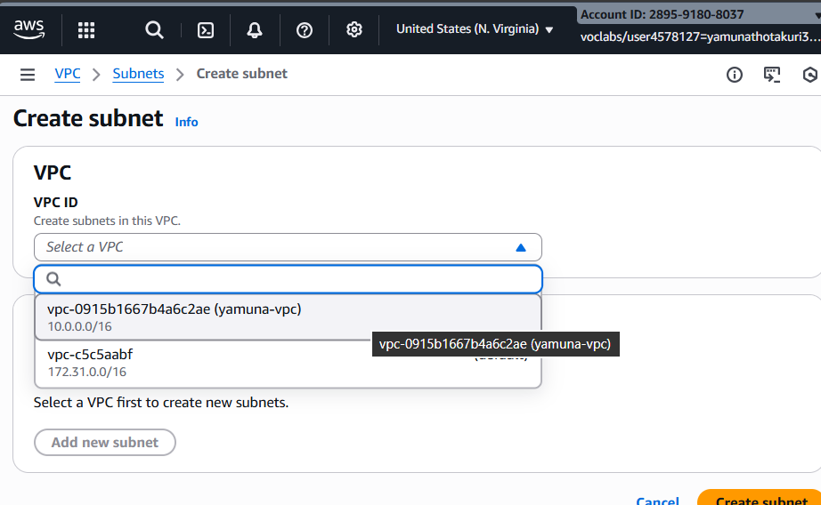
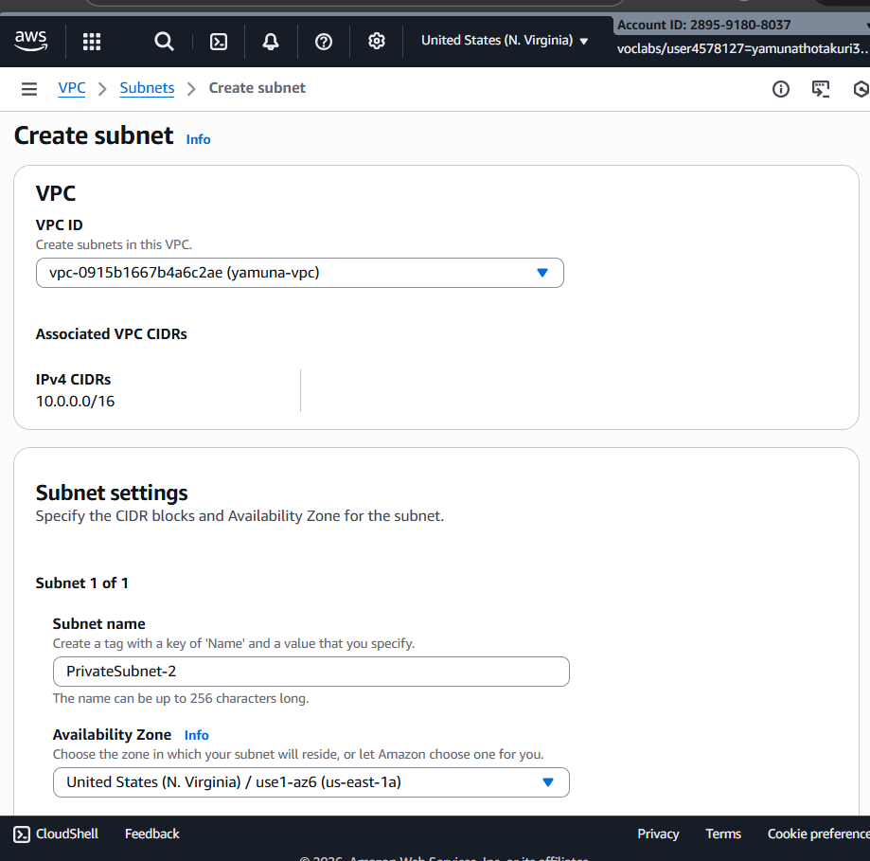
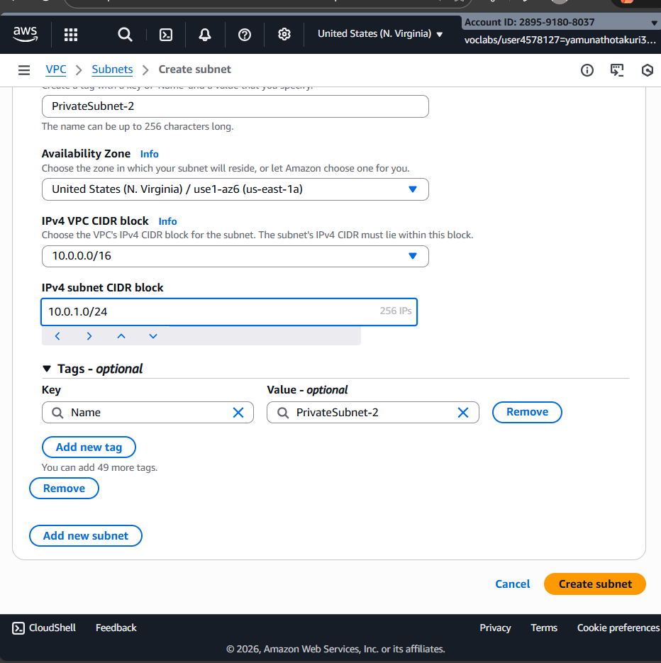
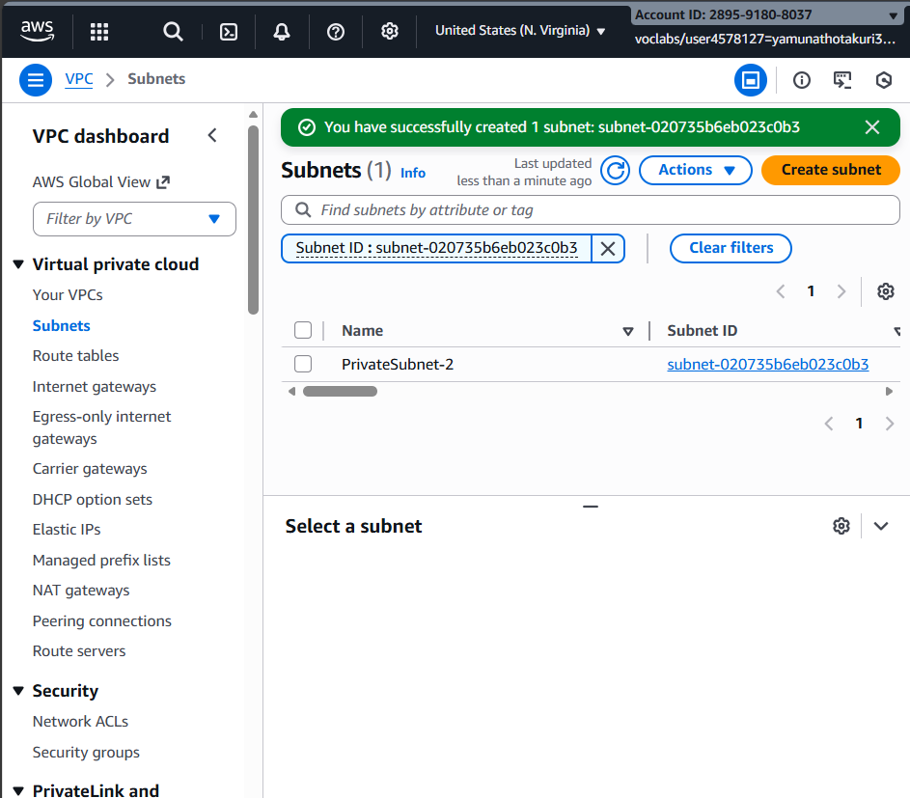
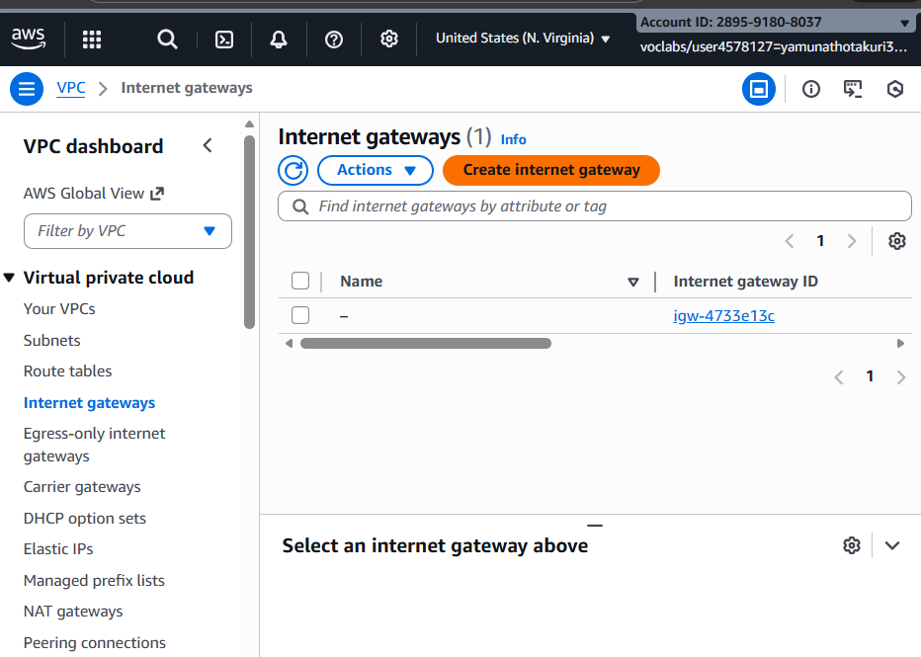
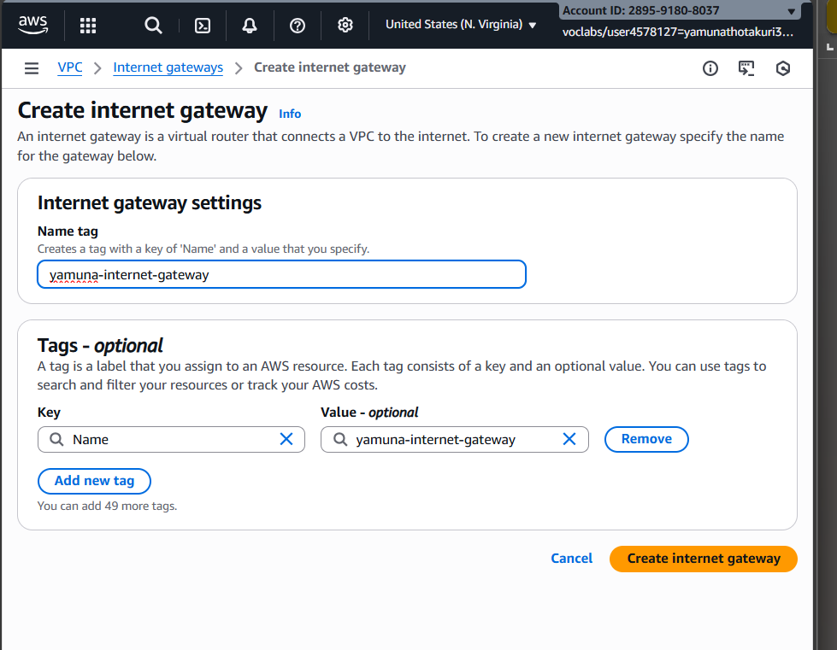
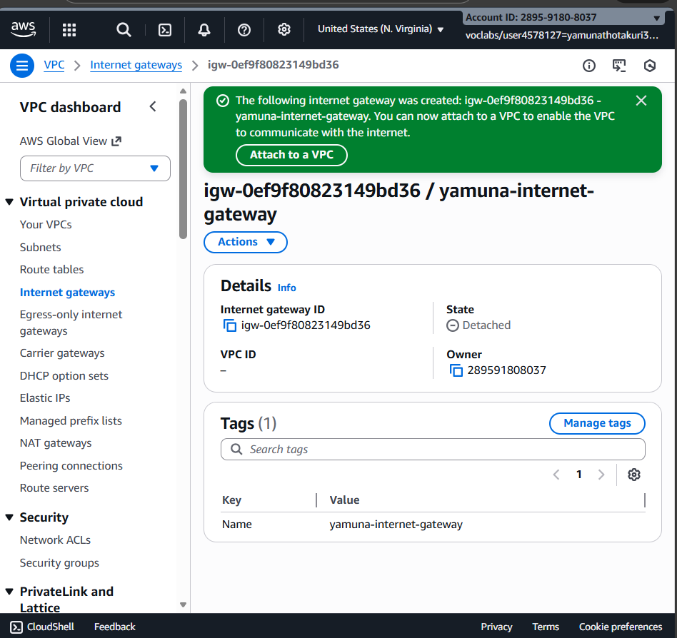
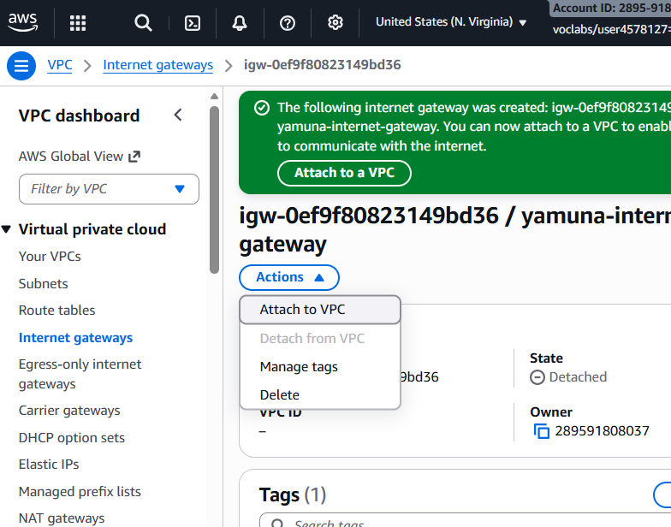
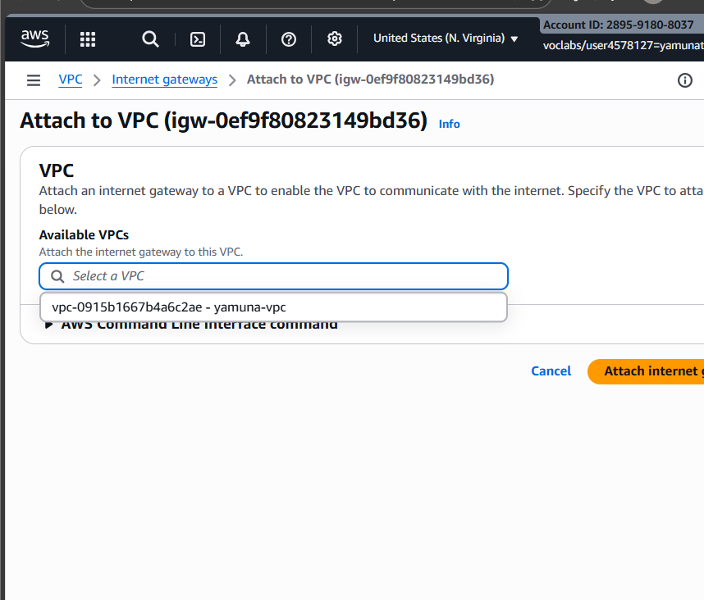
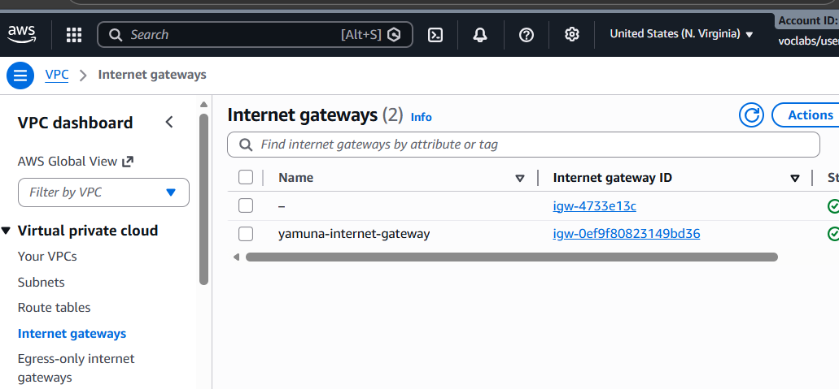
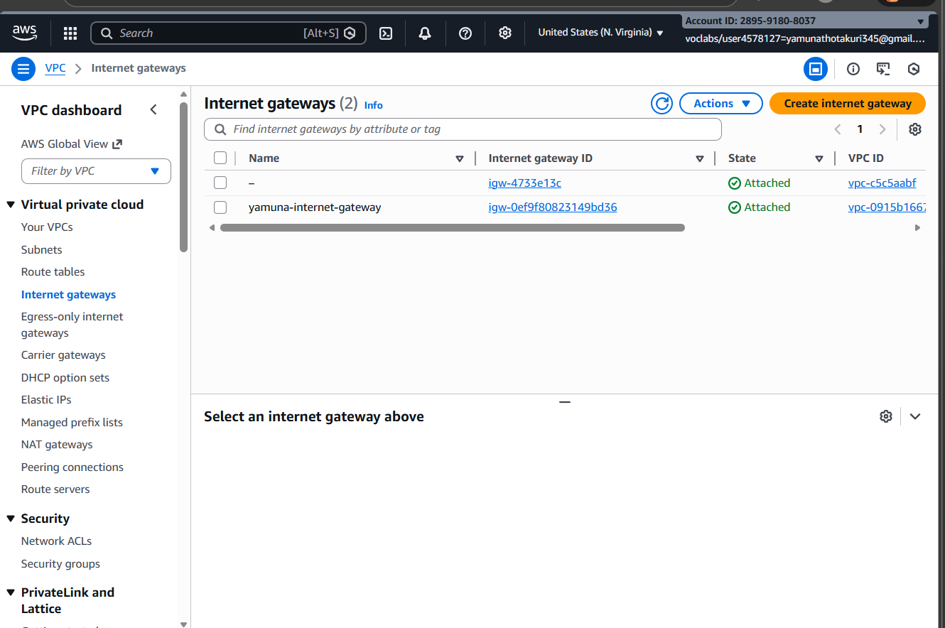
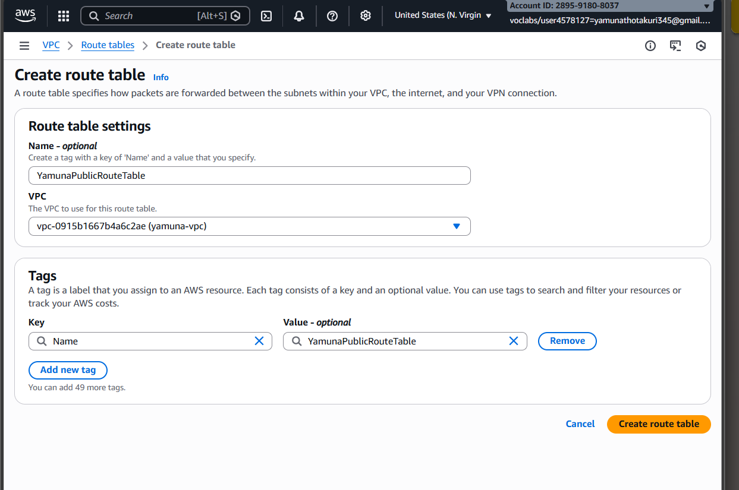
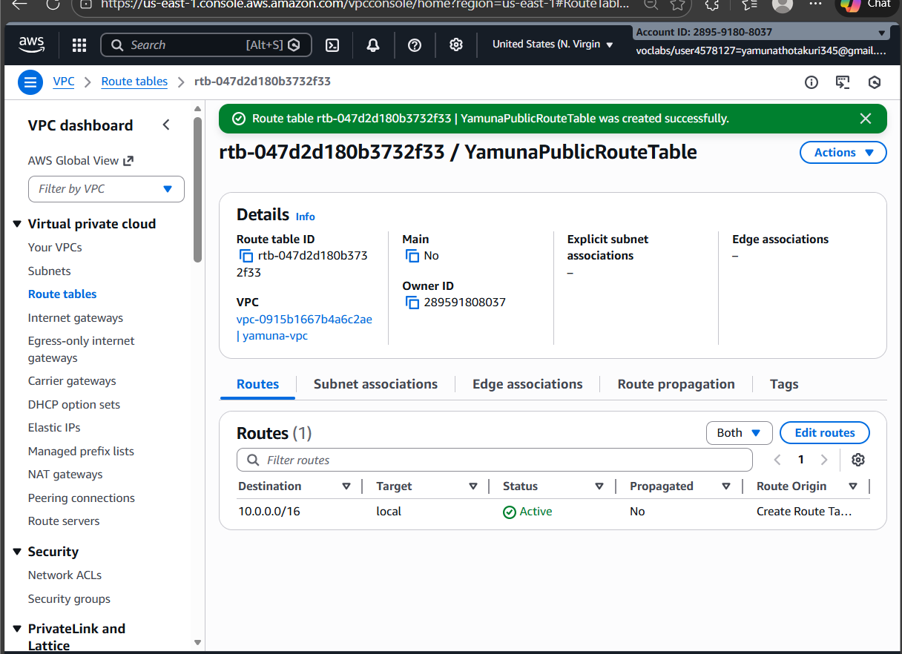
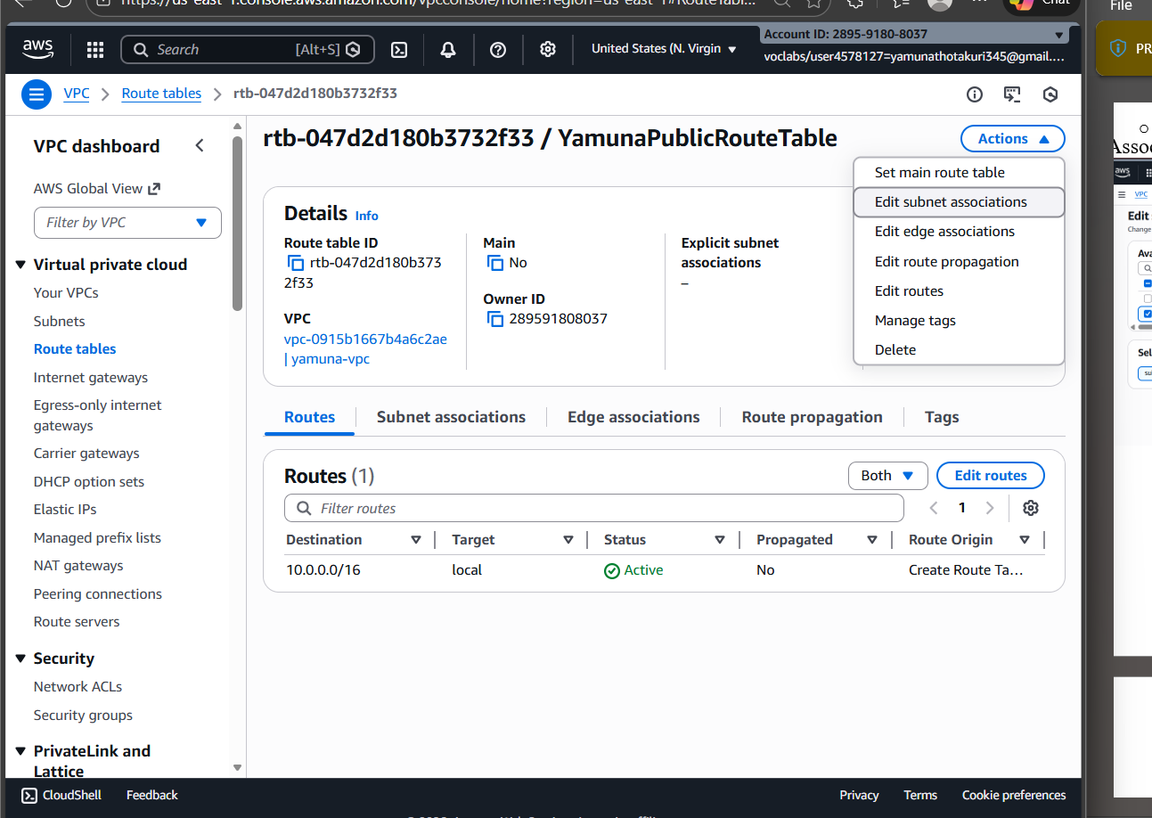
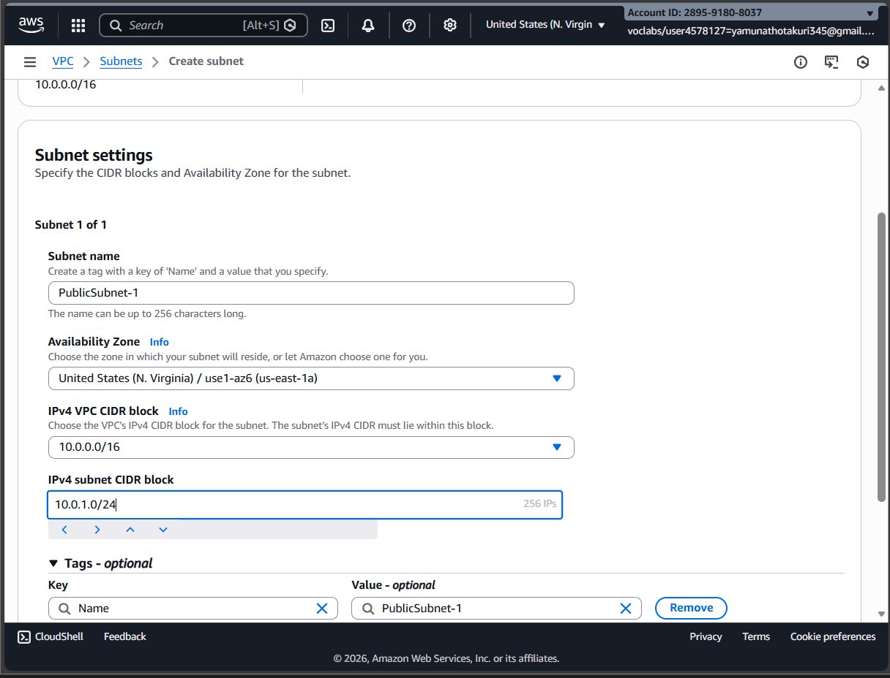
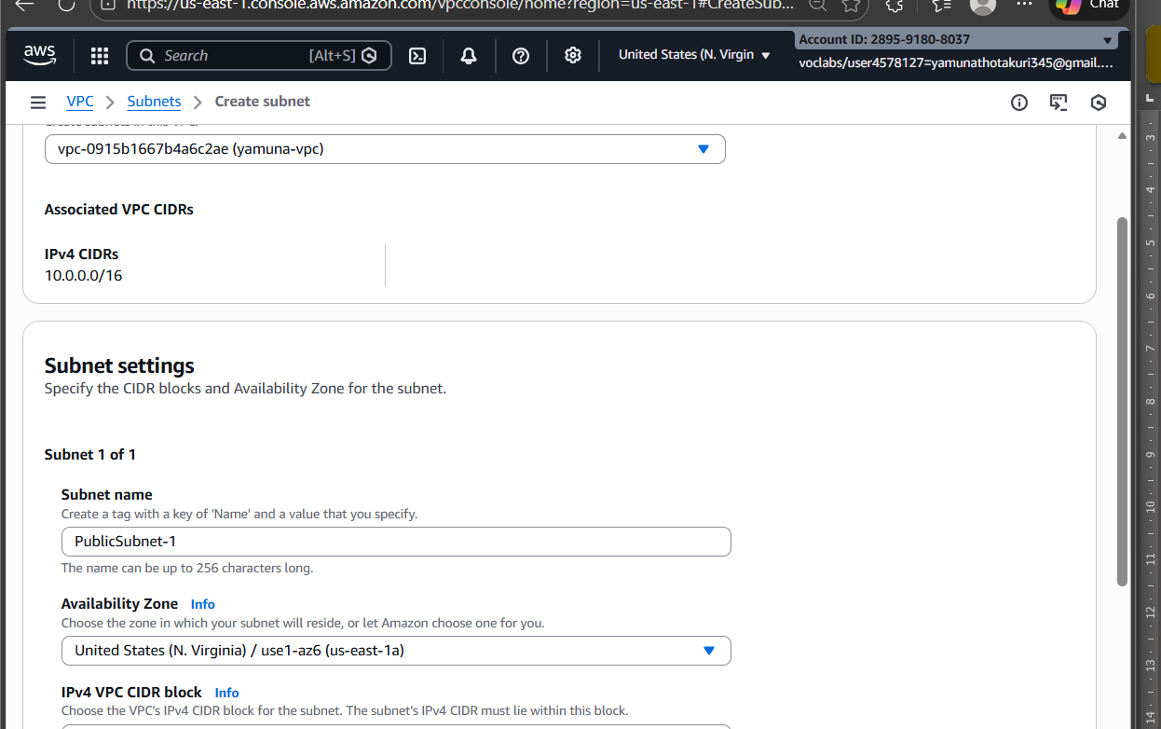
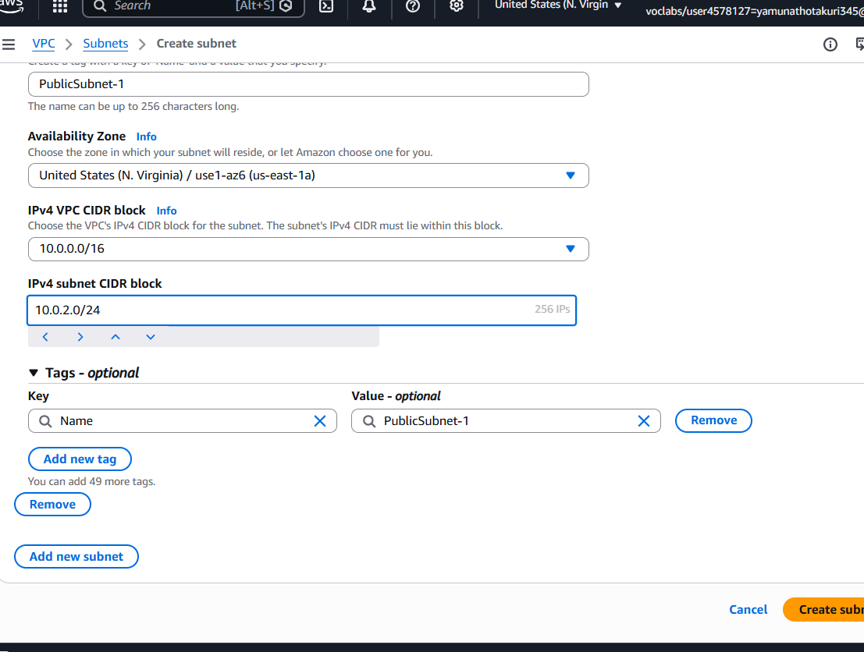
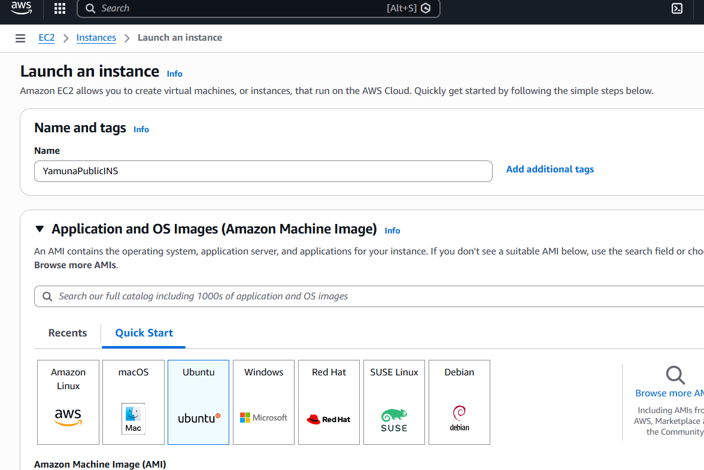
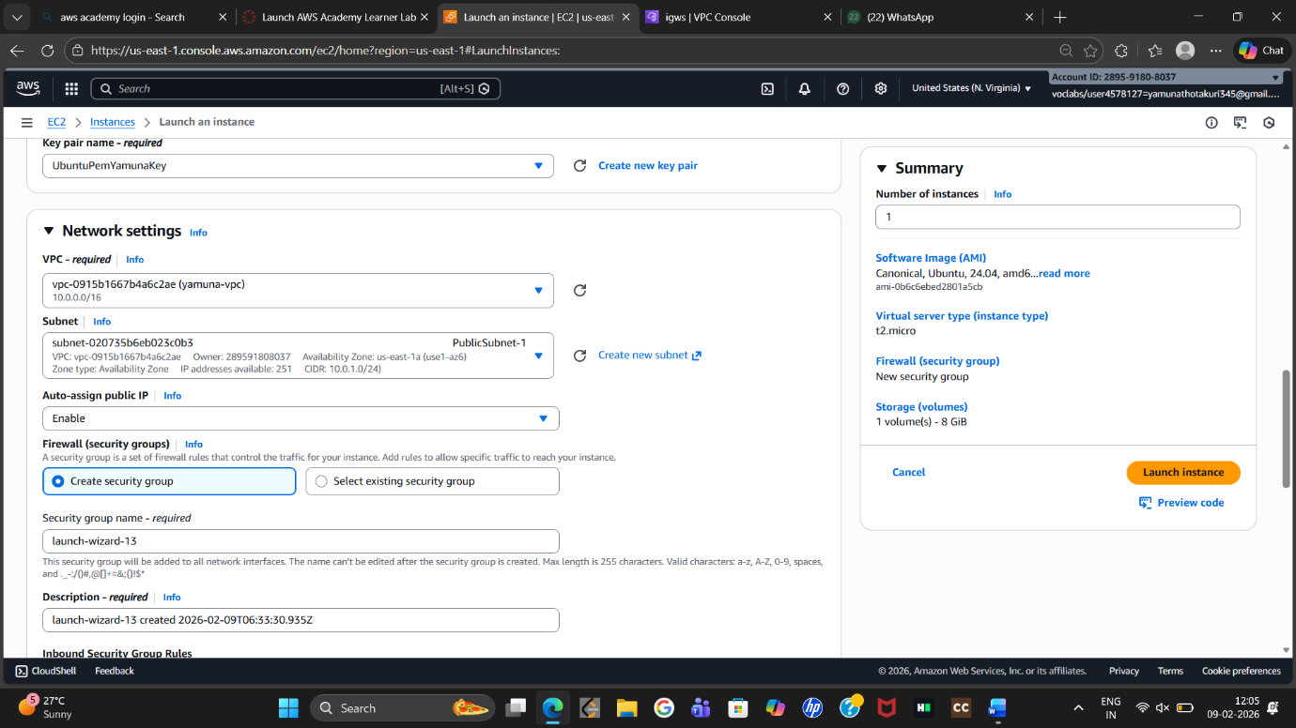
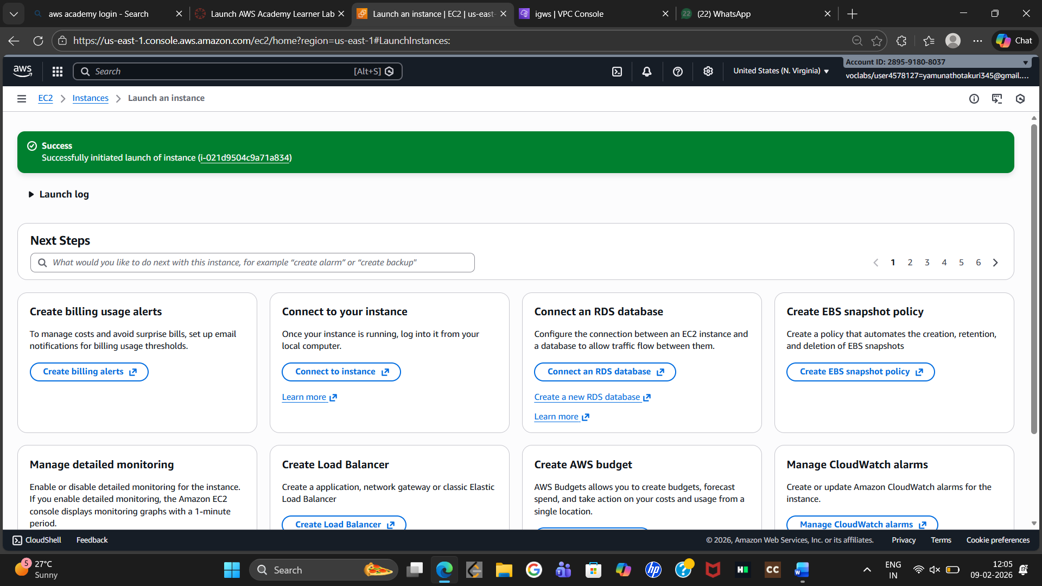
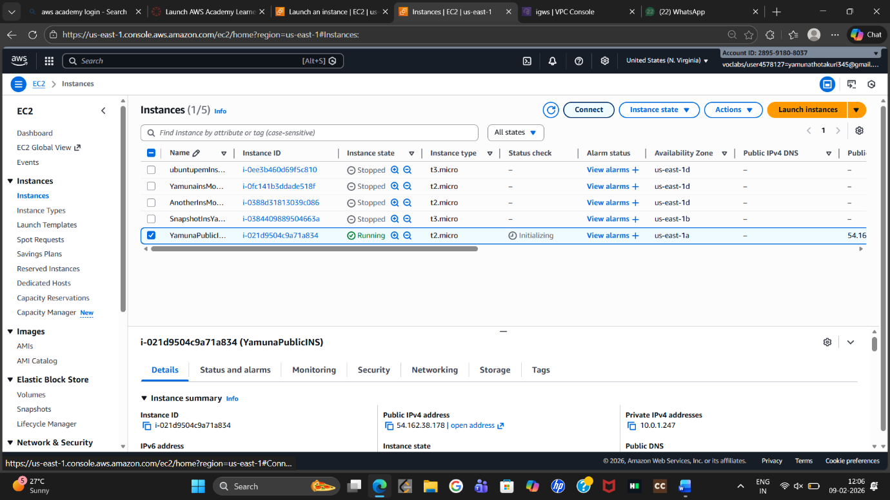

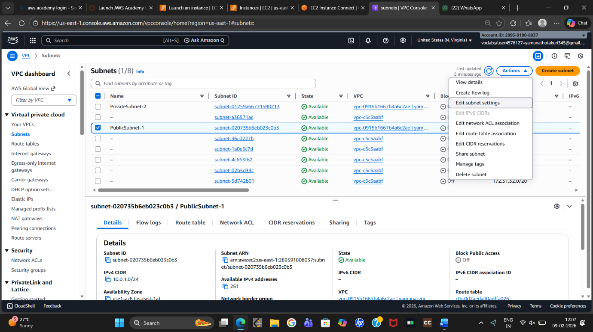
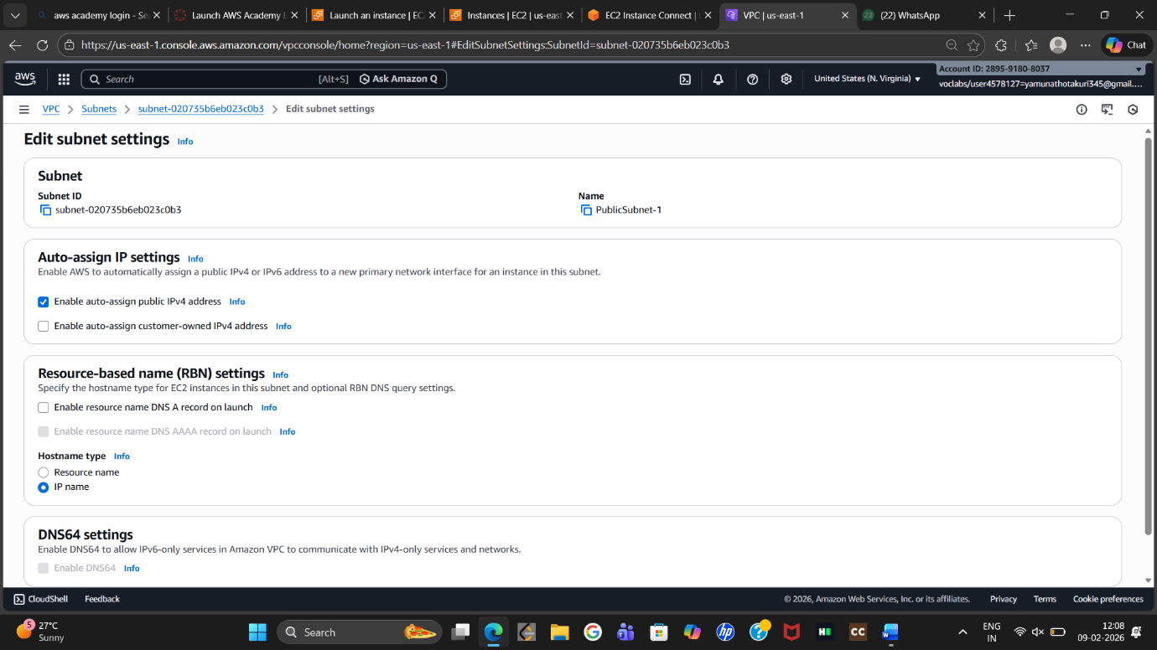
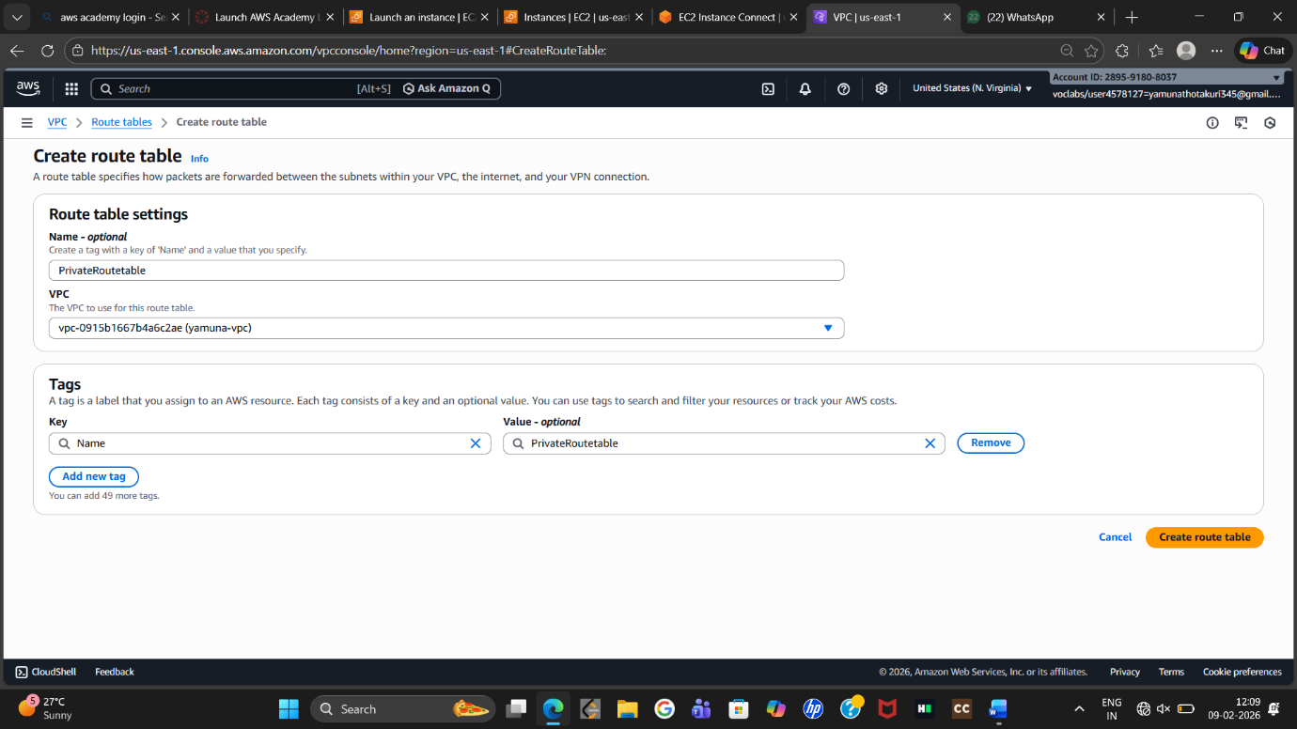
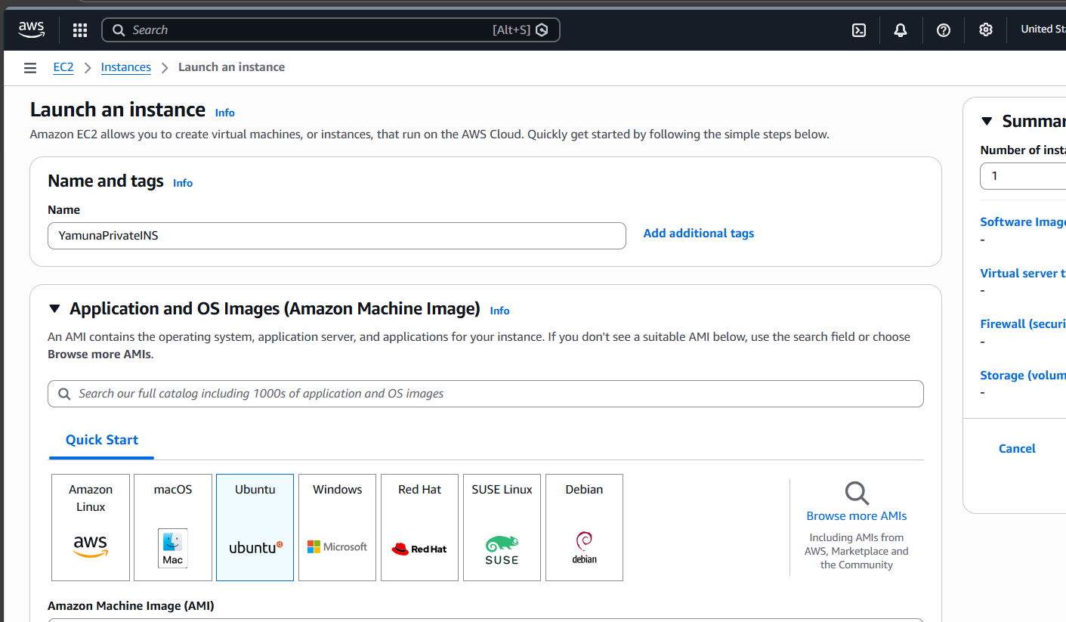
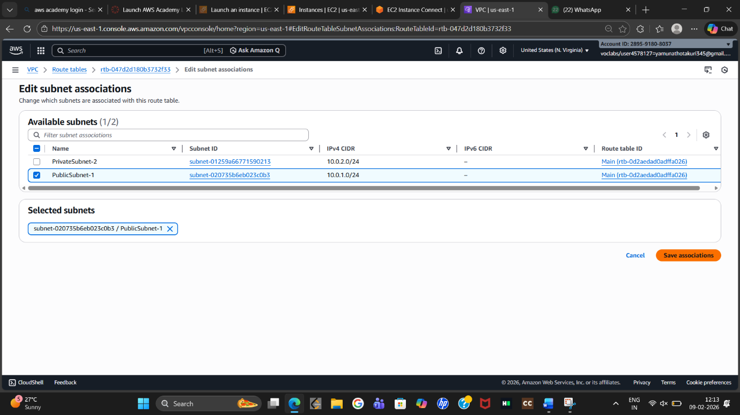
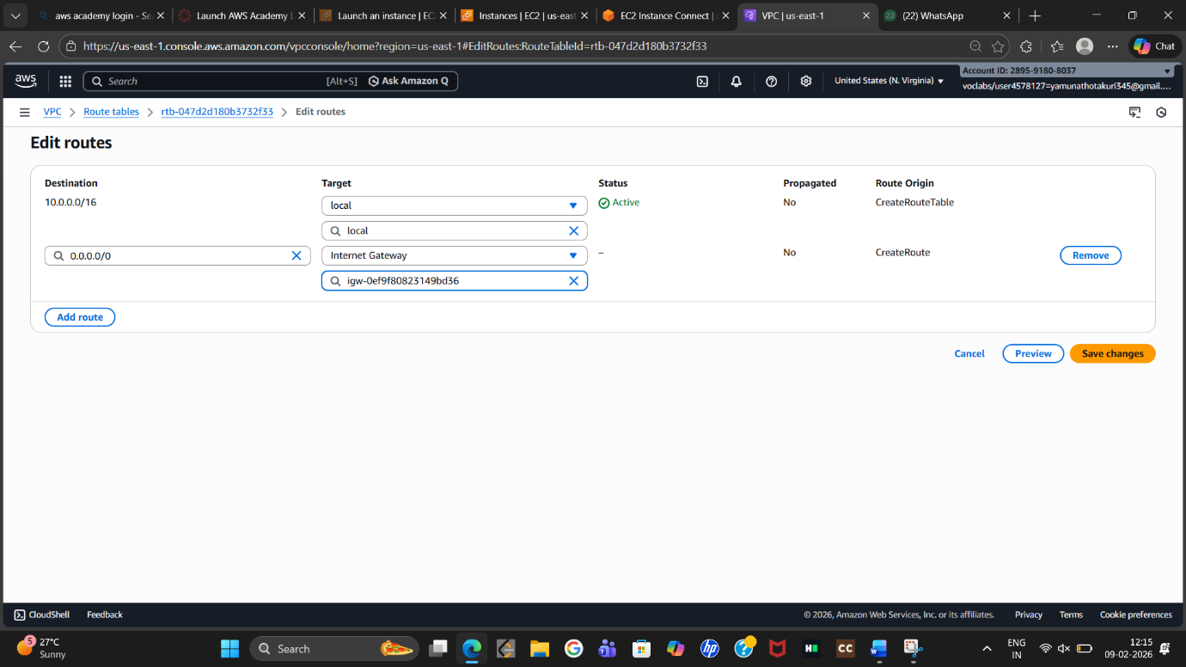
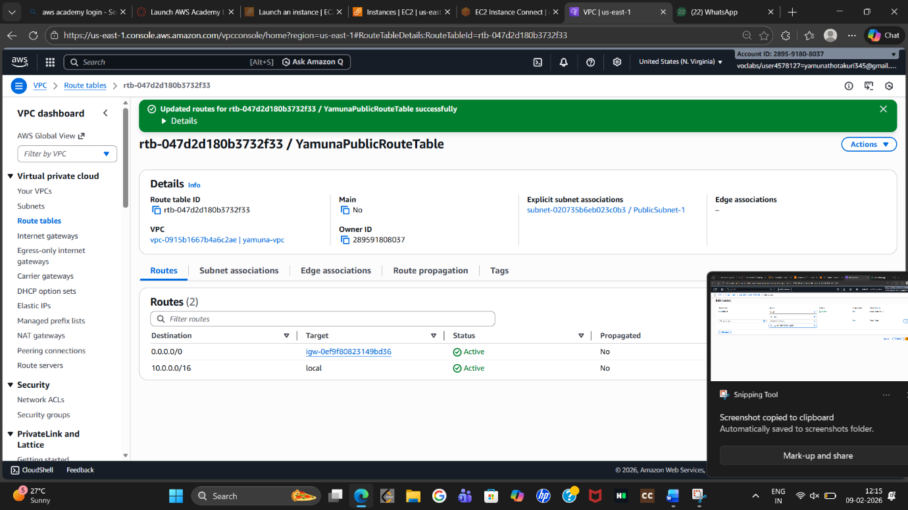

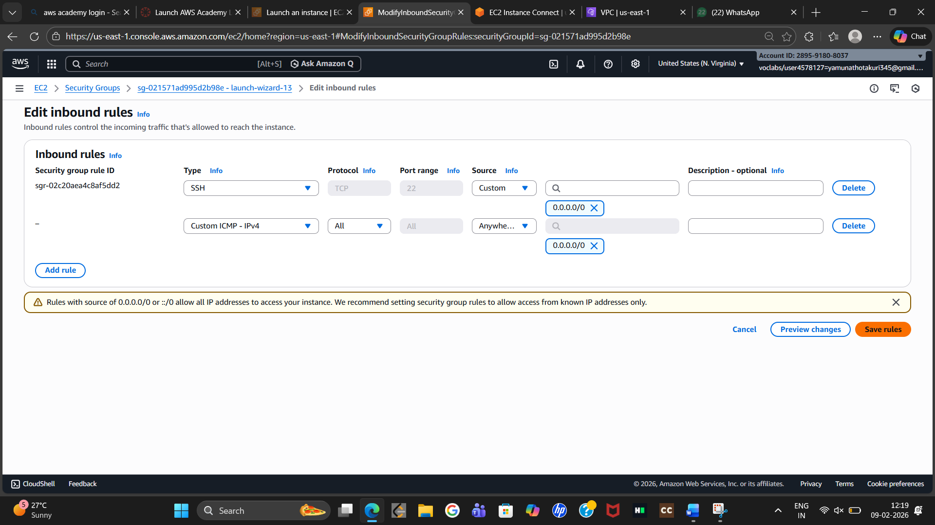
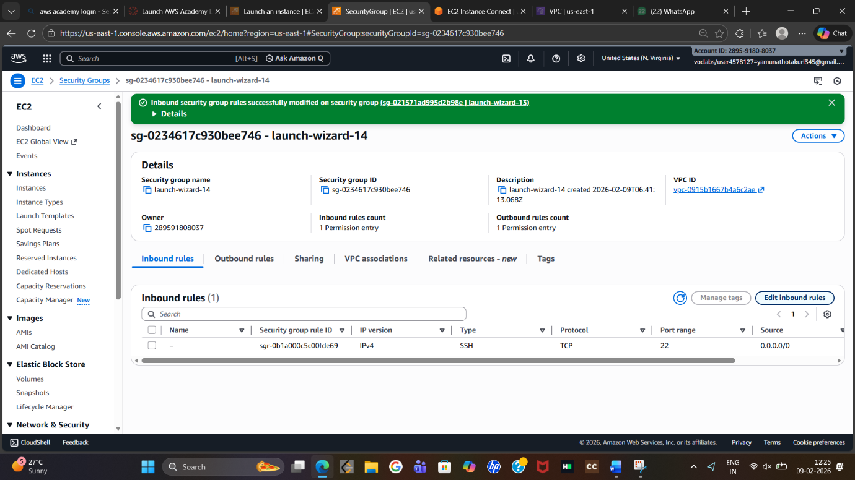
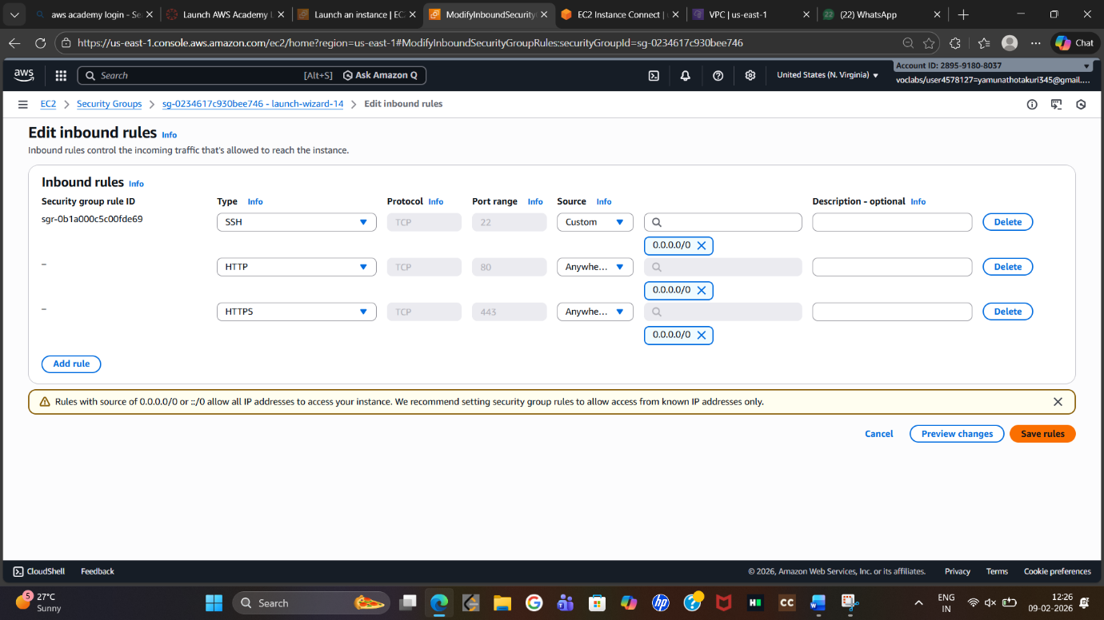
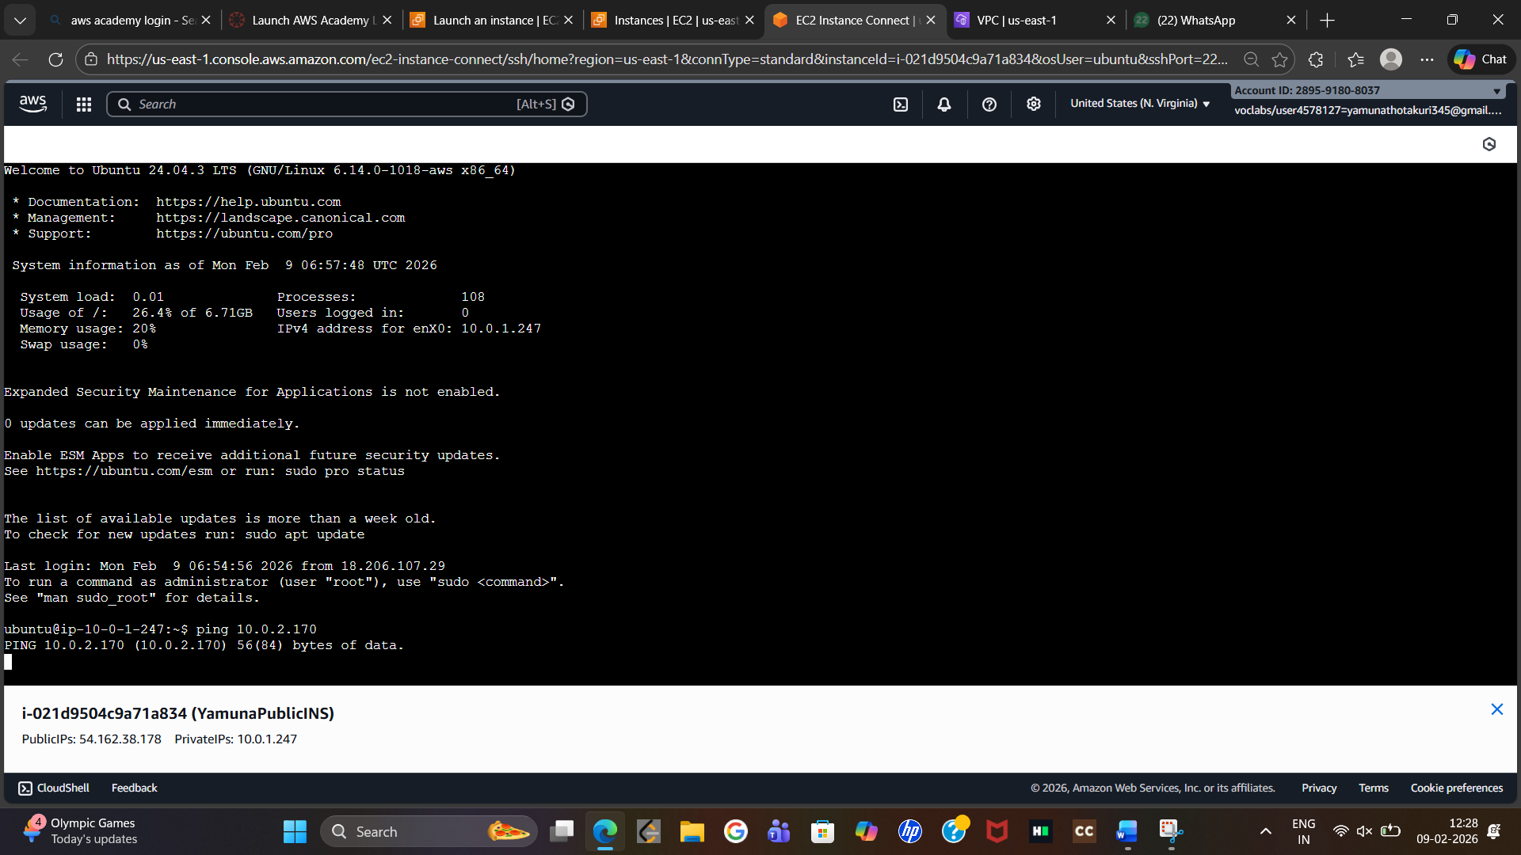

SBQ’s
1. Web app with private database – VPC design
Public subnet: Web servers, Load Balancer, Internet Gateway
Private subnet: Application servers, RDS database
Database has no internet access

2. Public subnet EC2 cannot access internet
Check Internet Gateway attached to VPC
Route table has 0.0.0.0/0 → IGW
Instance has public IP
Security Group and NACL allow traffic

3. Secure App server → RDS connection
Place both in private subnets
RDS SG allows inbound only from App SG
Disable public access to RDS

4. CIDR block for future scaling
Choose large CIDR like 10.0.0.0/16
Supports thousands of instances

5. On-premises to AWS connectivity
VPN: encrypted, fast setup, low cost
Direct Connect: private, high bandwidth, reliable
Choose based on performance needs

6. Two VPCs with same CIDR
Use NAT or PrivateLink
Best solution: change one VPC CIDR

7. Secure microservices communication
Use private subnets
Control access using Security Groups
Allow traffic only between required services

8. 3-tier VPC design
Public subnet: Web tier
Private subnets: App tier, DB tier
IGW for public, NAT for private
SGs allow only tier-to-tier access

9. Monitor unusual VPC traffic
Enable VPC Flow Logs
Use CloudWatch and GuardDuty

10. Why private subnet can’t use IGW
IGW requires public routing
Private subnets use NAT Gateway

11. Misconfigured route table
Network connectivity fails
Instances cannot reach internet or other subnets

12. Route table without local route
Subnets cannot communicate
VPC networking breaks

13. Port 80 allowed but traffic blocked
NACL blocking traffic
Missing route or public IP
Application not running

14. VPC for 1,000+ EC2 across AZs
Choose large CIDR like 10.0.0.0/16 or /15
Allows subnetting across multiple AZs

15. Only corporate IP can SSH
Security Group allows port 22 only from corporate IP
Use bastion host or AWS SSM for extra security

16. EC2 sends traffic but receives no response
NACL blocking inbound traffic
Missing return route
Security Group inbound rule missing

