1.Creation of Amazon EC2 Instances (Linux and Windows) and Establishing Secure Connections Using SSH from Local Machine, PuTTY (.pem & .ppk), AWS CloudShell, and Remote Desktop Protocol (RDP)
a. Creation of Amazon EC2 Instances (Linux / Ubuntu) and Establishing Secure Connections Using SSH from Local Machine
Q1. what is .pem file used for in aws ec2 imstance creation.
Answer: A .pem file in AWS EC2 is a file that contains the private key used for secure authentication to your EC2 instance via SSH (Secure Shell). It is a critical part of a key pair that serves as your digital identity or access key to the server, in place of a password.
Key Concepts
- Key Pair: When you launch a Linux EC2 instance, you create or specify a key pair. AWS stores the public key on the instance, and you download the private key as a .pem file to your local machine.
- Authentication: When you attempt to connect to your EC2 instance using an SSH client (like OpenSSH), you use the -i flag to point to your local .pem file. The EC2 instance then checks if the provided private key matches the public key stored on the server. If they match, a secure, encrypted connection is established, and you are granted access.
- Security: The private key in the .pem file is highly sensitive. Losing it means you lose the ability to SSH into that specific instance (unless alternative access methods are configured), and if it is compromised, an unauthorized person could gain full access to your server. AWS does not keep a copy of the private key, so you are responsible for storing it securely and cannot download it again if lost.

- Type aws academy login

- Click on Untitled

- Login
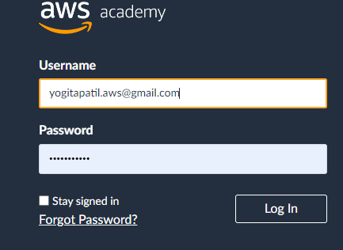
- Click here on AWS Academy Learner Lab
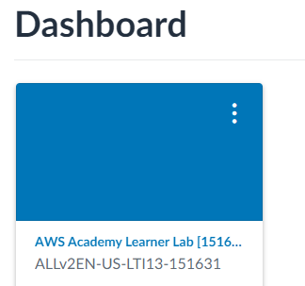
- Click on Modules
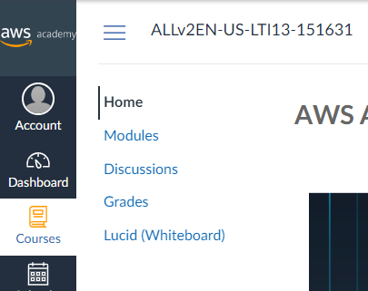
- Scroll down and click on Launch AWS Academy Learner Lab
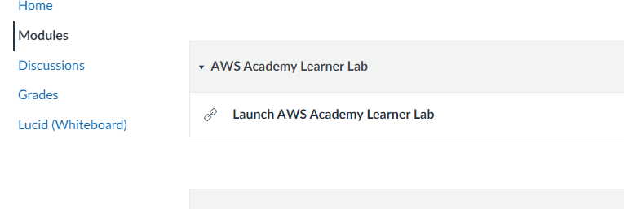
- Start Lab
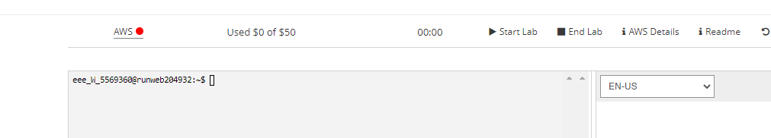
- Click on AWS
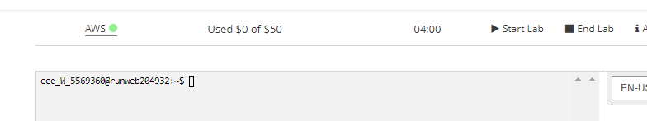
- Click on EC2
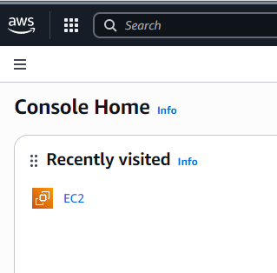

- Click on Launch instance
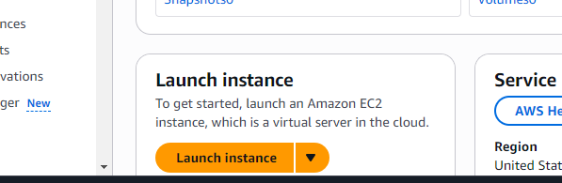
- Ubuntu INSTANCE WITH .pem
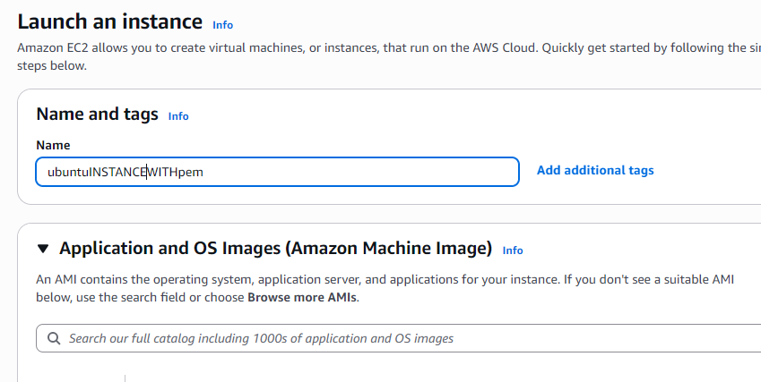
- Select ubuntu
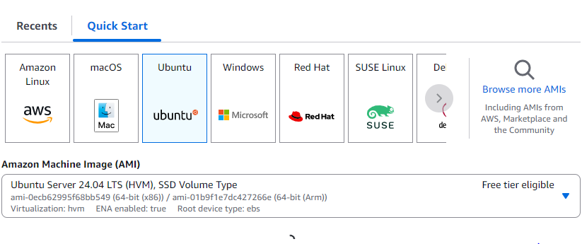
- Click on Create new key pair
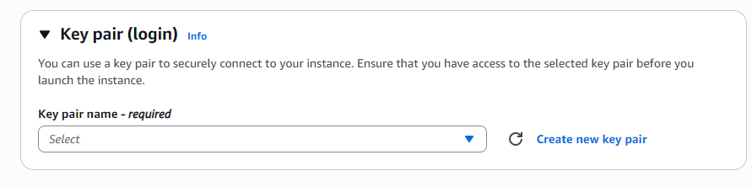
- Write key pair name ubuntukeypem and select .pem file format and press on Create key pair down
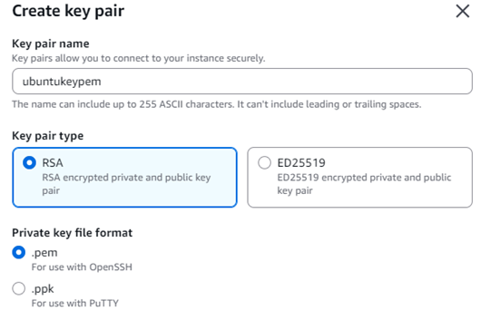
- Store downloaded ubuntukeyprm in folder AWSKEYS
- Next Launch instance

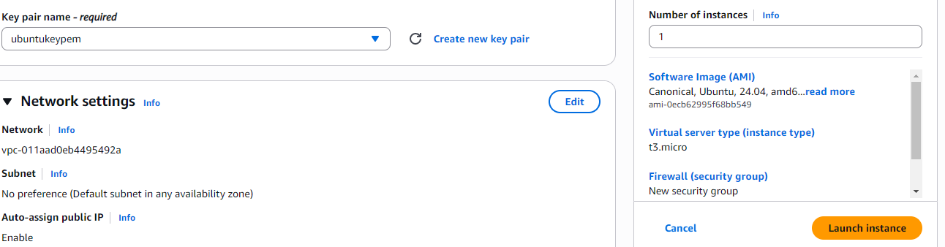

- Successful
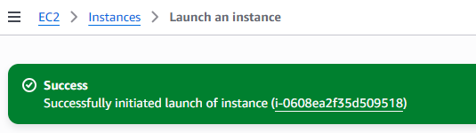
- Click on instance
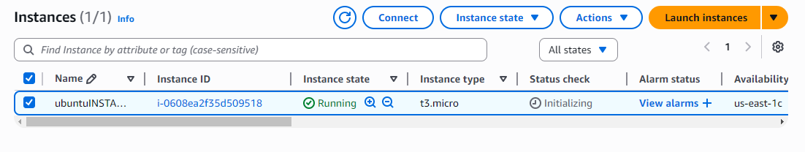
- Select instance and then click on Connect
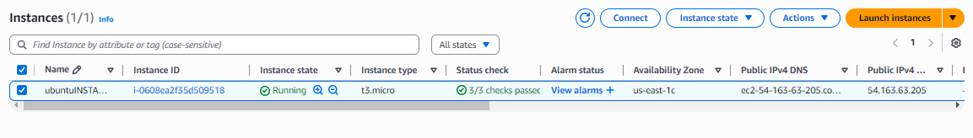
- Open Powershell in administrative mode and navigate to that path AWSKEYS folder and type CD C:\Users\User\Desktop\AWSKEYS
Or go to C:\Users\User\Desktop\AWSKEYS and open git bash
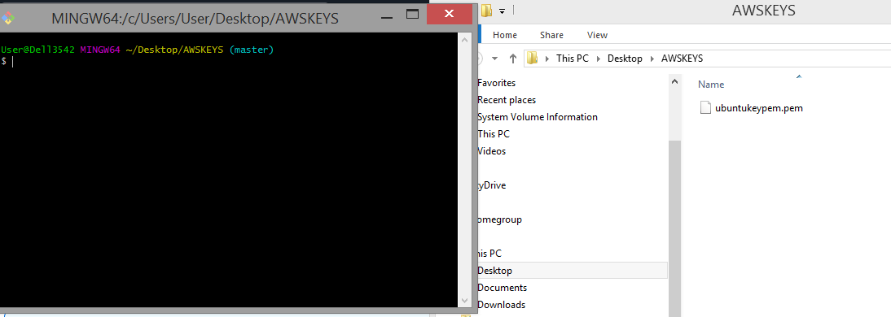
- : Go to SSH client and copy the command ssh which is present at the below
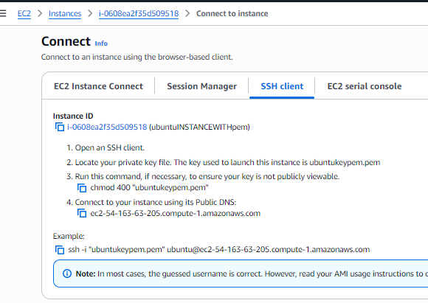
- Note: To connect to above terminals we need to go into the path of the keypair and paste the ssh -i command from the aws console
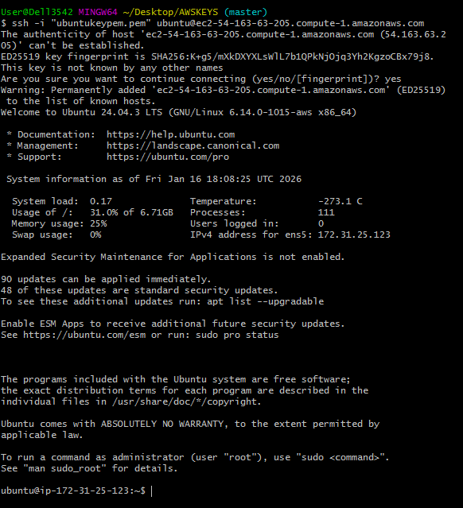
- You are now connected to your Ubuntu EC2 instance using SSH and .pem i.e. local machine connected to server of EC2instance. To verify connection,

Run:
whoami
Output should be:
ubuntu
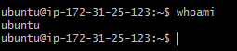
- To come out of above ubuntu type exit

b. Creation of Amazon EC2 Instances (Linux / Ubuntu) and Establishing Connections Using putty
Step 1 ubuntuINSTANCEWITHputty , select ubuntu
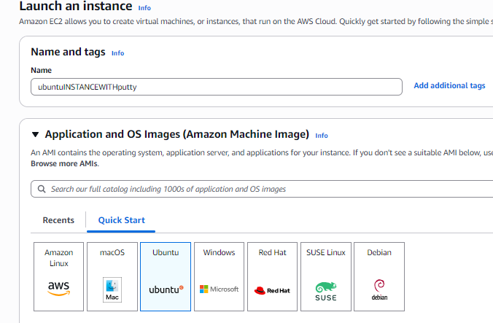
Step 2: Create key pair so click on .ppk
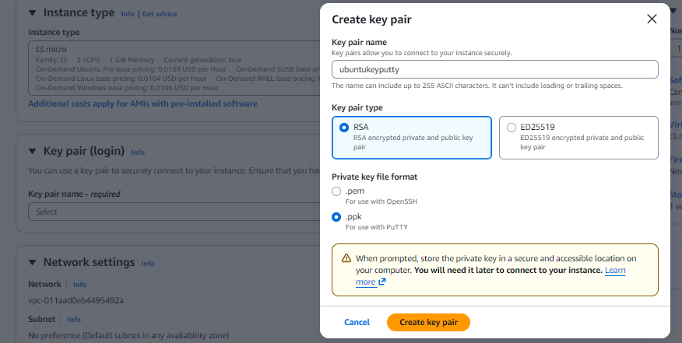

Step 3: keep downloaded ubuntukeyputty.ppk in AWSKEYS folder
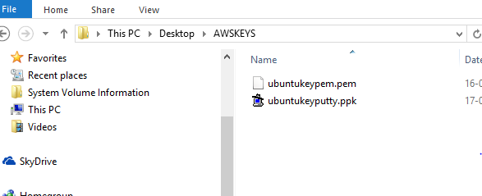

Step 4: Launch instance
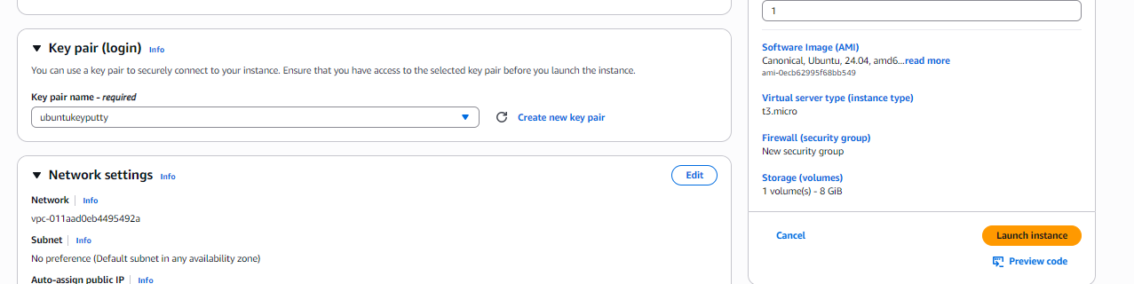

Step 5: click here
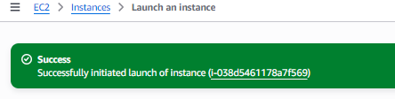
Step 6: Copy Public IPv4 address in Details
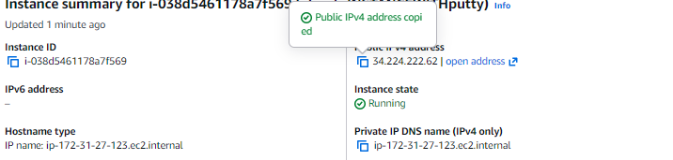
step 7: Click on Security and then security groups
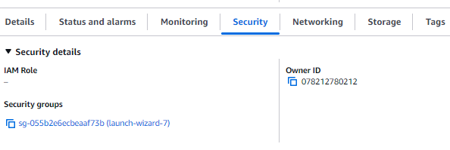
Step 8: Click on Edit inbound rule
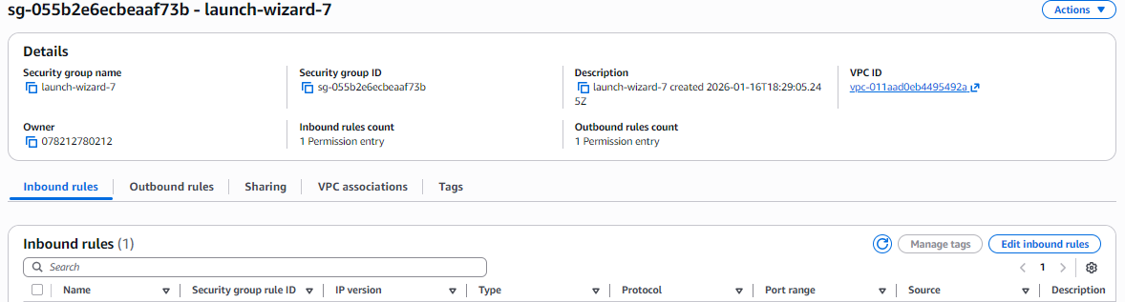
Step 9: See SSH is there with Port 22 and press on Save rule
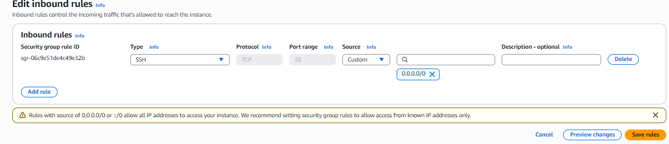
Step 10: Open putty
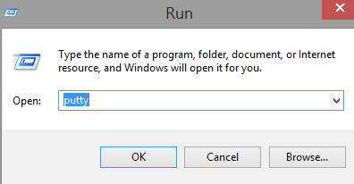
Step 11: copy IPv4 address as below
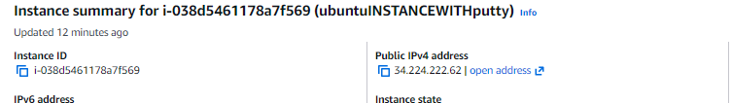

Step 12: Paste it in Putty at Host Name (or Ip address) and at Saved Session type ubuntuputty
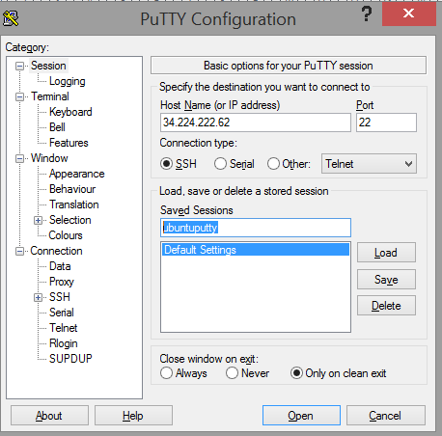
Step 13: Attach the .ppk Key
In PuTTY left menu, go to:
Connection → SSH → Auth → Credentials
- Click Browse
- Select your .ppk file
- Click Open
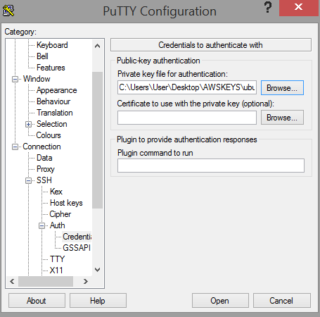
Next click on Accept
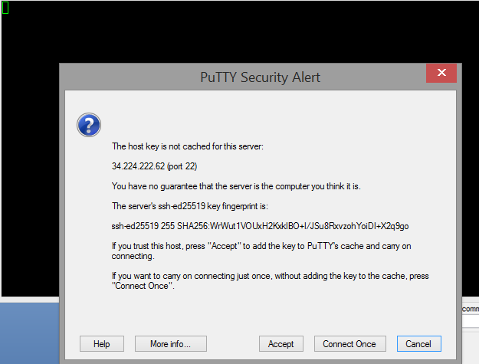

Next enter user name at login as: ubuntu as below
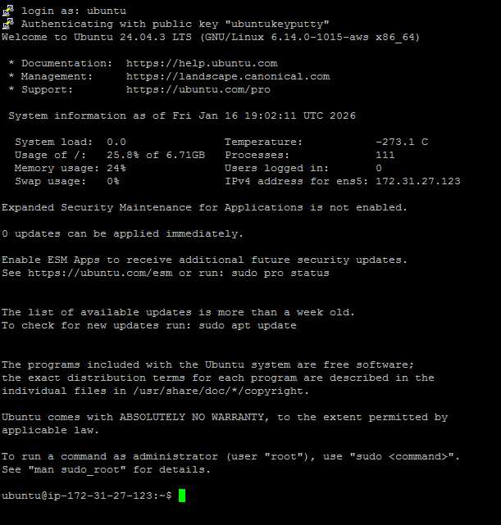
Step 14: 🧪 VERIFY CONNECTION
Run:
whoami
Output should be:
Ubuntu
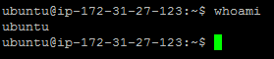

Note:
User name use correctly as per below Operating System you specified while creating EC2 instance:
• Amazon Linux / AL2023 → ec2-user ✅
• Ubuntu → ubuntu ✅
• RHEL → ec2-user or root ✅
• CentOS → centos ✅

Second Experiment:-------
Connect EC2 Ubuntu Instance Using PuTTY (Windows) ---for PEM KEYPAIR
Q2. why to convert .pem file to .ppk file
You convert a .pem file to .ppk primarily for Windows users to connect to servers (like AWS EC2) using the PuTTY SSH client, which doesn't natively understand the standard OpenSSH .pem format. The .ppk (PuTTY Private Key) format is PuTTY's proprietary, encrypted format, allowing Windows users to authenticate securely with their remote servers using tools like PuTTY and WinSCP.
Key Reasons for Conversion:
- Platform Compatibility: .pem files are standard for Linux/macOS, while .ppk is for Windows PuTTY.
- PuTTY Requirement: PuTTY (and clients like WinSCP) need the .ppk format for private key authentication.
- Bridging the Gap: It bridges the difference between keys generated by services (like AWS) and Windows-based SSH tools.
-----------------------
A .ppk (PuTTY Private Key) file is used to securely connect to an AWS EC2 instance from a Windows machine using the PuTTY SSH client. AWS provides the initial private key file in the .pem (Privacy Enhanced Mail) format, which is not directly compatible with PuTTY, requiring conversion to the .ppk format.
Purpose and Function
- Authentication: The .ppk file is one half of a security credential key pair (public and private keys). The public key resides on the EC2 instance, and the private key (.ppk file) is stored on your local machine. When you attempt to connect, PuTTY uses the private key to cryptographically verify your identity against the public key on the server.
- Windows Compatibility: The .ppk format is proprietary to the PuTTY software suite, which is a popular SSH client for Windows.
- Secure Connection: It enables a secure shell (SSH) connection, which encrypts the communication between your local computer and the EC2 instance, making it a secure way to manage the instance remotely without using passwords.
How it is used with AWS EC2
- Key Pair Creation: When you launch an EC2 instance, AWS generates or uses an existing key pair. The private key portion is downloaded to your local machine as a .pem file.
- Conversion: You use the PuTTYgen tool (PuTTY Key Generator) to convert the AWS-provided .pem file into the .ppk format.
- Connection: You then load this .ppk file within the PuTTY application's SSH authentication settings to establish a secure connection to your EC2 instance.


PREREQUISITES
You must have:
- ✅ EC2 Ubuntu instance running
- ✅ Public IPv4 address (or Elastic IP)
- ✅ Key pair (.pem file) used while launching EC2
- ✅ PuTTY & PuTTYgen installed
👉 Download PuTTY:
go to https://www.putty.org and down load putty.exe and puttygen.exe

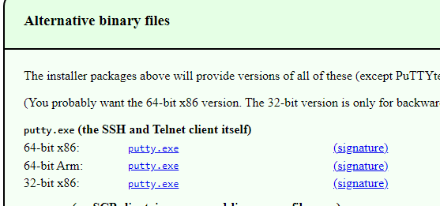
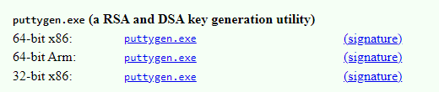

Keep in folder AWSKEYS
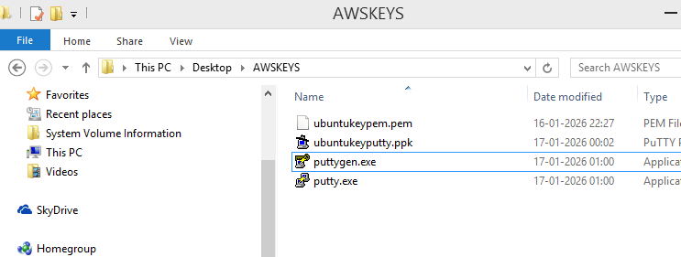

STEP 1: Convert .pem to .ppk using PuTTYgen
As PuTTY cannot use .pem directly.
Steps:
- Open PuTTYgen ( which is in AWSKEYS folder)
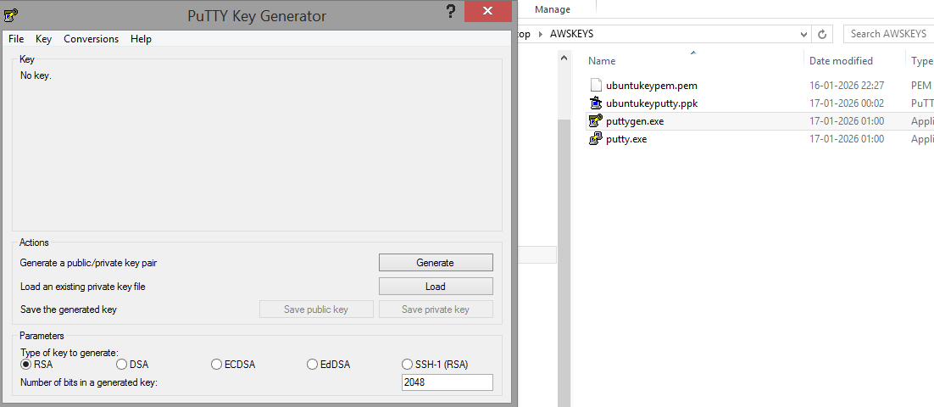
- Click Load
- Select your .pem file
(change file type to All Files)
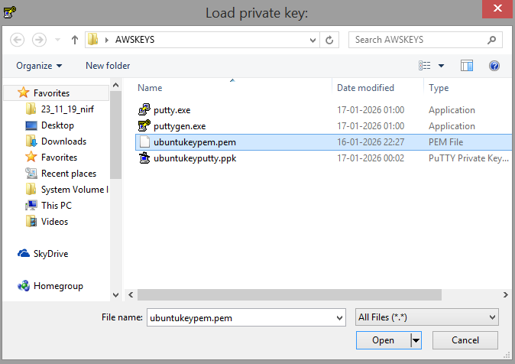
- Click Open
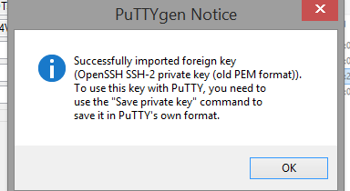
- Click Save private key
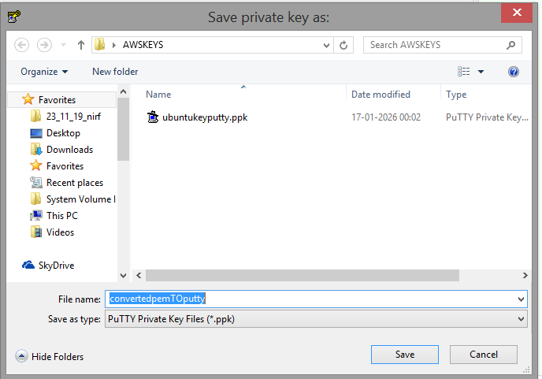
- Save as keyname.ppk i.e. with name convetedpemTOppk in folder AWSKEYS
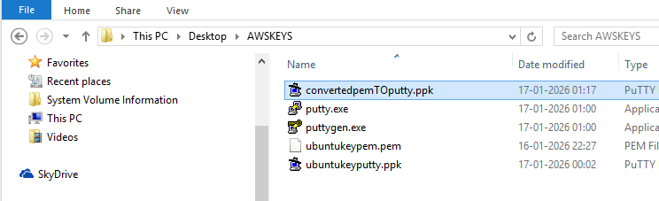
✔ Conversion done
STEP 2: Get EC2 Public IP
Go to:
AWS Console → EC2 → Instances---CONNECT –COPY DNS NAME / <PUBLIC-IP>
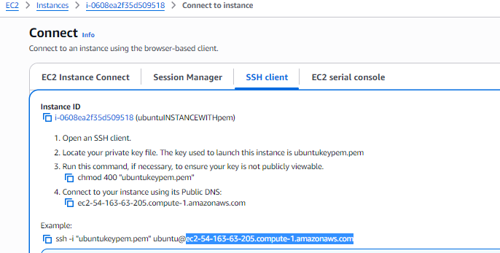
STEP 3: Configure PuTTY
1️⃣ Open PuTTY
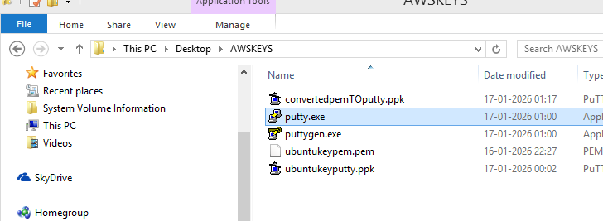
Session:
- Host Name (or IP address): dns name

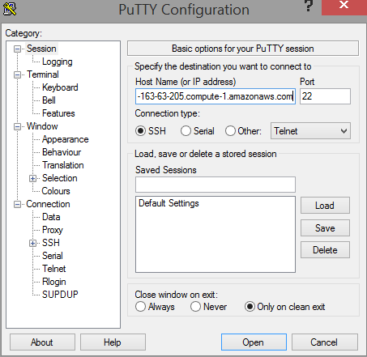
2 Load Private Key
Go to:
Connection → SSH → Auth → Credentials
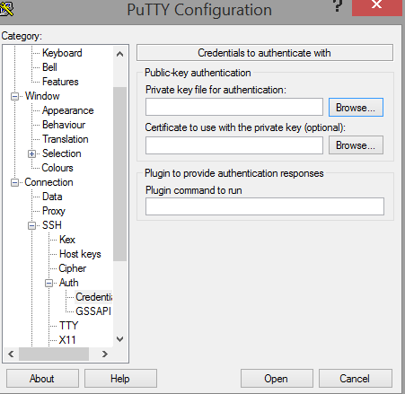
Click Browse to Select your .ppk file
- convertedpemtoputty file
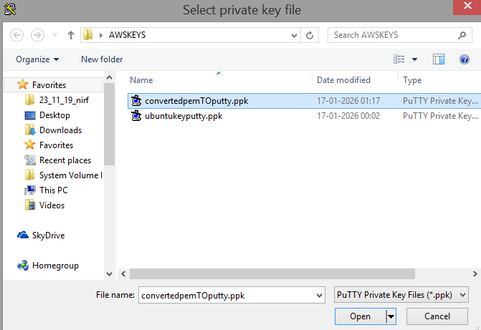
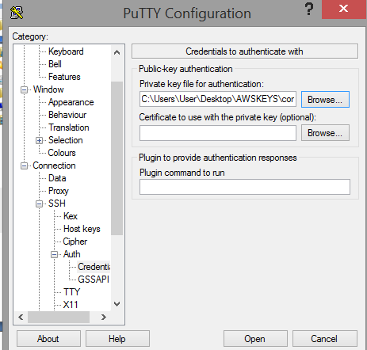
Now go to Data section on left side in putty
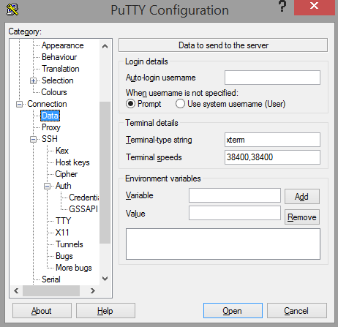
Now get user name from EC2 i.e user name is ubuntu
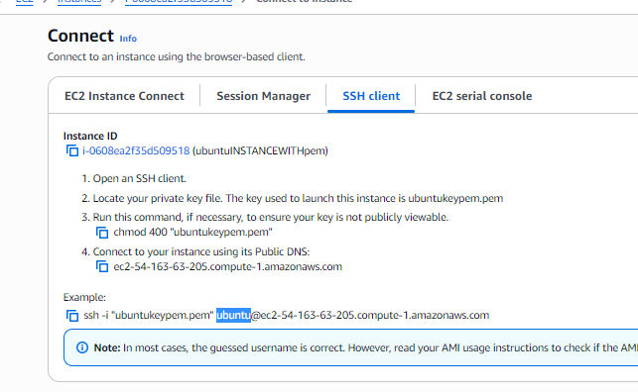

Paste user name here
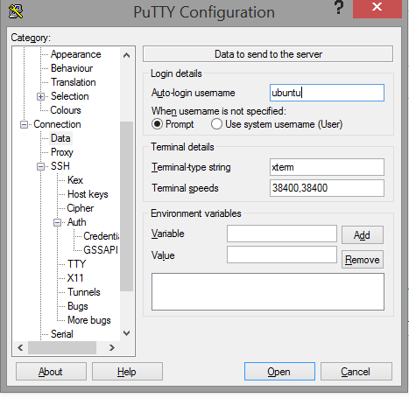
Now click on Session and give name pemputtysession and click on save
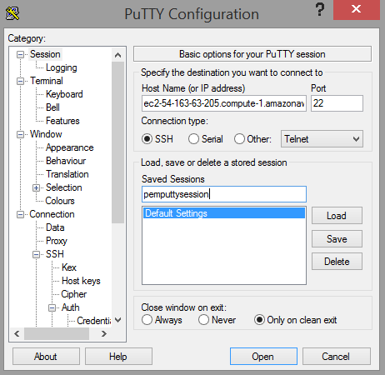

Click on open
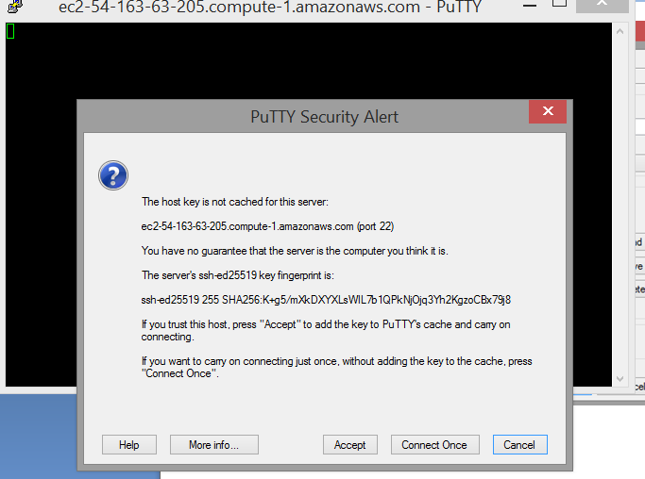
Accept
STEP 4: Connected
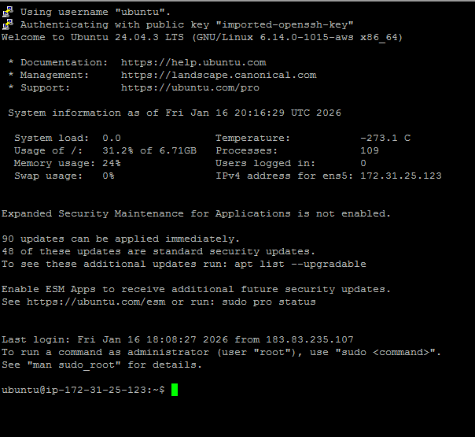
VERIFY CONNECTION
Run:
whoami
Output:
Ubuntu
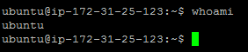

Now type exit at prompt
Next goto AWSKEYS and click on putty.exe

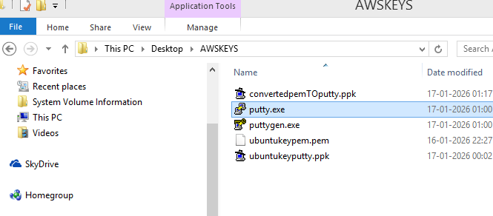
Click on session pemTOputtysession
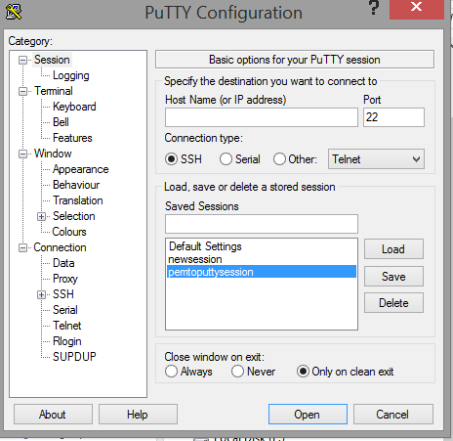
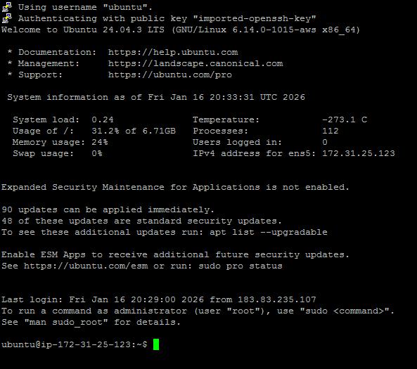
Above connection is established. To exit, type exit.
Stop and terminate EC2 instance

