TASK 5 🎊🎉💥
AI-Powered InAmigos Impact Analysis
Research, Insights, Challenges and Strategic Recommendations

Prepared by | Yamuna Tanuku
Focus Area | AI-Assisted NGO Impact Research
Method | Web Research + AI Analysis
Date | 31 August 2026
Executive Summary
InAmigos Foundation is a Section 8 registered non-profit organization founded on 23 September 2020 and based in Chhattisgarh. Its six major initiatives address community welfare, child education, animal welfare, women empowerment, environmental sustainability, and employability. This AI-assisted report analyzes the Foundation's publicly available impact information and identifies practical opportunities to strengthen measurement, outreach, and long-term sustainability.
1. Major Projects and Available Impact
Project | Primary Focus | Reported / Available Impact
Project Seva | Food and clothing support for underprivileged communities | 50,000+ meals and clothing distributions
Project BachpanShala | Education, digital literacy, life skills and school support | Qualitative educational support reported
Project Jeev | Animal feeding, rescue, protection and welfare | 50+ stray animals fed daily
Project Udaan | Women empowerment, skills and financial independence | Works with rural self-help groups and awareness programs
Project Prakriti | Environmental conservation and sustainability | 20,000+ saplings planted
Project Vikas | Internships, skill development and employability | 30,000+ interns trained in four years

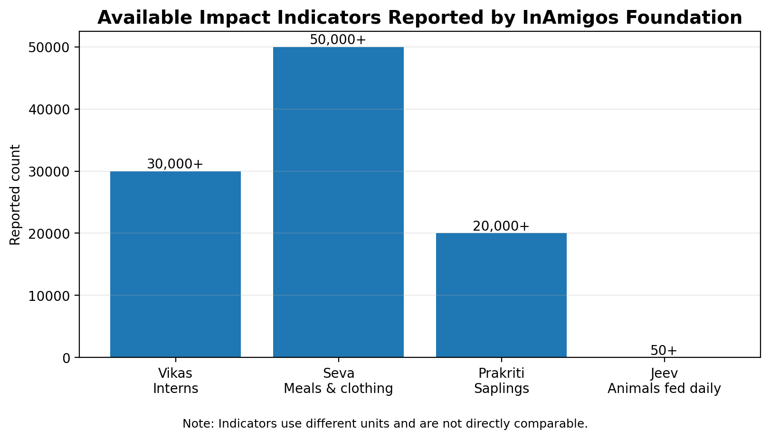
Figure 1. Selected available impact indicators reported by InAmigos Foundation.
2. Five Key Insights from AI-Assisted Analysis
• Diversified impact model: The Foundation addresses interconnected social issues rather than relying on a single program area, enabling broader community reach.
• Volunteer and partnership strength: A multi-state volunteer network can extend delivery capacity and create opportunities for community participation.
• Education and employability support long-term change: BachpanShala and Vikas focus on capabilities that can improve future opportunities beyond immediate assistance.
• Digital visibility can amplify impact: Online communication can attract volunteers, interns, donors, colleges and CSR partners while making activities more visible.
• Outcome measurement is the next growth opportunity: Activity counts are valuable, but tracking beneficiary outcomes and follow-up results would provide stronger evidence of long-term change.
3. Challenges / Areas for Improvement
• Limited outcome-level measurement: Public activity totals do not always show longer-term outcomes such as learning improvement, income change, employment or beneficiary retention.
• Consistency across a diverse network: Multiple projects, locations and volunteers can create challenges in training, quality control and standardized reporting.
• Long-term sustainability tracking: Programs such as plantation, education and skill development benefit from follow-up measures such as sapling survival, learning progress and career outcomes.
4. Practical Recommendations
• Create a digital impact dashboard: Publish clear indicators for beneficiaries reached, volunteers, project locations and project-specific outcomes. Update the dashboard periodically to improve transparency.
• Introduce standardized KPIs for every project: Examples include attendance and learning progress for BachpanShala, employment outcomes for Vikas, income-related outcomes for Udaan, and sapling survival rates for Prakriti.
• Strengthen digital storytelling and partnerships: Use beneficiary stories, before-and-after examples and concise data visualizations to attract universities, CSR partners, volunteers and community organizations.
5. Conclusion
The analysis indicates that InAmigos Foundation has built a broad, community-oriented model spanning immediate humanitarian support and longer-term empowerment. Its strongest opportunity for future growth is to connect activity data with measurable outcomes. A structured impact dashboard, common KPIs, regular follow-up and stronger digital storytelling could help the Foundation demonstrate results more clearly and expand its reach.
6. AI Tools and Important Prompts
AI tool used: ChatGPT for research synthesis, impact analysis, insight generation, critical evaluation, chart preparation and report structuring.
• Research InAmigos Foundation and identify its major projects, initiatives and publicly available impact data.
• Analyze the social impact of InAmigos Foundation based on its initiatives and reported achievements.
• Identify five key insights from the Foundation's activities and impact model.
• Identify three challenges or areas for improvement for an NGO operating across multiple social sectors.
• Suggest three practical, data-driven recommendations to improve impact measurement and outreach.
7. Sources
• InAmigos Foundation Official Website — https://inamigosfoundation.org.in/
• InAmigos Foundation About Us & Impact Information — https://inamigosfoundation.org.in/page/About-Us
• InAmigos Foundation Blog — https://inamigosfoundation.org.in/blog
• InAmigos Foundation, “Transforming Lives Through Compassion and Action” — https://inamigosfoundation.org.in/single/inamigos-foundation-transforming-lives
Data note: Reported figures are based on publicly available information from InAmigos Foundation and should be interpreted as organization-reported indicators. The chart intentionally includes only indicators with clear numeric values and labels them as different units.

