1. Update the categoryName From “Beverages” to "Drinks" in the categories table.

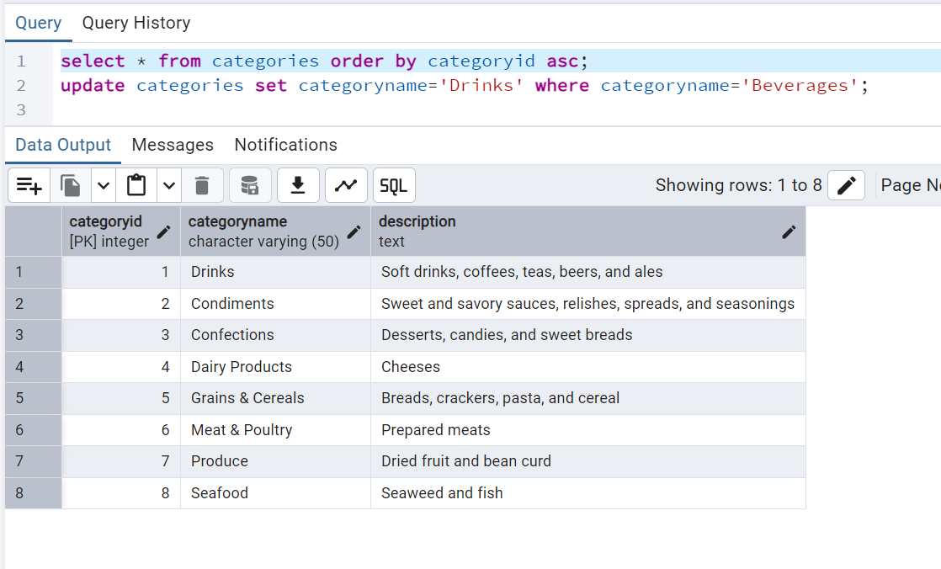

1. Insert into shipper new record (give any values) Delete that new record from shippers table.

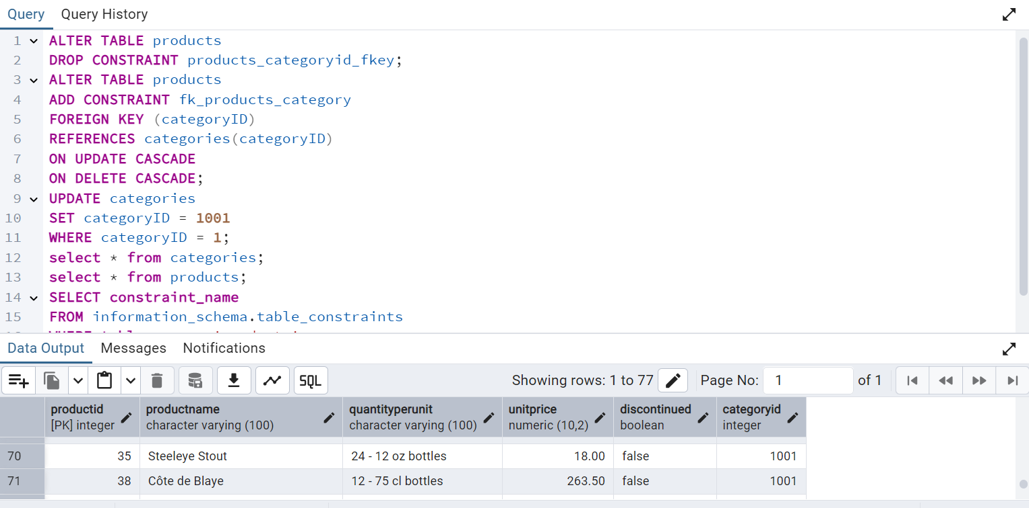

1. Update categoryID=1 to categoryID=1001. Make sure related products update their categoryID too. Display the both category and products table to show the cascade.
2. 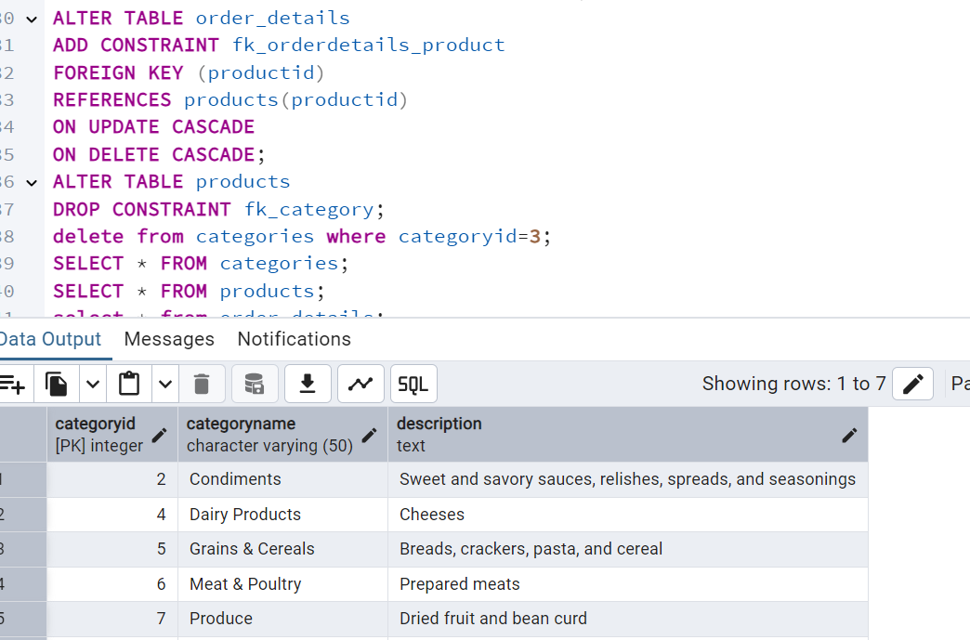
3. 

4)      Delete the customer = “VINET”  from customers. Corresponding customers in orders table should be set to null (HINT: Alter the foreign key on orders(customerID) to use ON DELETE SET NULL)

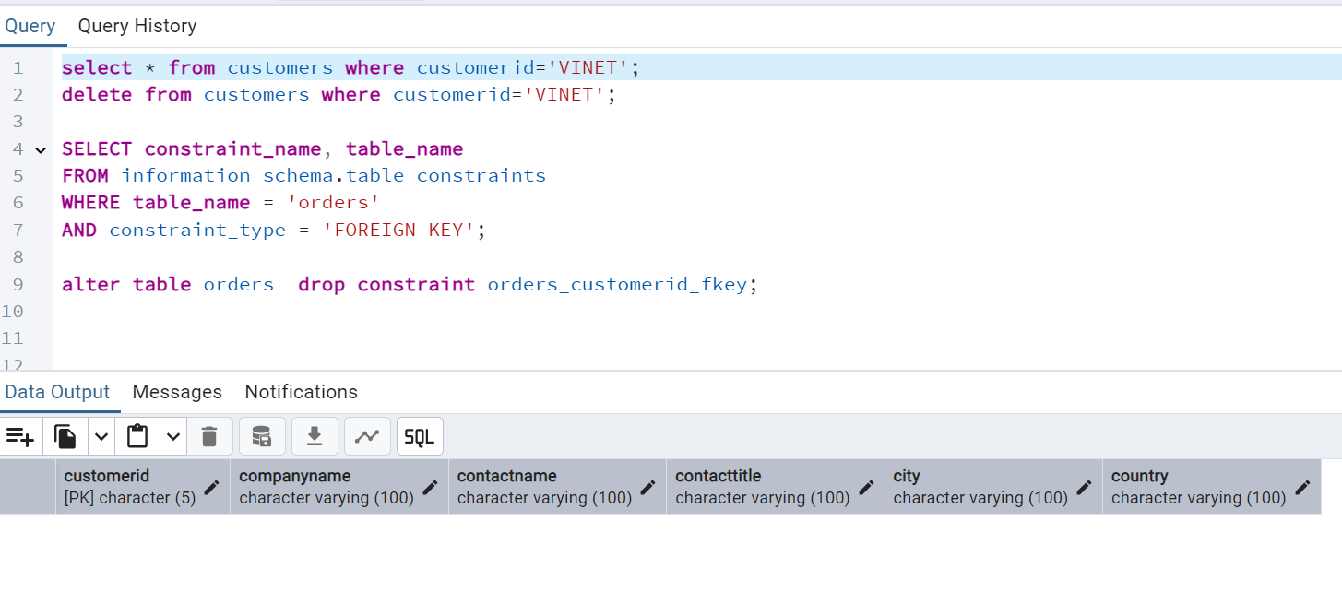

5)  Insert the following data to Products using UPSERT:

product_id = 100, product_name = Wheat bread, quantityperunit=1,unitprice = 13, discontinued = 0, categoryID=5

product_id = 101, product_name = White bread, quantityperunit=5 boxes,unitprice = 13, discontinued = 0, categoryID=5

product_id = 100, product_name = Wheat bread, quantityperunit=10 boxes,unitprice = 13, discontinued = 0, categoryID=5

-- Insert or update Wheat Bread (product_id 100)

INSERT INTO Products (productid, productname, quantityperunit, unitprice, discontinued, categoryid)

VALUES (100, 'Wheat bread', '1', 13, false, 5)

ON CONFLICT (productid)

DO UPDATE SET

productname = EXCLUDED.productname,

quantityperunit = EXCLUDED.quantityperunit,

unitprice = EXCLUDED.unitprice,

discontinued = EXCLUDED.discontinued,

categoryID = EXCLUDED.categoryid;

-- Insert White Bread (product_id 101)

INSERT INTO Products (productid, productname, quantityperunit, unitprice, discontinued, categoryid)

VALUES (101, 'White bread', '5 boxes', 13, false, 5)

ON CONFLICT (productid)

DO UPDATE SET

productname = EXCLUDED.productname,

quantityperunit = EXCLUDED.quantityperunit,

unitprice = EXCLUDED.unitprice,

discontinued = EXCLUDED.discontinued,

categoryid = EXCLUDED.categoryid;

-- Insert or update Wheat Bread again with new quantity (product_id 100)

INSERT INTO Products (productid, productname, quantityperunit, unitprice, discontinued, categoryid)

VALUES (100, 'Wheat bread', '10 boxes', 13, true, 5)

ON CONFLICT (productid)

DO UPDATE SET

productname = EXCLUDED.productname,

quantityperunit = EXCLUDED.quantityperunit,

unitprice = EXCLUDED.unitprice,

discontinued = EXCLUDED.discontinued,

categoryid = EXCLUDED.categoryid;

select * from products where productid in(100,101);

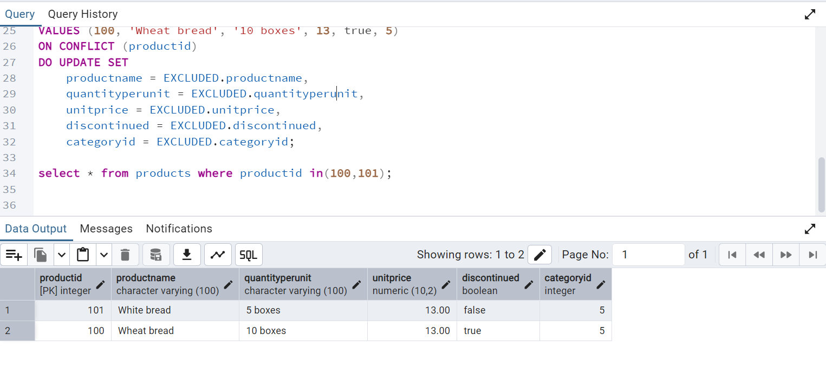

6)      Write a **MERGE query**:

Create **temp table with name:**  ‘updated_products’ and insert values as below:

|  |  |  |  |  |  |
| --- | --- | --- | --- | --- | --- |
| productID | productName | quantityPerUnit | unitPrice | discontinued | categoryID |
| 100 | Wheat bread | 10 | 20 | 1 | 5 |
| 101 | White bread | 5 boxes | 19.99 | 0 | 5 |
| 102 | Midnight Mango Fizz | 24 - 12 oz bottles | 19 | 0 | 1 |
| 103 | Savory Fire Sauce | 12 - 550 ml bottles | 10 | 0 | 2 |

* Update the price and discontinued status for from below table ‘updated_products’ only if there are matching products and updated_products .discontinued =0

* If there are matching products and updated_products .discontinued =1 then delete

* Insert any new products from updated_products that don’t exist in products only if updated_products .discontinued =0.

CREATE TEMP TABLE updated_product (

productid INT,

productname VARCHAR(100),

quantityperunit VARCHAR(50),

unitprice NUMERIC(10,2),

discontinued boolean,

categoryid INT

);

select * from updated_products;

INSERT INTO updated_product (productID, productName, quantityPerUnit, unitPrice, discontinued, categoryID)

VALUES

(100, 'Wheat bread', '10', 20, true, 5),

(101, 'White bread', '5 boxes', 19.99, false, 5),

(102, 'Midnight Mango Fizz', '24 - 12 oz bottles', 19, false, 1),

(103, 'Savory Fire Sauce', '12 - 550 ml bottles', 10, false, 2);

MERGE INTO products AS p

USING updated_product AS u

ON p.productid = u.productid

WHEN MATCHED AND u.discontinued = false THEN

UPDATE SET

unitprice = u.unitprice,

discontinued = u.discontinued

WHEN MATCHED AND u.discontinued = true THEN

DELETE

WHEN NOT MATCHED AND u.discontinued = false THEN

INSERT (productid, productname, quantityperunit, unitprice, discontinued, categoryid)

VALUES (u.productid, u.productname, u.quantityperunit, u.unitprice, u.discontinued, u.categoryid);

SELECT * FROM categories WHERE categoryid = 5;

INSERT INTO categories (categoryid, categoryname,description)

VALUES (1, 'Bread','Baked foods');

