1.     List all customers and the products they ordered with the order date. (Inner join)

**Tables used:** customers, orders, order_details, products

**Output should have below columns:**

    companyname AS customer,

    orderid,

    productname,

    quantity,

    orderdate

SELECT

c.companyname as customer,

o.orderid,

p.productname,

od.quantity,

o.orderdate

FROM

customers c

INNER JOIN

orders o ON c.customerid = o.customerid

INNER JOIN

order_details od ON o.orderid = od.orderid

INNER JOIN

products p ON p.productid = od.productid

ORDER BY

o.orderdate;

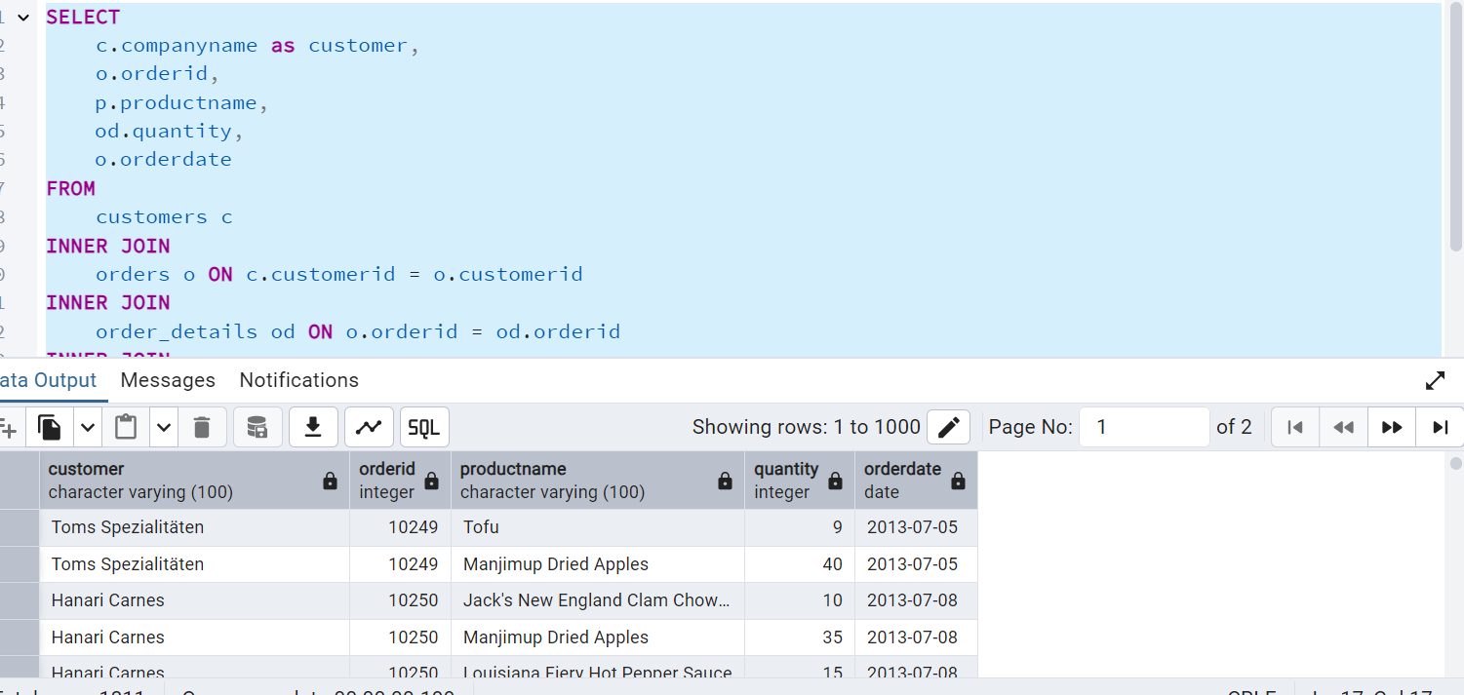

2.     Show each order with customer, employee, shipper, and product info — even if some parts are missing. (Left Join)

**Tables used: orders, customers, employees, shippers, order_details, products**

SELECT

o.orderid,

c.companyname as customer,

e.employeename,

s.companyname as shipper,

p.productname,

od.quantity,

o.orderdate

FROM

orders o

LEFT JOIN

customers c ON c.customerid = o.customerid

LEFT JOIN

employees e ON e.employeeid = o.employeeid

LEFT JOIN

shippers s ON s.shipperid = o.shipperid

LEFT JOIN

order_details od ON o.orderid = od.orderid

LEFT JOIN

products p ON p.productid = od.productid;

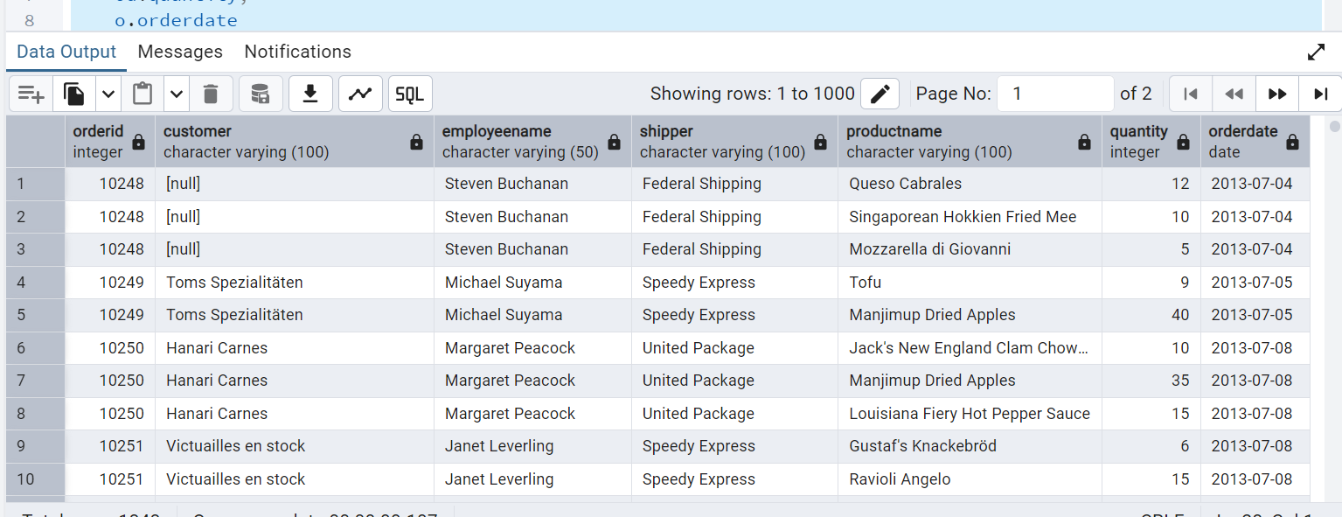

3.     Show all order details and products (include all products even if they were never ordered). (Right Join)

**Tables used: order_details, products**

**Output should have below columns:**

    orderid,

    productid,

    quantity,

    productname

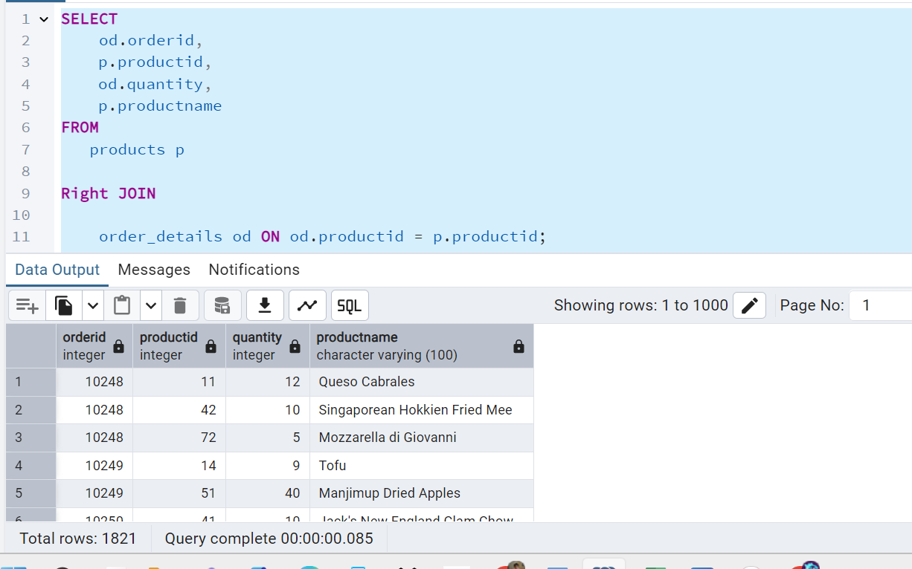

4. List all product categories and their products — including categories that have no products, and products that are not assigned to any category.(Outer Join)

**Tables used: categories, products**

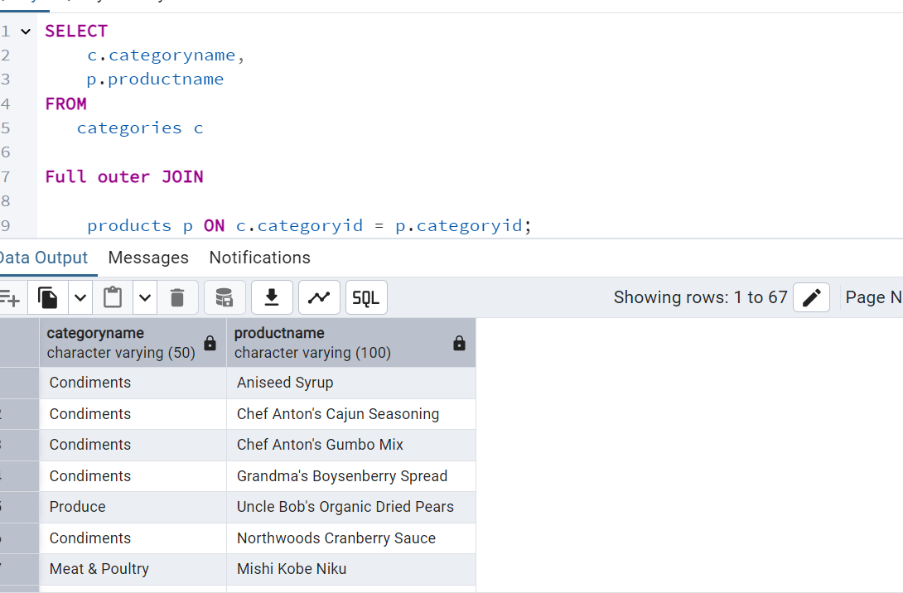

Show all possible product and category combinations (Cross join).

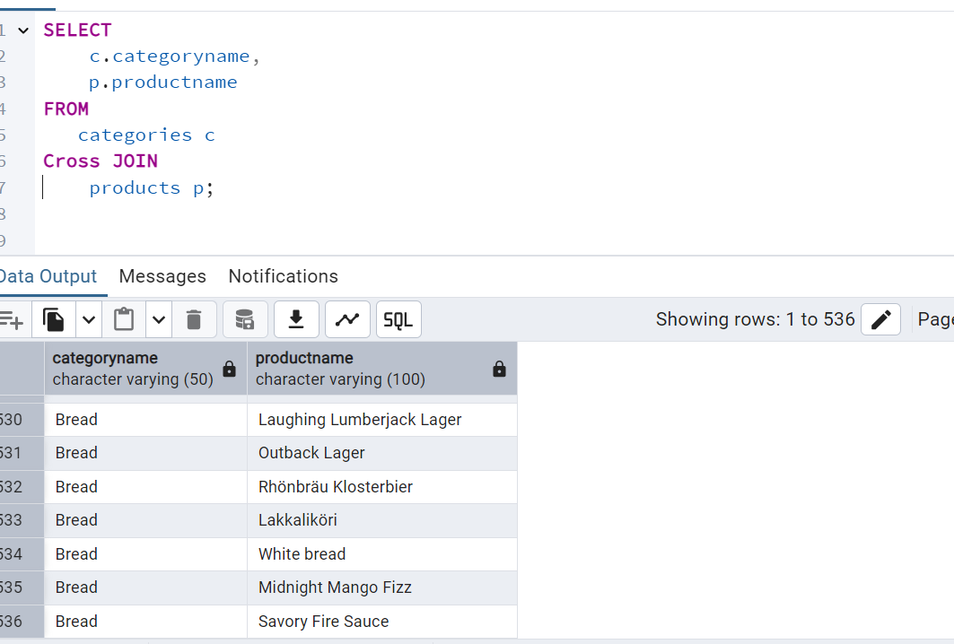

6)Show all employees and their manager(Self join(left join))

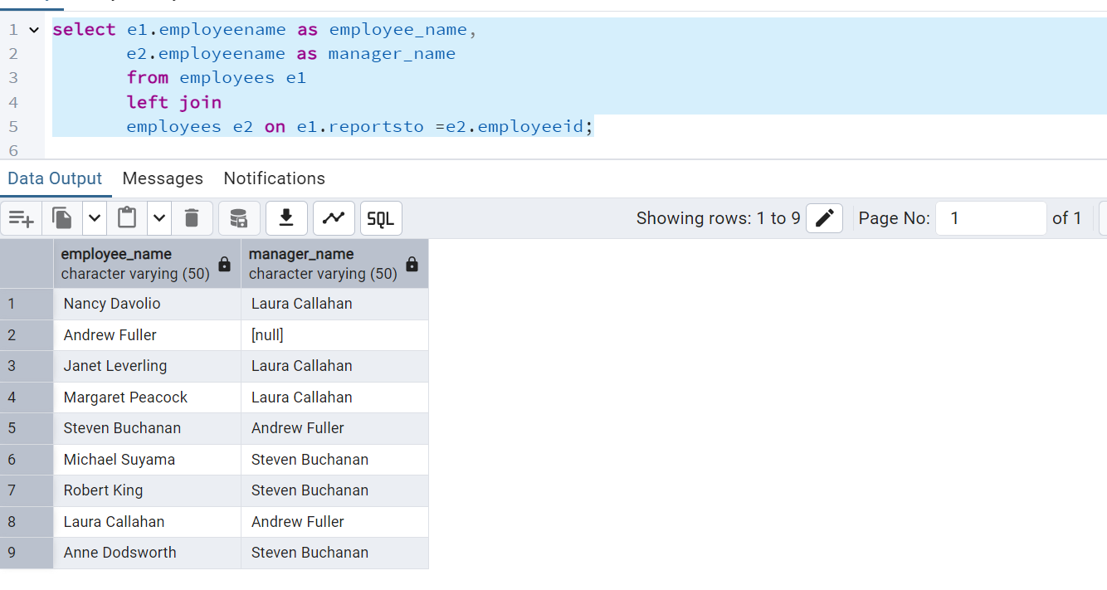

7. List all customers who have not selected a shipping method.

**Tables used:** customers, orders

**(Left Join, WHERE o.shipvia IS NULL)**