1)GROUP BY with WHERE - Orders by Year and Quarter

Display, order year, quarter, order count, avg freight cost only for those orders where freight cost > 100

select extract(year from order_date)as Order_year,

extract(Quarter from order_date)as Order_quarter,

count(*) as order_count,

avg(freight) as avg_freight_cost

from orders

where freight>100

group by

extract(year from order_date),

extract(Quarter from order_date)

order by

Order_year,Order_quarter;

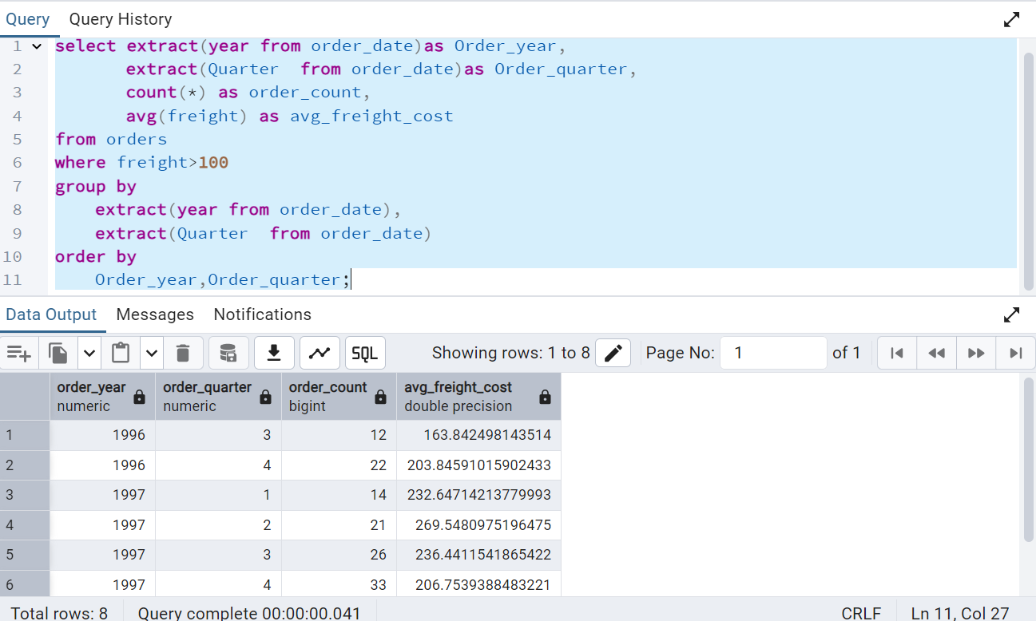

2.      GROUP BY with HAVING - High Volume Ship Regions

Display, ship region, no of orders in each region, min and max freight cost  
 Filter regions where no of orders >= 5

select

ship_region,

count(*) as Order_count,

min(freight),

max(freight)

from

orders

where

ship_region IS NOT NULL

group by

ship_region

having

count(*)>=5

order by

Order_count Desc;

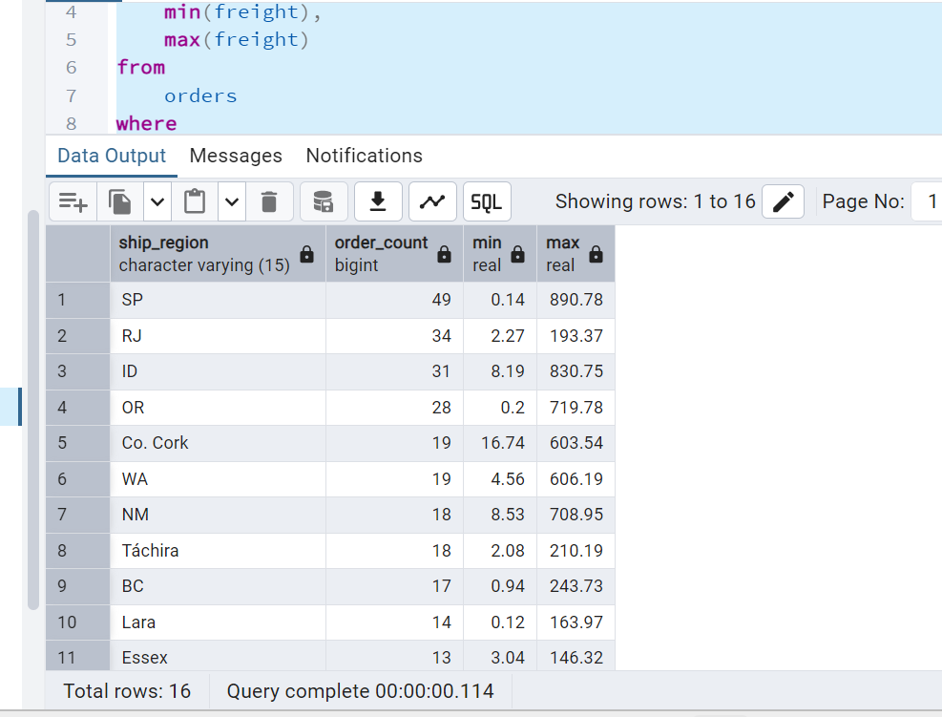

3.      Get all title designations across employees and customers ( Try UNION & UNION ALL)

select title from employees union select contact_title from customers;

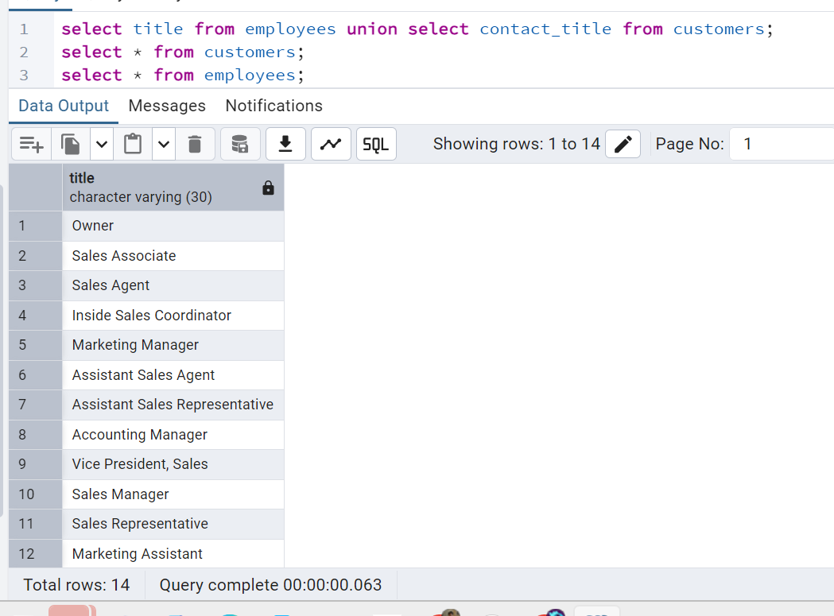

select title from employees union all select contact_title from customers;

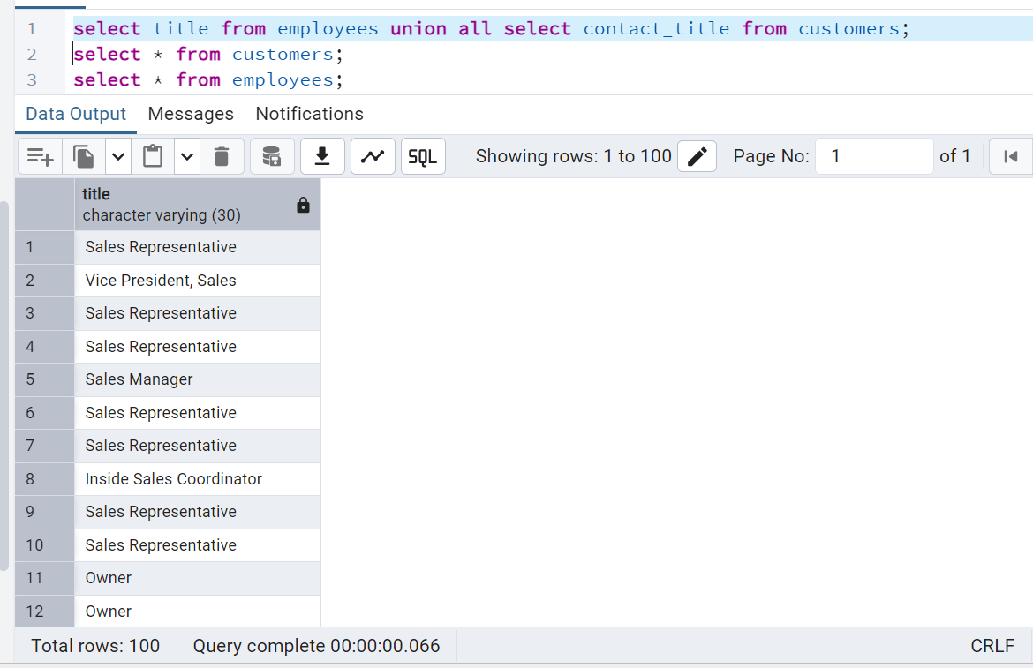

4. Find categories that have both discontinued and in-stock products

(Display category_id, instock means units_in_stock > 0, Intersect)

select category_id from products where discontinued=1

intersect

select units_in_stock from products where units_in_stock>0;

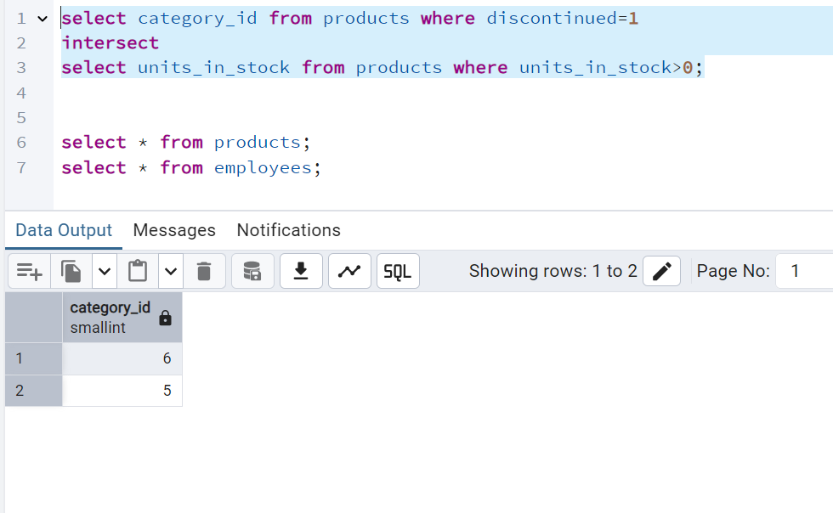

5.      Find orders that have no discounted items (Display the  order_id, EXCEPT)

select order_id from order_details

except

select order_id from order_details where discount>0;

