1.      Categorize products by stock status

(Display product_name, a new column stock_status whose values are based on below condition

 units_in_stock = 0  is 'Out of Stock'

       units_in_stock < 20  is 'Low Stock')

select product_name,

case

when units_in_stock=0 then 'Out_of_stock'

when units_in_stock<20 then 'low_stock'

else 'in stock'

end as stock_status from products;

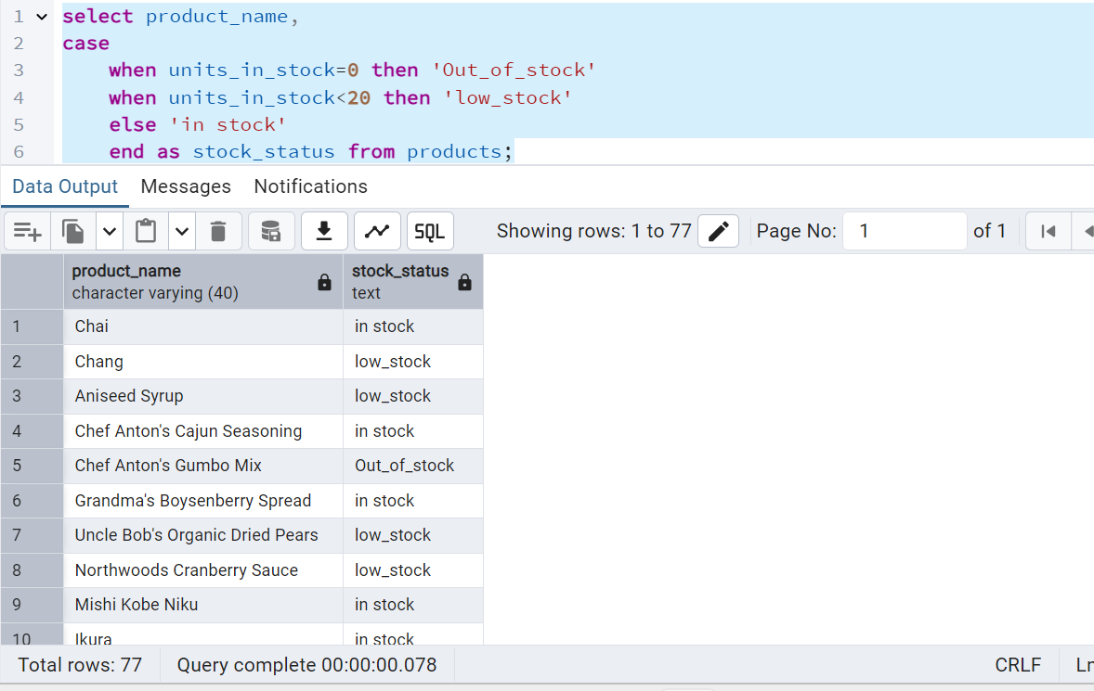

2.      Find All Products in Beverages Category

(Subquery, Display product_name,unitprice)

select product_name,

unit_price

from products

where category_id=(select category_id from categories where category_name='Beverages');

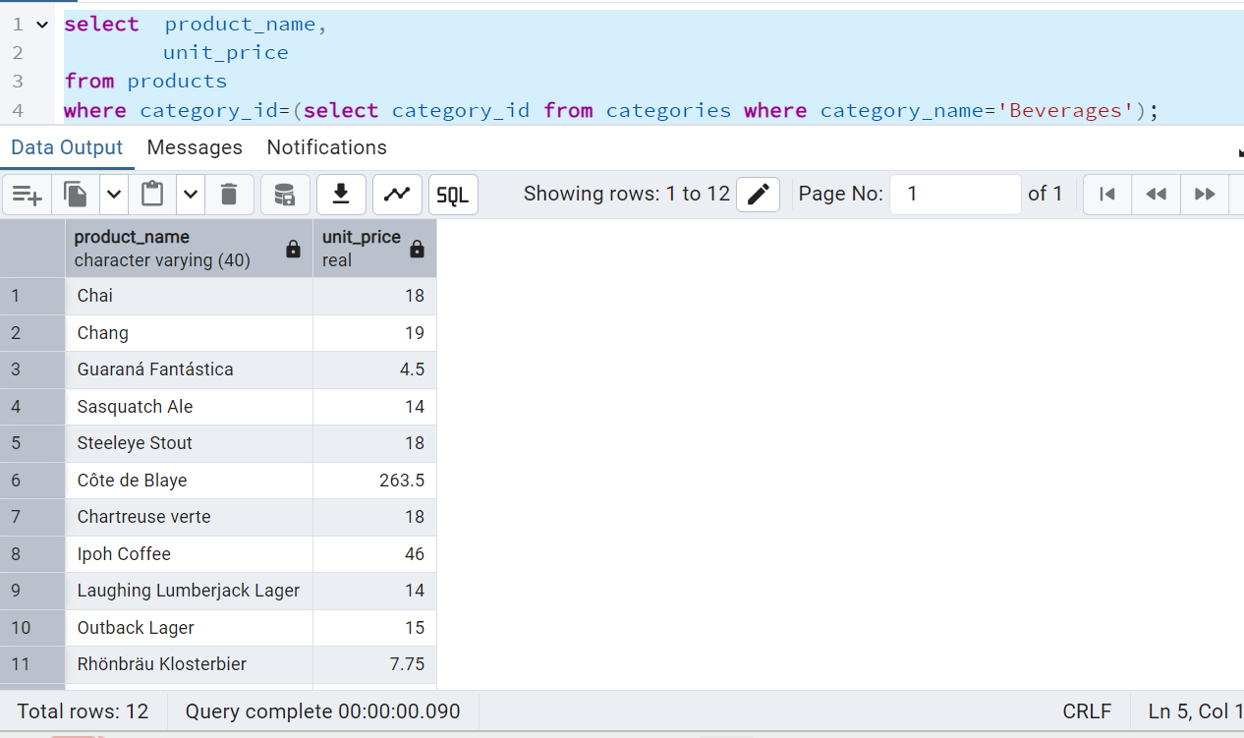

3.      Find Orders by Employee with Most Sales

(Display order_id,   order_date,  freight, employee_id.

Employee with Most Sales=Get the total no.of of orders for each employee then order by DESC and limit 1. Use Subquery)

select

order_id,

order_date,

freight,

employee_id

from orders

where employee_id=(select employee_id from orders group by employee_id order by count(*)Desc

limit 1);

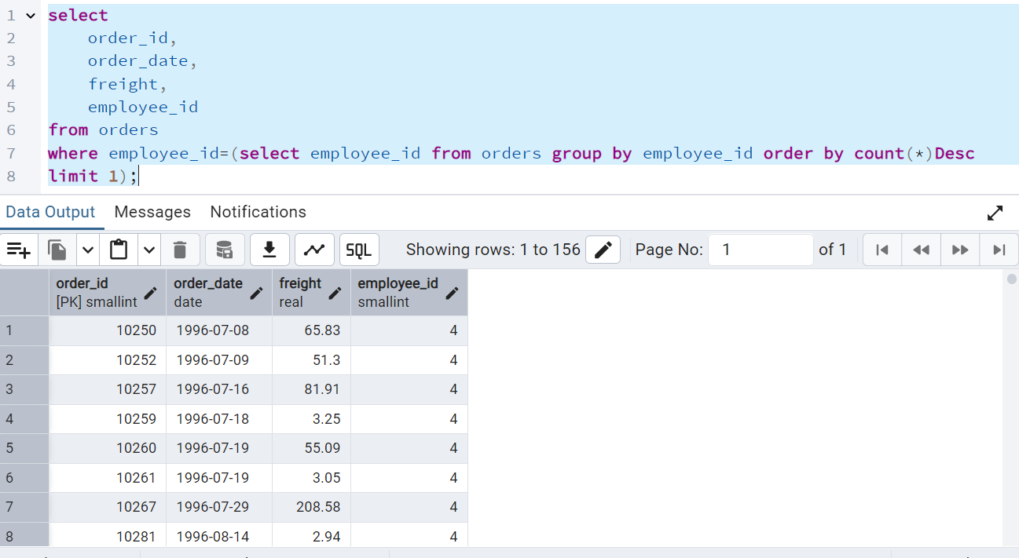

4.      Find orders  where for country!= ‘USA’ with freight costs higher than any order from USA. (Subquery, Try with ANY, ALL operators)

select

order_id,

order_date,

freight,

ship_country

from orders

where ship_country!='USA'

AND freight > Any(Select freight from orders where ship_country='USA');

