1.     Rank employees by their total sales

(Total sales = Total no of orders handled, JOIN employees and orders table)

select

e.employee_id,

CONCAT(e.first_name, ' ', e.last_name) AS employee_name,

count(o.order_id) as total_sales,

rank() over (order by count(o.order_id) desc) as sales_rank

from

employees e

join orders o on e.employee_id=o.employee_id

group by

e.employee_id,e.first_name,e.last_name

order by

total_sales desc;

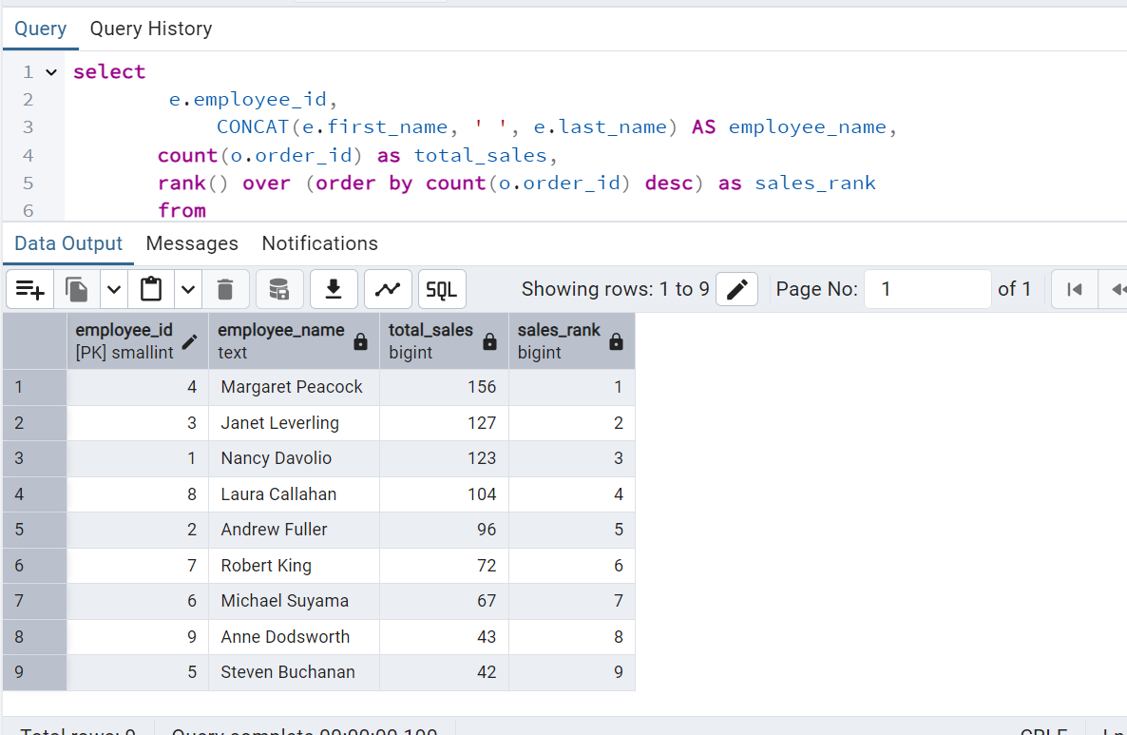

2.      Compare current order's freight with previous and next order for each customer.

(Display order_id,  customer_id,  order_date,  freight,

Use lead(freight) and lag(freight).

SELECT

order_id,

customer_id,

order_date,

freight,

LAG(freight) OVER (PARTITION BY customer_id ORDER BY order_date) AS previous_freight,

LEAD(freight) OVER (PARTITION BY customer_id ORDER BY order_date) AS next_freight

FROM

orders

ORDER BY

customer_id, order_date;

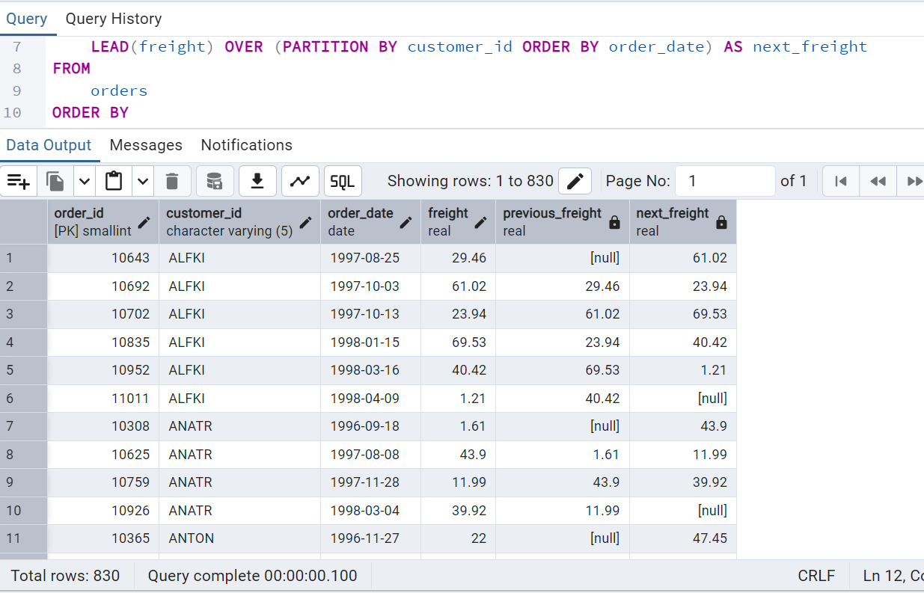

3.     Show products and their price categories, product count in each category, avg price:

         (HINT:

·  Create a CTE which should have price_category definition:

         WHEN unit_price < 20 THEN 'Low Price'

            WHEN unit_price < 50 THEN 'Medium Price'

            ELSE 'High Price'

·  In the main query display: price_category,  product_count in each price_category,  ROUND(AVG(unit_price)::numeric, 2) as avg_price)

