DAY 8

1.     Create view vw_updatable_products (use same query whatever I used in the training)

Try updating view with below query and see if the product table also gets updated.

Update query:

UPDATE updatable_products SET unit_price = unit_price * 1.1 WHERE units_in_stock < 10;

CREATE VIEW vw_updatable_products AS

SELECT product_id, product_name, unit_price, units_in_stock

FROM products

WHERE discontinued = 0;

UPDATE vw_updatable_products

SET unit_price = unit_price * 1.1

WHERE units_in_stock < 10;

SELECT * FROM products WHERE units_in_stock < 10;

CREATE VIEW vw_updatable_products AS

SELECT product_id, product_name, unit_price, units_in_stock

FROM products

WHERE discontinued = 0;

UPDATE vw_updatable_products

SET unit_price = unit_price * 1.1

WHERE units_in_stock < 10;

SELECT * FROM products WHERE units_in_stock < 10;

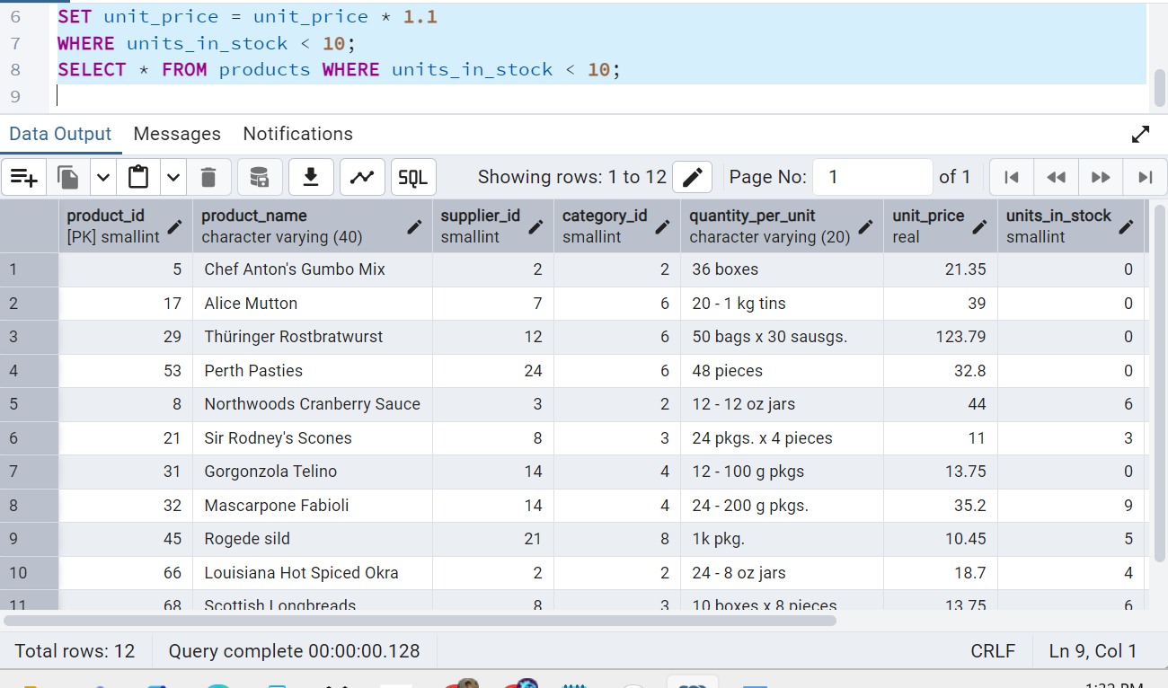

2.     Transaction:

Update the product price for products by 10% in category id=1

Try COMMIT and ROLLBACK and observe what happens.

BEGIN; -- Start a transaction

UPDATE products

SET unit_price = unit_price * 1.1

WHERE category_id = 1;

-- Check changes BEFORE commit (optional)

SELECT * FROM products WHERE category_id = 1;

COMMIT; -- Finalize the transaction (changes are saved)

BEGIN; -- Start a transaction

UPDATE products

SET unit_price = unit_price * 1.1

WHERE category_id = 1;

-- Check changes BEFORE rollback (optional)

SELECT * FROM products WHERE category_id = 1;

ROLLBACK; -- Cancel the transaction (no changes will be saved)

SELECT product_id, product_name, unit_price

FROM products

WHERE category_id = 1;

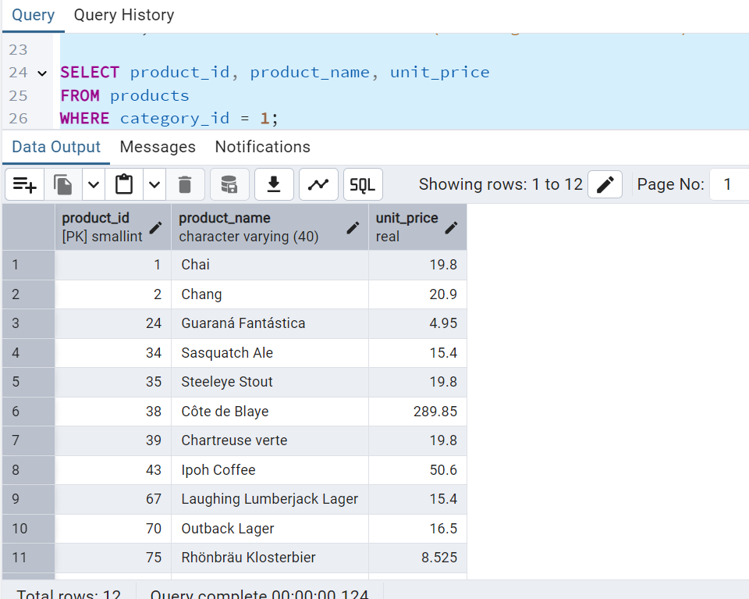

3.     Create a regular view which will have below details (Need to do joins):

Employee_id,

Employee_full_name,

Title,

Territory_id,

territory_description,

region_description

CREATE VIEW vw_employee_territories AS

SELECT

e.employee_id,

e.first_name || ' ' || e.last_name AS employee_full_name, -- For SQL Server use: e.first_name + ' ' + e.last_name

e.title,

t.territory_id,

t.territory_description,

r.region_description

FROM employees e

JOIN employee_territories et ON e.employee_id = et.employee_id

JOIN territories t ON et.territory_id = t.territory_id

JOIN region r ON t.region_id = r.region_id;

SELECT * FROM vw_employee_territories;

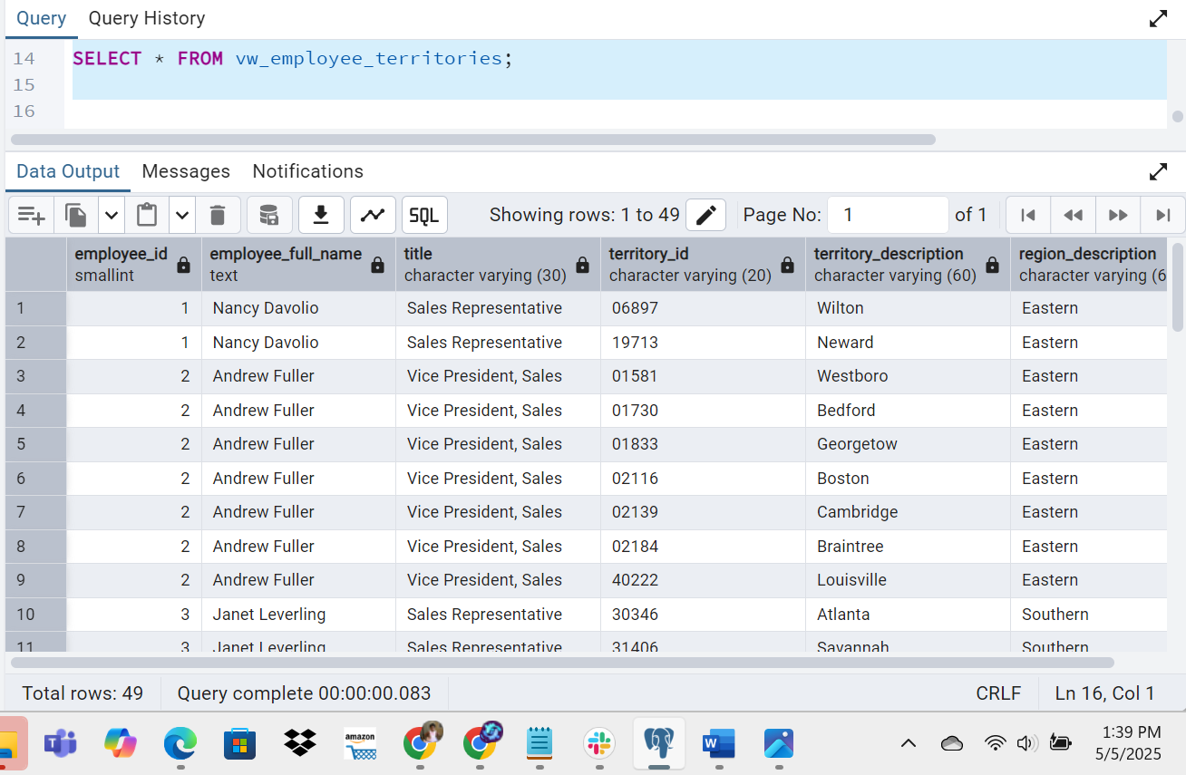

4.     Create a recursive CTE based on Employee Hierarchy

WITH RECURSIVE employee_hierarchy AS (

-- Anchor member: top-level managers (no one they report to)

SELECT

employee_id,

first_name,

last_name,

reports_to,

1 AS level

FROM employees

WHERE reports_to IS NULL

UNION ALL

-- Recursive member: employees who report to others

SELECT

e.employee_id,

e.first_name,

e.last_name,

e.reports_to,

eh.level + 1

FROM employees e

INNER JOIN employee_hierarchy eh ON e.reports_to = eh.employee_id

)

SELECT * FROM employee_hierarchy

ORDER BY level, employee_id;

