 | INSTITUTE OF DIGITAL RISK | CONFIDENTIAL

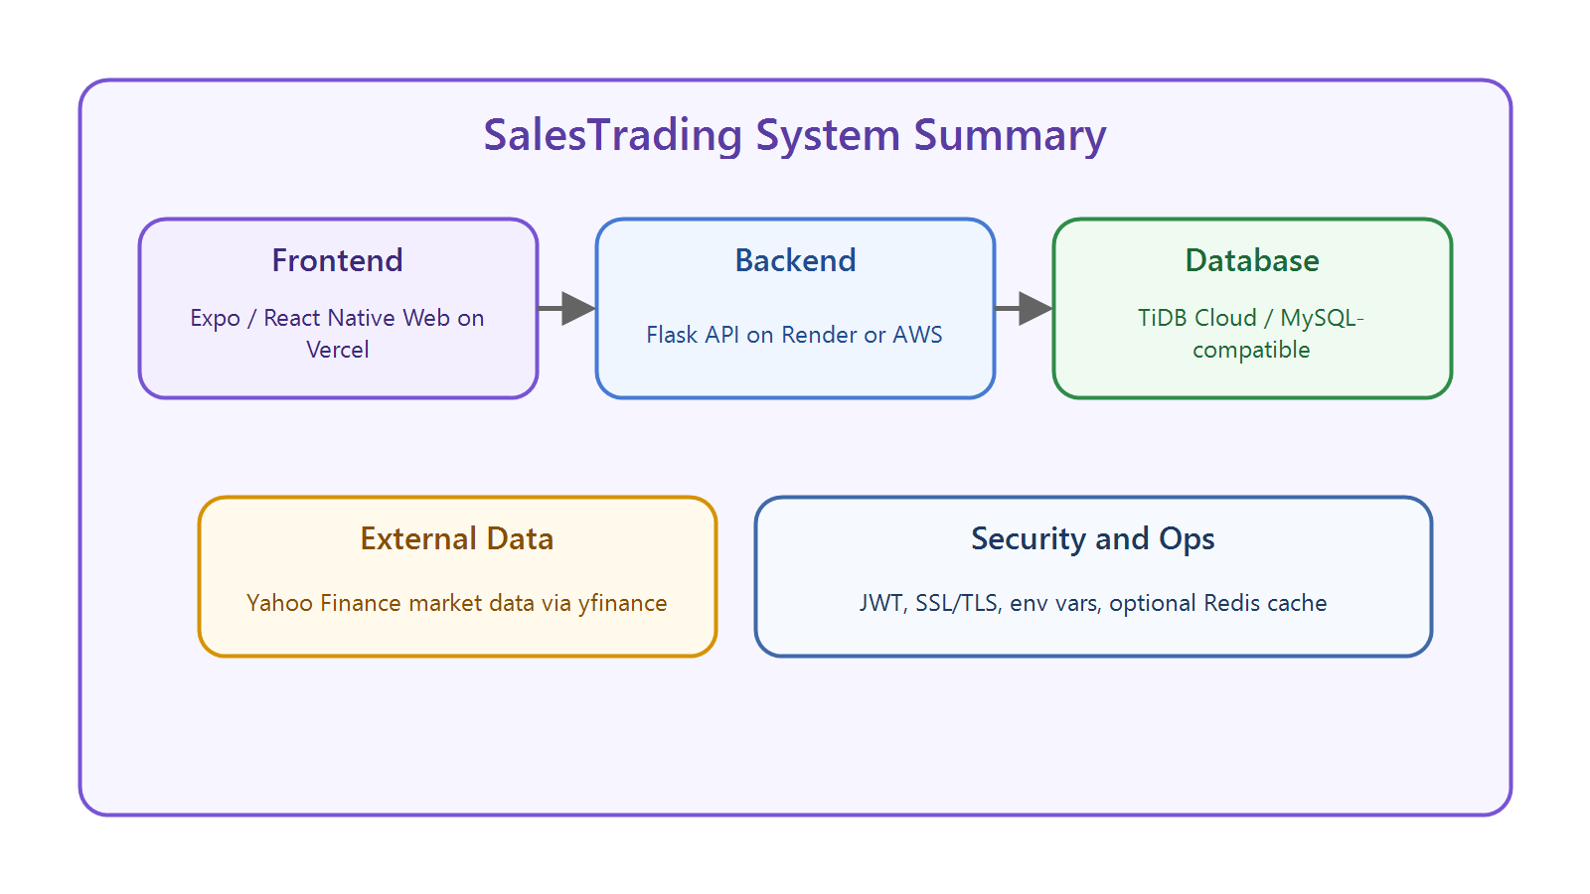

TECHNICAL ARCHITECTURE
& SYSTEM DOCUMENTATION

Version | v1.0 — Initial Release | Date | June 2026
Status | Draft | Prepared By | Ishita & Yamuna
Organisation | Institute of Digital Risk | Classification | Confidential
Frontend URL | trade-iq-deploy.vercel.app | Backend URL | trade-iq-deploy.onrender.com

CONFIDENTIAL — INSTITUTE OF DIGITAL RISK | Not for distribution without written consent

Table of Contents
Contents
Table of Contents 2
1. Platform Overview 4
1.1 Core Purpose & Audience 4
1.2 Deployment Topology 4
1.3 Core Feature Matrix 4
2. System Architecture 6
2.1 High-Level Architecture Diagram 6
2.2 Trade Execution Flow 6
2.3 Scoring & Leaderboard Flow 7
2.4 Frontend Architecture (React / React Native) 8
2.5 Backend Architecture (FastAPI + Python) 8
3. Database Architecture 9
3.1 Entity Relationship Diagram 9
3.2 Table Reference 10
4. API Reference 11
4.1 Authentication Flow 11
4.2 Route Map 11
4.3 FastAPI Project Structure 12
5. Security Architecture 13
5.1 Authentication & Authorisation 13
5.2 API Security Controls 13
5.3 Mobile App Security 13
5.4 Infrastructure Security 14
6. Cloud Infrastructure & Deployment 15
6.1 Deployment Architecture Diagram 15
6.2 Recommended Cloud Stack 15
6.3 Docker -- Backend Container 16
6.4 CI/CD Pipeline 16
6.5 Scalability Targets 16
7. Risk Register 18
8. Recommendations & Roadmap 19
8.1 Short-Term -- Before Launch 19
8.2 Medium-Term -- Post-Launch 19
8.3 Long-Term 19

1. Platform Overview
SalesTrading is a paper-trading platform for students that simulates investing without using real money.

It helps users register, explore stocks, place BUY/SELL trades, track holdings, submit a thesis, and see scores.
Dimension | Detail
Primary Users | Students enrolled in investment banking programmes
Simulation Period | 4-week academic cohort with leaderboard scoring
Starting Capital | $10,00 paper trading allocation per user
Asset Classes | Equities, Fixed Income, FX, Derivatives, Commodities, Crypto (optional)
Scoring Basis | Portfolio P&L + thesis submission quality + risk-adjusted metrics

1.1 Core Purpose & Audience
The platform is meant for learners who want a safe way to practice trading and understand how portfolio decisions affect results.
Service | Technology Stack | Deployment Target
Frontend (Web) | React (Vite / Next.js) | Vercel — trade-iq-deploy.vercel.app
Mobile App | React Native + Expo SDK | APK (Android) — Play Store ready
Backend API | Python + FastAPI | Render — trade-iq-deploy.onrender.com
Database | SQL — PostgreSQL / MySQL | TiDB Cloud
Payments | Stripe Payment Links | Stripe-hosted, webhook integration

1.2 Deployment Topology
Feature | Web App | Mobile APK
Paper trading dashboard | Yes | Yes
Real-time / 15-min delayed market data | Yes | Yes
Live P&L & portfolio tracker | Yes | Yes
Leaderboard (class-wide) | Yes | Yes
Risk metrics (VaR, Beta, Sharpe) | Yes | Yes
Stripe subscription / payment | Yes | Yes
Push notifications | No | Yes (Expo)
Offline-tolerant caching | Limited | Yes (AsyncStorage)
APK direct install | N/A | Yes

The system has three parts: a Vercel-hosted frontend, a Flask API backend, and a managed MySQL-compatible database such as TiDB Cloud.
1.3 Core Feature Matrix

The main features are authentication, market lookup, simulated trading, portfolio tracking, thesis scoring, and leaderboard display.

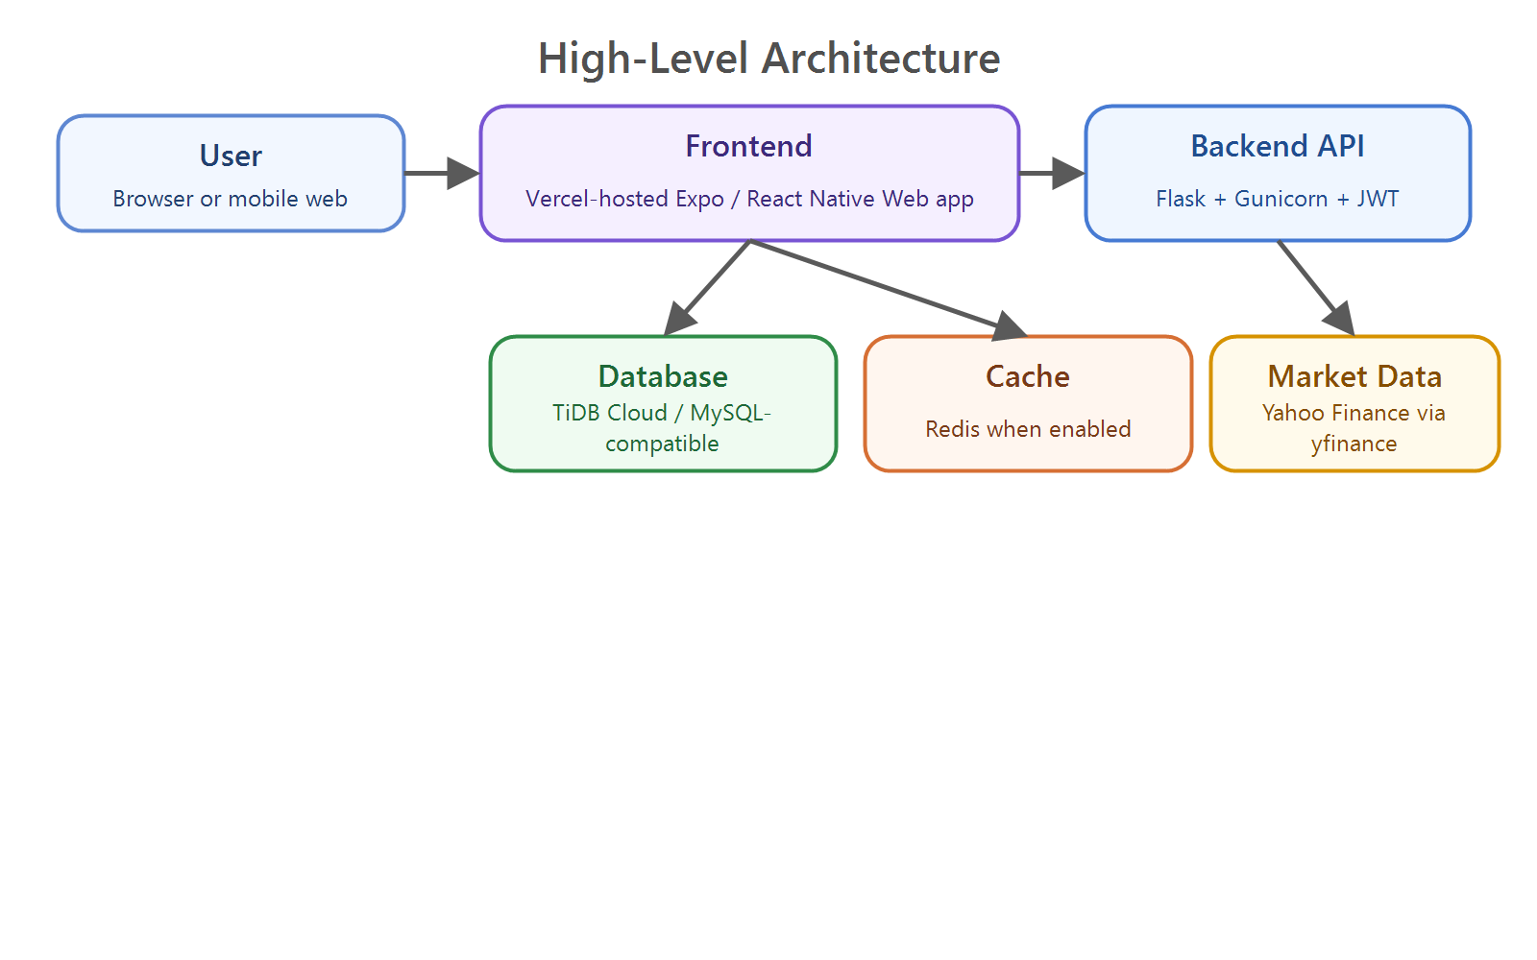
2. System Architecture

SalesTrading uses a simple three-layer design: user interface, application logic, and data storage.
2.1 High-Level Architecture Diagram

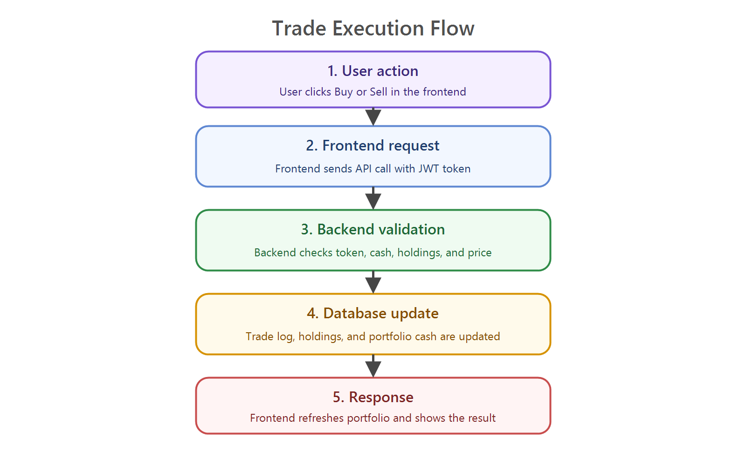
The frontend sends HTTPS requests to the backend, and the backend reads or writes the database and fetches market data from Yahoo Finance.

Figure 1 -- SalesTrading High-Level Architecture Diagram
2.2 Trade Execution Flow
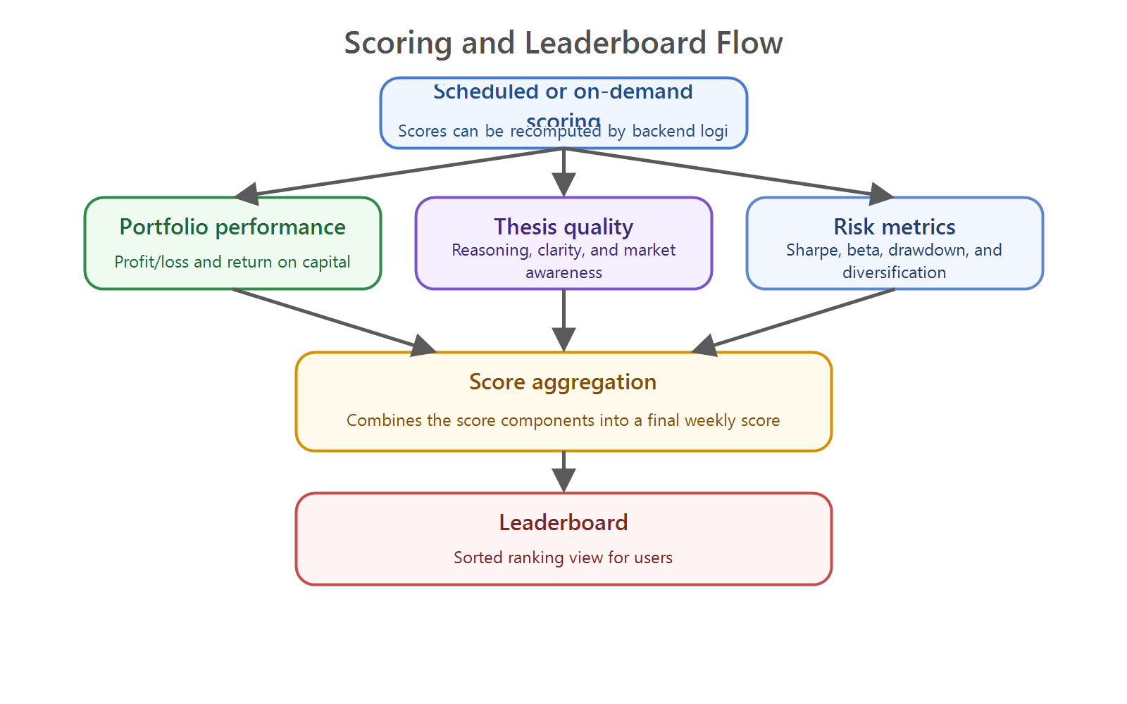
When a user buys or sells, the backend checks cash and holdings, records the trade, updates the portfolio, and returns the new state.

The diagram shows the full path from button click to database update and refreshed portfolio values.
Layer | Technology | Responsibility
UI Framework | React Native + Expo SDK | Cross-platform component rendering
Navigation | React Navigation v6 | Tab, Stack, and Drawer navigation
State Management | Redux Toolkit / Zustand | Global portfolio, auth, and trade state
API Layer | Axios / React Query | HTTP calls, caching, background refetch
Local Storage | Expo SecureStore + AsyncStorage | Auth tokens (secure) and offline cache
Push Notifications | Expo Notifications | Trade alerts, leaderboard updates
Charts | Victory Native / Recharts | P&L charts, portfolio visualizations
Payments | Stripe React Native SDK | Subscription checkout, payment redirect
Build & Distribution | EAS Build (Expo) | APK generation, OTA updates

Figure 2 -- Trade Execution Flow Diagram
Module | Description | Key Dependencies
Auth Service | JWT issuance, refresh, revocation | python-jose, passlib, bcrypt
User Management | Registration, profile, roles | SQLAlchemy, Pydantic
Trade Engine | Order placement, P&L calculation | Custom engine, asyncio
Market Data Proxy | 15-min delayed quotes feed | Yahoo Finance (yfinance)
Risk Calculator | Sharpe, VaR, Beta, MDD | NumPy, pandas, scipy
Portfolio Service | Holdings, allocation, rebalancing | SQLAlchemy ORM
Leaderboard Service | Rankings aggregation, scoring | Redis + SQL query
Stripe Webhook Handler | Payment events, subscription status | stripe-python, BackgroundTasks
Report Generator | Weekly auto-reports | Jinja2, WeasyPrint (PDF)
Notification Service | Push via Expo SDK | httpx, Expo Push API

2.3 Scoring & Leaderboard Flow
Scores combine portfolio performance, thesis quality, execution quality, and risk metrics.

The backend computes and stores score snapshots so the leaderboard can be shown quickly to users.
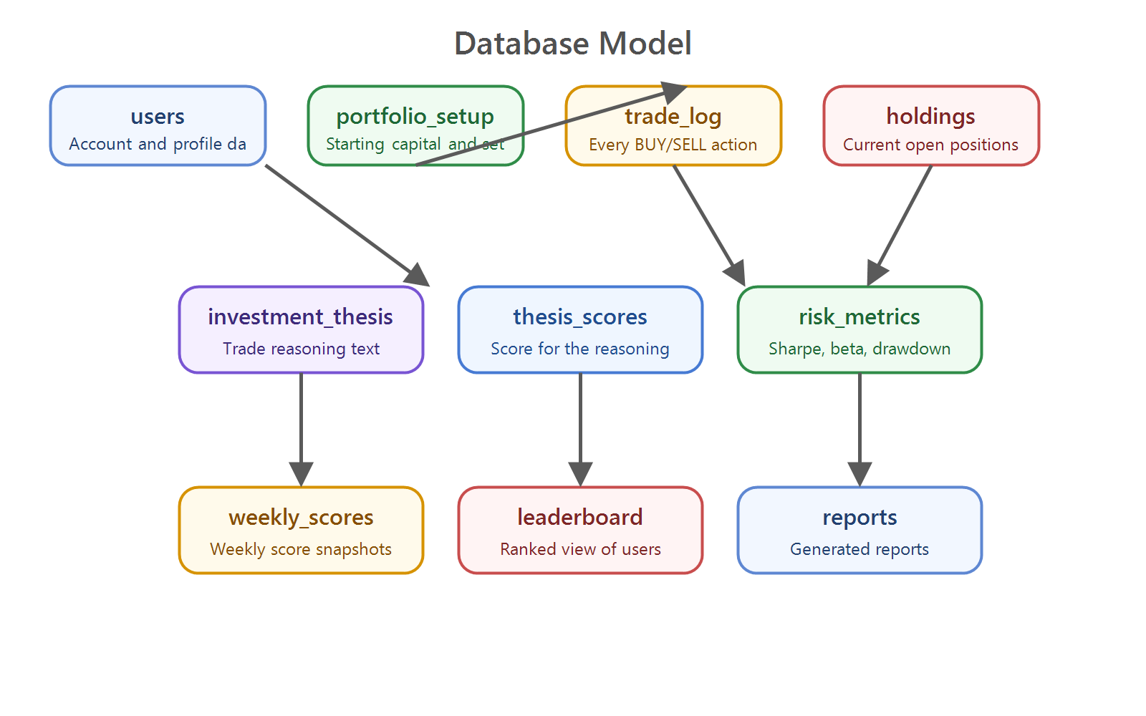
Figure 3 -- Scoring & Leaderboard Flow

2.4 Frontend Architecture (Expo / React Native Web)
Table | Key Columns | Purpose
users | id, email, hashed_pw, role, subscription_status | Core identity and access control
portfolios | id, user_id, cash_balance, total_value, starting_capital | One per user per simulation
positions | id, portfolio_id, symbol, asset_class, qty, avg_cost | Live holdings per user
orders | id, user_id, symbol, type, qty, price, status | Full trade blotter / audit trail
market_data_cache | symbol, price, timestamp, source | 15-min cache layer for market quotes
risk_metrics | user_id, sharpe, var, beta, mdd, calculated_at | Daily risk snapshot per user
leaderboard | user_id, simulation_id, score, rank, updated_at | Aggregated daily rankings
subscriptions | user_id, stripe_customer_id, plan, status, period_end | Stripe sync for billing
simulations | id, name, start_date, end_date, benchmark | Academic cohort configuration
reports | user_id, week_num, content_json, submitted_at | Student submitted reports/thesis

The frontend is an Expo application that runs on web through React Native Web and is hosted on Vercel.
It keeps the JWT token on the client and attaches it to protected API calls.

2.5 Backend Architecture (Flask + Python)

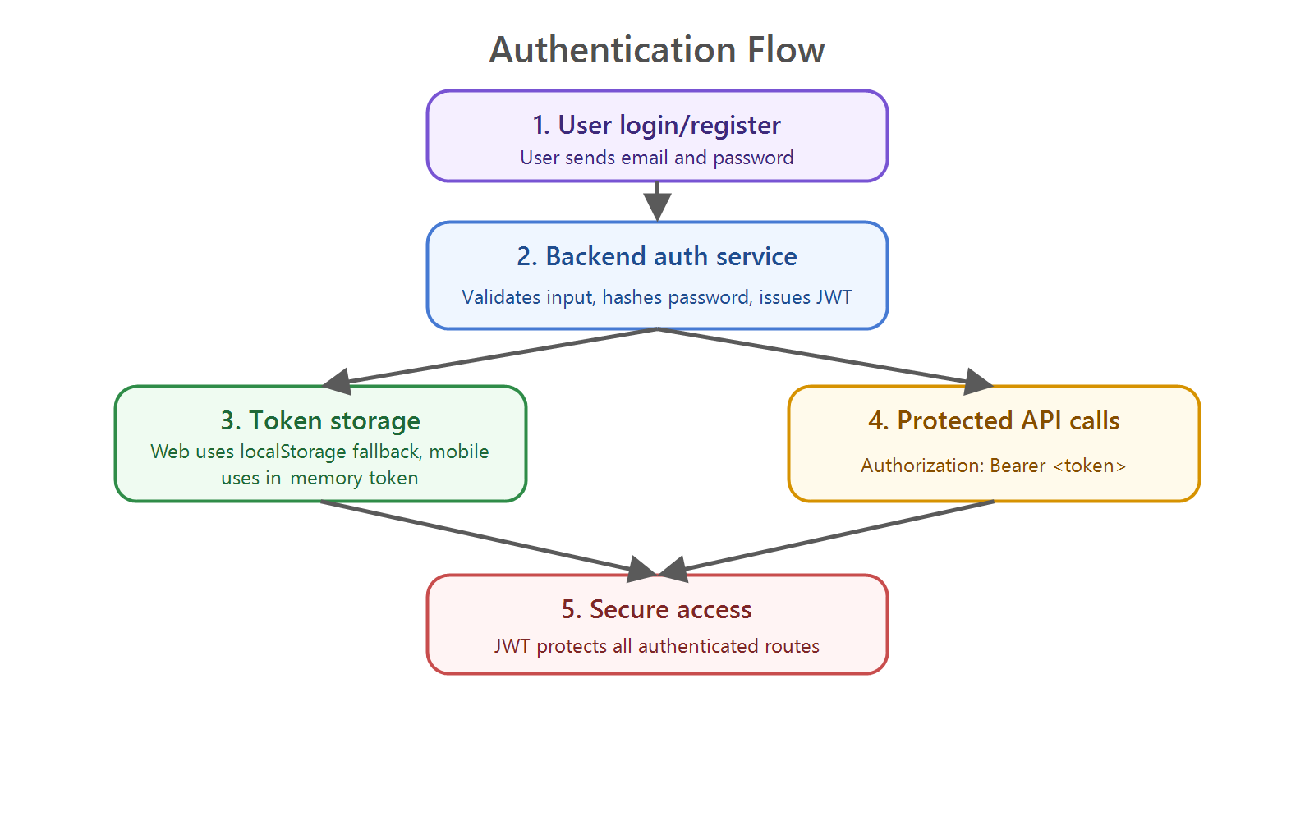
The backend is a Flask REST API organized into modules for auth, market data, portfolio logic, analytics, and scoring.

It runs with Gunicorn in production and gets configuration from environment variables.
Module | Method | Endpoint | Description
Auth | POST | /auth/login | Authenticate user, return JWT pair
Auth | POST | /auth/register | Create new user account
Auth | POST | /auth/refresh | Issue new access token using refresh token
Users | GET | /users/{id} | Retrieve user profile
Users | PUT | /users/{id} | Update user profile details
Portfolio | GET | /portfolio/{user_id} | Fetch full portfolio with holdings
Portfolio | GET | /portfolio/pnl | Get P&L summary and chart data
Orders | POST | /orders/place | Submit a buy or sell order
Orders | GET | /orders/history | Retrieve trade blotter for user
Market | GET | /market/quote | Fetch current price for symbol
Market | GET | /market/history | Historical OHLCV price data
Risk | GET | /risk/metrics/{user_id} | Sharpe ratio, VaR, Beta, MDD
Leaderboard | GET | /leaderboard | Current rankings for simulation
Leaderboard | GET | /leaderboard/weekly | Weekly breakdown of scores
Payments | POST | /webhooks/stripe | Stripe event webhook handler
Payments | GET | /subscriptions | Get user subscription status
Reports | GET | /reports/{user_id}/{week} | Retrieve weekly auto-report

3. Database Architecture
app/
+-- routers/
| +-- auth.py POST /auth/login | /register
| +-- users.py GET | PUT /users/{id}
| +-- portfolio.py GET /portfolio/{user_id}
| +-- orders.py POST /orders/place
| +-- market.py GET /market/quote | /history
| +-- risk.py GET /risk/metrics/{user_id}
| +-- leaderboard.py GET /leaderboard
| +-- payments.py POST /webhooks/stripe
| +-- reports.py GET /reports/{user_id}/{week}
+-- models/ SQLAlchemy ORM models
+-- schemas/ Pydantic request/response
+-- services/ Business logic layer
+-- core/ Config, security, DB session
+-- main.py App entrypoint, CORS, MW

The database is a relational MySQL-compatible store that keeps all persistent user, trade, scoring, and report data.
3.1 Entity Relationship Diagram

The tables are connected mainly through user_id and related score or trade references.
Area | Implementation | Standard
Password hashing | bcrypt with salt rounds >= 12 | OWASP recommended
Token type | JWT (Access + Refresh token pair) | RFC 7519
Access token TTL | 15 minutes maximum | Short-lived, rotation required
Refresh token TTL | 7-30 days, stored in SecureStore (mobile) | Expo SecureStore (AES-256)
Token storage (web) | HttpOnly cookies only — never localStorage | OWASP best practice
Token revocation | Refresh token blacklist in Redis | Stateful invalidation
Role-based access | student | professor | admin roles per endpoint | FastAPI Depends()
MFA (future) | TOTP via pyotp recommended for admin accounts | RFC 6238

Figure 4 -- Database Entity Relationship Diagram
Threat | Mitigation | Implementation
SQL Injection | ORM-only queries, never raw SQL | SQLAlchemy parameterized
XSS | Response sanitization, CSP headers | FastAPI + Helmet-equivalent
CSRF | SameSite=Strict cookies, CSRF tokens | FastAPI middleware
DDoS / Brute Force | Rate limiting per IP and per user | slowapi / Cloudflare
Mass assignment | Pydantic schema whitelisting on all inputs | FastAPI Pydantic models
Secrets exposure | All secrets in env vars / Secrets Manager | Never in code or Git
CORS | Whitelist only app domains, no wildcard in prod | FastAPI CORSMiddleware
HTTPS enforcement | HSTS headers, redirect all HTTP to HTTPS | ALB / Cloudflare
Bot prevention | reCAPTCHA on registration / login | Google reCAPTCHA v3

3.2 Table Reference
- users stores account details, login identity, and profile fields.
- portfolio_setup stores starting capital and each user's portfolio configuration.
- trade_log stores every BUY and SELL action for history and auditing.
- holdings stores the current stock positions for each user.
- investment_thesis stores the user's written reason for a trade.
- thesis_scores stores the system's evaluation of the thesis.
- risk_metrics stores volatility and other risk calculations.

weekly_scores stores score snapshots by week.
Control | Action | Priority
VPC isolation | Deploy backend and DB in private VPC subnets — no public DB exposure | Critical
Security Groups | Whitelist only required ports (8000 API, 5432 DB internal) | Critical
Secrets rotation | Rotate JWT secrets, DB passwords, and Stripe keys every 90 days | High
WAF | Enable AWS WAF or Cloudflare WAF in front of all public endpoints | High
Dependency scanning | Run pip audit and npm audit in CI — block on critical CVEs | High
Container scanning | Trivy or Snyk container scan in CI before ECR push | High
Access logs | Enable ALB access logs, FastAPI structured logging to CloudWatch | High
Intrusion detection | AWS GuardDuty or equivalent for anomaly detection | Medium
Penetration testing | Commission third-party pen test before global launch | High

leaderboard stores the ranked results shown on screen.

reports stores generated report references or downloadable output.
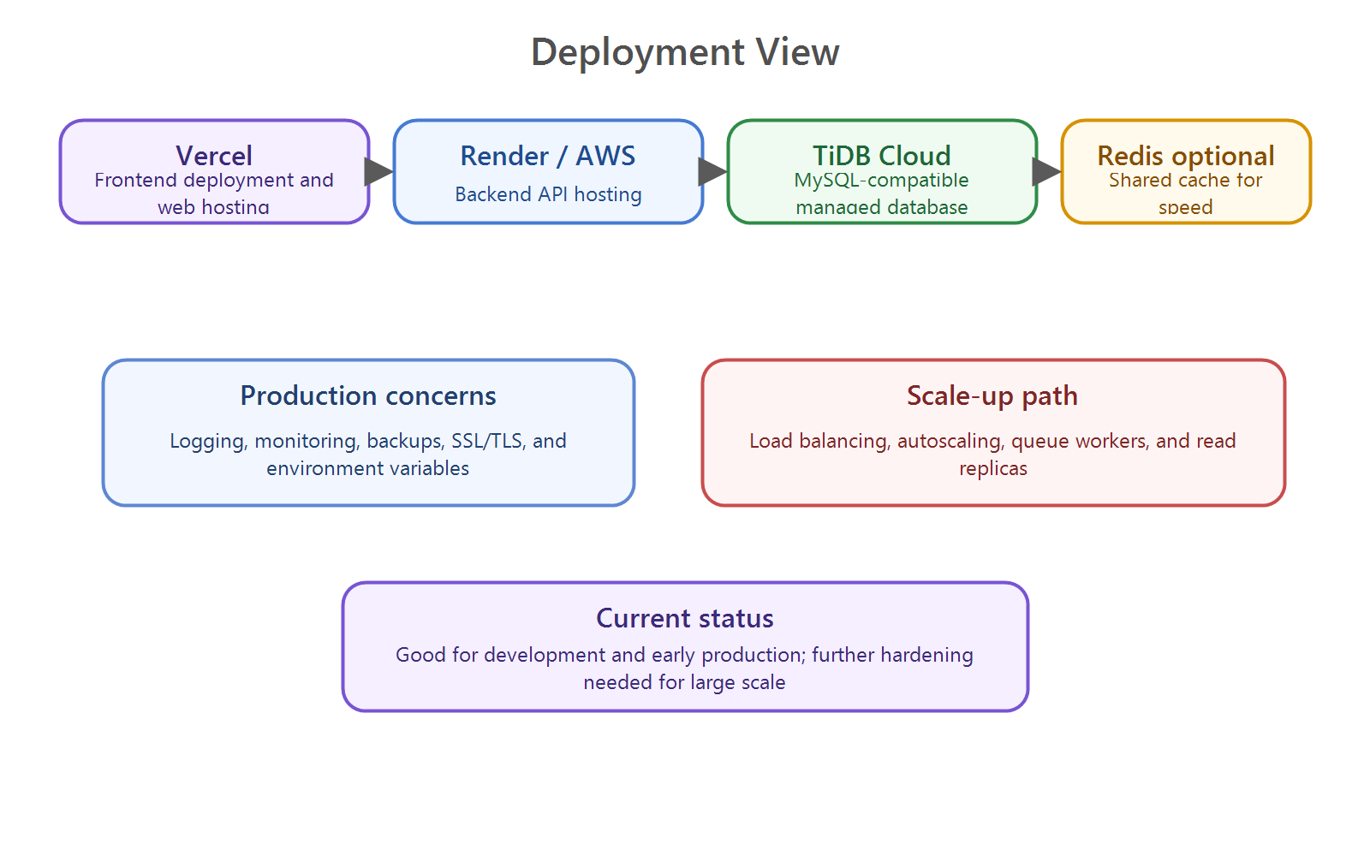
4. API Reference

The backend exposes REST endpoints for login, stock lookup, trading, portfolio views, and analytics.
Service | Recommended Provider | Alternative
Frontend CDN (Web) | Vercel (already deployed) | Netlify, Cloudflare Pages
Mobile (APK) | Expo EAS Build + Direct APK or Play Store | Firebase App Distribution
Backend API | Render (current) / AWS ECS Fargate | GCP Cloud Run, Azure Container Apps
SQL Database | TiDB Cloud (current) / AWS RDS PostgreSQL | Supabase, PlanetScale, Neon
Redis Cache | Upstash Redis / AWS ElastiCache | Redis Cloud
Object Storage | AWS S3 (reports, assets) | Cloudflare R2
Load Balancer | AWS ALB or Cloudflare | NGINX on EC2
Secrets Manager | AWS Secrets Manager / Doppler | HashiCorp Vault
Monitoring | Datadog / Grafana + Prometheus | AWS CloudWatch
Error Tracking | Sentry (mobile + backend) | Rollbar

4.1 Authentication Flow
# Dockerfile (production)
FROM python:3.11-slim
WORKDIR /app
COPY requirements.txt .
RUN pip install --no-cache-dir -r requirements.txt
COPY . .
EXPOSE 8000
CMD ["gunicorn", "main:app",
"-w", "4",
"-k", "uvicorn.workers.UvicornWorker",
"--bind", "0.0.0.0:8000"]

Users register with email and password, then receive a JWT access token after login.
Stage | Tool | Trigger
Source Control | GitHub / GitLab | Developer push
Backend CI | GitHub Actions -- lint, test, build Docker | PR to main branch
Backend CD | Push Docker image to ECR, deploy ECS | Merge to main
Frontend CI/CD | Vercel auto-deploy on Git push | Push to main
Mobile Build | Expo EAS Build (eas build --platform android) | Manual or tagged release
APK Distribution | EAS Submit or Firebase App Distribution | After successful build
DB Migrations | Alembic (FastAPI) run before deploy | Pre-deploy hook
Smoke Tests | Automated API health checks post-deploy | Post-deploy hook

Figure 5 -- Authentication & JWT Token Flow
Metric | Target | Strategy
API P95 response time | < 200ms | Load test with k6 or Locust
Concurrent users (launch) | 500 simultaneous | Horizontal scaling via ECS/Fargate
Concurrent users (scaled) | 10,000+ | Auto-scaling validation
DB query P95 | < 100ms | Read replicas, pg_stat_statements
Leaderboard refresh | < 20ms (Redis cache) | Cache hit rate > 95% target
Mobile app cold start | < 3 seconds on mid-range Android | Expo performance profiling
Stripe webhook processing | < 200ms acknowledgment | FastAPI BackgroundTasks + queue
Market data refresh | 15-min delayed, 10s UI refresh | Redis TTL + polling

4.2 Route Map
/auth handles register and login.
Risk | Likelihood | Impact | Mitigation Strategy
DB single point of failure | Medium | Critical | RDS Multi-AZ + tested failover procedure
Market data API rate limit exceeded | High | High | Redis cache (15-min TTL) + fallback data provider
Stripe webhook delivery failure | Medium | High | Idempotent handlers + automatic Stripe retry logic
JWT secret compromised | Low | Critical | Rotation policy (90 days) + immediate all-token revocation
APK on rooted device | Medium | Medium | Root detection via expo-device + warning prompt to user
DDoS on API endpoints | Medium | High | Cloudflare WAF + slowapi rate limiting per IP
SQL injection via API | Low | Critical | Mandatory ORM, parameterized queries, regular pen testing
User data breach | Low | Critical | Encryption at rest, Row-Level Security, strict access controls
Stripe payment fraud | Medium | High | Stripe Radar rules + 3DS authentication + manual review
Mobile app crash on launch | Low | High | Sentry integration + OTA hotfix + APK rollback plan

/market handles stock search, price lookup, history, benchmark data, and indices.

/portfolio handles trade execution, holdings, summary, and trade history.
- /analytics handles scores, leaderboard, and recalculation jobs.
- /health is used for uptime and deployment checks.
- 4.3 Flask Project Structure
- app/auth contains the registration and login routes and supporting logic.

app/market contains market-data fetchers and search endpoints.
- app/portfolio contains trade execution and portfolio summary logic.
- app/analytics contains leaderboard and scoring endpoints.
- app/scoring contains helper functions used by the scoring engine.
- 5. Security, Deployment, and Scale

Security is based on JWT auth, environment-based secrets, database SSL/TLS, and careful control of browser access.
- Passwords should be hashed safely, protected routes should validate JWT, and secrets should never be committed to source control.
- In production, CORS should be restricted, rate limiting should be enabled, and the app should use secure environment variables for config.
- The recommended cloud setup is Vercel for frontend, Render or AWS for backend, and TiDB Cloud or managed MySQL for the database.
- SalesTrading is ready for demos and early users today, and the next roadmap items are caching, background jobs, monitoring, backups, stronger password hashing, and autoscaling for growth.

