**PROJECT REPORT ON**

**E-SURVEYING APPLICATION**

**A PROJECT REPORT**

**ON**

**“E-SURVEYING”**

**in partial fulfillment for the award of**

**B.E**

**COMPUTER ENGINEERING**

**BY**

**A.YAMUNA SHIVANI (2451-15-733-302)**

**J.YAMINI (2451-15-733-306)**

**Under the guidance of**

**Mr. P.Phani Prasad.**

**DEPARTMENT OF COMPUTER ENGINEERING**

**M.V.S.R. ENGINEERING COLLEGE**

(Sponsored by Matrusri Educational Society &

Affiliated to Osmania University) Estd.1981

Nadergul (po), Saroornagar (m), Hyderabad, TS.

**2017-2018.**

**M.V.S.R. ENGINEERING COLLEGE**

**HYDERBAD**



**CERTIFICATE**

This is to certify the project entitled **“E-SURVEYING APPLICATION”** by the student **A.YAMUNA SHIVANI** of (2451-15-733-302) & **J.YAMINI** (2451-15-733-306) **B.E-3/4, CSE-1, 1** semester during the academic year (2017-2018). Begin Submitted in partial fulfillment for the award of “**B.E IN COMPUTER ENGINEERING” to the M.V.S.R ENGINEERING, NADERGUL, HYDERBAD,** During the Year **2017-2018.**

PROJECT GUIDE COORINATOR.

Mr. P.Phani Prasad. N.Vikram.

Asst.Prof. Asst.Prof.

CSE department. CSE department.

**ACKNOWLEDGMENT**

A project is never the outcome of a single person’s effort. It is a confluence of varied thought process harmoniously integrated into a resourceful product. I am indebted to several people for having made this project possible. In the endeavor to do this, several people have given their valuable suggestions and guidance at every step.

I express my deep sense of gratitude to the coordinator of the B.E (CSE) and for giving us an opportunity of gaining practical experience in computer programming by the introduction of the project work as a part of our syllabus.

I take this opportunity to thank our principal **DR.V.Chandra Sekhar** for her patronage, encouragement and facilities that were offered to us while carrying out motivations in making the project.

It is our pleasure to thank **MR. DR.AKHIL KARE** Headof CSE Department for his encouragement during the progress of this project work guide.

**MR.PHANI PRASAD** for his earnest effort and timely suggestions and motivated us to come out with excellent output.

We would also like to express my gratitude and sincere thanks to my internal guide: **S.AMULYA, N.VIKRAM, M V R JOYTISREE.**

Last but not the least I would like to thank my parents, indebted to, for providing me with their blessings for the faithful outcome and my friends for their support.

E-Surveying

ABSTRACT

In previous days, Surveying is difficult to do. It includes loads of paper work and man power to conduct surveys, but now a day, there are efficient and easy to use software tools to conduct surveys. This E-Surveying Application enables the user to interact with the system through Graphical User Interface (GUI). This E-Surveying Application enables user to conduct survey on any topic and This Application performs the surveying After taking the certain inputs from user.

**Guide Batch:**

P.PHANI PRASAD A. Yamuna Shivani (2451-15-733-302)

Asst.prof. CSED J.Yamini (2451-15-733-306)

Contents

CHAPTER-1 1

1.1 INTRODUCTION: 1

1.2 PROBLEM STATEMENT: 1

1.3 SCOPE: 1

1.4 OBJECTIVES: 1

CHAPTER-2 2

2.1 EXISTING SYSTEM: 2

2.2PROPOSED SYSTEM: 2

2.3 REQUIREMENTS: 2

2.3.1 FUNCTIONAL REQUIREMENTS: 2

2.3.2 NON-FUNCTIONAL REQUIREMENTS: 3

CHAPTER-3 4

3 SYSTEM DESIGN: 4

3.1: SYSTEM ARCHITECTURE 4

3.2: MODULES: 4

3.3 DATA FLOW DIAGRAM: 5

3.4 UML DIAGRAMS: 5

3.4.1 USECASE DIAGRAM: 5

3.4.2 ACTIVITY DIAGRAM: 6

3.4.3 SEQUENCE DIAGRAM: 6

CHAPTER-4………………………………………………………………………………………………………………………………………

4.1 IMPLEMENTATION………………………………………………………………………………………………………………….

4.2 SCREEN SHOTS………………………………………………………………………………………………………………………

CHAPTER-5………………………………………………………………………………………………………………………………………

5.1 CONCLUSION……………………………………………………………………………………………………………………..

5.2 FUTURE ENHANCEMENT……………………………………………………………………………………………………..

REFERENCES……………………………………………………………………………………………………………………………….

## 

s**CHAPTER-1**

## 1.1 INTRODUCTION:

The Application “E-Surveying” helps the user to conduct surveys

# 1.2 PROBLEM STATEMENT:

Program to create a GUI Application which takes input from user and compute the result on the console.

This Application is fruitful to conduct surveys and view the result very easily via a Graphical User Interface.

## 1.3 SCOPE:

This Application is an attempt to provide an environment that is convenient and efficient way to conducting a survey program to choose a option towards number of options.

## 1.4 OBJECTIVES:

The Goal of this Application is to interact with the system through Graphical User Interface (GUI).

Enable the Administrator to enter a time limit for voting program to continue.

Enable the Administrator to enter a list of options.

Enable the Administrator to start the survey.

Enable the voter to cast his vote to the option he wishes to.

Enable the Administrator to view the results.

Enable the Administrator to save the voting results for future reference.

## CHAPTER-2

## 2.1 EXISTING SYSTEM:

Disadvantages:

In Existing System there is no such efficient and easy to use software to conduct surveys through opting procedure. The Existing system involves loads of paper work and man power to conduct as well as to analyze and calculate the results.

## 2.2PROPOSED SYSTEM:

Advantages:

The proposed system enables the user to:

* Interact through Graphical User Interface (GUI).
* Enable the Administrator to enter a time limit for voting program to continue.
* Enable the Administrator to enter a list of options.
* Enable the Administrator to start the survey.
* Enable the voter to cast his vote to the option he wishes to.
* Enable the Administrator to view the results.
* Enable the Administrator to save the voting results for future reference

## 

## 2.3 REQUIREMENTS:

## 2.3.1 FUNCTIONAL REQUIREMENTS:

In Software Engineering, a functional requirement defines a function of a software system or its components. A function is described as a set of inputs, the behavior and outputs. Functional requirements may be calculations, technical detail, data manipulations and processing and other specific functionality that define what a system is supposed to accomplish. Behavioral requirements describing all the cases where the system uses the functional requirements are captured in use cases. Functional requirements are supposed by non-functional.

The Administrator should be able to set a name for the surveying.

The Administrator should be able to set the number of options for the survey.

The Administrator should be able to set the time duration to conduct survey.

The Administrator should be able to enter the names of the options for surveying.

The Administrator should be asked to enter the usernameand password before starting the surveying.

The System should verify the username and password to match the correct ones.

The voter should able to view all the options.

The voters should be able to vote for one of the option.

The System should record each vote the voter has casted.

The system should check for duration of Survey.

The system should stop survey if duration has been completed.

The System should analyze the votes against each option and calculate results.

The system should display the results.

The user should able to save the results.

## 2.3.2 NON-FUNCTIONAL REQUIREMENTS:

A Non functional requirement is a requirement that specify the criteria that can be used to judge the operation of the system, rather than specific behaviors. Whereas Non Functional requirements define how a system is supposed to be. Non Functional requirements often called qualities of a system.

Maintainability: This project will be well documented including design activities hence supporting maintainability.

Security:The Application enforces security at many different concerns, such as hiding the backend details from the user.

Performance:The response time utilization and throughput behavior of the system will be accurate.

Usability:The Application is developed such that it does not involve much training for the end users or the administrator.

Portability:The Application can run under different computing environments. The environment types can be either hardware or software, but is usually a combination of two.

Reusability:The application can be reused a number of times without any technical difficulties.

### CHAPTER-3

### 3.0 SYSTEM DESIGN:

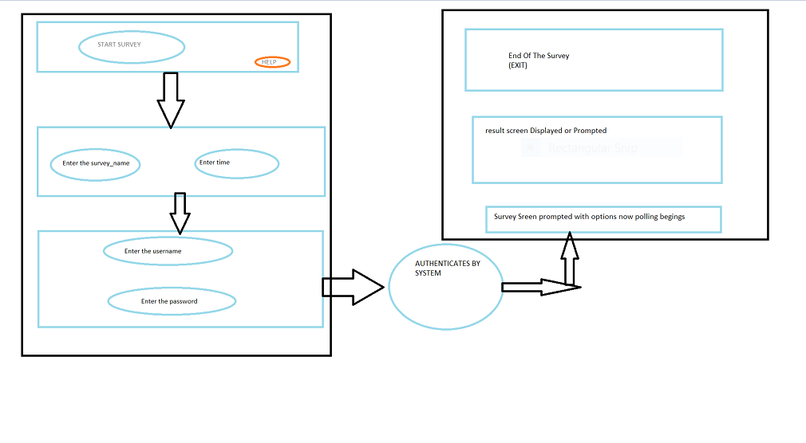

Fig.3.0.1 System Design.

### 3.1: SYSTEM ARCHITECTURE

One-Tier architecture involves putting all of the required components for a software application or technology on a single server or a platform. This kind of architecture is often contrasted with multi tiered Architecture of the three tier Architecture that used for some web applications and other technologies where various presentation, business and data access layer are housed separately. One tier architecture is also known as single tier architecture

Basically, a one tier Architecture keeps all of the elements of an application, including the interface, middleware and back end data, in one place. Developers see these types of system as the simplest and the most direct.

### 3.2 DATA FLOW DIAGRAM:

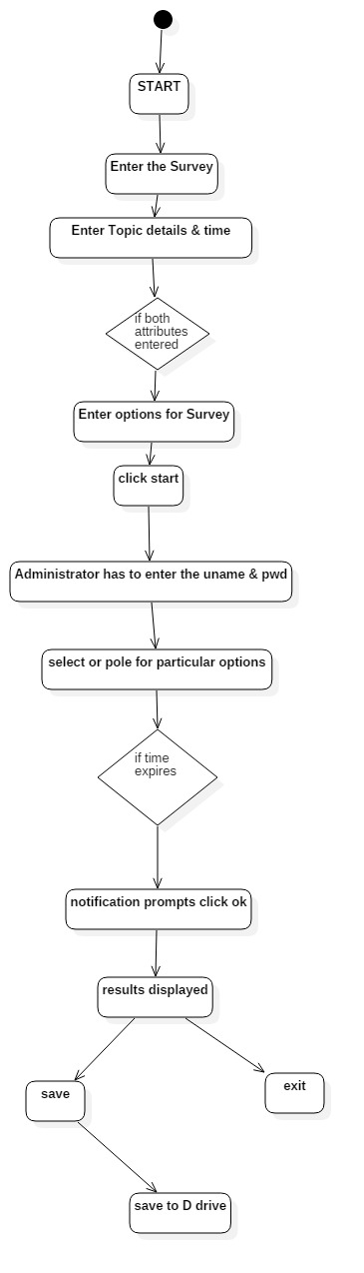

Fig.3.2.1 Dataflow Diagram.

### 3.3 UML DIAGRAMS:

### 3.3.1 USECASE DIAGRAM:

Use case diagrams are set of use cases, actors and their relationships. They represent the use case view of a system. A use case represents a particular functionality of a system. So use case diagram is used to describe relationships among the functionalities and their internal/external controllers. These controllers are known as actors.

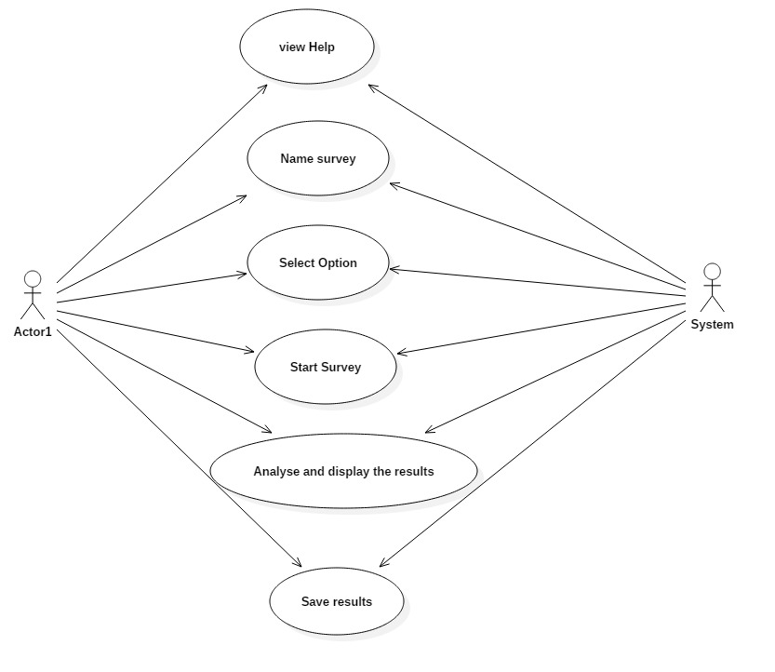

Fig.3.3.1.1 Use Case Diagram.

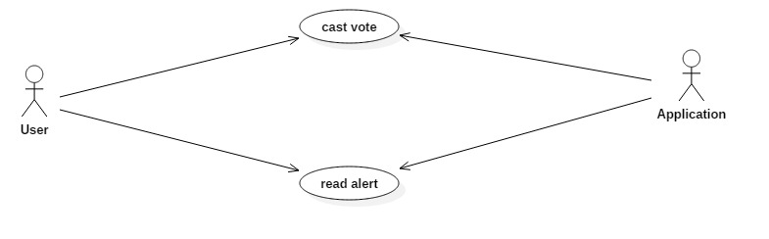

Fig.3.3.1.2 use case diagram.

### 3.3.2 ACTIVITY DIAGRAM:

Activity Diagram describes the flow of control in a system. So it consists of activities and links. The flow can be sequential, concurrent and branched. Activities are nothing but the functions of a system. Numbers of activity diagrams are prepared to capture the entire flow in a system. Activity diagrams are used to visualize the flow of controls in a system. This is prepared to have an idea of how the system will work when executed.



Fig.3.3.2.1 Activity Diagram.

### 3.3.3 SEQUENCE DIAGRAM:

A Sequence Diagram is an interaction diagram.From the name is clear that the diagram deals with some sequences, which are the sequence of messages flowing from one object to another. Interaction among the component of a system is very important from implementation and execution perspectives Sequence diagram is used to visualize the sequence of calls in a system to perform a specific functionality.

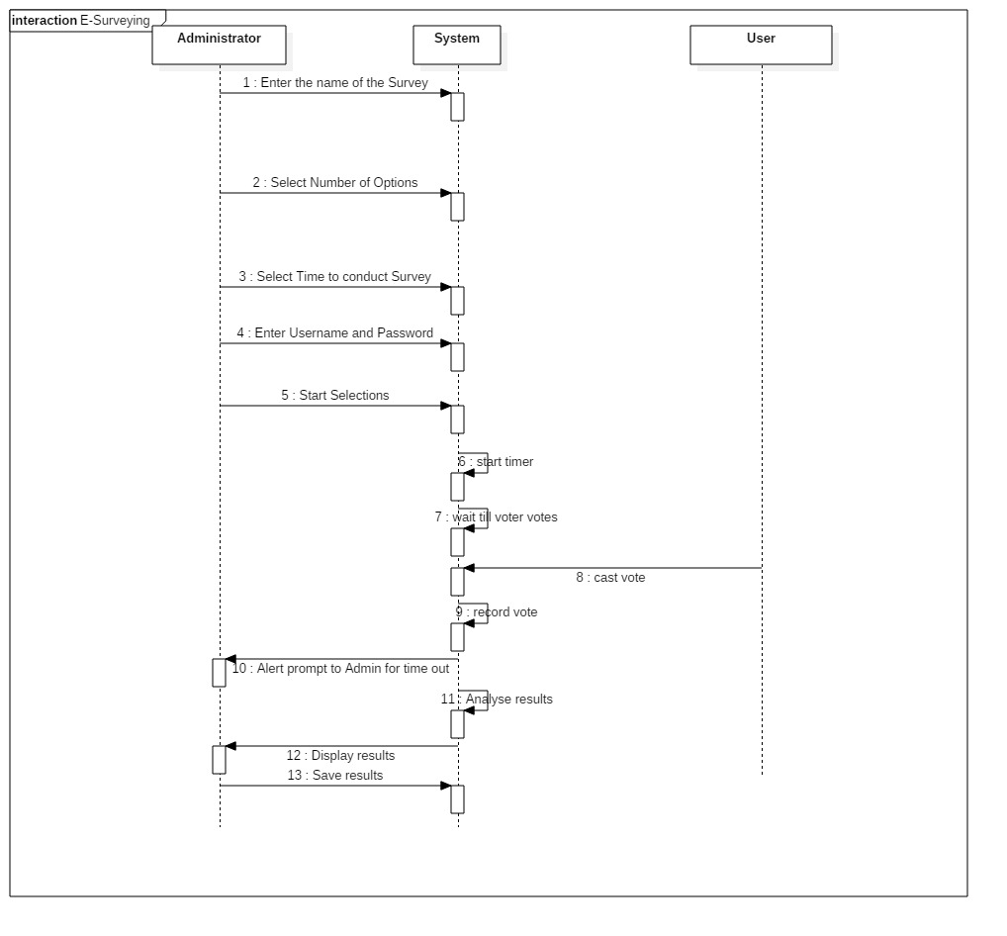

Fig.3.3.3.1 Sequence Diagram.

#### CHAPTER-4

#### 4. IMPLEMENTATION:

#### 4.1 JAVA CODE:

Import java.awt.*;

Import java.awt.event.*;

Import java.applet.*;

Import java.util.*;

Import javax.swing.*;s

Import java.io.*;

Import java.text.SimpleDateFormat;

Class eSurveying extends JFrame implements Runnable , ActionListener

{

Static int height=500, width=500;

Panel p1=new Panel();

Panel p2=new Panel();

Panel p3=new Panel();

Panel p4=new Panel();

Panel p5=new Panel();

Panel p6=new Panel();

Panel p7=new Panel();

Panel p8=new Panel();

Panel p9=new Panel();

FileWriter fw;

Thread t1,t2,t3;

int noo=0,hrs,mins,index,time,winnervotes,tie;

boolean timer=false,votingstarted=false;

String date = "yyyy-MM-dd HH:mm:ss";

String options []=new String[100];

String tieoptions[]=new String[100];

String winnername=new String("");

String purpose=new String("");

String detail="";

String helptext="How to use this application\n\n*Click on Start survey button.\n* Enter the topic you want to survey for.\n* Enter the duration of survey to be conducted in hours minutes format.\n* Enter all options you desire.\n* Enter the user name and password given to you by the programmer.\n* Now the survey starts.\n* The participants can now cast their respective votes of their choice.\n* Once the time duration of the survey completes, results are declared.\n* You can save the result into a text file if you desire by clicking the save button.";

char waitsymbols[]={'|','/','-','\\'};

int votes[]=new int[100];

String result=new String("The");

int i=0;

JLabel jl1=new JLabel("e-Survey");

JLabel jl2=new JLabel("");

JLabel jl3=new JLabel("Duration to conduct survey: ");

JLabel jl4=new JLabel("Enter the topic detail: ");

JLabel jl5=new JLabel("Enter viable options for surveying: ");

JLabel jl6=new JLabel("User name: ");

JLabel jl7=new JLabel("Password: ");

JLabel jl8=new JLabel("Click on any one of the following options to record your opinion");

JLabel jl9=new JLabel("Congratulations! Survey completed. Results are as per the following.");

JLabel jl10=new JLabel("Enter name of the survey:");

JLabel jl11=new JLabel("");

JButton jb1=new JButton("Start Survey");

JButton jb2=new JButton("Help");

JButton jb3=new JButton("Next");

JButton jb4=new JButton("Start");

JButton jb5=new JButton("Start Survey");

JButton jb6=new JButton("Start Survey");

JButton jb7=new JButton("Save Result");

JButton jb8=new JButton("Exit");

JButton jb9=new JButton("Add option");

JTextField jtf1=new JTextField("");

JTextField jtf2=new JTextField("");

JTextField jtf3=new JTextField("");

JTextField jtf4=new JTextField("");

JTextField jtf5=new JTextField("");

JPasswordField jtf6=new JPasswordField("");

JTextField jtf7=new JTextField("");

JTextArea jta1=new JTextArea();

JTextArea jta2=new JTextArea();

JRadioButton optionlist[]=new JRadioButton[100];

ButtonGroup group=new ButtonGroup();

Dimension size;

Insets insets;

boolean loading=true,valid=true;

eSurveying()

{

super("e-Surveying");

add(p1);

p1.setLayout(null);

p2.setLayout(null);

p3.setLayout(null);

p4.setLayout(null);

p5.setLayout(null);

p6.setLayout(null);

p7.setLayout(null);

p8.setLayout(null);

p9.setLayout(null);

insets=p1.getInsets();

t1=new Thread(this);

t2=new Thread(this);

t3=new Thread(this);

t1.start();

for(int i=0;i<100;i++)

options[i]="";

size=jl1.getPreferredSize();

jl1.setBounds(insets.left+170,insets.top+10,size.width+200,size.height+30);

jl1.setFont(new Font("Serif",Font.BOLD,30));

jl1.setForeground(Color.magenta);

p1.add(jl1);

size=jl2.getPreferredSize();

jl2.setBounds(170,insets.top+200,size.width+200,size.height+30);

jl2.setFont(new Font("Serif",Font.BOLD,40));

insets=p2.getInsets();

size=jb1.getPreferredSize();

jb1.setBounds(insets.left+150,insets.top+150,size.width,size.height);

jb1.addActionListener(this);

jb1.setActionCommand("start survey");

size=jb2.getPreferredSize();

jb2.setBounds(insets.left+173,insets.top+210,size.width+4,size.height);

jb2.addActionListener(this);

jb2.setActionCommand("help");

insets=p3.getInsets();

size=jl10.getPreferredSize();

jl10.setBounds(insets.left+20,insets.top+110,size.width+100,size.height);

size=jtf7.getPreferredSize();

jtf7.setBounds(insets.left+200,insets.top+110,size.width+150,size.height);

size=jl3.getPreferredSize();

jl3.setBounds(insets.left+20,insets.top+165,size.width+100,size.height);

size=jtf1.getPreferredSize();

jtf1.setBounds(insets.left+200,insets.top+140,size.width+250,size.height);

size=jl4.getPreferredSize();

jl4.setBounds(insets.left+20,insets.top+140,size.width+150,size.height);

size=jtf2.getPreferredSize();

jtf2.setBounds(insets.left+200,insets.top+165,size.width+30,size.height);

jtf2.setText("h");

size=jtf3.getPreferredSize();

jtf3.setBounds(insets.left+240,insets.top+165,size.width+30,size.height);

jtf3.setText("mm");

jtf3.addActionListener(this);

jtf3.setActionCommand("next");

size=jb3.getPreferredSize();

jb3.setBounds(insets.left+150,insets.top+205,size.width+4,size.height);

jb3.setActionCommand("next");

jb3.addActionListener(this);

insets=p4.getInsets();

size=jl5.getPreferredSize();

jl5.setBounds(insets.left+00,insets.top+100,size.width+150,size.height);

size=jtf4.getPreferredSize();

jtf4.setBounds(insets.left+210,insets.top+100,size.width+250,size.height);

jtf4.setActionCommand("add option");

jtf4.addActionListener(this);

size=jb4.getPreferredSize();

jb4.setBounds(insets.left+230,insets.top+160,size.width,size.height);

jb4.setActionCommand("added option");

jb4.addActionListener(this);

size=jb9.getPreferredSize();

jb9.setBounds(insets.left+110,insets.top+160,size.width,size.height);

jb9.setActionCommand("add option");

jb9.addActionListener(this);

insets=p5.getInsets();

size=jl6.getPreferredSize();

jl6.setBounds(insets.left+130,insets.top+100,size.width+50,size.height);

size=jtf5.getPreferredSize();

jtf5.setBounds(insets.left+200,insets.top+100,size.width+100,size.height);

size=jl7.getPreferredSize();

jl7.setBounds(insets.left+130,insets.top+140,size.width+100,size.height);

size=jtf6.getPreferredSize();

jtf6.setBounds(insets.left+200,insets.top+140,size.width+100,size.height);

jtf6.setActionCommand("start surveying");

jtf6.addActionListener(this);

jtf6.setEchoChar('*');

size=jb5.getPreferredSize();

jb5.setBounds(insets.left+160,insets.top+200,size.width ,size.height);

jb5.setActionCommand("start surveying");

jb5.addActionListener(this);

insets=p6.getInsets();

size=jl8.getPreferredSize();

jl8.setBounds(5,insets.top+60,size.width+500,size.height);

insets=p8.getInsets();

size=jta2.getPreferredSize();

jta2.setBounds(insets.left+10,insets.top+100,width-35,height-250);

jta2.setText(helptext);

jta2.setEditable(false);

size=jb6.getPreferredSize();

jb6.setBounds(insets.left+160,400,size.width,size.height);

jb6.setActionCommand("start surveying from help");

jb6.addActionListener(this);

insets=p9.getInsets();

size=jl9.getPreferredSize();

jl9.setBounds(7,75,size.width,size.height);

insets=p9.getInsets();

size=jta1.getPreferredSize();

jta1.setBounds(10,100,width-35,height-250);

jta1.setText(result);

jta1.setEditable(false);

size=jb7.getPreferredSize();

jb7.setBounds(insets.left+100,400,size.width,size.height);

jb7.addActionListener(this);

jb7.setActionCommand("save");

size=jb8.getPreferredSize();

jb8.setBounds(insets.left+230,400,size.width,size.height);

jb8.addActionListener(this);

jb8.setActionCommand("exit");

}

public void run()

{

if(loading)

{

try

{

for(int i=1;i<=4;i++)

{

for(int j=0;j<4;j++)

{

jl2.setText(" "+waitsymbols[j]+" "+waitsymbols[j]+" "+waitsymbols[j]+" "+waitsymbols[j]);

p1.add(jl2);

t1.sleep(200);

}

}

}

catch (Exception e){}

loading=false;

jl2.setVisible(false);

remove(p1);

add(p2);

p2.setSize(height,width);

p2.add(jl1);

p2.add(jb1);

p2.add(jb2);

}

if(timer)

{

try

{

Thread.sleep(time);

timeout();

}

catch (Exception e){}

}

}

void timeout()

{

/*for(int i=0;i<noo;i++)

optionlist[i].setEnabled(false);*/

JOptionPane.showMessageDialog(this,"No more voting!! Voting time exhausted.","Time up",JOptionPane.INFORMATION_MESSAGE);

for(int i=0;i<noo;i++)

{

if(votes[i]>winnervotes)

{

winnervotes=votes[i];

winnername=options[i];

}

}

for(int i=0;i<noo;i++)

{

if(votes[i]==winnervotes)

{

tie++;

}

}

if(tie>1)

{

int j=0;

JOptionPane.showMessageDialog(this,"There is a tie between "+tie+" options","Tie",JOptionPane.INFORMATION_MESSAGE);

for(int i=0;i<noo;i++)

{

if(votes[i]==winnervotes)

{

tieoptions[j++]=options[i];

}

}

result+="re is a tie between "+tie+" options ";

for(int i=0;i<tie;i++)

{

if(i<tie-1)

result+=tieoptions[i]+", ";

else

result+=tieoptions[i]+" each";

}

}

else

{

result="The most voted option is "+winnername;

}

if(winnervotes==1)

result+=" with "+winnervotes+" vote.\n\nNumber of votes casted for each option are\n\n";

else

result+=" with "+winnervotes+" votes.\n\nNumber of votes casted for each option are\n\n";

for(int i=0;i<noo;i++)

{

result+=options[i]+"\t"+votes[i]+"\n";

}

remove(p6);

remove(p7);

add(p9);

jta1.setText(result);

p9.setSize(height,width);

p9.add(jl1);

p9.add(jl9);

p9.add(jta1);

p9.add(jb7);

p9.add(jb8);

}

public void actionPerformed(ActionEvent ae)

{

if(ae.getActionCommand().equals("start survey"))

{

jb1.setVisible(false);

jb2.setVisible(false);

remove(p2);

add(p3);

p3.setSize(height,width);

p3.add(jl1);

p3.add(jl10);

p3.add(jtf7);

p3.add(jl3);

p3.add(jl4);

p3.add(jtf1);

p3.add(jtf2);

jtf2.setToolTipText("hours");

p3.add(jtf3);

jtf3.setToolTipText("minutes");

p3.add(jb3);

}

if(ae.getActionCommand().equals("next"))

{

if((!jtf7.getText().equals(""))&&(!jtf1.getText().equals(""))&&(!jtf2.getText().equals(""))&&(!jtf3.getText().equals("")))

{

purpose=jtf7.getText();

detail=jtf1.getText();

try

{

hrs = Integer.parseInt(jtf2.getText());

mins = Integer.parseInt(jtf3.getText());

}

catch (Exception e)

{

}

valid=true;

if(hrs<0)

{

JOptionPane.showMessageDialog(this,"Hours value should be atleast 0","Error",JOptionPane.ERROR_MESSAGE);

valid=false;

}else

if(mins<1)

{

JOptionPane.showMessageDialog(this,"Survey should be scheduled for atleast 1 minute","Error",JOptionPane.ERROR_MESSAGE);

valid=false;

}

if(valid)

{

try

{

hrs = Integer.parseInt(jtf2.getText());

mins = Integer.parseInt(jtf3.getText());

mins=mins+(hrs*60);

time=(mins*60)*1000;

remove(p3);

add(p4);

p4.setSize(height,width);

p4.add(jl1);

p4.add(jl5);

p4.add(jb4);

p4.add(jtf4);

p4.add(jb9);

}

catch(Exception e)

{

JOptionPane.showMessageDialog(this,"Please specify appropriate values","Error",JOptionPane.ERROR_MESSAGE);

}

}

}

else

JOptionPane.showMessageDialog(this,"Please specify appropriate values for each field","Error",JOptionPane.ERROR_MESSAGE);

}

if(ae.getActionCommand().equals("add option"))

{

if(jtf4.getText().equals(""))

{

JOptionPane.showMessageDialog(this,"Please specify an option","Alert",JOptionPane.INFORMATION_MESSAGE);

}

else

{

boolean matched=false;

for(int i=0;i<noo;i++)

{

if(options[i].equals(jtf4.getText()))

{

matched=true;

JOptionPane.showMessageDialog(this,"Option already exists!!","Alert",JOptionPane.INFORMATION_MESSAGE);

}

}

if(!matched)

{

options[index++]=jtf4.getText();

jtf4.setText("");

noo++;

}

}

}

if(ae.getActionCommand().equals("added option"))

{

if(noo<2)

JOptionPane.showMessageDialog(this,"There should be atleast 2 options to survey","Error",JOptionPane.ERROR_MESSAGE);

else

{

JOptionPane.showMessageDialog(this," "+noo+" options successfully added to survey","Alert",JOptionPane.INFORMATION_MESSAGE);

remove(p4);

add(p5);

p5.setSize(height,width);

p5.add(jl1);

p5.add(jl6);

p5.add(jtf5);

p5.add(jl7);

p5.add(jtf6);

p5.add(jb5);

}

}

if(ae.getActionCommand().equals("start surveying"))

{

if(jtf5.getText().equals("admin") && jtf6.getText().equals("admin"))

{

JOptionPane.showMessageDialog(this,"You are about to start survey for "+purpose,"Alert",JOptionPane.INFORMATION_MESSAGE);

timer=true;

t2.start();

votingstarted=true;

remove(p5);

add(p6);

p6.setSize(height,width);

insets=p6.getInsets();

size=p7.getPreferredSize();

p7.setBounds(insets.left,insets.top+90,500,height-100);

p6.add(p7);

insets=p7.getInsets();

for(i=0;i<noo;i++)

{

optionlist[i]=new JRadioButton(options[i]);

group.add(optionlist[i]);

optionlist[i].setToolTipText("Record my vote towards "+options[i]);

p6.add(jl1);

jl8.setText("Click on any one of the following options to cast your vote for "+purpose+".");

jl11.setText(detail);

jl11.setFont(new Font("Serif",Font.BOLD,15));

size=jl11.getPreferredSize();

jl11.setBounds(5,5,500,size.height);

p6.add(jl8);

size=optionlist[i].getPreferredSize();

optionlist[i].setBounds(insets.left,(i*size.height)+35,width-15,size.height);

p7.add(jl11);

p7.add(optionlist[i]);

optionlist[i].setActionCommand(options[i]);

optionlist[i].setFont(new Font("Serif",Font.BOLD,15));

optionlist[i].addActionListener(new ActionListener()

{

public void actionPerformed(ActionEvent ae)

{

for(int j=0;j<noo;j++)

{

if(ae.getActionCommand().equals(options[j]))

{

votes[j]+=1;

JOptionPane.showMessageDialog(new eSurveying(),"Your vote is recorded succesfully!","Alert",JOptionPane.INFORMATION_MESSAGE);

}

}

for(int j=0;j<noo;j++)

{

optionlist[j].setSelected(false);

}

/*for(int j=0;j<noo;j++)

System.out.print(" "+votes[j]);

System.out.print("\n\n");*/

}

});

}

}

else

{

JOptionPane.showMessageDialog(this,"Entered user name or password are incorrect","Alert",JOptionPane.ERROR_MESSAGE);

}

}

if(ae.getActionCommand().equals("help"))

{

remove(p2);

add(p8);

p8.setSize(height,width);

p8.add(jl1);

p8.add(jta2);

p8.add(jb6);

}

if(ae.getActionCommand().equals("start surveying from help"))

{

remove(p8);

add(p3);

add(p3);

p3.setSize(height,width);

p3.add(jl1);

p3.add(jl10);

p3.add(jtf7);

p3.add(jl3);

p3.add(jl4);

p3.add(jtf1);

p3.add(jtf2);

jtf2.setToolTipText("hours");

p3.add(jtf3);

jtf3.setToolTipText("minutes");

p3.add(jb3);

}

if(ae.getActionCommand().equals("save"))

{

Calendar cal = Calendar.getInstance();

SimpleDateFormat sdf = new SimpleDateFormat(date);

date=sdf.format(cal.getTime());

date=date.replace(" ","_");

date=date.replace("-","");

date=date.replace(":","");

try

{

result+="\n Results for "+purpose+" survey held on "+date;

String filename="D:/survey_"+purpose+"_"+date+".txt";

fw=new FileWriter(filename);

char buffer[]=new char[result.length()];

result.getChars(0,result.length(),buffer,0);

fw.write(buffer);

fw.close();

JOptionPane.showMessageDialog(this,"Result recorded succesfully as "+"D:/survey_"+purpose+"_"+date+".txt","Alert",JOptionPane.INFORMATION_MESSAGE);

}

catch (Exception e)

{

System.out.println(e);

JOptionPane.showMessageDialog(this,"Sorry! Could not save data to file.","Error",JOptionPane.INFORMATION_MESSAGE);

}

}

if(ae.getActionCommand().equals("exit"))

{

System.exit(0);

}

}

public static void main(String[] args)

{

System.out.println("Welcome to e-Surveying");

eSurveying esurveying=new eSurveying();

esurveying.setSize(height,width);

esurveying.setVisible(true);

//esurveying.setResizable(false);

esurveying.setDefaultCloseOperation(JFrame.EXIT_ON_CLOSE);

}}

#### 4.2 SCREEN SHOTS:

**SCREENSHOTS FOR E-SURVEYING:**

* **Start Screen**

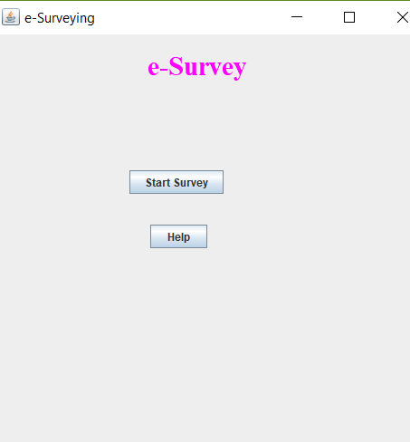

Fig.4.2.1 Start Screen

s

* **Help Screen**

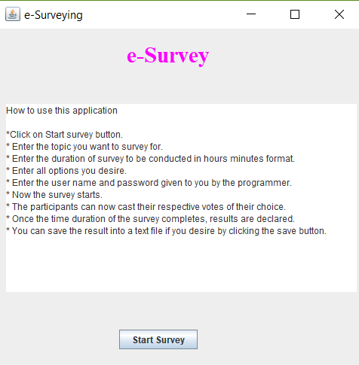

Fig.4.2.2 Help Screen

* **Starting with Survey**

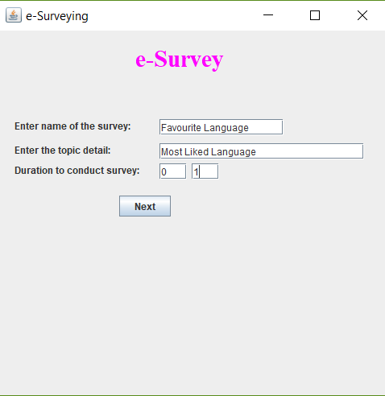

Fig4.2.3 Starting with Survey

* **Adding Options.**

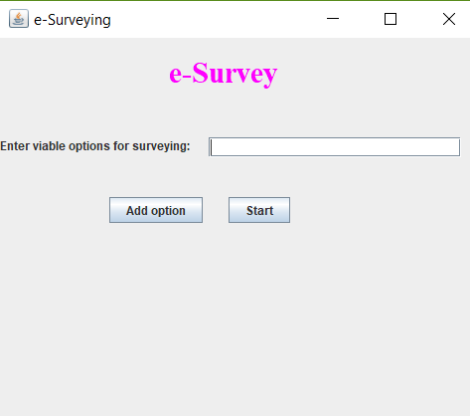

Fig.4.2.4 Adding Options.

**Prompt for User Name and Password.**

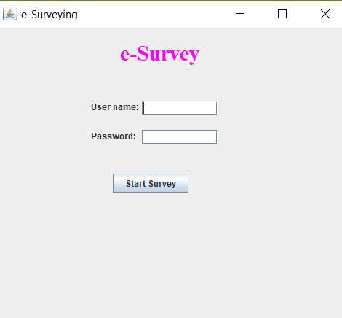

Fig4.2.5 Prompt for User Name and Password.

* **The Survey Screen when the vote is casted.**

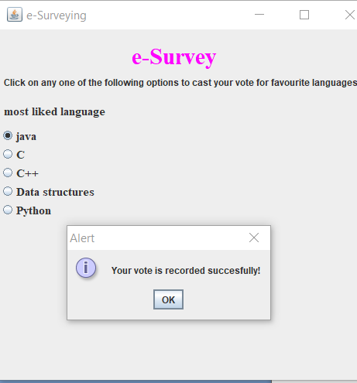

Fig4.2.6. the Survey Screen when the vote is casted.

* **Time out Screen.**

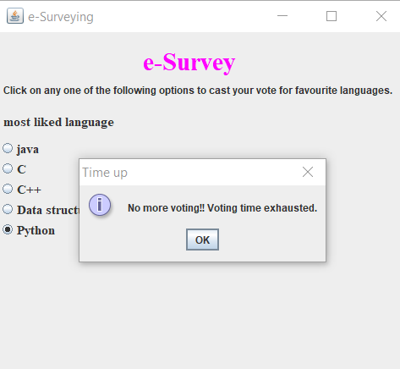

Fig.4.2.7 Time out Screen.

* **Results screens**

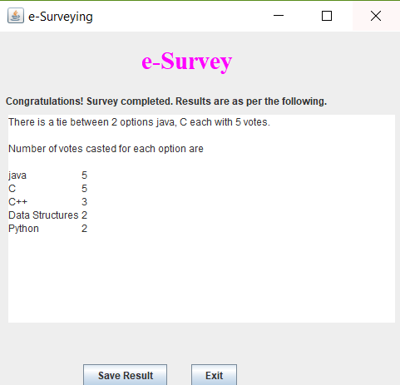

Fig4.2.8 Results screens.

##### 5. CONCLUSION:

##### 5.1 CONCLUSION:

We have developed the application “e-Surveying” that lets its users to interact with polling way of Surveying on any particular topic Here Administration is taken care by attempting the polling.

##### 5.2 FUTURE ENHANCEMENT:

In Future we may make the application so that it can incorporate online voting of users.etc.

###### **REFERENCES:**

We have used all of these resources in developing the application “e-Survey”

1. Sun Microsystems

2. [http://www.java.com/en/]

3. [[http://www.oracle.com/technetwork/java /index.html](http://www.oracle.com/technetwork/java%20/index.html)]

4. Java complete reference by Herbert Schildt.

5. [www.javaranch.com]s