
A Project Report
on

PHONE DIRECTORY APPLICATION

Submitted in partial fulfilment of requirements for the award of the course
of
CGB1122 – DATA STRUCTURES

Under the guidance of

Mrs.S.RAMYA,M.E.,(Ph.D)

Assistant Professor,Department of Artificial Intelligence

Submitted By
YAMUNA DEVI G (927624BAD124)

DEPARTMENT OF FRESHMAN ENGINEERING

M.KUMARASAMY COLLEGE OF ENGINEERING
(Autonomous)
KARUR – 639 113
MAY 2025

M. KUMARASAMY COLLEGE OF ENGINEERING
(Autonomous Institution affiliated to Anna University, Chennai)

KARUR – 639 113

BONAFIDE CERTIFICATE

Certified that this project report on “MESSAGE QUEUE SYSTEM” is the bonafide work of YAMUNA DEVI G (927624BAD124) who carried out the project work during the academic year 2024- 2025 under my supervision.

Signature | Signature
Mrs.S.RAMYA,M.E.,(Ph.D., ) | Dr. K.CHITIRAKALA, M.Sc., M.Phil.,Ph.D.,
SUPERVISOR, | HEAD OF THE DEPARTMENT,
Department of Artificial intelligence , | Department of Freshman Engineering,
M. Kumarasamy College of Engineering, | M. Kumarasamy College of Engineering,
Thalavapalayam, Karur -639 113. | Thalavapalayam, Karur -639 113.

Submitted for the End Semester Review held on __________________________
DEPARTMENT OF ARTIFICIAL INTELLIGENCE AND DATA SCIENCE

VISION OF THE INSTITUTION
To emerge as a leader among the top institutions in the field of technical education
MISSION OF THE INSTITUTION
- Produce smart technocrats with empirical knowledge who can surmount the global challenges
- Create a diverse, fully-engaged, learner-centric campus environment to provide quality education to the students
- Maintain mutually beneficial partnerships with our alumni, industry, and Professional associations
VISION OF THE DEPARTMENT
To produce competent industry relevant education, skillful research, technical and innovative computer science professionals acquaintance with managerial skills, human and social values.
MISSION OF THE DEPARTMENT
- To impart technical knowledge through innovative teaching, research, and consultancy.
- To develop and to promote student ability thereby to compete globally through excellence in education.
- To facilitate the development of academic-industry Collaboration.
- To produce competent engineers with professional ethics, technical competence and a spirit of innovation and managerial skills.
PROGRAM EDUCATIONAL OBJECTIVES (PEOs)
PEO 1: To acquire technical knowledge and proficiency required for the employment and higher education in the contemporary areas of computer science or management studies.
PEO 2: To apply their competency in design and development of innovative solutions for real-world problems.
PEO 3: To demonstrate leadership qualities with high ethical standards and collaborated with other industries for the socio-economical growth of the country.
PROGRAM OUTCOMES (POs)
Engineering students will be able to:
- Engineering knowledge: Apply the knowledge of mathematics, science, engineering fundamentals, and an engineering specialization to the solution of complex engineering problems.
- Problem analysis: Identify, formulate, review research literature, and analyze complex engineering problems reaching substantiated conclusions using first principles of mathematics, natural sciences, and engineering sciences.
- Design/development of solutions: Design solutions for complex engineering problems and design system components or processes that meet the specified needs with appropriate consideration for the public health and safety, and the cultural, societal, and environmental considerations.
- Conduct investigations of complex problems: Use research-based knowledge and research methods including design of experiments, analysis and interpretation of data, and synthesis of the information to provide valid conclusions.
- Modern tool usage: Create, select, and apply appropriate techniques, resources, and modern engineering and IT tools including prediction and modeling to complex engineering activities with an understanding of the limitations.
- The engineer and society: Apply reasoning informed by the contextual knowledge to assess societal, health, safety, legal and cultural issues and the consequent responsibilities relevant to the professional engineering practice.
- Environment and sustainability: Understand the impact of the professional engineering solutions in societal and environmental contexts, and demonstrate the knowledge of, and need for sustainable development.
- Ethics: Apply ethical principles and commit to professional ethics and responsibilities and norms of the engineering practice.
- Individual and team work: Function effectively as an individual, and as a member or leader in diverse teams, and in multidisciplinary settings.
- Communication: Communicate effectively on complex engineering activities with the engineering community and with society at large, such as, being able to comprehend and write effective reports and design documentation, make effective presentations, and give and receive clear instructions.

- Project management and finance: Demonstrate knowledge and understanding of the engineering and management principles and apply these to one’s own work, as a member and leader in a team, to manage projects and in multidisciplinary environments.
- Life-long learning: Recognize the need for, and have the preparation and ability to engage in independent and life-long learning in the broadest context of technological change.

PROGRAM SPECIFIC OUTCOMES (PSOs)
- PSO1: Ability to apply the analytical and business skills to provide sustainable solutions as an engineer/researcher for the real-time applications using Machine Learning, Internet of Things and Data analytics.
- PSO2: Ability to practice ethical and human values with soft-skills qualities in computer science and business disciplines to emerge as an entrepreneur for the growth and development of the society.

ABSTRACT

A Message Queue System is a fundamental component in distributed systems and concurrent computing, facilitating asynchronous communication between processes or services. In the context of data structures, a message queue is typically implemented using linked lists, arrays, or circular buffers, and follows the First-In-First-Out (FIFO) principle. This system enables decoupling of producers and consumers, improving system scalability, fault tolerance, and responsiveness. The abstract data type (ADT) behind a message queue allows for efficient enqueue and dequeue operations, ensuring ordered message delivery. This paper explores the design, implementation, and performance characteristics of message queue systems, emphasizing their critical role in real-time data processing, task scheduling, and inter-process communication.

ABSTRACT WITH POs AND PSOs MAPPING
ABSTRACT | POs MAPPED | PSOs MAPPED
A Message Queue System is a fundamental component in distributed systems and concurrent computing, facilitating asynchronous communication between processes or services. In the context of data structures, a message queue is typically implemented using linked lists, arrays, or circular buffers, and follows the First-In-First-Out (FIFO) principle. This system enables decoupling of producers and consumers, improving system scalability, fault tolerance, and responsiveness. The abstract data type (ADT) behind a message queue allows for efficient enqueue and dequeue operations, ensuring ordered message delivery. This paper explores the design, implementation, and performance characteristics of message queue systems, emphasizing their critical role in real-time data processing, task scheduling, and inter-process communication. | PO1(2)  PO2(3)  PO3(2)  PO4(2)  PO5(3)  PO6(1)  PO7(3)  PO8(2)  PO9(3)  PO10(3)  PO11(2)  PO12(2) | PSO1(3)  PSO2(2)
Note: 1- Low, 2-Medium, 3- High

SUPERVISOR HEAD OF THE DEPARTMENT

TABLE OF CONTENTS

CHAPTER  No. | TITLE | PAGE  No.
1 | Introduction
 | 1.1 Introduction
 | 1.2 Objective
 | 1.3 Data Structure Choice
2 | Project Methodology
 | 2.1
 | 2.2 Block Diagram
3 | Modules
 | 3.1 Module 1
 | 3.2 Module 2
 | 3.3 Module 3
4 | Results and Discussion
5 | Conclusion
 | References
 | Appendix

CHAPTER 1

INTRODUCTION

1.1 Introduction
In modern computing, the need for efficient, reliable, and scalable communication between different components of a system is paramount. A Message Queue System serves this purpose by enabling asynchronous communication, where messages are sent by producers and stored in a queue until they are processed by consumers. This approach allows for decoupling of components, ensuring that the sender and receiver do not need to interact with the queue at the same time.
From a data structure perspective, a message queue is typically implemented using basic structures such as arrays, linked lists, or circular buffers, and operates on the First-In-First-Out (FIFO) principle. This ensures that messages are processed in the order they were sent, maintaining consistency and reliability in communication. The underlying data structure not only affects the performance of enqueue and dequeue operations but also plays a crucial role in handling large volumes of messages efficiently
Message queue systems are widely used in operating systems, cloud services, distributed computing, and real-time applications, making them an essential topic in the study of data structures. This paper delves into the concepts, implementation techniques, and practical applications of message queues, highlighting their significance in enabling robust system architecturer.

1.2 Objective
To explore the fundamental principles of message queues and their role in enabling asynchronous communication between system components.
1.3 Data Structure Choice
The choice of data structure is important for building an efficient message queue system. A simple array is easy to implement but has a fixed size and can be inefficient when removing elements, as it requires shifting. A better option for fixed-size queues is the circular array, which allows the queue to reuse empty space and perform both enqueue and dequeue operations in constant time. For systems with unpredictable or growing message loads, a linked list is more suitable, as it supports dynamic sizing and efficient operations at both ends, though it uses more memory due to pointers. In more flexible systems, double-ended queues (deques) are used, allowing insertion and deletion at both the front and rear. Overall, the choice depends on system requirements—circular arrays for predictable loads and linked lists for variable workloads.
CHAPTER 2
PROJECT METHODOLOGY

2.1 Queue
In this project, the message queue system is implemented using only the queue data structure. A queue operates on the First-In-First-Out (FIFO) principle, which aligns naturally with the core behavior of a message queue—ensuring that messages are processed in the order they arrive.
By using a standard queue, we can efficiently perform the two main operations: enqueue, which adds a message to the rear of the queue, and dequeue, which removes a message from the front. Most programming languages provide built-in support for queues, making them easy to use without requiring manual memory management or pointer handling.
Using a queue simplifies implementation and ensures ordered message processing. However, for more advanced features like priority handling or concurrent processing, additional structures or mechanisms would typically be needed. In this project, the focus remains on the basic, single-threaded queue-based message system, demonstrating core functionality and behavior using the queue as the sole data structure.

2.2 Block Diagram
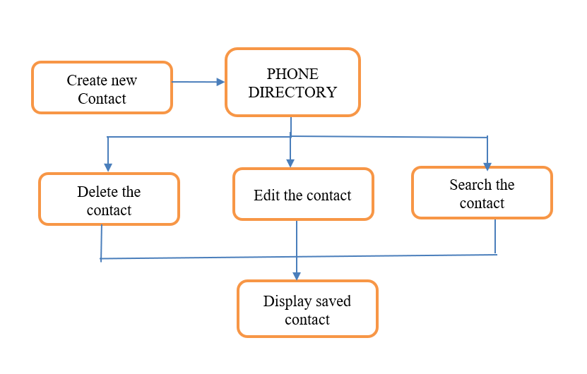

CHAPTER 3
MODULES

3.1 Delivery and Acknowledgement Module:

The Delivery and Acknowledgement Module is responsible for ensuring reliable message transmission between the producer and consumer in the message queue system. Once a message is enqueued by the producer, it enters the delivery stage, where the system checks whether the consumer is ready to receive the message. If the consumer is available, the message is dequeued and delivered.After the consumer receives the message, an acknowledgement is sent back to the system. This acknowledgment confirms that the message has been successfully processed and can be safely removed from the system. If the acknowledgment is not received (e.g., due to failure or timeout), the message may be re-queued for redelivery to ensure no data is lost—this is called message durability or at-least-once delivery.This module helps maintain message integrity, prevents data loss, and ensures that every message is either processed successfully or retried. For a basic implementation using queues, acknowledgments can be tracked using flags, status codes, or a separate acknowledgment queue.

3.2 Error Handling Module:

The Error Handling Module in a message queue system plays a vital role in ensuring the reliability and stability of message processing. It is designed to detect and manage various types of errors that may occur during the enqueueing, delivery, or consumption of messages. One common issue is **queue overflow**, which happens when the queue reaches its maximum capacity; this is handled by either rejecting new messages or implementing delay and retry mechanisms. Another frequent problem is **queue underflow**, where a consumer tries to dequeue from an empty queue. In such cases, the system may return a null response or block until a message becomes available.The module also deals with **delivery failures**, such as consumer disconnection or timeout, by re-queuing the message for a later attempt or logging it for manual intervention. If an **acknowledgment** from the consumer is not received within a specific time frame, the system assumes the message was not processed and re-sends it to maintain delivery guarantees. Additionally, any **corrupted or improperly formatted messages** are either discarded or moved to a special “dead letter queue” for later analysis. Through the use of error logs, retry counters, and exception handling, this module ensures that errors are addressed promptly, preventing data loss and supporting fault tolerance within the queue system.

3.3 Security and Access Control Module

The Security and Access Control Module is essential for protecting the integrity, confidentiality, and availability of the message queue system. This module ensures that only authorized users or systems can access and interact with the queue, whether they are producers sending messages or consumers retrieving them. Access control is typically enforced through authentication mechanisms such as usernames, passwords, or API keys. Once authenticated, users are granted specific permissions, such as enqueue-only, dequeue-only, or full access, depending on their role in the system.To safeguard the contents of the messages, especially in sensitive applications, **data encryption** may be used—either during transmission (using protocols like TLS) or at rest. This prevents unauthorized interception or tampering. Additionally, the system maintains **audit logs** to track all interactions with the queue, helping to identify any unauthorized access attempts or anomalies. Rate limiting and session timeouts can further protect the system from abuse or denial-of-service (DoS) attacks. Overall, the security and access control module ensures that message communication remains secure, compliant, and resilient against threats

3.4 Monitoring and Logging Module

The Monitoring and Logging Module is a critical component of the message queue system that helps track system performance, detect issues, and ensure smooth operation. This module continuously monitors key metrics such as queue length, message throughput, processing time, error rates, and system resource usage. By observing these indicators, administrators can identify bottlenecks, prevent overload conditions, and ensure messages are being processed in a timely manner.In addition to real-time monitoring, the system generates **logs** that record every significant event, including message enqueueing and dequeueing, delivery status, acknowledgment responses, errors, and system alerts. These logs are essential for debugging, auditing, and maintaining transparency in system behavior. They can also be used to generate performance reports or trigger automated alerts in case of failures or unusual activity. Together, monitoring and logging enhance visibility, improve reliability, and support proactive maintenance of the message queue system.

CHAPTER 4
RESULTS AND DISCUSSION
4.1 Results
4.1.1 Add Contacts
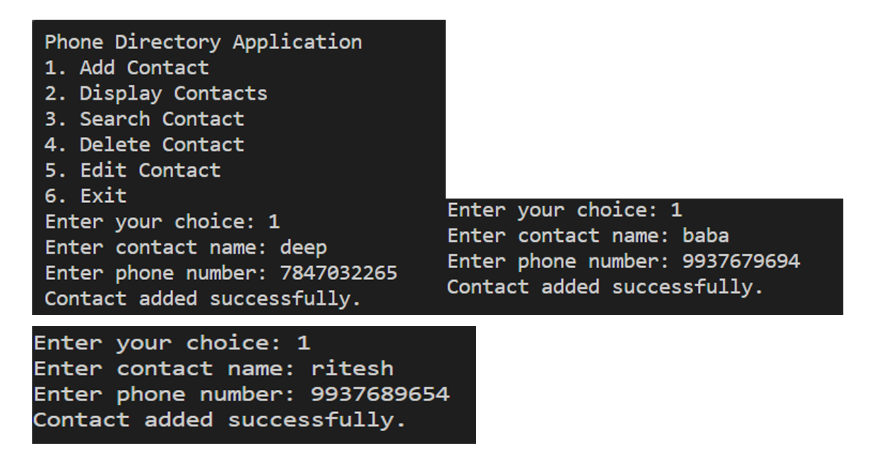

4.1.2 Display Contacts
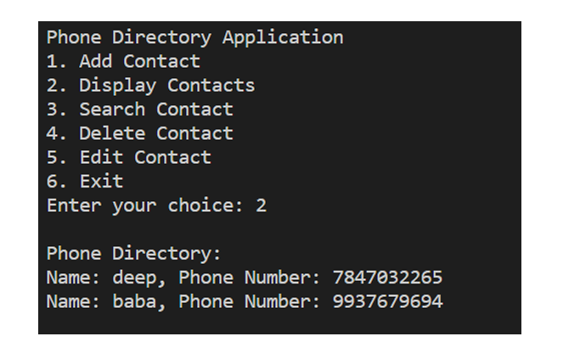

4.1.3 Search Contacts
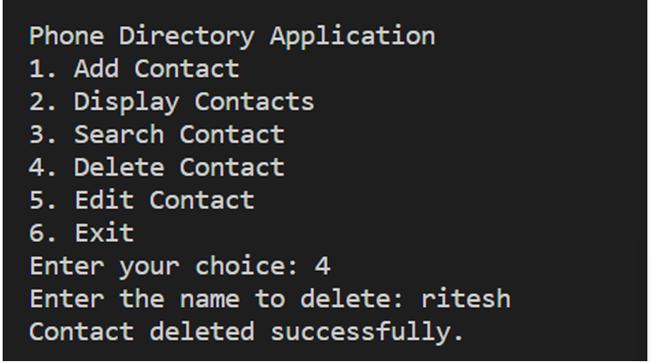

4.1.4 Delete Contacts
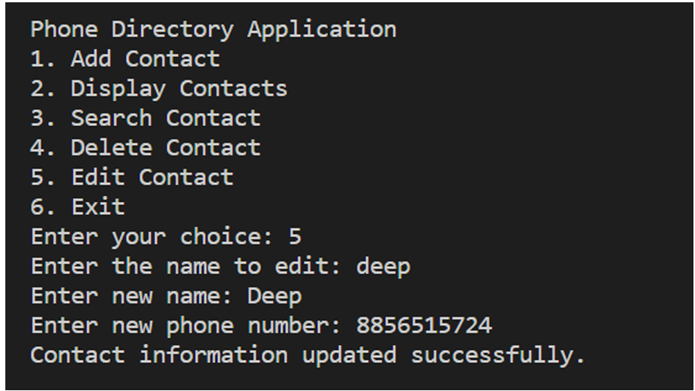
4.2 Discussion
The implementation of a message queue system using data structures highlights the practical application of core computer science concepts to real-world communication problems. The queue, as a First-In-First-Out (FIFO) data structure, naturally supports the ordered and asynchronous flow of messages between producers and consumers. Through this project, it becomes clear how different variations of queues—such as circular queues or linked-list-based queues—can influence system performance based on the requirements for memory, speed, and scalability.The inclusion of additional modules such as delivery acknowledgment, error handling, and security further emphasizes the complexity and reliability needs of real-time systems. Each module demonstrates how robust system design goes beyond basic data structure operations to ensure fault tolerance, data integrity, and controlled access. Monitoring and logging also prove essential for maintaining operational insight and system health. Overall, the discussion reveals that while the queue is a simple structure, its thoughtful application—alongside supporting modules—forms the foundation of scalable and dependable message-driven architectures.
CHAPTER 5
CONCLUSION
In conclusion, the message queue system serves as a fundamental component in asynchronous communication, effectively managing the flow of messages between producers and consumers. By utilizing the queue data structure, which operates on a First-In-First-Out (FIFO) principle, the system ensures orderly and reliable message processing. This project demonstrates how a basic data structure can be extended and enhanced with additional modules like delivery acknowledgment, error handling, security, and monitoring to build a robust and scalable communication mechanism. Overall, the message queue system not only reinforces theoretical knowledge of data structures but also highlights their critical role in real-world computing environments, especially in distributed and real-time applications

REFERENCES
1.Leslie Lamport – Known for work on distributed systems, including logical clocks and consensus algorithms, which are foundational to message ordering in queues.
2.Eugene W. Myers – Known for algorithms relevant to data structures, sometimes cited in queue-related discussions.
3.Martin Kleppmann – Author of Designing Data-Intensive Applications, covers message queues, event sourcing, and data streams deeply.

APPENDIX

#include <stdio.h>
#include <stdlib.h>
#include <string.h>
// Structure to represent a contact typedef
struct Contact
{
char name[50];
char phoneNumber[15];
struct Contact* next;
struct Contact* prev;
} Contact;

// Function to create a new contact Contact* createContact(const char* name, const char* phoneNumber)
{
Contact* newContact = (Contact*)malloc(sizeof(Contact));
if (newContact != NULL)
{
strcpy(newContact->name, name);
strcpy(newContact->phoneNumber, phoneNumber);
newContact->next = NULL;
newContact->prev = NULL;
}
return newContact;
}

// Function to insert a contact into the phone directory void insertContact(Contact** head, const char* name, const char* phoneNumber)
{
Contact* newContact = createContact(name, phoneNumber);
if (newContact == NULL)
{
printf("Memory allocation failed.\n");
return;
}
if (*head == NULL)
{ // List is empty
*head = newContact;
}
else
{
// Insert at the end
Contact* temp = *head;
while (temp->next != NULL)
{
temp = temp->next;
}
temp->next = newContact;
newContact->prev = temp;
}
printf("Contact added successfully.\n");
}

// Function to display all contacts in the phone directory
void displayContacts(Contact* head)
{ printf("\nPhone Directory:\n");
while (head != NULL)
{
printf("Name: %s, Phone Number: %s\n", head->name, head->phoneNumber); head = head->next;
} printf("\n");
}
// Function to search for a contact by name
Contact* searchContact(Contact* head, const char* name)
{
while (head != NULL)
{
if (strcmp(head->name, name) == 0)
{
return head;
// Contact found
}
head = head->next;
}
return NULL;
// Contact not found
}

int main()
{
Contact* phoneDirectory = NULL;
// Menu-driven phone directory application
int choice;
char name[50];
char phoneNumber[15];
do {
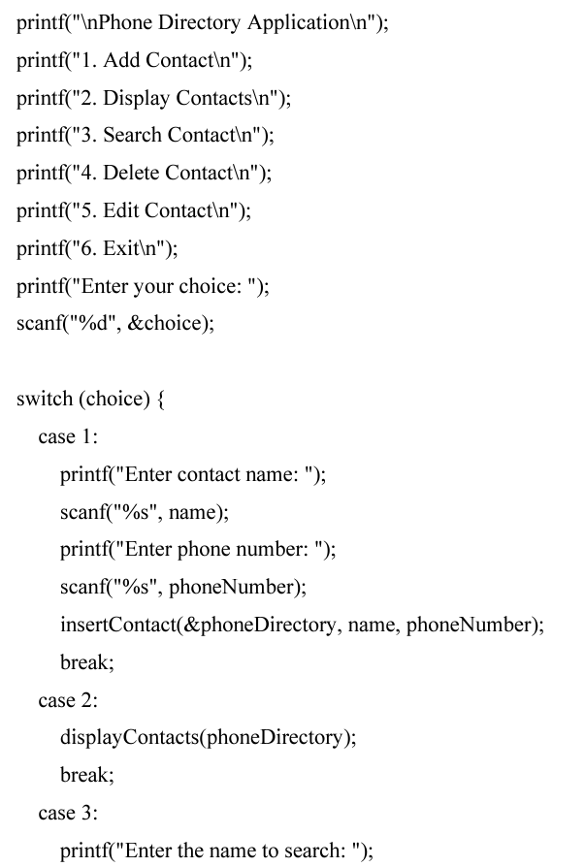
scanf("%s", name);
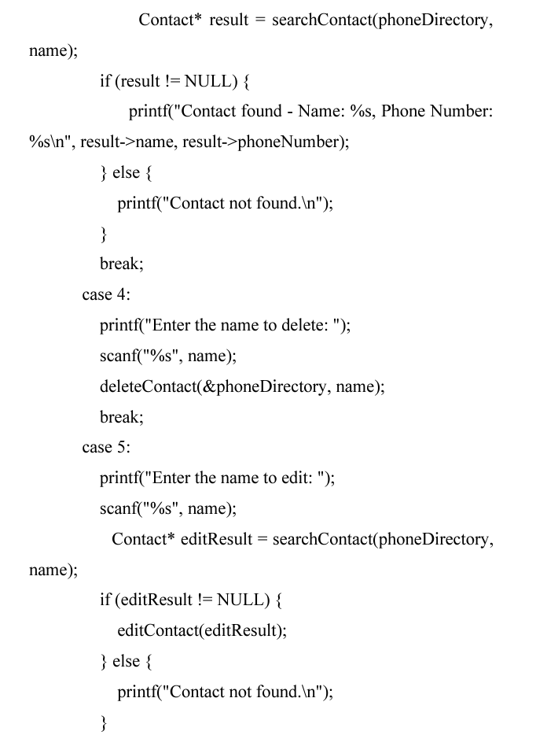
break;
