

### DEPARTMENT OF COMPUTER SCIENCE ENGINEERING

**Rajiv Gandhi University of Knowledge Technologies – Nuzvid Nuzvid, Krishna, Andhra Pradesh – 521202.**

**Employee Management System**

**Using React and Spring boot**

A Summer Internship Report

Submitted in partial fulfillment for the degree of

### BACHELOR OF TECHNOLOGY

**in**

### COMPUTER SCIENCE AND ENGINEERING

Submitted by

CHITTI YAMUNASRI (N190421)

*Under the Esteem Guidance of*

**Mrs Padma Bai**



### DEPARTMENT OF COMPUTER SCIENCE ENGINEERING

#### Rajiv Gandhi University of Knowledge Technologies – Nuzvid Nuzvid, Krishna, Andhra Pradesh – 521202.

**CERTIFICATE OF COMPLETION**

This is to certify that the work entitled, **“Employee Management System”**is the bonafied work of **CHITTI.YAMUNASRI (ID No*:* N190421),** carried out under my guidance and supervision for 3rd year summer internship of **Bachelor of Technology** in the department of Computer Science and Engineering under RGUKT IIIT Nuzvid. This work is done during the academic session November 2023 – February 2024, in EDUBOT company.

#### Mrs Padma Bai Mrs NAGARJUNA DEVI

Assistant professor, Head of the Department,

Department of CSE Department of CSE

RGUKT Nuzvid RGUKT Nuzvid



### DEPARTMENT OF COMPUTER SCIENCE ENGINEERING

#### Rajiv Gandhi University of Knowledge Technologies – Nuzvid Nuzvid, Krishna, Andhra Pradesh – 521202.

**CERTIFICATE OF EXAMINATION**

This is to certify that the work entitled, **“Employee Management System”** is the bonafied work of **CHITTI YAMUNASRI(ID No*:* N190421)** and here by accord our approval of it as a study carried out and presented in a manner required for its acceptance in Third year of **Bachelor of Technology** for which it has been submitted. This approval does not necessarily endorse or accept every statement made, opinion expressed or conclusion drawn, as recorded in this thesis. It only signifies the acceptance of this thesis for the purpose for which it has been submitted.

#### Mrs.Padma Bai Project Examiner

Assistant Professor, RGUKT-Nuzvid

Department of CSE

RGUKT-NUZVID



**DEPARTMENT OF COMPUTER SCIENCE ENGINEERING**

**Rajiv Gandhi University of Knowledge Technologies – Nuzvid Nuzvid, Krishna, Andhra Pradesh – 521202.**

### DECLARATION

we hereby declare that the project report entitled **“Employee Management System”** done by us under the guidance of Mrs. Padma Bai, Assistant Professor is submitted for the partial fulfillment for the award of degree of Bachelor of Technology in Computer Science and Engineering during the academic session 2023- 2024 at RGUKT-Nuzvid.

We also declare that this project is a result of our own effort and has not been copied or imitated from any source. Citations from any websites are mentioned in the references. The results embodied in this project report have not been submitted to any other university or institute for the award of any degree or diploma.

|  |  |  |
| --- | --- | --- |
| **Date:4-07-2024**  **Place: Nuzvid** |  | |
|  | CHITTI YAMUNASRI | (N190421) |
|  |  |  |

### ACKNOWLEDGEMENT

We would like to express our profound gratitude and deep regards to our guide **Mrs. Padma Bai** for his exemplary guidance, monitoring and constant encouragement to us throughout the B.Tech course. We shall always cherish the time spent with her during the course of this work due to the invaluable knowledge gained in the field of reliability engineering.

We are extremely grateful for the confidence bestowed in us and entrusting our project entitled

### “Employee Management System”

We express gratitude to Mrs Nagarjuna Devi (HOD of CSE) and other faculty members for being a source of inspiration and constant encouragement which helped us in completing the project successfully.

Our sincere thanks to all the batch mates of 2019 CSE, who have made our stay at RGUKT-NUZVID, a memorable one.

Finally, yet importantly, we would like to express our heartfelt thanks to our beloved God and parents for their blessings, our friends for their help and wishes for the successful completion of this project.

### ABSTRACT

The Employee Management System project focuses on developing a comprehensive and user-friendly application designed to streamline various aspects of employee management within an organization. Key features include the ability for managers to add projects that are visible to employees, the functionality for managers to assign employees to project teams, and an employee self-registration system based on their position. Leveraging modern software engineering principles and advanced technologies, the system will automate key functions such as employee onboarding, attendance tracking, performance evaluation, and payroll processing. The primary objective is to enhance organizational efficiency by providing a centralized platform that facilitates seamless communication and data management. The expected outcome is a versatile and scalable employee management tool that optimizes administrative tasks and supports strategic HR decision-making.

**Table of Contents**

ABSTRACT [6](https://docs.google.com/document/d/1KtsRpLDl_6xXcfD6e3rGcyWkZ7UKYQdwUXP7cZIXy_Q/edit#heading%3Dh.gjdgxs)

CHAPTER 1 9

INTRODUCTION 9

* 1. Overview of Employee Management Systems 10
  2. Importance of Efficient Employee Management [10](https://docs.google.com/document/d/1KtsRpLDl_6xXcfD6e3rGcyWkZ7UKYQdwUXP7cZIXy_Q/edit#heading%3Dh.2et92p0)

CHAPTER 2 [11](https://docs.google.com/document/d/1KtsRpLDl_6xXcfD6e3rGcyWkZ7UKYQdwUXP7cZIXy_Q/edit#heading%3Dh.1t3h5sf)

REQUIREMENTS AND ANALYSIS [11](https://docs.google.com/document/d/1KtsRpLDl_6xXcfD6e3rGcyWkZ7UKYQdwUXP7cZIXy_Q/edit#heading%3Dh.4d34og8)

* 1. Hardware components: [11](https://docs.google.com/document/d/1KtsRpLDl_6xXcfD6e3rGcyWkZ7UKYQdwUXP7cZIXy_Q/edit#heading%3Dh.2s8eyo1)
  2. Software components: [11](https://docs.google.com/document/d/1KtsRpLDl_6xXcfD6e3rGcyWkZ7UKYQdwUXP7cZIXy_Q/edit#heading%3Dh.17dp8vu)
  3. Functional requirements [11](https://docs.google.com/document/d/1KtsRpLDl_6xXcfD6e3rGcyWkZ7UKYQdwUXP7cZIXy_Q/edit#heading%3Dh.3rdcrjn)
  4. Non-Functional requirements [12](https://docs.google.com/document/d/1KtsRpLDl_6xXcfD6e3rGcyWkZ7UKYQdwUXP7cZIXy_Q/edit#heading%3Dh.26in1rg)

CHAPTER 3 [13](https://docs.google.com/document/d/1KtsRpLDl_6xXcfD6e3rGcyWkZ7UKYQdwUXP7cZIXy_Q/edit#heading%3Dh.lnxbz9)

PROPOSED MODEL AND FLOW OF THE PROJECT [13](https://docs.google.com/document/d/1KtsRpLDl_6xXcfD6e3rGcyWkZ7UKYQdwUXP7cZIXy_Q/edit#heading%3Dh.35nkun2)

* 1. Proposed model [13](https://docs.google.com/document/d/1KtsRpLDl_6xXcfD6e3rGcyWkZ7UKYQdwUXP7cZIXy_Q/edit#heading%3Dh.1ksv4uv)
  2. Flow of the project
  3. Features and Functionality

3.3.1 Manager Capabilities

3.3.2 Employee Capabilities [14](https://docs.google.com/document/d/1KtsRpLDl_6xXcfD6e3rGcyWkZ7UKYQdwUXP7cZIXy_Q/edit#heading%3Dh.44sinio)

* 1. Advantages and disadvantages 15
     1. **Advantages 15**
     2. **Disadvantages** 15
  2. Applications 16

CHAPTER 4 17

IMPLEMENTATION 17

* 1. Environmental setup 17
  2. Frontend
  3. Backend
  4. Execution 18
  5. Results 19

CHAPTER 5 23

CONCLUSION 23

REFERENCES 24

### CHAPTER 1 INTRODUCTION

The Employee Management System (EMS) is a comprehensive digital platform designed to streamline various aspects of employee management within an organization. By automating key processes such as project assignment, team management, and employee self-registration, the EMS aims to enhance organizational efficiency and support strategic HR decision-making.

**1.1 Overview of Employee Management Systems**

Employee Management Systems are essential tools that assist organizations in managing their workforce more effectively. These systems provide a centralized platform for handling employee-related tasks, from recruitment and onboarding to performance tracking and payroll processing. By integrating various functionalities, EMSs help in reducing administrative burdens, improving data accuracy, and ensuring compliance with organizational policies.

**1.2 Importance of Efficient Employee Management**

Efficient employee management is crucial for the success of any organization. It involves not only the effective utilization of human resources but also the creation of a supportive work environment that fosters productivity and employee satisfaction. Key benefits of an efficient EMS include improved resource allocation, enhanced communication, streamlined workflows, and better alignment of employee goals with organizational objectives.

**Key Features of the Employee Management System**

**Project Management:** Managers can add projects to the system, which are visible to all employees. This feature enables transparent communication of project details and objectives.

**Team Assignment:** Managers can assign employees to specific project teams based on their skills and positions. This ensures that the right resources are allocated to the right projects.

**Employee Self-Registration:** Employees can register themselves in the system based on their position. This self-service feature simplifies the onboarding process and ensures that employee data is accurately captured.

## **Key Libraries and Technologies**

The development of the EMS leverages modern software engineering principles and advanced technologies to ensure robust performance and scalability:

**Spring Boot:** A powerful Java-based framework used for building microservices and robust backend systems. It is used for the backend development of the EMS.

**React:** A JavaScript library for building user interfaces. It is used for the frontend development, providing a responsive and interactive user experience.

**MySQL:** An open-source relational database management system. It is used for storing and managing the employee and project data.

**Postman:** A popular API development and testing tool. It is used for testing and verifying the API endpoints of the EMS.

## **Components in Employee Management System**

**User Authentication and Authorization:** The system includes robust authentication and authorization mechanisms to ensure that only authorized personnel can access sensitive information and perform certain actions.

**Project Dashboard:** A central dashboard where managers can add new projects, view existing projects, and assign employees to project teams.

**Employee Dashboard:** A personalized dashboard for employees to view their assigned projects, update their profiles, and manage their tasks.

**Performance Tracking:** Tools for tracking employee performance, including goal setting, progress monitoring, and performance reviews.

**Payroll Management:** An integrated payroll system that automates salary calculations, tax deductions, and payment processing.

**Reporting and Analytics:** Advanced reporting tools that provide insights into various aspects of employee management, such as attendance, performance, and project progress.

## **Real-Time Applications of Employee Management System**

**Automated Onboarding:** The EMS automates the onboarding process, allowing new employees to register themselves and get assigned to projects quickly and efficiently.

**Project Tracking:** Managers can monitor the progress of projects in real-time, ensuring that deadlines are met and resources are utilized effectively.

**Performance Reviews:** The system facilitates regular performance reviews, helping managers provide timely feedback and support to employees.

**Payroll Automation:** By automating payroll processes, the EMS ensures accurate and timely salary payments, reducing the risk of errors and compliance issues.

**Data-Driven Decision Making:** The reporting and analytics tools provide valuable insights that support strategic decision-making and improve overall organizational performance.

**CHAPTER 2**

**REQUIREMENTS AND ANALYSIS**

**2.1 Hardware Components**

Processor: Intel Core i5 or equivalent.

RAM: 16 GB.

Storage: 256 GB SSD.

**2.2 Software Components**

1. **Operating System:** Windows OS, 64-bit or any modern Linux distribution.
2. **Programming Languages:**
   * **Java:** For backend development using Spring Boot.
   * **JavaScript:** For frontend development using React.
3. **Integrated Development Environment (IDE):**
   * **Visual Studio Code:** For frontend development with React.
4. **Database Management System:**
   * **MySQL:** For storing and managing the employee and project data.
5. **API Development and Testing Tools:**
   * **Postman:** For testing and verifying the API endpoints of the EMS.

**Essential Libraries and Frameworks**

**Spring Boot:** A powerful framework for building Java-based backend applications. It simplifies the development of robust and scalable server-side applications.

**Installation:** Spring Boot can be set up through Maven or Gradle dependencies.

**React:** A popular JavaScript library for building user interfaces, particularly single-page applications.

**Installation:** npm install react react-dom

**Axios:** A promise-based HTTP client for JavaScript, used for making HTTP requests from React applications.

**Installation:** npm install axios

**React Router:** A library for routing in React applications, enabling navigation between different views.

**Installation:** npm install react-router-dom

**MySQL Connector/J:** A JDBC driver for MySQL, allowing Java applications to connect to MySQL databases.

**Installation:** MySQL Connector/J can be set up through Maven or Gradle dependencies.

**Postman:** A popular API development and testing tool used for testing and verifying the API endpoints of the EMS.

**Installation:** Postman can be downloaded and installed from its official website.

**2.3 Functional Requirements**

• **Project Management:**

* The system must allow managers to add new projects and make them visible to all employees.
* The system must enable managers to assign employees to specific project teams based on their skills and positions.

• **Employee Self-Registration:**

* The system must allow employees to register themselves in the system based on their position.
* The system should capture and store employee details accurately during the registration process.

• **Attendance Tracking:**

* The system must track and record employee attendance.
* The system should provide an interface for employees to mark their attendance and for managers to view attendance records.

• **User Authentication and Authorization:**

* The system must include robust authentication mechanisms to ensure that only authorized personnel can access sensitive information.
* The system should implement role-based access control to restrict certain actions based on user roles (e.g., manager, employee).

• **API Integration:**

* The system must provide RESTful APIs to enable seamless communication between the frontend and backend.
* The APIs should be tested using tools like Postman to ensure they function correctly.

• **Data Management:**

* The system must use a reliable database (MySQL) to store and manage employee and project data.
* The system should ensure data integrity and security through appropriate data handling practices.

**2.4 Non-Functional Requirements**

**Response Time:**

* The system should provide quick responses to user actions to ensure efficiency in employee management processes. The average response time for any action should be less than 2 seconds.

**Error Handling:**

* The system must include robust error handling to manage and log any issues during operations. Errors should be logged with detailed information to facilitate troubleshooting and resolution.

**Usability:**

* The system should have a user-friendly interface that is easy to navigate. Users should be able to perform their tasks with minimal training.

### CHAPTER 3

### PROPOSED MODEL AND FLOW OF THE PROJECT

### 3.1 Proposed Model

The Employee Management System (EMS) utilizes a structured approach to streamline employee management processes. It integrates various components and technologies to ensure efficient handling of tasks such as project management, team assignment, and employee registration.

### 3.2 Flow of the Project

**Problem Definition and Data Collection:**

• **Task Definition:** Define the key functionalities of the EMS, focusing on project management, team assignment, employee registration, and performance tracking.

• **Data Gathering:** Collect relevant data inputs required for setting up projects, assigning teams, and registering employees within the system

**System Architecture Design:**

* Integrate frontend (React) and backend (Spring Boot) components for seamless communication.
* Implement MySQL database for secure storage and management of employee and project data.

**Deployment and Maintenance:**

* Deploy EMS using effective deployment strategies to ensure scalability and availability.
* Establish a maintenance plan for regular updates and enhancements to meet evolving organizational needs.

**Security Implementation:**

* Implement robust authentication and authorization mechanisms for data security.
* Encrypt sensitive data stored in MySQL to ensure confidentiality.

**3.3 Features and Functionality**

**3.3.1 Manager Capabilities**

* Project Management: Add, view, and manage projects.
* Team Assignment: Assign employees to project teams based on skills.
* Data Access: Access employee and project data for decision-making.

**3.3.2 Employee Capabilities**

* Self-Registration: Register based on predefined positions.
* Project Participation: View assigned projects and team details.
* Attendance Tracking: Mark attendance and view own records.

**3.4 Advantages and Disadvantages**

**3.4.1 Advantages**

* Efficiency: Streamlines project management and team assignment processes.
* Transparency: Enhances visibility and accessibility of project and employee data.
* Scalability: Supports growth and scalability of employee management operations.

**3.4.2 Disadvantages**

* **Dependency:** Relies on consistent network and server availability.
* **Learning Curve:** Requires training for users unfamiliar with the EMS interface.

**3.5 Applications**

The EMS finds applications in various organizational settings:

* **Corporate Environments:** Efficient management of employee resources and project allocations.
* **Educational Institutions:** Facilitation of faculty and student management processes.
* **Healthcare Facilities:** Coordination of staff assignments and patient care schedules.

### CHAPTER 4

### IMPLEMENTATION

Implementing an advanced Employee Management System (EMS) involves leveraging various technologies and methodologies to manage employee data, streamline HR processes, and enhance overall efficiency. The following steps outline the implementation process:

**Main components:-**

* There are mainly 2 components running
* Frontend is running at port 3000 and backend is running at port 8000
  1. **Frontend**
* Create react app with running the below command
* $npx create-react-app frontend
* Then start the implementing the components required for project
* Implement the components EmployeeForm, EmployeeList, TaskForm, TaskList, Login
  1. **Backend**
* Create a maven project for backend
* Define the dependencies use are using in this project in pom.xml

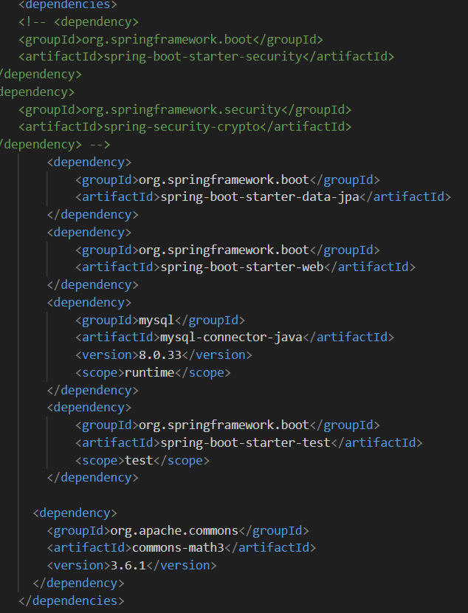

* Configure the backend details in application.properties

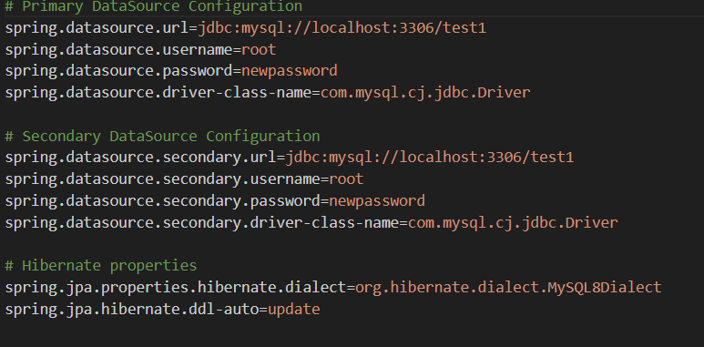

* Define the api calls
* And check in postman whether api calls are getting correct or not

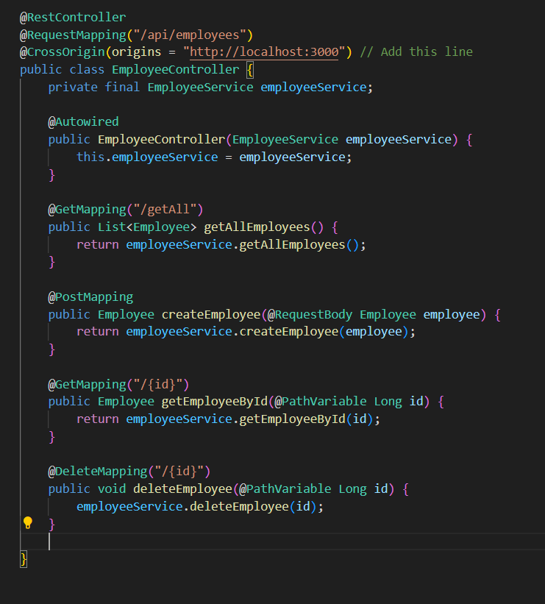

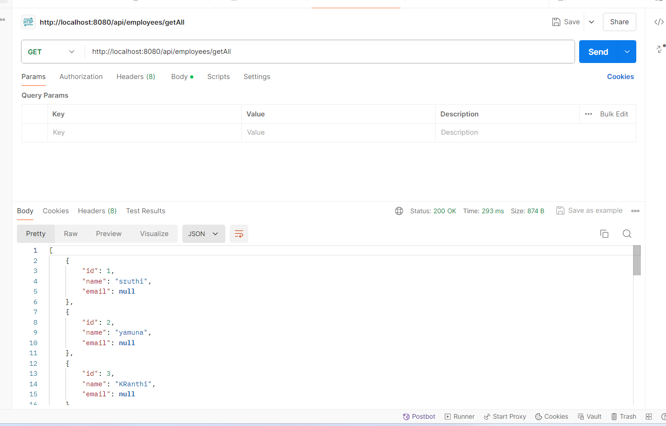

4.3. **Execution**

* Login page

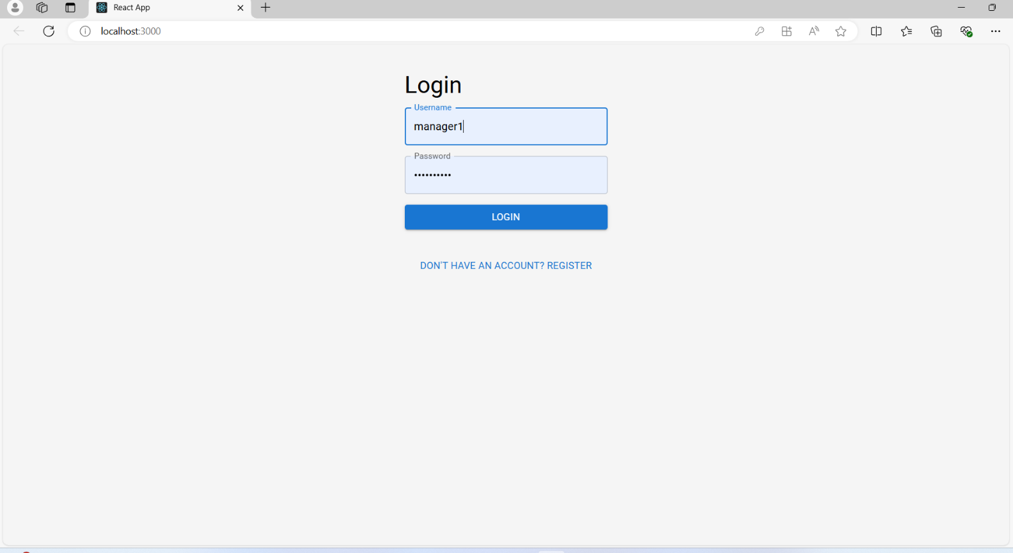

* Register when new employee is hiring

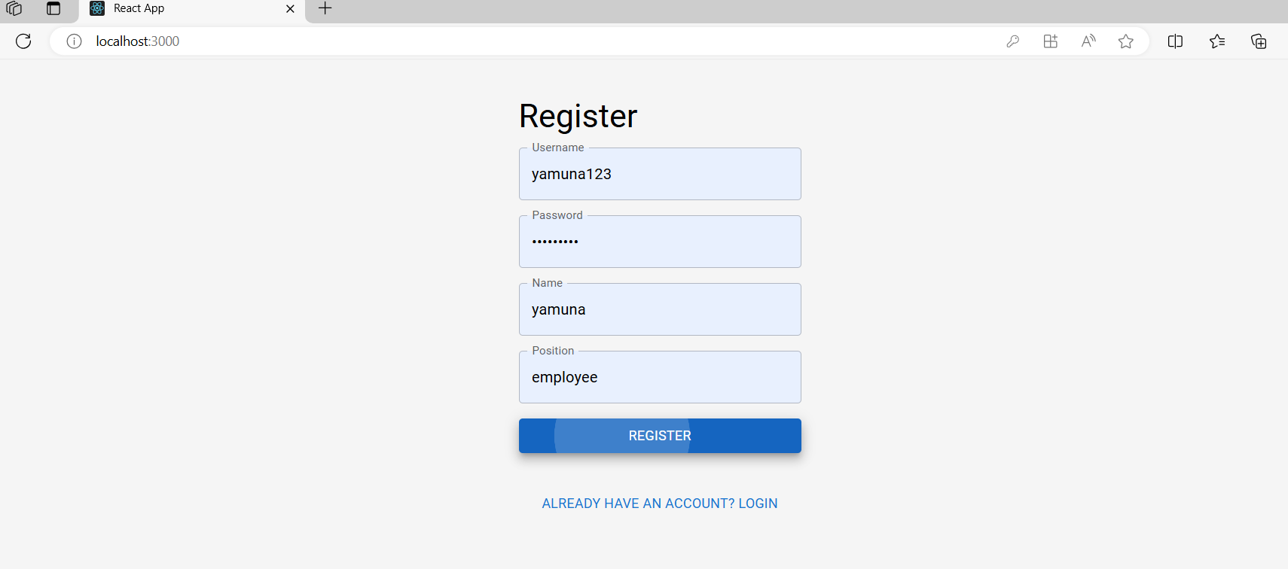

* When manager add an employee with name and postion

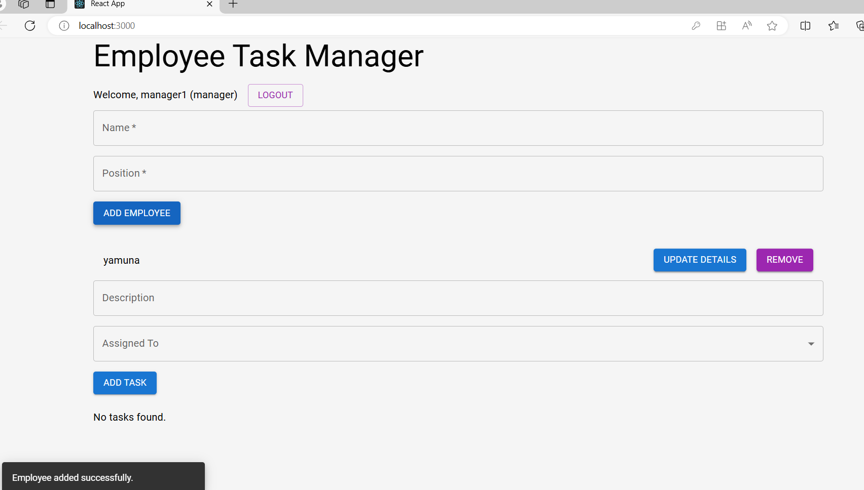

* Adding task for the employee

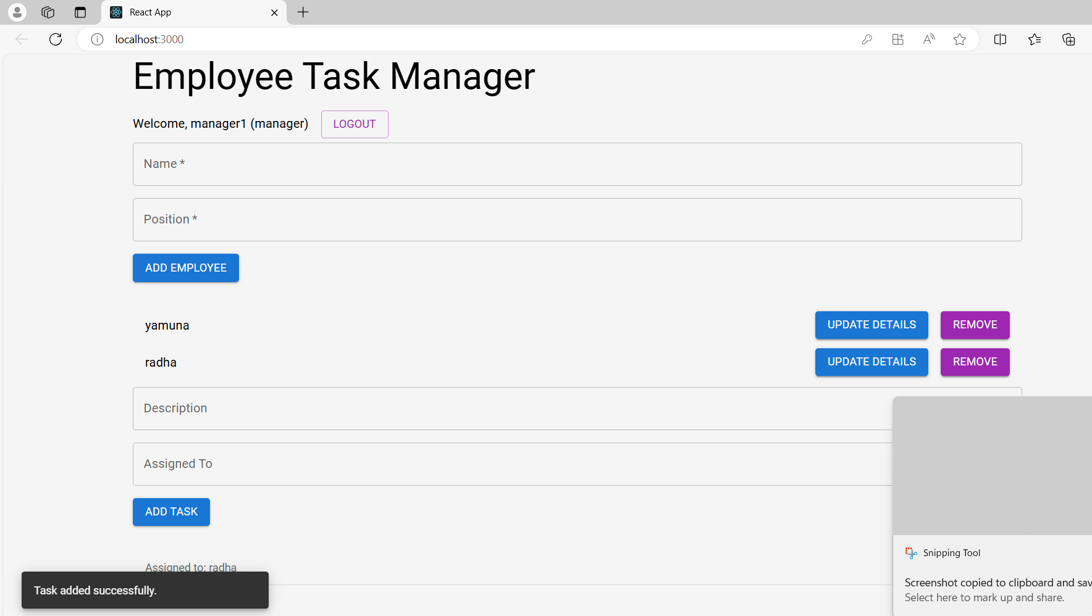

* Remaining employee can see the task in their profile

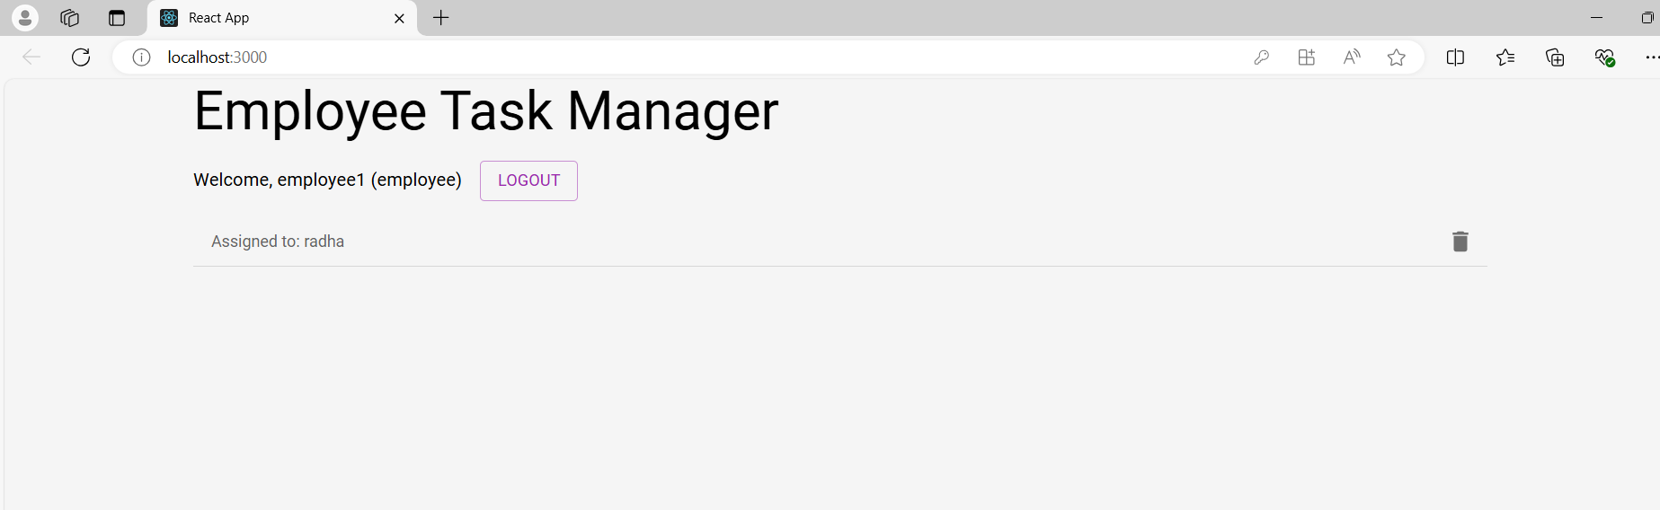

CHAPTER - 5

**Conclusion**

Developing a comprehensive Employee Management System (EMS) presents a significant opportunity to enhance organizational efficiency, improve employee satisfaction, and streamline HR processes. By leveraging advanced technologies such as AI and automation, an EMS can effectively manage employee data, track performance, and handle administrative tasks with ease. Key features like automated payroll processing, attendance tracking, and performance management ensure that HR personnel can focus on strategic initiatives rather than routine tasks. Additionally, integrating capabilities for employee self-service and feedback mechanisms can further empower employees, fostering a positive workplace environment. Overall, a well-designed Employee Management System has the potential to transform HR operations, making them more efficient, transparent, and aligned with organizational objectives.

# REFERENCES :

* [Courses (blackboard.com)](https://edubot.blackboard.com/ultra/course)
* [Learn Spring Boot Tutorial - javatpoint](https://www.javatpoint.com/spring-boot-tutorial)
* [Getting Started – React (reactjs.org)](https://legacy.reactjs.org/docs/getting-started.html)