

Dayananda Sagar University
School of Engineering
Devarakaggalahalli, Harohalli, Kanakapura Road, Bangalore South Dt., Bengaluru – 562112

Department of
Computer Science & Technology

ACADEMIC YEAR 2025-26

Internship Report
(22CT4802)
on
Data Analytics Intern

Submitted in partial fulfilment for the award of degree of
B.Tech in
Computer Science & Technology
Submitted By

YAMUNA V - ENG22CT0052

(8th Semester)

Department of Computer Science and Technology
Dayananda Sagar University


Dayananda Sagar University
School of Engineering
Devarakaggalahalli, Harohalli, Kanakapura Road, Bangalore South Dt., Bengaluru – 562112

Department of Computer Science & Technology

CERTIFICATE
This is to certify that the Internship work done at “ CODTECH IT SOLUTIONS PRIVATE LIMITED ” is being submitted by YAMUNA V - ENG22CT0052 is the record of the internship carried out by her under our supervision. This report is submitted towards the partial fulfillment of B.Tech in Computer Science & Technology during the academic year 2025-2026. It is certified that all the suggestions or corrections indicated for internal assessment have been incorporated in the report. This Internship Report has been approved as it satisfies the academic requirements under the rules prescribed for the Bachelor of Technology degree.

Dr. Ramandeep Kaur  Assistant Professor,  Dept. of Computer Science & Technology,  School of Engineering,  Dayananda Sagar University. | Dr. Hemchandra Reddy K  Assistant Professor,  Dept. of Computer Science & Technology,  School of Engineering,  Dayananda Sagar University.
Neela Santhosh Kumar  Human Resources & Academic Head  CODTECH IT SOLUTIONS PRIVATE LIMITED | Dr. M Shahina Parveen  Professor & Chairperson,  Dept. of Computer Science & Technology,  School of Engineering,  Dayananda Sagar University.

Internal Examiner External Examiner



Dayananda Sagar University
School of Engineering
Devarakaggalahalli, Harohalli, Kanakapura Road, Bangalore South Dt., Bengaluru – 562 112

Department of Computer Science & Technology

DECLARATION

I, Ms. YAMUNA V (ENG22CT0052) student of eighth semester B.Tech in Computer Science & Technology, at School of Engineering, Dayananda Sagar University, hereby declare that the Internship entitled “Full Stack Web Development Intern” is Bonafide work carried out at CODTECH IT SOLUTIONS PRIVATE LIMITED, is a partial fulfillment for the award of degree in Bachelor of Technology in Computer Science & Technology during the academic year 2025-2026.

YAMUNA V - ENG22CT0052 Student Signature

Place : Bangalore Date:

ACKNOWLEDGEMENT

I am content and grateful for having been provided with this internship opportunity at CODTECH IT SOLUTIONS PRIVATE LIMITED. I take this opportunity to express my deepest gratitude and appreciation to all those who have been helping me directly or indirectly towards the successful completion of this internship.

I would like to thank Dr. M Shahina Parveen, Chairperson of the Department of Computer Science & Technology, for her warm support and for providing the required resources to land this internship opportunity.
I express my gratitude to Dr. Ramandeep Kaur, Assistant Professor, Dept. of Computer Science & Technology, and Dr. Hemchandra Reddy K, Assistant Professor, Dept. of Computer Science & Technology, Internship Coordinator, for their diligent guidance and coordination for the success of my internship.

I would like to thank Neela Santhosh Kumar (Human Resources & Academic Head) for giving me an opportunity to be a part of this project and intern at their company, CODTECH IT SOLUTIONS PRIVATE LIMITED .

I am grateful to the staff of the Department of Computer Science & Technology for imparting invaluable knowledge and guiding me throughout the duration of my course as a Computer Science & Technology student at Dayananda Sagar University.

YAMUNA V
B.Tech (CST),
8th Semester (ENG22CT0052)

ABSTRACT
This report presents a detailed overview of the knowledge and practical experience gained during the internship at Codtech IT Solutions Pvt. Ltd. The internship primarily focused on Data Analysis, Machine Learning, and Data Visualization techniques, aiming to bridge the gap between theoretical learning and real-world applications.
During the internship, four major tasks were completed: Exploratory Data Analysis (EDA), House Price Prediction using Machine Learning, Sales Dashboard Development, and Sentiment Analysis of textual data. Each task was designed to enhance understanding of data preprocessing, feature engineering, predictive modeling, and interactive visualization.
The internship provided hands-on experience in using tools and technologies such as Python, Pandas, NumPy, Matplotlib, Scikit-learn, Plotly, and Dash. Through these tasks, real-world datasets were analyzed to extract meaningful insights and build efficient models.
In addition to technical knowledge, the internship also improved problem-solving skills, logical thinking, and the ability to interpret and present data effectively. Overall, this internship significantly contributed to strengthening both technical and analytical skills required in the field of data science.

TABLE OF CONTENTS

CHAPTER 1: COMPANY PROFILE
- ABOUT THE COMPANY ………………………………………... 2
- SERVICES AND PRODUCTS …………………………………… 2
CHAPTER 2: SYSTEM REQUIREMENTS
- HARDWARE REQUIREMENTS …………………………………… 3
- SOFTWARE REQUIREMENTS …………………………………….. 3
CHAPTER 3: PROJECT WORK
- PROBLEM STATEMENT ………………………………………….. 3
- TECHNOLOGIES USED …………………………………………… 3
- TRAINING ………………………………………………………….. 4
- RESULT …………………………………………………………. 4 - 9
CONCLUSION ……………………………………………………………... 9 - 10
REFERENCES ……………………………………………………………… 10
INTERNSHIP OFFER LETTER ………………………………………….. 11
COMPLETION CERTIFICATE

CHAPTER 1: COMPANY PROFILE

  - ABOUT THE COMPANY
Codtech IT Solutions Pvt. Ltd is a technology-driven organization that focuses on providing IT services, software development solutions, and industry-oriented training programs. The company aims to bridge the gap between academic knowledge and industry requirements by offering practical exposure through internships and real-time projects.

The organization specializes in areas such as Data Science, Machine Learning, Web Development, and Software Engineering. It emphasizes hands-on learning, enabling students to gain practical experience by working on real-world datasets and projects.
Codtech promotes a learning environment where students can develop technical skills, understand industry workflows, and improve their problem-solving abilities. The company also focuses on modern tools, frameworks, and best practices such as version control, clean coding, and project documentation.

  - SERVICES AND PRODUCTS

Codtech IT Solutions Pvt. Ltd provides a wide range of services and solutions aimed at enhancing technical skills and delivering efficient software solutions.
Services Offered
- Data Analysis and Machine Learning training
- Full Stack Web Development
- Internship programs with real-time projects
- Technical mentoring and project guidance
- Debugging, testing, and deployment support
Products and Solutions
- Data-driven analytical tools
- Machine learning-based prediction models
- Interactive dashboards and visualization systems
- Real-time web applications
- Automation and data processing systems

CHAPTER 2: SYSTEM REQUIREMENTS
2.1 HARDWARE REQUIREMENTS
- Laptop/Desktop with minimum 4GB RAM
- Processor: Intel i3 or above
- Internet connectivity

2.2 SOFTWARE REQUIREMENTS
- Python (3.x)
- Jupyter Notebook / VS Code
- Libraries:
  - Pandas
  - NumPy
  - Matplotlib
  - Scikit-learn
  - Plotly
  - Dash

CHAPTER 3: SYSTEM REQUIREMENTS
3.1 PROBLEM STATEMENT
The primary objective of this internship is to analyze datasets, extract meaningful insights, build predictive models, and develop interactive visualization systems. The tasks aim to demonstrate the application of data science techniques in solving real-world problems.

3.2 TECHNOLOGIES USED
The following tools and technologies were used during the internship:
Programming Language
- Python
Libraries
- Pandas – data manipulation and analysis
- NumPy – numerical computations
- Matplotlib – data visualization
- Seaborn – advanced visualization
- Scikit-learn – machine learning models
- Plotly – interactive visualizations
- Dash – dashboard development
Tools
- VS Code / Jupyter Notebook – coding environment
- GitHub – version control and project submission

3.3 TRAINING
During the internship, structured training was provided to understand both theoretical and practical aspects of data analysis and machine learning.
The training included:
- Understanding data preprocessing techniques
- Learning how to clean and prepare datasets
- Applying statistical methods for data analysis
- Building machine learning models for prediction
- Developing dashboards using visualization tools
- Performing sentiment analysis using NLP techniques
Through continuous practice and task-based learning, hands-on experience was gained in handling real datasets, debugging code, and improving model performance.

3.4 RESULTS
TASK 1: EXPLORATORY DATA ANALYSIS (EDA)
Objective
To understand the structure and characteristics of the dataset using statistical analysis and visualization techniques.
Methodology
- Imported dataset using Pandas
- Analyzed dataset using .info() and .describe()
- Handled missing values and cleaned data
- Performed univariate and bivariate analysis
- Visualized data using histograms, bar charts, and scatter plots
Insights
- Identified patterns and trends in data
- Understood relationships between variables
- Detected outliers and anomalies
Result
EDA helped in gaining a clear understanding of the dataset, which was essential for further model building and analysis.

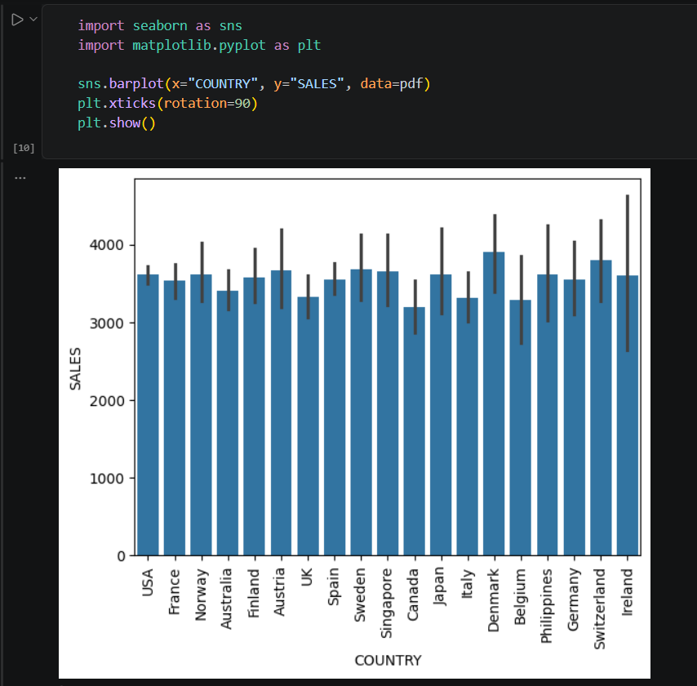

Fig 1: Sales Distribution Across Different Countries
Description: This bar chart shows sales across different countries. It helps compare performance and identify which countries have higher or lower sales.

TASK 2: HOUSE PRICE PREDICTION
Objective
To build a machine learning model that predicts house prices based on various features.
Methodology
- Data preprocessing (handling missing values, encoding categorical data)
- Feature selection
- Splitting dataset into training and testing sets
- Applied regression algorithms
- Evaluated model performance
Model Used
- Linear Regression / Machine Learning Regression Model
Results
- Successfully predicted house prices
- Model showed good accuracy and performance
Conclusion
This task demonstrated how machine learning can be used to solve real-world prediction problems.

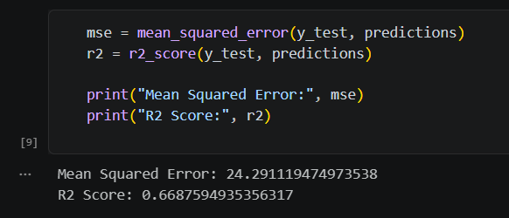

Fig 2.1: Model Evaluation Metrics (MSE and R² Score)
Description: This output shows the performance of the regression model using Mean Squared Error (MSE) and R² score. The MSE indicates the prediction error, while the R² score represents how well the model explains the data.

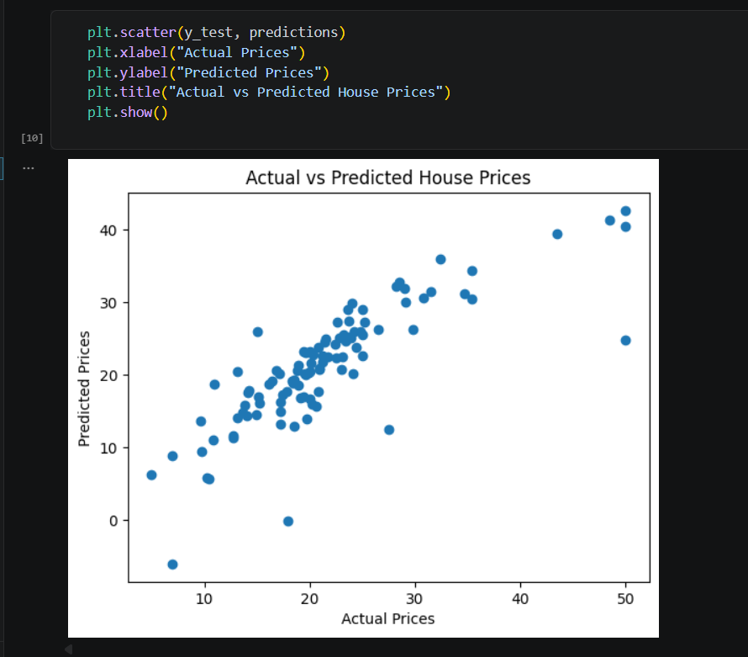

Fig 2.2: Actual vs Predicted House Prices
Description: This scatter plot compares actual house prices with predicted values from the model. The closer the points are to a straight line, the better the model’s predictions, indicating good accuracy.
TASK 3: SALES DASHBOARD
Objective
To develop an interactive dashboard that visualizes sales data.
Implementation
- Used Dash framework for web application
- Used Plotly for visualization
- Created interactive components:
  - Dropdown filter (Country selection)
  - Bar chart (Sales by product line)
  - Line chart (Sales over time)
  - Pie chart (Sales distribution)
Features
- Dynamic updates based on user input
- Clean and user-friendly interface
- Real-time data visualization
Result
The dashboard successfully displayed sales insights and trends, making data easy to understand and analyze.

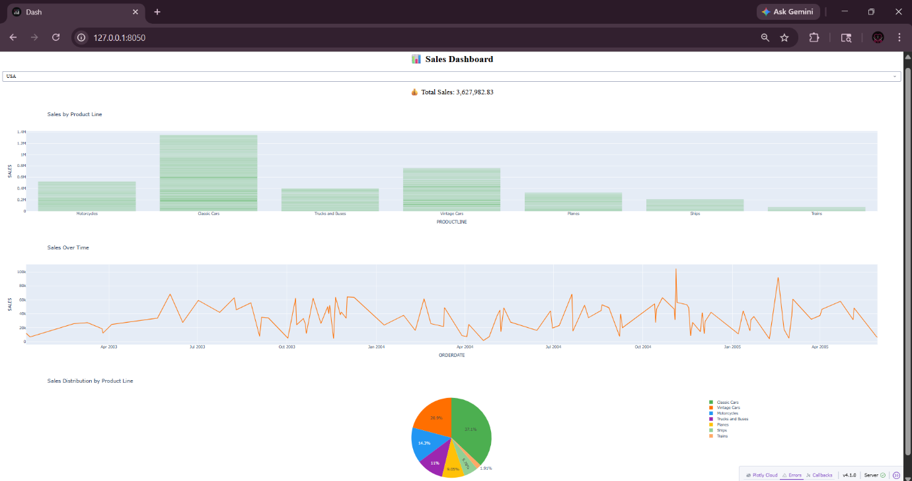

Fig 3: Interactive Sales Dashboard
Description: This dashboard displays sales insights using interactive visualizations, including bar, line, and pie charts. It allows users to analyze sales by product line, track sales over time, and view distribution across categories.

TASK 4: SENTIMENT ANALYSIS
Objective
To classify text reviews into positive and negative sentiments.
Methodology
- Data cleaning and preprocessing
- Converted text to numerical form using TF-IDF vectorization
- Applied Logistic Regression model
- Evaluated model using accuracy and confusion matrix
Results
- Accuracy achieved: ~91%
- Balanced dataset improved model performance
- Successfully classified new reviews
Insights
- Model relies on keywords like "good", "bad", "excellent"
- Struggles with sarcasm and complex context

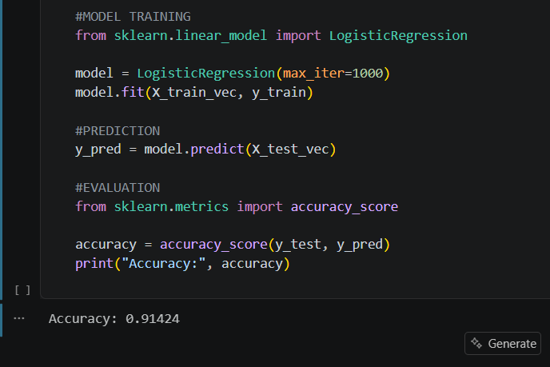

Fig 4.1: Logistic Regression Model Training and Accuracy
Description: This output shows the training and evaluation of the Logistic Regression model for sentiment analysis. The model is trained on text data and achieves an accuracy of approximately 91%, indicating good performance in classification.

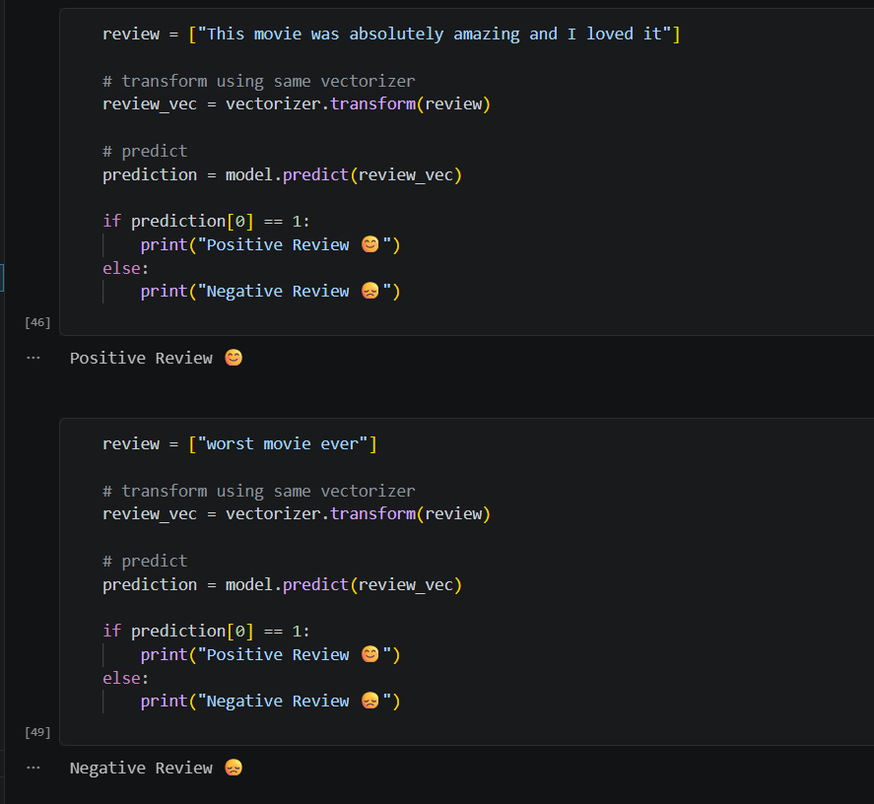

Fig 4.2: Sentiment Prediction on Sample Reviews
Description: This output demonstrates the model predicting sentiment for new text inputs. The model correctly classifies a positive review and a negative review, showing its effectiveness in real-time sentiment prediction.

CONCLUSION

The internship provided valuable exposure to real-world data analysis and machine learning applications. It helped in understanding how raw data can be collected, cleaned, processed, and analyzed to extract meaningful insights. Through various tasks, the importance of data preprocessing, feature selection, and visualization in building accurate models was clearly understood.

The hands-on tasks significantly improved technical skills in Python programming, data visualization, and machine learning techniques. Working with libraries such as Pandas, NumPy, Matplotlib, Scikit-learn, Plotly, and Dash enhanced practical knowledge and confidence in implementing real-time projects. The development of models and dashboards also strengthened the ability to translate theoretical concepts into practical solutions.
In addition to technical skills, the internship enhanced analytical thinking, problem-solving ability, and logical reasoning. It provided experience in handling real-world datasets, identifying patterns, and making data-driven decisions. The challenges faced during implementation helped in improving debugging skills and understanding model limitations.
Furthermore, the internship improved time management, documentation, and presentation skills. It encouraged independent learning and adaptability to new tools and technologies.
Overall, this internship experience has played a crucial role in preparing for future opportunities in the field of data science and analytics. It has built a strong foundation in data handling, model development, and visualization, making it easier to approach more advanced concepts and real-world projects with confidence.

REFERENCES

- Scikit-learn Developers, Scikit-learn: Machine Learning in Python, Available at: https://scikit-learn.org

- Pandas Development Team, Pandas Documentation, Available at: https://pandas.pydata.org

- Plotly Technologies Inc., Plotly Python Graphing Library Documentation, Available at: https://plotly.com/python

- Dash Documentation, Dash by Plotly – Web Application Framework, Available at: https://dash.plotly.com

- NumPy Developers, NumPy Documentation, Available at: https://numpy.org

- Matplotlib Development Team, Matplotlib Visualization Library, Available at: https://matplotlib.org

- Géron, A., Hands-On Machine Learning with Scikit-Learn, Keras, and TensorFlow, O’Reilly Media

- Various Online Tutorials and Research Articles related to Data Analysis and Machine Learning

INTERNSHIP OFFER LETTER

