Department of Computer Science & Engineering
Assignment-2
Subject: Full Stack Development
Assignment: GULLY CRIX — Street Cricket Scoring Web Application with Gully AI Chatbot
Student Details
Name | Yamini Chittygori
Roll No. | 160623733013
Semester | VII
Section | A
GitHub Repository URL | https://github.com/Yamzxx/GullyCrix
Live Application URL | https://gully-crix-en.vercel.app/
1.Objective
Design and develop a full-stack, responsive, and interactive street cricket scoring web application (GULLY CRIX) using React.js, Tailwind CSS, JavaScript (ES6+), Node.js, Express.js, LocalStorage, and REST APIs. The application provides live ball-by-ball cricket scoring, match history filtering, real-time statistical calculations, user profile customization with JSON export, and an integrated Gully AI chatbot assistant connected to a secure backend API.
2.Technologies Used
Technology | Concepts / Features Used
HTML5 & SVG | Semantic document structure (index.html), favicon.svg, custom inline SVG graphics for the cricket ball, wickets, navigation icons, and Gully AI emblem.
CSS3 & Tailwind CSS | Utility classes, custom striped cricket ground (.mow) and pitch (.pitch-bg) styles, keyframe animations (gullyAiPulseRing, gullyAiTwinkle, gullyBounce), and responsive layout.
React.js (SPA) & Wouter | Component-based architecture, React Hooks (useState, useEffect, useRef), Context state store, client-side routing (/, /setup, /match/:id, /result/:id, /matches, /stats, /profile), and Framer Motion transitions.
JavaScript (ES6+) | Arrow functions, array methods (map, filter, reduce), event-sourced match engine, dynamic statistics computation, and safe JSX markdown rendering (renderGullyText).
LocalStorage & Web Audio | Client-side persistence (gullycrix.v1.matches, gullycrix.v1.settings), JSON export download, match deletion confirmation, and sound/animation preference toggles.
Node.js & Express.js | Backend server (server/index.js), static asset serving from public/, SPA fallback routing, CORS middleware, and dotenv environment variable management.
REST API & Fetch API | GET /api/health and POST /api/chat endpoints, asynchronous fetch() calls with AbortSignal.timeout, multi-provider AI integration (Groq, Gemini, xAI Grok, OpenAI), and verified offline cricket rulebook fallback.
Deployment & Git | Git/GitHub version control, Render Blueprint configuration (render.yaml), and Vercel serverless support (vercel.json, api/chat.js, api/health.js).
GULLY CRIX Application Features
- Home Page: Displays the dark-green striped cricket ground, central pitch with wickets, interactive red cricket ball to start a match, and fixed dark-green navigation sidebar.
- Match Setup & Live Scoring: Supports custom team names, configurable overs and gully rules, ball-by-ball scoring (0–6 runs, wides, no-balls, free hits, wickets, undo/cursor tracking).
- Matches Page: Lists recorded matches with filter pills (All, Live, Complete, Abandoned), team badges, scores, overs, match result summary, and delete confirmation.
- Stats Page: Calculates real-time statistics from stored matches including total runs, sixes, fours, wickets, overs bowled, scoring rate, highest total, and team ledger.
- Profile Page: Allows editing the scorer name, toggling sound effects and animations, exporting all match data as JSON, and clearing stored matches.
- Gully AI Chatbot: Highlighted floating circular button at the bottom-right corner that opens a right-side chat drawer for cricket rules, scoring edge cases, and live match statistics.
Implementation Details
Frontend Architecture (React.js, HTML5, CSS3 & Tailwind CSS)
- Component & Routing Structure: Built as a React Single Page Application using Wouter for client-side navigation across Home (/), Setup (/setup), Live Match (/match/:id), Result (/result/:id), Matches (/matches), Stats (/stats), and Profile (/profile).
- Visual Styling & Color System: Uses Tailwind CSS combined with custom CSS field stripes and animations, preserving the signature GULLY CRIX palette (#102B17 dark green, #F8F5E8 cream, #F5C451 yellow, #4CAF50 cricket green, and #E52525 red).
- Responsive Design: Adapts the fixed left vertical sidebar on desktop into a mobile-friendly bottom navigation bar, while keeping the Gully AI drawer responsive across screen sizes.
Client-Side State & LocalStorage Persistence (JavaScript ES6+)
- Event-Sourced Match Store: Stores match configurations and ball-by-ball events under gullycrix.v1.matches and user preferences under gullycrix.v1.settings in browser localStorage.
- Dynamic Statistics Engine: Uses ES6+ array iteration and state reduction to compute runs, boundaries, wickets, legal balls, overs notation, scoring rates, and team standings directly from stored events.
- Data Portability & Safety: Provides one-click JSON export of all device data and confirmation prompts before deleting individual or all matches.

Backend Server & REST API (Node.js & Express.js)
- Express Application (server/index.js): Serves compiled static frontend assets from public/, handles SPA fallback routing, enables CORS, and loads environment variables securely via dotenv so API keys are never exposed in frontend code.
- API Endpoints: Exposes GET /api/health to report server and AI provider status, and POST /api/chat to process user questions alongside sanitized matchContext and recent conversation history.
Gully AI Chatbot & Cloud Deployment
- Multi-Provider AI + Offline Fallback: Automatically detects configured API keys (Groq, Google Gemini, xAI Grok, or OpenAI) and enforces a 12-second timeout; if no funded key is configured, it displays an honest notice and answers via a built-in cricket rulebook and live match stats calculator.
- Rich Chat UX: Includes a highlighted pulsing yellow/green floating button, suggested topic chips, typing indicator, error handling, and safe React JSX markdown formatting (renderGullyText).
- Cloud Deployment (Render & Vercel): Configured with render.yaml (Node Web Service running npm start with /api/health check) and vercel.json with serverless handlers (api/chat.js, api/health.js).
Screenshots
Screenshot 1: Home Page (Cricket Ground & Gully AI Button)
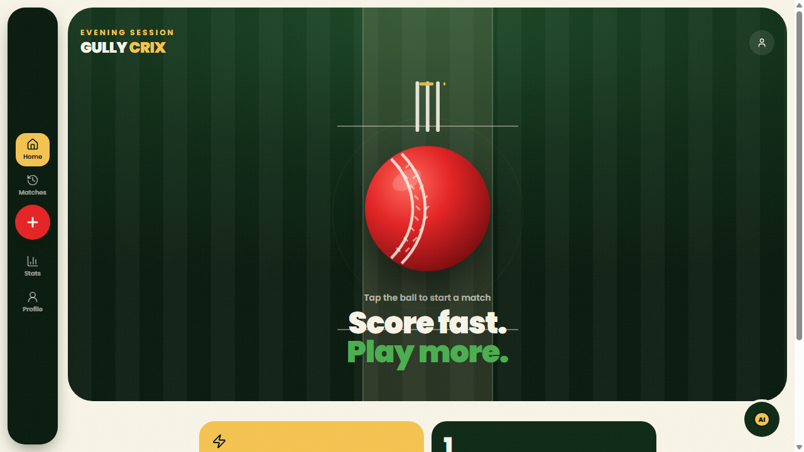

Screenshot 2: Matches Page (Filter Pills & Match Card)
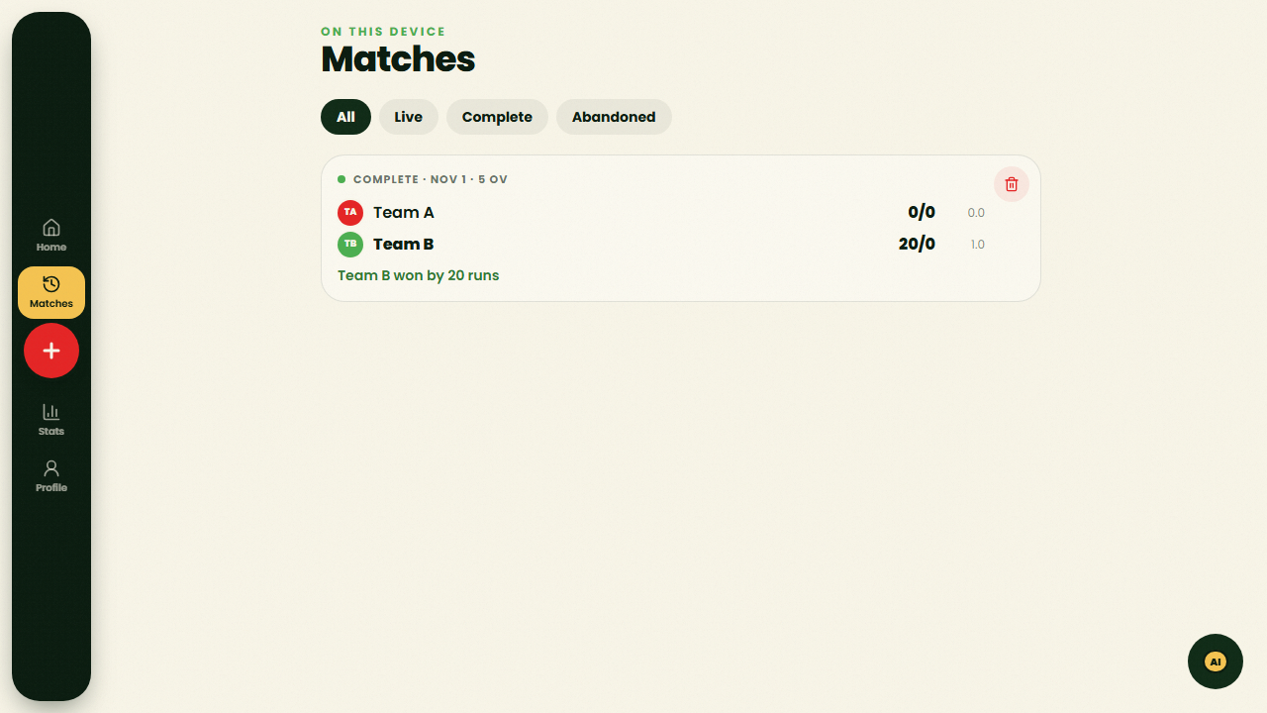
Screenshot 3: Stats Page (Real-Time Calculated Statistics)
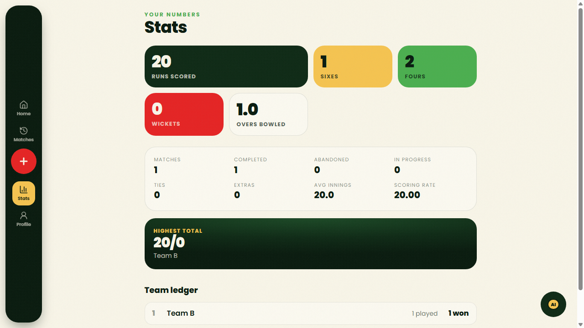

Screenshot 4: Profile Page (Scorer Settings & Data Controls)
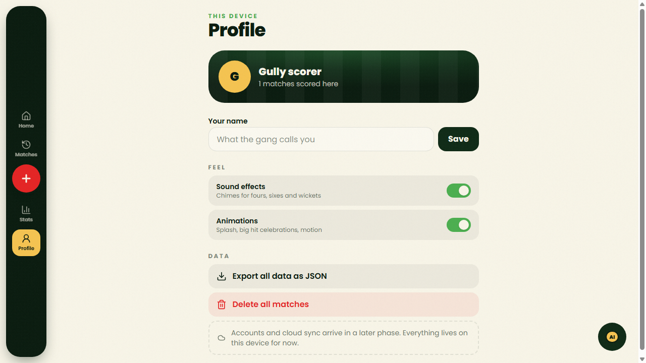
Screenshot 5: Gully AI Chatbot Drawer Open
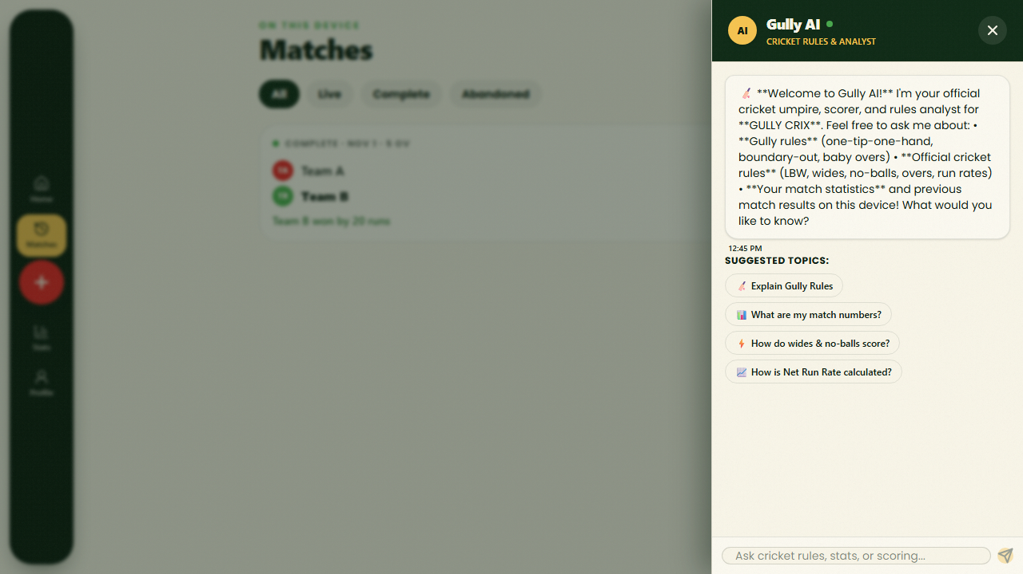

Testing
Test Case | Expected Result | Actual Result | Status
Sidebar navigation (Home, Matches, Stats, Profile) | Navigates smoothly to each view without page reload | Navigated cleanly to all 4 views via Wouter router | Pass
Match creation & live ball scoring | Runs, wickets, overs, and extras update immediately | Scoreboard and localStorage updated on every ball | Pass
Match history filtering & delete confirmation | Filters match status and confirms before deletion | All/Live/Complete/Abandoned filters and delete worked | Pass
Dynamic statistics & JSON export | Stats match stored events and JSON downloads cleanly | 20 runs, 1 six, 2 fours, 1.0 ov calculated accurately | Pass
Gully AI chat API & offline fallback | POST /api/chat returns formatted cricket & stats answer | HTTP 200 returned clean markdown + match stats | Pass
Server health & responsive layout | GET /api/health returns 200; UI adapts to mobile | Health check OK and responsive drawer/nav verified | Pass
Learning Outcomes
Through this assignment, I gained hands-on experience building a complete full-stack web application using React.js, Tailwind CSS, ES6+ JavaScript, Node.js, and Express.js. I learned how to manage event-sourced application state with localStorage persistence, calculate dynamic sports statistics from raw ball-by-ball records, design RESTful API endpoints (/api/health and /api/chat) with environment-based secret management, integrate external AI APIs with graceful fallback handling, and configure cloud deployments using GitHub, Render, and Vercel.

