Новиков Я.В. Школа Eltex. Модуль 4, ЛР2.

1) Для заданной на схеме schema-lab2 сети, состоящей из управляемых коммутаторов и персональных компьютеров настроить протокол STP, назначив явно один из коммутаторов корневым настройкой приоритета

Настройка НЕ корневых коммутаторов:
vIOS-L2-01>enable
vIOS-L2-01#conf t
Enter configuration commands, one per line. End with CNTL/Z.
vIOS-L2-01(config)#spanni
vIOS-L2-01(config)#spanning-tree vlan 1

Настройка корневого коммутатора:
vIOS-L2-01>enable
vIOS-L2-01#conf t
Enter configuration commands, one per line. End with CNTL/Z.
vIOS-L2-01(config)#sp
vIOS-L2-01(config)#spanning-tree vlan 1 prio
vIOS-L2-01(config)#spanning-tree vlan 1 priority 4096

Проверка дерева:
vIOS-L2-01(config)#exit
vIOS-L2-01#
*Apr 27 10:26:22.411: %SYS-5-CONFIG_I: Configured from console by console
vIOS-L2-01#show spann
vIOS-L2-01#show spanning-tree

VLAN0001
Spanning tree enabled protocol ieee
Root ID Priority 4097
Address 0ca3.bb42.0000
Cost 4
Port 3 (GigabitEthernet0/2)
Hello Time 2 sec Max Age 20 sec Forward Delay 15 sec

Bridge ID Priority 32769 (priority 32768 sys-id-ext 1)
Address 0c24.b22a.0000
Hello Time 2 sec Max Age 20 sec Forward Delay 15 sec
Aging Time 300 sec

Interface Role Sts Cost Prio.Nbr Type
------------------- ---- --- --------- -------- --------------------------------
Gi0/0 Desg FWD 4 128.1 Shr
Gi0/1 Desg FWD 4 128.2 Shr
Gi0/2 Root FWD 4 128.3 Shr
Gi0/3 Altn BLK 4 128.4 Shr
Gi1/0 Desg FWD 4 128.5 Shr
Gi1/1 Desg FWD 4 128.6 Shr

VLAN0100
Spanning tree enabled protocol ieee
Root ID Priority 32868
Address 0c24.b22a.0000
This bridge is the root
Hello Time 2 sec Max Age 20 sec Forward Delay 15 sec

Bridge ID Priority 32868 (priority 32768 sys-id-ext 100)
Address 0c24.b22a.0000
Hello Time 2 sec Max Age 20 sec Forward Delay 15 sec
Aging Time 300 sec

Interface Role Sts Cost Prio.Nbr Type
------------------- ---- --- --------- -------- --------------------------------
Gi0/2 Desg FWD 4 128.3 Shr
Gi0/3 Desg FWD 4 128.4 Shr
Gi1/0 Desg FWD 4 128.5 Shr
Gi1/1 Desg FWD 4 128.6 Shr

VLAN0200
Spanning tree enabled protocol ieee
Root ID Priority 32968
Address 0c24.b22a.0000
This bridge is the root
Hello Time 2 sec Max Age 20 sec Forward Delay 15 sec

Bridge ID Priority 32968 (priority 32768 sys-id-ext 200)
Address 0c24.b22a.0000
Hello Time 2 sec Max Age 20 sec Forward Delay 15 sec
Aging Time 300 sec

Interface Role Sts Cost Prio.Nbr Type
------------------- ---- --- --------- -------- --------------------------------
Gi0/2 Desg FWD 4 128.3 Shr
Gi0/3 Desg FWD 4 128.4 Shr
Gi1/0 Desg FWD 4 128.5 Shr
Gi1/1 Desg FWD 4 128.6 Shr

VLAN0300
Spanning tree enabled protocol ieee
Root ID Priority 33068
Address 0c24.b22a.0000
This bridge is the root
Hello Time 2 sec Max Age 20 sec Forward Delay 15 sec

Bridge ID Priority 33068 (priority 32768 sys-id-ext 300)
Address 0c24.b22a.0000
Hello Time 2 sec Max Age 20 sec Forward Delay 15 sec
Aging Time 300 sec

Interface Role Sts Cost Prio.Nbr Type
------------------- ---- --- --------- -------- --------------------------------
Gi0/2 Desg FWD 4 128.3 Shr
Gi0/3 Desg FWD 4 128.4 Shr
Gi1/0 Desg FWD 4 128.5 Shr
Gi1/1 Desg FWD 4 128.6 Shr

2) Проверить доступность каждого с каждым всех персональных компьютеров (VPCS), результаты запротоколировать

Ниже будет представлена проверка доступности для каждого ПК.
PC1:
PC1> ip 192.168.0.2/24 192.168.0.1
Checking for duplicate address...
PC1 : 192.168.0.2 255.255.255.0 gateway 192.168.0.1

PC1>
PC1> ping 192.168.0.3

84 bytes from 192.168.0.3 icmp_seq=1 ttl=64 time=0.973 ms
84 bytes from 192.168.0.3 icmp_seq=2 ttl=64 time=7.660 ms
84 bytes from 192.168.0.3 icmp_seq=3 ttl=64 time=4.866 ms
84 bytes from 192.168.0.3 icmp_seq=4 ttl=64 time=9.343 ms
84 bytes from 192.168.0.3 icmp_seq=5 ttl=64 time=5.526 ms

PC1> ping 192.168.0.4

84 bytes from 192.168.0.4 icmp_seq=1 ttl=64 time=10.182 ms
84 bytes from 192.168.0.4 icmp_seq=2 ttl=64 time=5.844 ms
84 bytes from 192.168.0.4 icmp_seq=3 ttl=64 time=6.170 ms
84 bytes from 192.168.0.4 icmp_seq=4 ttl=64 time=1.956 ms
84 bytes from 192.168.0.4 icmp_seq=5 ttl=64 time=6.219 ms

PC1> ping 192.168.0.5

84 bytes from 192.168.0.5 icmp_seq=1 ttl=64 time=15.291 ms
84 bytes from 192.168.0.5 icmp_seq=2 ttl=64 time=2.250 ms
84 bytes from 192.168.0.5 icmp_seq=3 ttl=64 time=4.757 ms
84 bytes from 192.168.0.5 icmp_seq=4 ttl=64 time=6.623 ms
84 bytes from 192.168.0.5 icmp_seq=5 ttl=64 time=14.649 ms

PC1> ping 192.168.0.6

84 bytes from 192.168.0.6 icmp_seq=1 ttl=64 time=9.366 ms
84 bytes from 192.168.0.6 icmp_seq=2 ttl=64 time=14.130 ms
84 bytes from 192.168.0.6 icmp_seq=3 ttl=64 time=4.459 ms
84 bytes from 192.168.0.6 icmp_seq=4 ttl=64 time=10.010 ms
84 bytes from 192.168.0.6 icmp_seq=5 ttl=64 time=6.980 ms

PC1> ping 192.168.0.7

84 bytes from 192.168.0.7 icmp_seq=1 ttl=64 time=15.664 ms
84 bytes from 192.168.0.7 icmp_seq=2 ttl=64 time=10.058 ms
84 bytes from 192.168.0.7 icmp_seq=3 ttl=64 time=6.757 ms
84 bytes from 192.168.0.7 icmp_seq=4 ttl=64 time=6.863 ms
84 bytes from 192.168.0.7 icmp_seq=5 ttl=64 time=7.090 ms

PC2:
PC2> ip 192.168.0.3/24 192.168.0.1
Checking for duplicate address...
PC2 : 192.168.0.3 255.255.255.0 gateway 192.168.0.1

PC2> ping 192.168.0.4

84 bytes from 192.168.0.4 icmp_seq=1 ttl=64 time=3.249 ms
84 bytes from 192.168.0.4 icmp_seq=2 ttl=64 time=10.023 ms
84 bytes from 192.168.0.4 icmp_seq=3 ttl=64 time=8.965 ms
84 bytes from 192.168.0.4 icmp_seq=4 ttl=64 time=5.382 ms
84 bytes from 192.168.0.4 icmp_seq=5 ttl=64 time=1.635 ms

PC2> ping 192.168.0.2

84 bytes from 192.168.0.2 icmp_seq=1 ttl=64 time=9.447 ms
84 bytes from 192.168.0.2 icmp_seq=2 ttl=64 time=5.566 ms
84 bytes from 192.168.0.2 icmp_seq=3 ttl=64 time=1.940 ms
84 bytes from 192.168.0.2 icmp_seq=4 ttl=64 time=0.663 ms
84 bytes from 192.168.0.2 icmp_seq=5 ttl=64 time=6.240 ms

PC2> ping 192.168.0.5

84 bytes from 192.168.0.5 icmp_seq=1 ttl=64 time=19.727 ms
84 bytes from 192.168.0.5 icmp_seq=2 ttl=64 time=4.897 ms
84 bytes from 192.168.0.5 icmp_seq=3 ttl=64 time=10.096 ms
84 bytes from 192.168.0.5 icmp_seq=4 ttl=64 time=7.389 ms
84 bytes from 192.168.0.5 icmp_seq=5 ttl=64 time=9.107 ms

PC2> ping 192.168.0.6

84 bytes from 192.168.0.6 icmp_seq=1 ttl=64 time=5.628 ms
84 bytes from 192.168.0.6 icmp_seq=2 ttl=64 time=12.285 ms
84 bytes from 192.168.0.6 icmp_seq=3 ttl=64 time=1.970 ms
84 bytes from 192.168.0.6 icmp_seq=4 ttl=64 time=6.979 ms
84 bytes from 192.168.0.6 icmp_seq=5 ttl=64 time=6.746 ms

PC2> ping 192.168.0.7

84 bytes from 192.168.0.7 icmp_seq=1 ttl=64 time=15.734 ms
84 bytes from 192.168.0.7 icmp_seq=2 ttl=64 time=4.082 ms
84 bytes from 192.168.0.7 icmp_seq=3 ttl=64 time=7.811 ms
84 bytes from 192.168.0.7 icmp_seq=4 ttl=64 time=4.376 ms
84 bytes from 192.168.0.7 icmp_seq=5 ttl=64 time=7.019 ms

PC3:
PC3> ip 192.168.0.4/24 192.168.0.1
Checking for duplicate address...
PC3 : 192.168.0.4 255.255.255.0 gateway 192.168.0.1

PC3> ping 192.168.0.2

84 bytes from 192.168.0.2 icmp_seq=1 ttl=64 time=11.059 ms
84 bytes from 192.168.0.2 icmp_seq=2 ttl=64 time=9.078 ms
84 bytes from 192.168.0.2 icmp_seq=3 ttl=64 time=11.617 ms
84 bytes from 192.168.0.2 icmp_seq=4 ttl=64 time=5.658 ms
84 bytes from 192.168.0.2 icmp_seq=5 ttl=64 time=3.942 ms

PC3> ping 192.168.0.3

84 bytes from 192.168.0.3 icmp_seq=1 ttl=64 time=15.560 ms
84 bytes from 192.168.0.3 icmp_seq=2 ttl=64 time=4.597 ms
84 bytes from 192.168.0.3 icmp_seq=3 ttl=64 time=3.175 ms
84 bytes from 192.168.0.3 icmp_seq=4 ttl=64 time=7.025 ms
84 bytes from 192.168.0.3 icmp_seq=5 ttl=64 time=8.350 ms

PC3> ping 192.168.0.5

84 bytes from 192.168.0.5 icmp_seq=1 ttl=64 time=1.056 ms
84 bytes from 192.168.0.5 icmp_seq=2 ttl=64 time=11.326 ms
84 bytes from 192.168.0.5 icmp_seq=3 ttl=64 time=1.362 ms
84 bytes from 192.168.0.5 icmp_seq=4 ttl=64 time=0.762 ms
84 bytes from 192.168.0.5 icmp_seq=5 ttl=64 time=3.789 ms

PC3> ping 192.168.0.6

84 bytes from 192.168.0.6 icmp_seq=1 ttl=64 time=18.840 ms
84 bytes from 192.168.0.6 icmp_seq=2 ttl=64 time=7.521 ms
84 bytes from 192.168.0.6 icmp_seq=3 ttl=64 time=1.824 ms
84 bytes from 192.168.0.6 icmp_seq=4 ttl=64 time=4.184 ms
84 bytes from 192.168.0.6 icmp_seq=5 ttl=64 time=5.900 ms

PC3> ping 192.168.0.7

84 bytes from 192.168.0.7 icmp_seq=1 ttl=64 time=9.581 ms
84 bytes from 192.168.0.7 icmp_seq=2 ttl=64 time=6.912 ms
84 bytes from 192.168.0.7 icmp_seq=3 ttl=64 time=5.979 ms
84 bytes from 192.168.0.7 icmp_seq=4 ttl=64 time=8.961 ms
84 bytes from 192.168.0.7 icmp_seq=5 ttl=64 time=6.723 ms

PC4:
PC4> ip 192.168.0.5/24 192.168.0.1
Checking for duplicate address...
PC4 : 192.168.0.5 255.255.255.0 gateway 192.168.0.1

PC4> ping 192.168.0.2

84 bytes from 192.168.0.2 icmp_seq=1 ttl=64 time=3.273 ms
84 bytes from 192.168.0.2 icmp_seq=2 ttl=64 time=10.306 ms
84 bytes from 192.168.0.2 icmp_seq=3 ttl=64 time=10.177 ms
84 bytes from 192.168.0.2 icmp_seq=4 ttl=64 time=7.857 ms
84 bytes from 192.168.0.2 icmp_seq=5 ttl=64 time=6.281 ms

PC4> ping 192.168.0.3

84 bytes from 192.168.0.3 icmp_seq=1 ttl=64 time=12.944 ms
84 bytes from 192.168.0.3 icmp_seq=2 ttl=64 time=5.235 ms
84 bytes from 192.168.0.3 icmp_seq=3 ttl=64 time=13.880 ms
84 bytes from 192.168.0.3 icmp_seq=4 ttl=64 time=5.980 ms
84 bytes from 192.168.0.3 icmp_seq=5 ttl=64 time=5.303 ms

PC4> ping 192.168.0.4

84 bytes from 192.168.0.4 icmp_seq=1 ttl=64 time=7.707 ms
84 bytes from 192.168.0.4 icmp_seq=2 ttl=64 time=0.990 ms
84 bytes from 192.168.0.4 icmp_seq=3 ttl=64 time=5.763 ms
84 bytes from 192.168.0.4 icmp_seq=4 ttl=64 time=6.134 ms
84 bytes from 192.168.0.4 icmp_seq=5 ttl=64 time=8.549 ms

PC4> ping 192.168.0.6

84 bytes from 192.168.0.6 icmp_seq=1 ttl=64 time=15.120 ms
84 bytes from 192.168.0.6 icmp_seq=2 ttl=64 time=6.925 ms
84 bytes from 192.168.0.6 icmp_seq=3 ttl=64 time=2.728 ms
84 bytes from 192.168.0.6 icmp_seq=4 ttl=64 time=14.419 ms
84 bytes from 192.168.0.6 icmp_seq=5 ttl=64 time=10.832 ms

PC4> ping 192.168.0.7

84 bytes from 192.168.0.7 icmp_seq=1 ttl=64 time=13.281 ms
84 bytes from 192.168.0.7 icmp_seq=2 ttl=64 time=10.618 ms
84 bytes from 192.168.0.7 icmp_seq=3 ttl=64 time=3.657 ms
84 bytes from 192.168.0.7 icmp_seq=4 ttl=64 time=10.010 ms
84 bytes from 192.168.0.7 icmp_seq=5 ttl=64 time=12.142 ms

PC5:
PC5> ip 192.168.0.6/24 192.168.0.1
Checking for duplicate address...
PC5 : 192.168.0.6 255.255.255.0 gateway 192.168.0.1

PC5> ping 192.168.0.2

84 bytes from 192.168.0.2 icmp_seq=1 ttl=64 time=3.037 ms
84 bytes from 192.168.0.2 icmp_seq=2 ttl=64 time=8.941 ms
84 bytes from 192.168.0.2 icmp_seq=3 ttl=64 time=3.915 ms
84 bytes from 192.168.0.2 icmp_seq=4 ttl=64 time=5.265 ms
84 bytes from 192.168.0.2 icmp_seq=5 ttl=64 time=5.213 ms

PC5> ping 192.168.0.3

84 bytes from 192.168.0.3 icmp_seq=1 ttl=64 time=10.569 ms
84 bytes from 192.168.0.3 icmp_seq=2 ttl=64 time=6.689 ms
84 bytes from 192.168.0.3 icmp_seq=3 ttl=64 time=5.154 ms
84 bytes from 192.168.0.3 icmp_seq=4 ttl=64 time=10.390 ms
84 bytes from 192.168.0.3 icmp_seq=5 ttl=64 time=6.031 ms

PC5> ping 192.168.0.4

84 bytes from 192.168.0.4 icmp_seq=1 ttl=64 time=9.920 ms
84 bytes from 192.168.0.4 icmp_seq=2 ttl=64 time=3.533 ms
84 bytes from 192.168.0.4 icmp_seq=3 ttl=64 time=8.227 ms
84 bytes from 192.168.0.4 icmp_seq=4 ttl=64 time=4.656 ms
84 bytes from 192.168.0.4 icmp_seq=5 ttl=64 time=4.553 ms

PC5> ping 192.168.0.5

84 bytes from 192.168.0.5 icmp_seq=1 ttl=64 time=6.764 ms
84 bytes from 192.168.0.5 icmp_seq=2 ttl=64 time=2.873 ms
84 bytes from 192.168.0.5 icmp_seq=3 ttl=64 time=3.821 ms
84 bytes from 192.168.0.5 icmp_seq=4 ttl=64 time=5.286 ms
84 bytes from 192.168.0.5 icmp_seq=5 ttl=64 time=10.139 ms

PC5> ping 192.168.0.7

84 bytes from 192.168.0.7 icmp_seq=1 ttl=64 time=1.710 ms
84 bytes from 192.168.0.7 icmp_seq=2 ttl=64 time=1.461 ms
84 bytes from 192.168.0.7 icmp_seq=3 ttl=64 time=7.142 ms
84 bytes from 192.168.0.7 icmp_seq=4 ttl=64 time=1.502 ms
84 bytes from 192.168.0.7 icmp_seq=5 ttl=64 time=5.183 ms

PC6:
PC6> ip 192.168.0.7/24 192.168.0.1
Checking for duplicate address...
PC6 : 192.168.0.7 255.255.255.0 gateway 192.168.0.1

PC6> ping 192.168.0.2

84 bytes from 192.168.0.2 icmp_seq=1 ttl=64 time=7.271 ms
84 bytes from 192.168.0.2 icmp_seq=2 ttl=64 time=7.531 ms
84 bytes from 192.168.0.2 icmp_seq=3 ttl=64 time=1.813 ms
84 bytes from 192.168.0.2 icmp_seq=4 ttl=64 time=6.883 ms
84 bytes from 192.168.0.2 icmp_seq=5 ttl=64 time=7.164 ms

PC6> ping 192.168.0.3

84 bytes from 192.168.0.3 icmp_seq=1 ttl=64 time=15.729 ms
84 bytes from 192.168.0.3 icmp_seq=2 ttl=64 time=10.836 ms
84 bytes from 192.168.0.3 icmp_seq=3 ttl=64 time=6.811 ms
84 bytes from 192.168.0.3 icmp_seq=4 ttl=64 time=3.914 ms
84 bytes from 192.168.0.3 icmp_seq=5 ttl=64 time=7.658 ms

PC6> ping 192.168.0.4

84 bytes from 192.168.0.4 icmp_seq=1 ttl=64 time=6.692 ms
84 bytes from 192.168.0.4 icmp_seq=2 ttl=64 time=1.662 ms
84 bytes from 192.168.0.4 icmp_seq=3 ttl=64 time=4.887 ms
84 bytes from 192.168.0.4 icmp_seq=4 ttl=64 time=7.204 ms
84 bytes from 192.168.0.4 icmp_seq=5 ttl=64 time=1.874 ms

PC6> ping 192.168.0.5

84 bytes from 192.168.0.5 icmp_seq=1 ttl=64 time=9.340 ms
84 bytes from 192.168.0.5 icmp_seq=2 ttl=64 time=7.583 ms
84 bytes from 192.168.0.5 icmp_seq=3 ttl=64 time=6.663 ms
84 bytes from 192.168.0.5 icmp_seq=4 ttl=64 time=7.799 ms
84 bytes from 192.168.0.5 icmp_seq=5 ttl=64 time=6.972 ms

PC6> ping 192.168.0.6

84 bytes from 192.168.0.6 icmp_seq=1 ttl=64 time=1.672 ms
84 bytes from 192.168.0.6 icmp_seq=2 ttl=64 time=0.656 ms
84 bytes from 192.168.0.6 icmp_seq=3 ttl=64 time=6.027 ms
84 bytes from 192.168.0.6 icmp_seq=4 ttl=64 time=7.293 ms
84 bytes from 192.168.0.6 icmp_seq=5 ttl=64 time=2.728 ms

3) На изображении схемы отметить BID каждого коммутатора и режимы работы портов (RP/DP/blocked) и стоимости маршрутов, результат сохранить в файл

Для получения BID воспользуемся следующей командой
vIOS-L2-01#show spanning-tree vlan 1
VLAN0001
Spanning tree enabled protocol ieee
Root ID Priority 32769
Address 0c24.b22a.0000
Cost 8
Port 5 (GigabitEthernet1/0)
Hello Time 2 sec Max Age 20 sec Forward Delay 15 sec
Bridge ID Priority 32769 (priority 32768 sys-id-ext 1)
Address 0cc9.9620.0000
Hello Time 2 sec Max Age 20 sec Forward Delay 15 sec
Aging Time 300 sec

Фактически BID – это Priority:Address. Т.е. для данного коммутатора он будет равным 32769:0cc9.9620.0000.

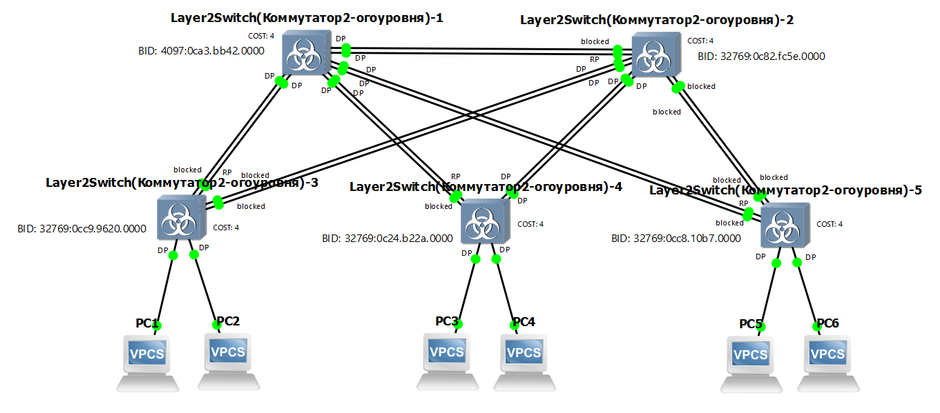
Рисунок 1 – Схема сети со всеми требуемыми обозначениями

4) При помощи wireshark отследить передачу пакетов hello от корневого коммутатора на всех линках (nb!), результаты включить в отчет
Поскольку по условию задания анализ заголовков пакетов не требуется, ниже будет представлено по одному скриншоту пакета для каждого линка (см. рис. 2-21).
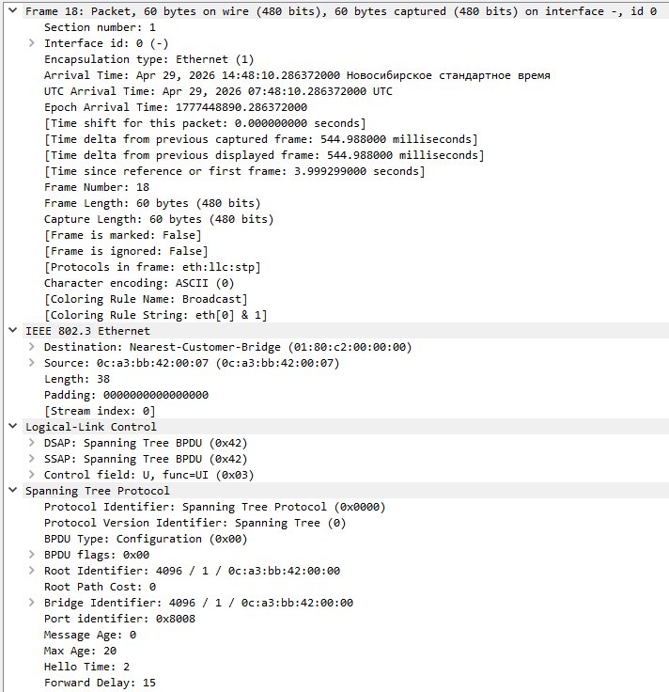
Рисунок 2 – hello-пакет на линке SW1-SW2 (Ethernet 7 – Ethernet 7)

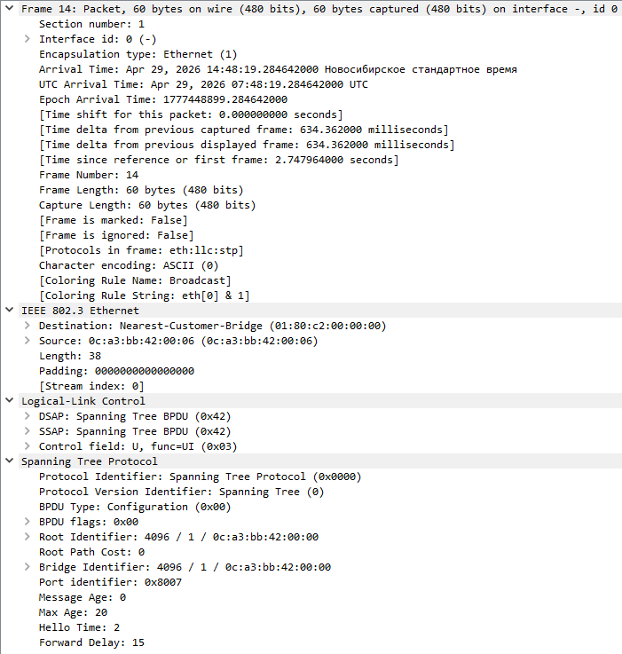
Рисунок 3 - hello-пакет на линке SW1-SW2 (Ethernet 6 – Ethernet 6)

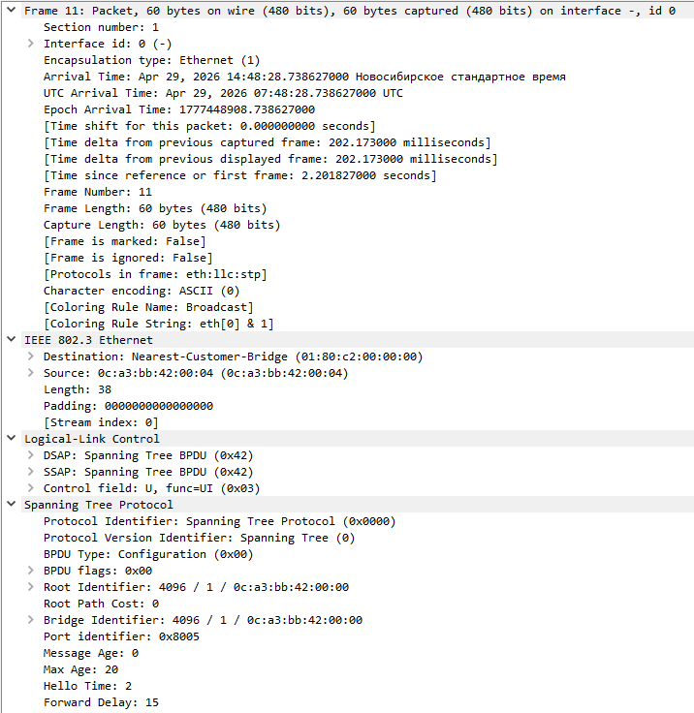
Рисунок 4 - hello-пакет на линке SW1-SW5 (Ethernet 4 – Ethernet 2)

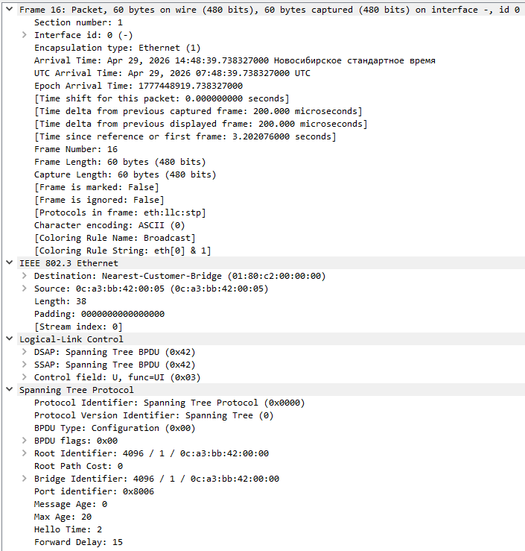
Рисунок 5 - hello-пакет на линке SW1-SW5 (Ethernet 5 – Ethernet 3)

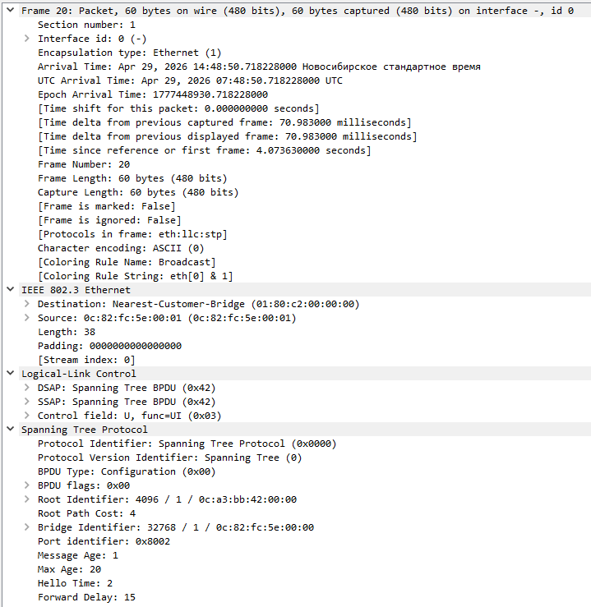
Рисунок 6 - hello-пакет на линке SW2-SW3 (Ethernet 1 – Ethernet 5)

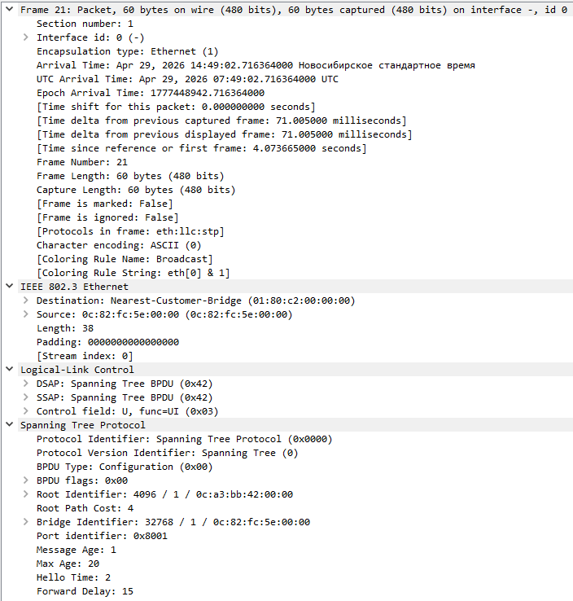
Рисунок 7 - hello-пакет на линке SW2-SW3 (Ethernet 0 – Ethernet 4)

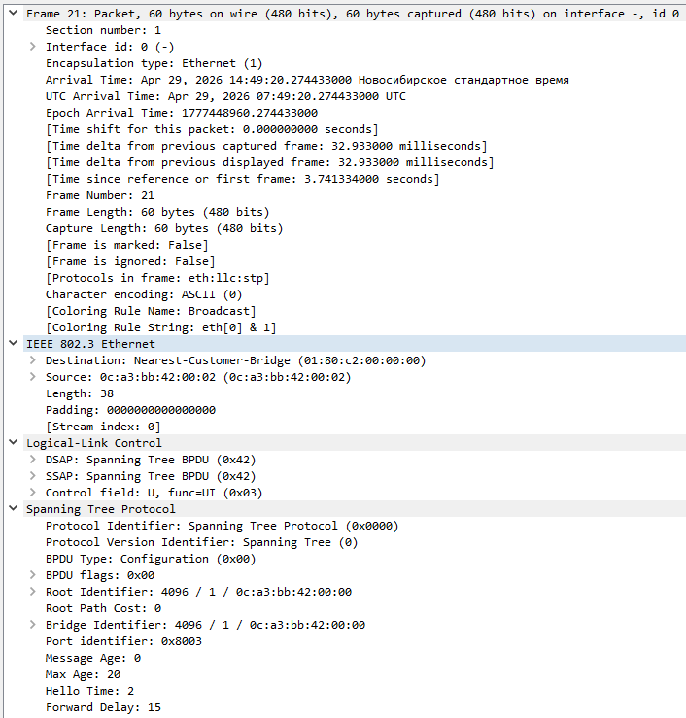
Рисунок 8 - hello-пакет на линке SW1-SW4 (Ethernet 2 – Ethernet 2)

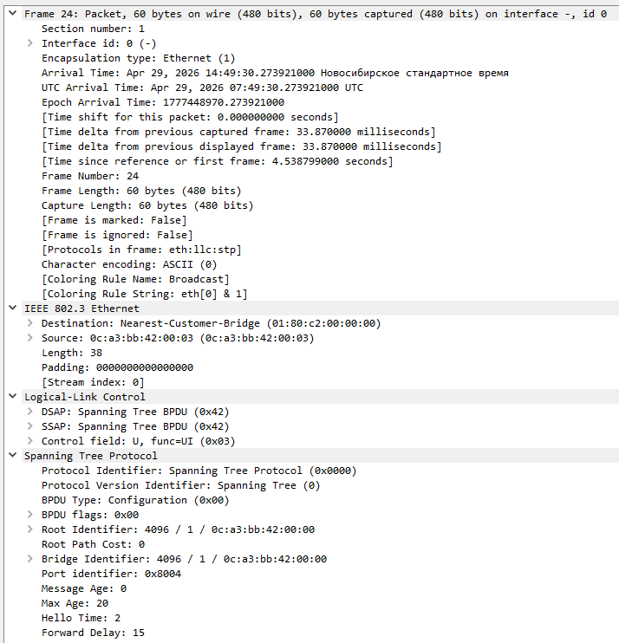
Рисунок 9 - hello-пакет на линке SW1-SW4 (Ethernet 3 – Ethernet 3)

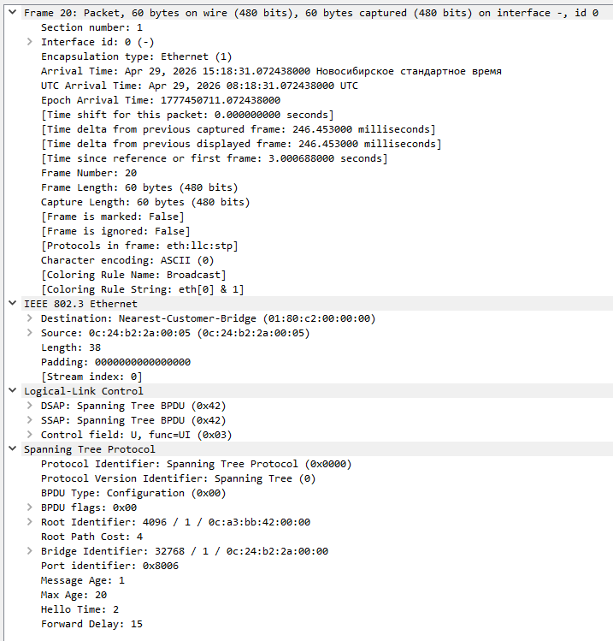
Рисунок 10 - hello-пакет на линке SW2-SW4 (Ethernet 3 – Ethernet 5)

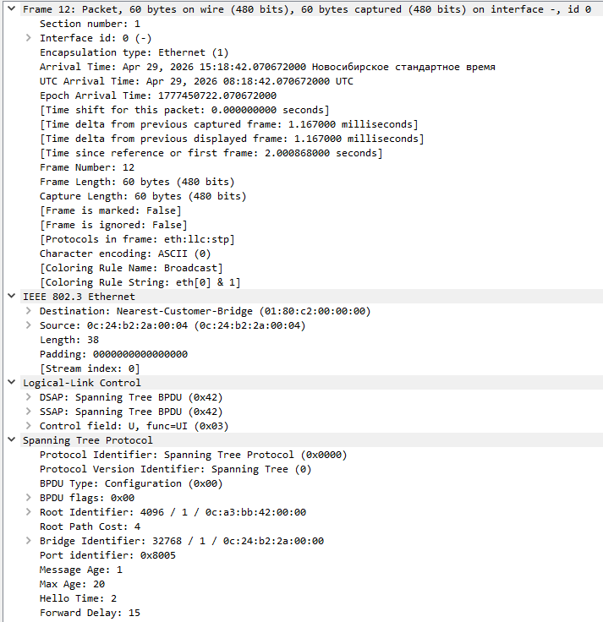
Рисунок 11 - hello-пакет на линке SW2-SW4 (Ethernet 2 – Ethernet 4)

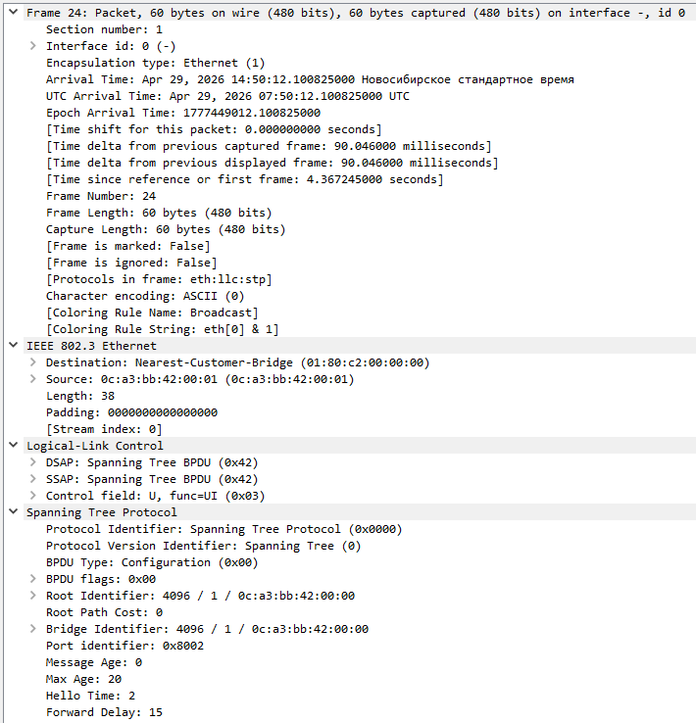
Рисунок 12 - hello-пакет на линке SW1-SW3 (Ethernet 1 – Ethernet 3)

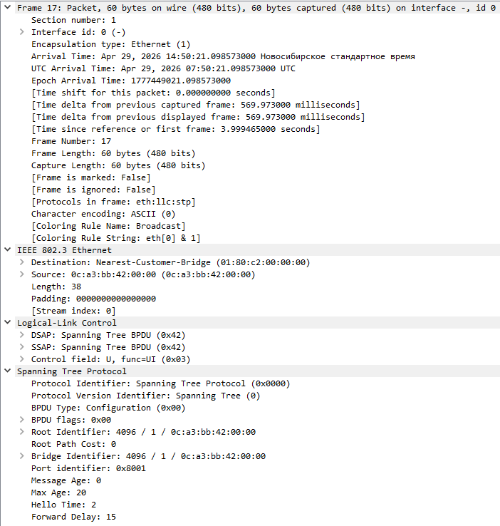
Рисунок 13 - hello-пакет на линке SW1-SW3 (Ethernet 0 – Ethernet 2)

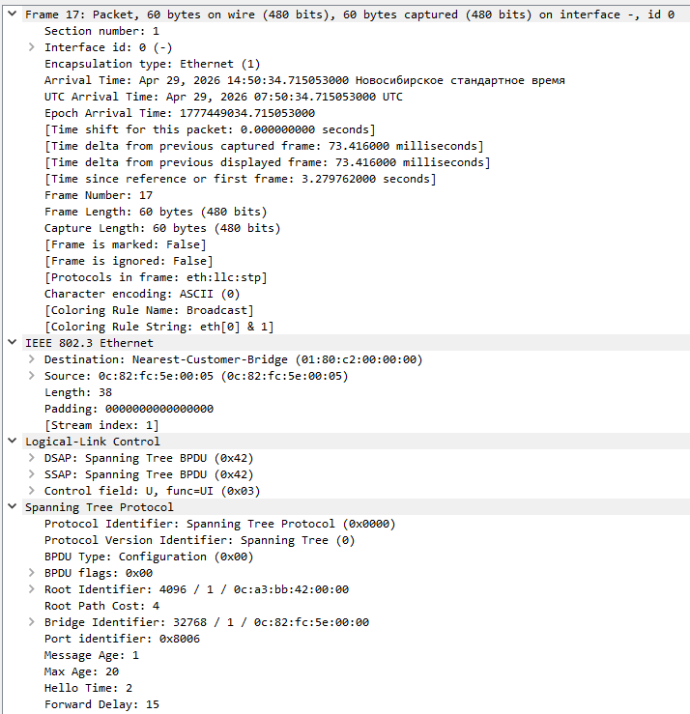
Рисунок 14 - hello-пакет на линке SW2-SW5 (Ethernet 5 – Ethernet 5)

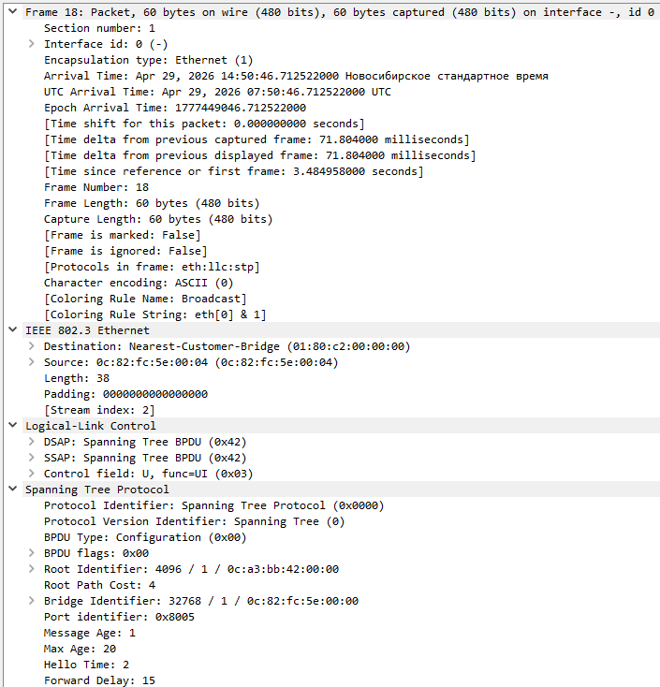
Рисунок 15 - hello-пакет на линке SW2-SW5 (Ethernet 4 – Ethernet 4)

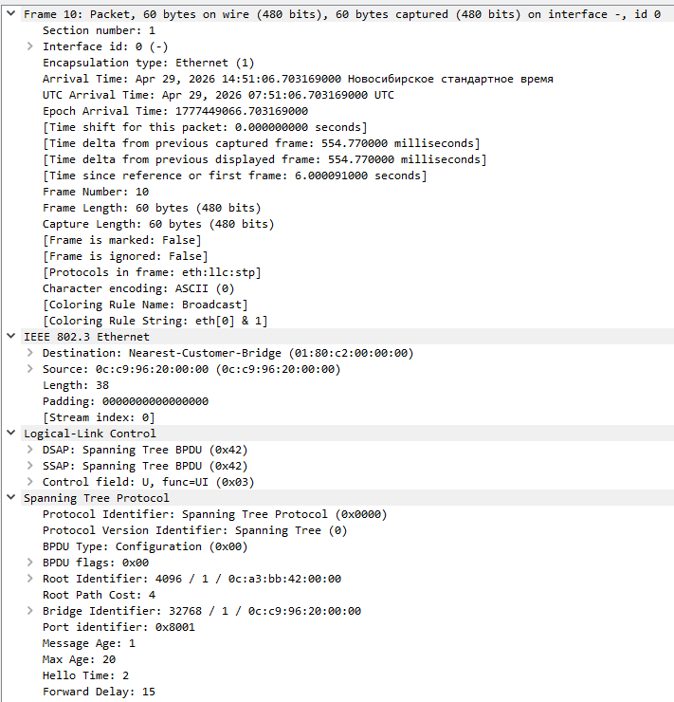
Рисунок 16 - hello-пакет на линке SW3-PC1 (Ethernet 0 – Ethernet 0)

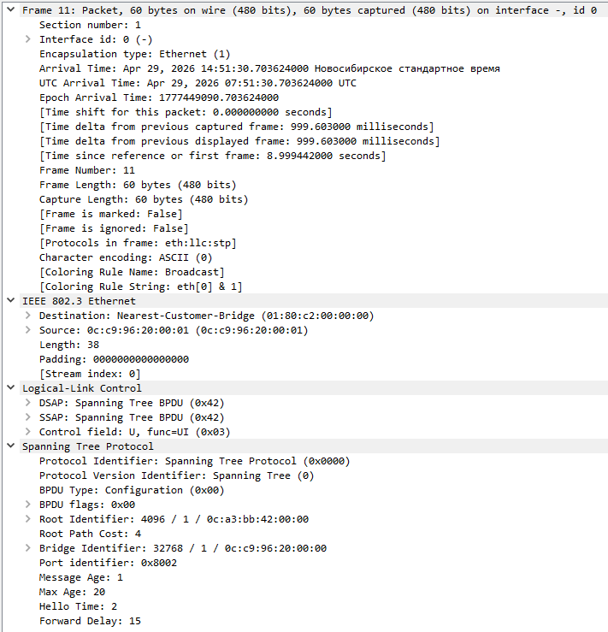
Рисунок 17 - hello-пакет на линке SW3-PC2 (Ethernet 1 – Ethernet 0)

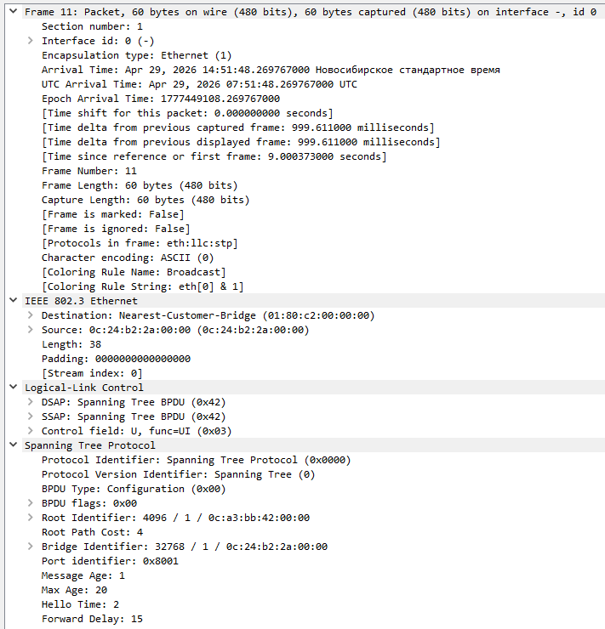
Рисунок 18 - hello-пакет на линке SW4-PC3 (Ethernet 0 – Ethernet 0)

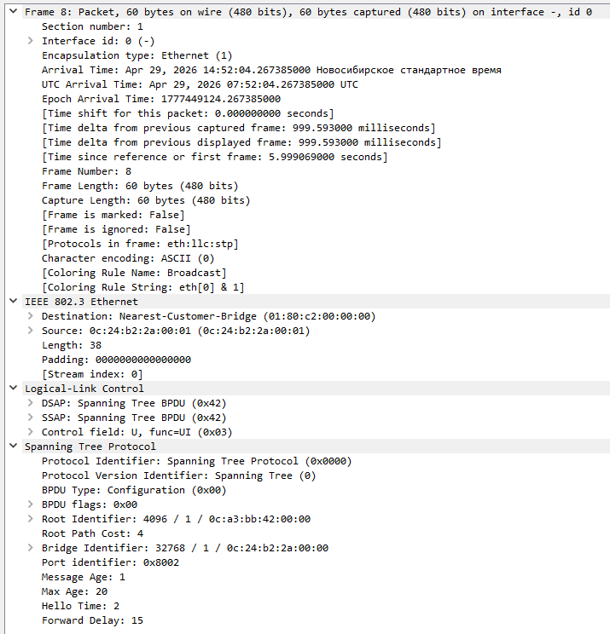
Рисунок 19 - hello-пакет на линке SW4-PC4 (Ethernet 1 – Ethernet 0)

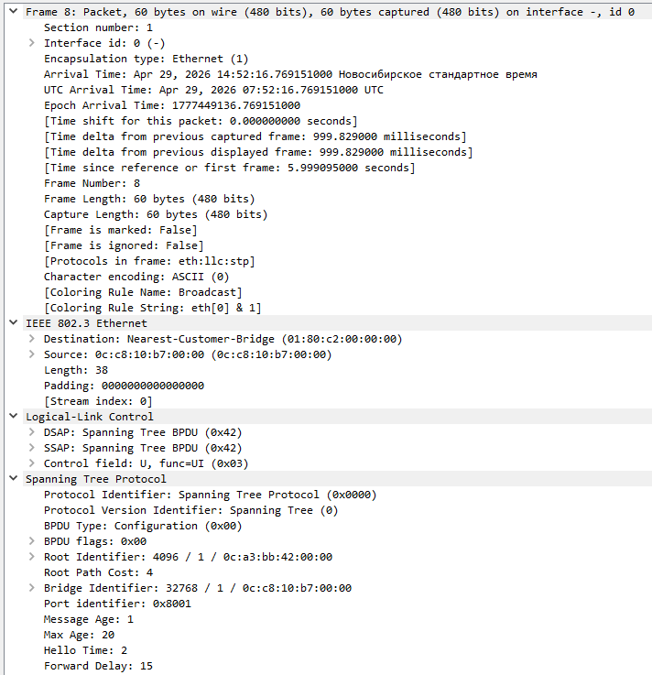
Рисунок 20 - hello-пакет на линке SW5-PC5 (Ethernet 0 – Ethernet 0)

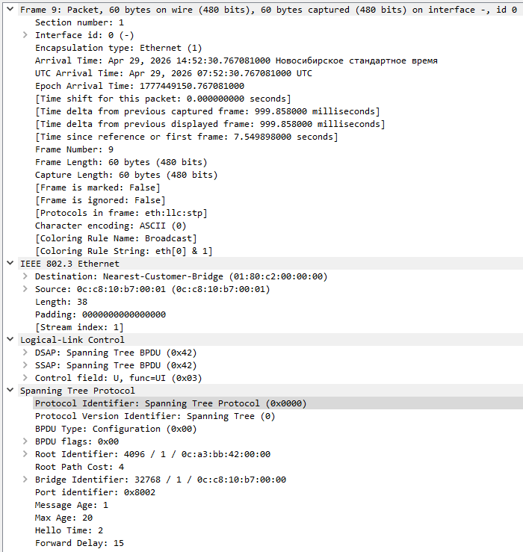
Рисунок 21 - hello-пакет на линке SW5-PC6 (Ethernet 1 – Ethernet 0)

Также вкратце опишу, почему эти пакеты были отнесены к «hello-пакетам». В сетях STP hello-пакетами называют Configuration Bridge Protocol Data Units (Configuration BPDU) — служебные кадры, которыми коммутаторы обмениваются для построения топологии без петель. Из содержимого таких пакетов видим:
- Protocol Identifier: Spanning Tree Protocol (0x0000)
- BPDU Type: Configuration (0x00) – т.е. Configuration BPDU.
5) Изменить стоимость маршрута для порта RP произвольного назначенного (designated) коммутатора, повторить действия из п.3, результат сохранить в отдельный файл
Ниже представлено изменение стоимости маршрута для порта RP второго коммутатора:
vIOS-L2-01#show spanning-tree vlan 1

VLAN0001
Spanning tree enabled protocol ieee
Root ID Priority 4097
Address 0ca3.bb42.0000
Cost 4
Port 7 (GigabitEthernet1/2)
Hello Time 2 sec Max Age 20 sec Forward Delay 15 sec

Bridge ID Priority 32769 (priority 32768 sys-id-ext 1)
Address 0c82.fc5e.0000
Hello Time 2 sec Max Age 20 sec Forward Delay 15 sec
Aging Time 300 sec

Interface Role Sts Cost Prio.Nbr Type
------------------- ---- --- --------- -------- --------------------------------
Gi0/0 Desg FWD 4 128.1 Shr
Gi0/1 Desg FWD 4 128.2 Shr
Gi0/2 Altn BLK 4 128.3 Shr
Gi0/3 Altn BLK 4 128.4 Shr
Gi1/0 Desg FWD 4 128.5 Shr
Gi1/1 Desg FWD 4 128.6 Shr
Gi1/2 Root FWD 4 128.7 Shr
Gi1/3 Altn BLK 4 128.8 Shr

vIOS-L2-01#
vIOS-L2-01#conf t
Enter configuration commands, one per line. End with CNTL/Z.
vIOS-L2-01(config)#int
vIOS-L2-01(config)#interface gi
vIOS-L2-01(config)#interface gigabitEthernet 1/2
vIOS-L2-01(config-if)#span
vIOS-L2-01(config-if)#spanning-tree cost 100000
vIOS-L2-01(config-if)#end
vIOS-L2-01#
*Apr 29 09:41:24.284: %SYS-5-CONFIG_I: Configured from console by console

После изменения стоимости, на каждом коммутаторе была повторно выполнена команда «show spanning-tree vlan 1» и выполнены корректировки в схеме сети (см. рис. 22).
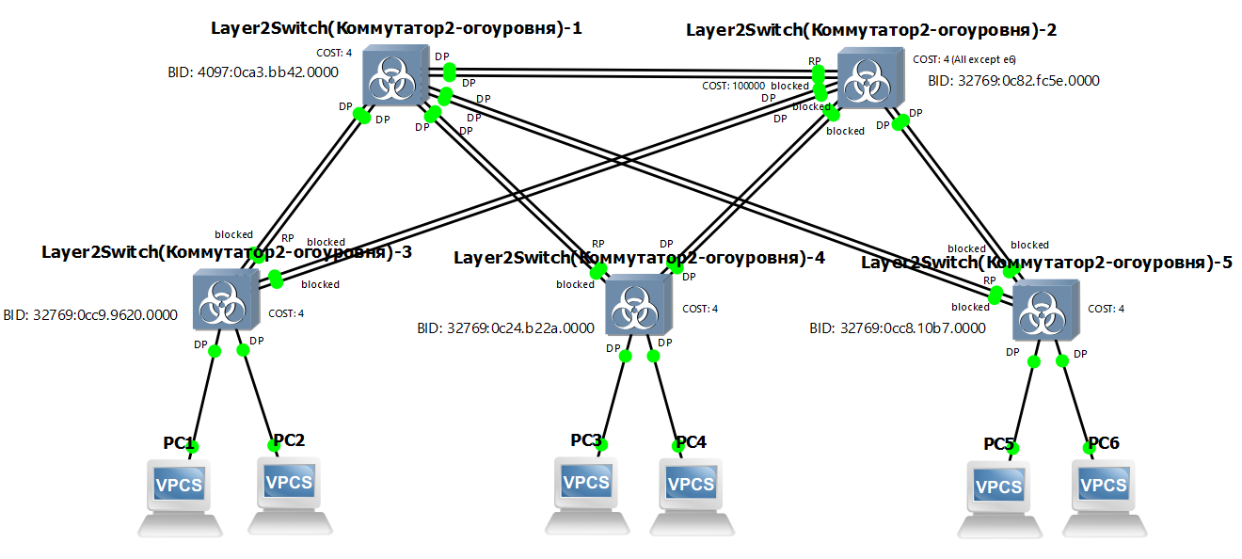
Рисунок 22 – Скорректированная схема сети под изменённый cost

Фактически корневой порт переместился на смежную линию.
6) Сохранить файлы конфигураций устройств в виде набора файлов с именами, соответствующими именам устройств
На каждом коммутаторе выполняем:
vIOS-L2-01>enable
vIOS-L2-01#cop
vIOS-L2-01#copy runn
vIOS-L2-01#copy running-config start
vIOS-L2-01#copy running-config startup-config
Destination filename [startup-config]?
Building configuration...
Compressed configuration from 5211 bytes to 2003 bytes[OK]
vIOS-L2-01#
*Apr 29 10:01:58.863: %GRUB-5-CONFIG_WRITING: GRUB configuration is being updated on disk. Please wait...
*Apr 29 10:01:59.616: %GRUB-5-CONFIG_WRITTEN: GRUB configuration was written to disk successfully.
vIOS-L2-01#show running-
vIOS-L2-01#show running-config

После чего копируем вывод в текстовый файл с соответствующим устройству именем.

