## Policies开发

类路径：sdwanmano001\sdwan\sdwan-service\src\main\java\com\cmcc\sdwan\controller\PoliciesController.java

1. 查询列表

接口路径：/controller/sdwan/v1/policies

请求方式：GET

路径传参：

|  |  |  |
| --- | --- | --- |
| offset | Integer | 起始位置 |
| limit | Integer | 展示条数 |
| name | String | 需要查询的名称 |
| Device_name | String | 设备名 |
| User_name | String | 组织名 |

返回参数：

|  |
| --- |
| {  "status": "0000",  "message": "Success",  "result": {  "rules": {  "app-qos-policy": [  {  "name": "test001",  "description": "123",  "set": {  "action": "allow",  "tcp-session-keepalive": "disabled",  "qos-profile": "tesstProfile"  }  },  {  "name": "12321",  "description": "1",  "set": {  "action": "allow",  "tcp-session-keepalive": "disabled",  "qos-profile": "tesstProfile"  }  }  ]  }  }  } |

1. 增加policies

接口路径：/controller/sdwan/v1/policies

请求方式：POST

路径传参：

|  |  |  |
| --- | --- | --- |
| Device_name | String | 设备名 |
| User_name | String | 组织名 |

对象传参：

|  |
| --- |
| {  "name": "xxxxx",  "description": "miaoshu",  "tag": ["1","2"],  "match": {  "source": {  "zone": {  "zoneList": ["Intf-CM-Cloud-Zone","Intf-DF-MPLS-Zone"]  },  "address": {  "addressList":[],  "addressGroupList":[],  "negate":""  },  "region": ["CA"]  },  "destination": {  "zone": {  "zoneList": ["Intf-CM-Cloud-Zone"]  },  "address": {  "addressList":[],  "addressGroupList":[],  "negate":""  },  "region": ["CA"]  },  "services": {  "predefinedServicesList": ["tcpmux"]  },  "application": {  "predefinedApplicationList": ["01NET"]  },  "urlCategory": {  "predefined": ["abortion"]  },  "ipVersion": "ipv4",  "ipFlags": "DF",  "dscp": ["1"],  "ttl": {"le": "2"}  },  "set": {  "action": "allow",  "qosProfile": "kang123",  "sessionTimeout": "1",  "tcpSessionKeepalive": "enabled"  }  } |

返回参数：

|  |
| --- |
| {  "status": "0000",  "message": "Success",  "result": null  } |

1. 修改policies

接口路径：/controller/sdwan/v1/policies/update/{id}

请求方式：POST

路径传参：

|  |  |  |
| --- | --- | --- |
| Device_name | String | 设备名 |
| User_name | String | 组织名 |

对象传参：

|  |
| --- |
| {  "name": "xxxxx",  "description": "miaoshu",  "tag": ["1","2"],  "match": {  "source": {  "zone": {  "zoneList": ["Intf-CM-Cloud-Zone","Intf-DF-MPLS-Zone"]  },  "address": {},  "region": ["CA"]  },  "destination": {  "zone": {  "zoneList": ["Intf-CM-Cloud-Zone"]  },  "address": {},  "region": ["CA"]  },  "services": {  "predefinedServicesList": ["tcpmux"]  },  "application": {  "predefinedApplicationList": ["01NET"]  },  "urlCategory": {  "predefined": ["abortion"]  },  "ipVersion": "ipv4",  "ipFlags": "DF",  "dscp": ["1"],  "ttl": {"le": "2"}  },  "set": {  "action": "allow",  "qosProfile": "kang123",  "sessionTimeout": "1",  "tcpSessionKeepalive": "enabled"  }  } |

返回参数：

|  |
| --- |
| {  "status": "0000",  "message": "Success",  "result": null  } |

1. 删除policies

接口路径：/controller/sdwan/v1/policies/delete/{id}

请求方式：POST

路径请求：

|  |  |  |
| --- | --- | --- |
| Device_name | String | 设备名 |
| User_name | String | 组织名 |

返回参数：

|  |
| --- |
| {  "status": "0000",  "message": "Success",  "result": null  } |

## Address开发

类路径：sdwanmano001\sdwan\sdwan-service\src\main\java\com\cmcc\sdwan\controller\AddressController.java

1. Address接口列表

请求路径：/controller/sdwan/v1/address

请求方式：GET

请求参数：

|  |  |  |
| --- | --- | --- |
| offset | Integer | 起始位置 |
| limit | Integer | 展示条数 |
| name | String | 需要查询的名称 |
| Device_name | String | 设备名 |
| User_name | String | 组织名 |

返回参数:

|  |
| --- |
| {  "status": "0000",  "message": "Success",  "result": {  "address": [  {  "name": "1",  "dynamic-address": [  null  ],  "match": [  "1"  ]  },  {  "name": "123",  "description": "123",  "tag": [  "123"  ],  "fqdn": "123"  },  {  "name": "kang",  "description": "miao",  "tag": [  "biao",  "qian"  ],  "fqdn": "1"  },  {  "name": "test",  "fqdn": "1111"  },  {  "name": "testname",  "description": "mianshu",  "tag": [  "biaoqian"  ],  "fqdn": "1"  }  ]  }  } |

1. Address接口新增

请求路径：/controller/sdwan/v1/address

请求方式：POST

路径传参：

|  |  |  |
| --- | --- | --- |
| Device_name | String | 设备名 |
| User_name | String | 组织名 |

对象传参：

|  |
| --- |
| {  "name":"xxxxx",  "description":"xxxxx",  "tag":["1","2"],  "type":"ipv4-prefix",  "value":"1.1.1.0/24"  } |

返回参数：

|  |
| --- |
| {  "status": "0000",  "message": "Success",  "result": null  } |

1. Address接口修改

请求路径：/controller/sdwan/v1/address/{id}

请求方式：POST

路径传参：

|  |  |  |
| --- | --- | --- |
| Device_name | String | 设备名 |
| User_name | String | 组织名 |

对象传参：

|  |
| --- |
| {  "name":"xxxxx",  "description":"xxxxx",  "tag":["1","2"],  "type":"ipv4-prefix",  "value":"1.1.1.0/24"  } |

返回参数：

|  |
| --- |
| {  "status": "0000",  "message": "Success",  "result": null  } |

1. Address接口删除

请求路径：/controller/sdwan/v1/address/delAddress/{id]

请求方式：POST

路径传参：

|  |  |  |
| --- | --- | --- |
| Device_name | String | 设备名 |
| User_name | String | 组织名 |

返回参数：

|  |
| --- |
| {  "status": "0000",  "message": "Success",  "result": null  } |

## 其他接口

1. 查询Profile_Setting的值

接口路径：/controller/sdwan/v1/policies/getProfileSetting

请求方式：GET

路径传参：

|  |  |  |
| --- | --- | --- |
| Device_name | String | 设备名 |
| User_name | String | 组织名 |

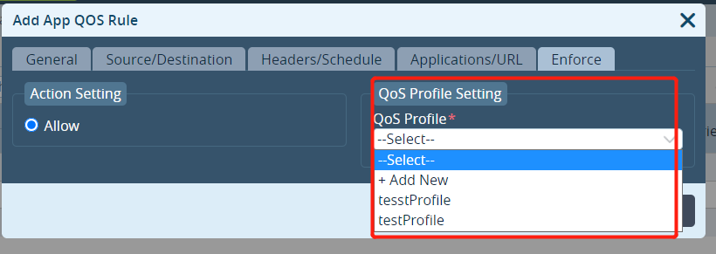

1. Source_zone/Destination里面的Source_zone和Destination_zone值

接口路径：/controller/sdwan/v1/policies/getQOSZone

请求方式：GET

路径传参：

|  |  |  |
| --- | --- | --- |
| Device_name | String | 设备名 |
| User_name | String | 组织名 |

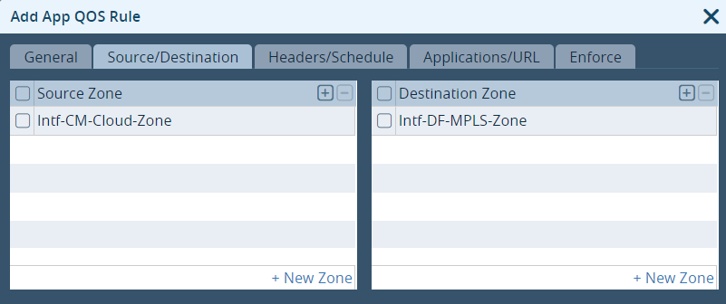

1. Header/Schedules 里 Schedules

接口路径：/controller/sdwan/v1/policies/getSchedules

请求方式：GET

路径传参：

|  |  |  |
| --- | --- | --- |
| Device_name | String | 设备名 |
| User_name | String | 组织名 |

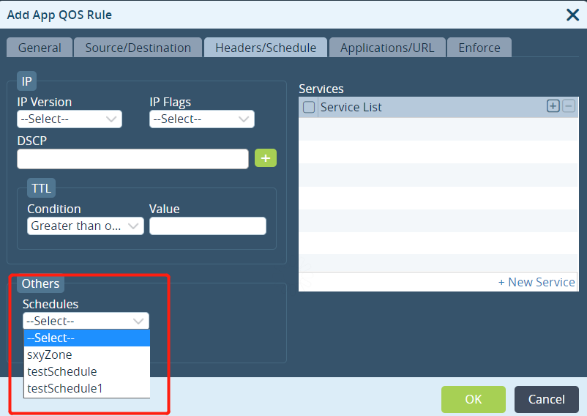

1. Application/URL里的Application List 值

接口路径：/controller/sdwan/v1/policies/getApplications

请求方式：GET

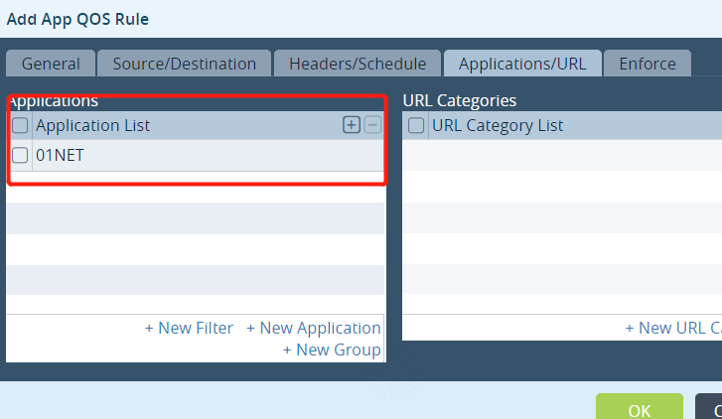

1. Application/URL 里面的 URL Category List

接口路径：/controller/sdwan/v1/policies/getURLCategoryList

请求方式：GET

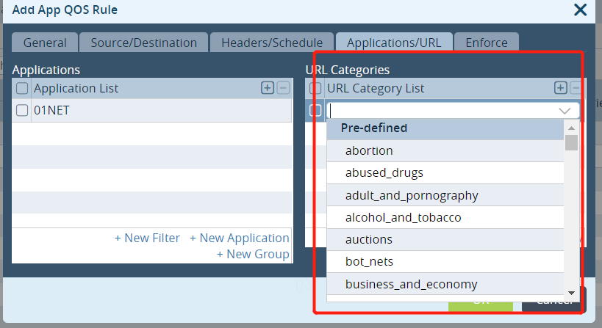

1. Headers/Schedule 里面的 Service List

接口路径：/controller/sdwan/v1/policies/getServiceList

请求方式：GET

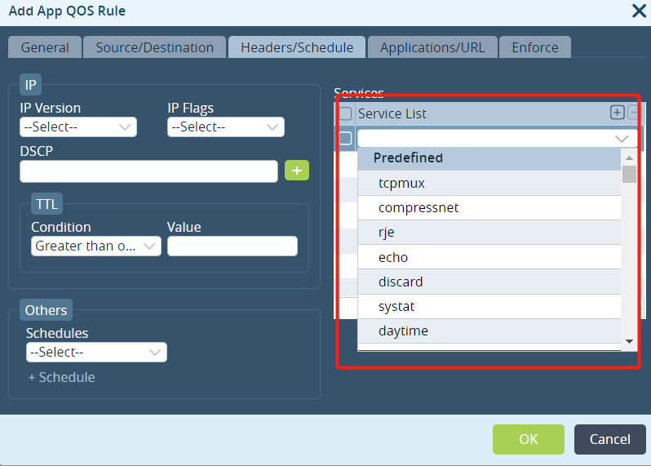

1. Source/Destination 里的 Source Address和Destination Address 数据

接口路径：/controller/sdwan/v1/policies/getDestinationAddress

请求方式：GET

