Российский Университет Транспорта (МИИТ)

Институт Управления и Информационных Технологий

Кафедра “Вычислительные Системы и Сети”

**Пояснительная записка к курсовому проекту**

**по дисциплине:**

**«Вычислительные сети»**

**На тему:**

**«Разработка сети передачи данных с помощью протоколов HSRP, OSPF, BGP.»**

**Выполнил:**

Студент группы УИБ-411

Гуленко Ян Андреевич

**Приняли:**

Желенков Б.В.

Голдовский Я.М.

Москва 2018

**Задание**

Разработать сеть передачи данных предприятия, с использованием протоколов HSRP, OSPF, BGP основываясь на его структуре и политиках доступа, указанных в таблице. Сконфигурировать сеть на реальном оборудовании, с использованием указанных протоколов.

Протестировать работоспособность развёрнутой сети.

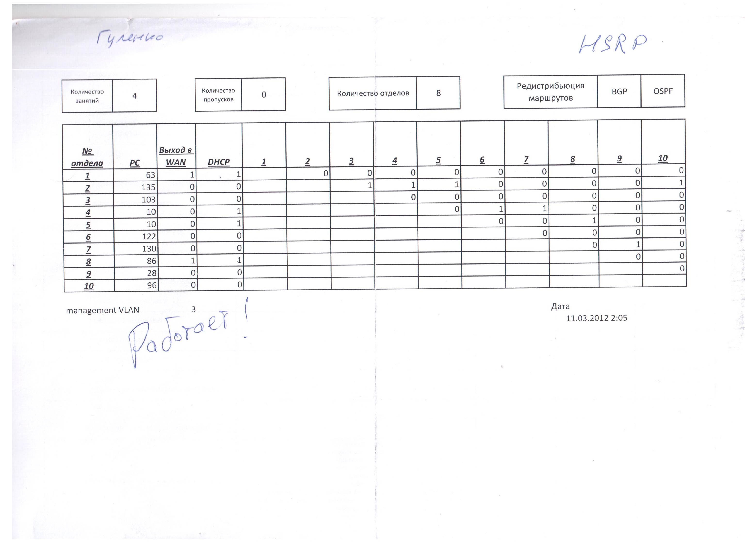

**Оборудование**

1. 3 маршрутизатора Cisco Catalyst 2800
2. 2 коммутатора 3го уровня Cisco 3560 (24 порта FastEthernet + 2 порта GigabitEthernet). *Используется как коммутатор 2го уровня.*
3. Несколько ПК.

|  |  |  |  |  |  |  |  |
| --- | --- | --- | --- | --- | --- | --- | --- |
| № отдела  (№ Vlan) | Число хостов | Выделенных адресов | № сети | Маска | Диапазон | Адрес широковещательной рассылки | Шлюз  (адреса физических шлюзов) |
| 4  (vlan34) | 11 | 16 | 145.110.4.128 | 255.255.255.240 | 145.110.4.129-145.110.4.142 | 145.110.4.143 | 145.110.4.142 |
| 7 (vlan37) | 130 | 256 | 145.110.1.0 | 255.255.255.0 | 145.110.1.1-145.110.1.254 | 145.110.1.255 | 145.110.1.254 |
| 2 (vlan32) | 136 | 256 | 145.110.2.0 | 255.255.255.128 | 145.110.0.1-145.110.0.254 | 145.110.0.255 | 145.110.0.254 |
| 8 (vlan38) | 80 | 128 | 145.110.2.128 | 255.255.255.128 | 145.110.3.129-145.110.3.254 | 145.110.3.255 | 145.110.3.254 |
| 6 (vlan36) | 72 | 130 | 145.110.3.0 | 255.255.255.128 | 145.110.3.1-145.110.3.126 | 145.110.3.127 | 145.110.3.126 |
| 3 (vlan33) | 56 | 64 | 145.110.3.128 | 255.255.255.192 | 145.110.3.129-145.110.1.190 | 145.110.3.191 | 145.110.3.190 |
| 1  (vlan31) | 87 | 128 | 145.110.3.192 | 255.255.255.224 | 145.110.4.1-145.110.4.126 | 145.110.4.127 | 145.110.4.126 |
| 5 (vlan35) | 11 | 16 | 145.110.3.224 | 255.255.255.240 | 145.110.4.145-145.110.4.158 | 145.110.4.159 | 145.110.4.158 |
| *Root-R1* | 2* | 256 | 15.1.1.0 | 255.255.255.0 | 15.1.1.1-15.1.1.254 | 15.1.1.255 | - |
| *Root-R2* | 2* | 256 | 16.1.1.0 | 255.255.255.0 | 16.1.1.1-16.1.1.254 | 16.1.1.255 | - |

# Адресный план сети (145.110.0.0/16) Всего 591 адресов

# *\*адреса для интерфейсов маршрутизаторов в соединениях точка-точка*

**Полная схема сети**

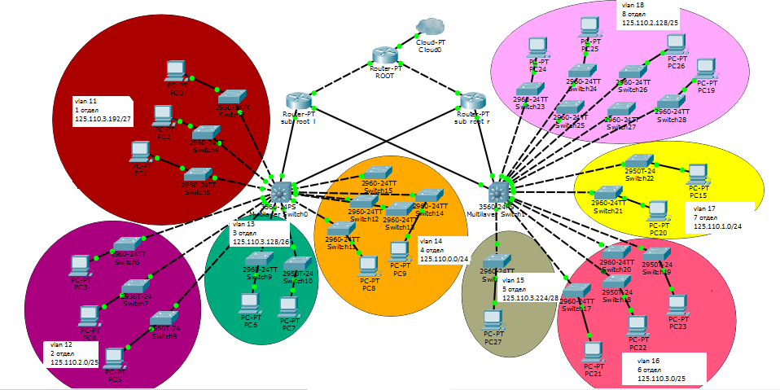

**Упрощённая схема, для сборки на оборудовании**

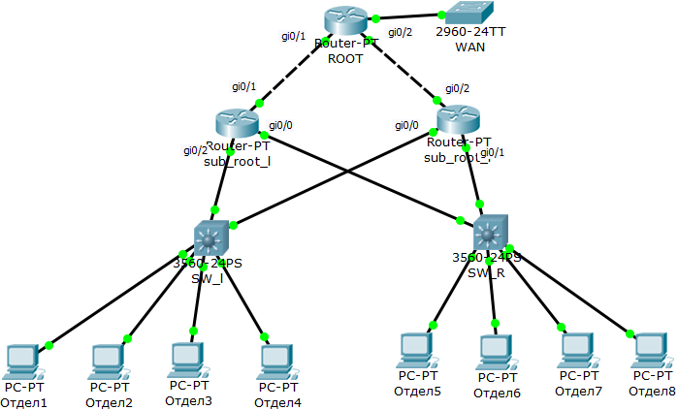

**Конфигурация оборудования**

**Маршрутизаторы:**

**ROOT**

ROOOT#sh run

Building configuration...

Current configuration : 1705 bytes

!

version 12.4

service timestamps debug datetime msec

service timestamps log datetime msec

no service password-encryption

!

hostname ROOOT

!

boot-start-marker

boot-end-marker

!

!

no aaa new-model

!

resource policy

!

memory-size iomem 5

ip subnet-zero

!

!

ip cef

!

!

!

!

voice-card 0

no dspfarm

!

!

!

!

!

!

!

!

!

!

!

!

!

!

!

!

!

!

!

!

!

!

interface GigabitEthernet0/0

ip address 17.1.1.1 255.255.255.0

ip access-group WAN out

ip nat outside

ip virtual-reassembly

duplex auto

speed auto

!

interface GigabitEthernet0/1

no ip address

duplex auto

speed auto

!

interface Serial0/0/0

ip address 15.1.1.2 255.255.255.0

ip nat inside

ip virtual-reassembly

clock rate 125000

!

interface Serial0/0/1

ip address 16.1.1.2 255.255.255.0

ip nat inside

ip virtual-reassembly

!

router ospf 1

log-adjacency-changes

redistribute bgp 65000 metric 1

network 15.0.0.0 0.0.0.255 area 0

network 16.0.0.0 0.0.0.255 area 0

network 17.0.0.0 0.0.0.255 area 0

default-information originate

!

router bgp 65000

no synchronization

bgp router-id 3.3.3.3

bgp log-neighbor-changes

network 15.1.1.0

network 16.1.1.0

network 17.1.1.0

redistribute ospf 1 metric 0

neighbor 16.1.1.1 remote-as 65000

neighbor 16.1.1.1 default-originate

default-information originate

no auto-summary

!

ip classless

ip route 0.0.0.0 0.0.0.0 GigabitEthernet0/0

!

!

ip http server

no ip http secure-server

ip nat inside source list 1 interface GigabitEthernet0/0 overload

!

ip access-list standard WAN

permit 17.1.1.1

!

access-list 1 permit 145.110.4.0 0.0.0.15

access-list 1 permit 145.110.3.128 0.0.0.127

!

!

!

!

control-plane

!

!

!

!

!

!

!

!

!

!

line con 0

line aux 0

line vty 0 4

login

!

scheduler allocate 20000 1000

!

End

**R1**

BGP1#SH RUN

Building configuration...

Current configuration : 6676 bytes

!

version 12.4

service timestamps debug datetime msec

service timestamps log datetime msec

no service password-encryption

!

hostname BGP1

!

boot-start-marker

boot-end-marker

!

!

no aaa new-model

!

resource policy

!

memory-size iomem 5

ip subnet-zero

!

!

ip cef

ip dhcp use vrf connected

ip dhcp excluded-address 145.110.0.1

ip dhcp excluded-address 145.110.0.2

ip dhcp excluded-address 145.110.1.1

ip dhcp excluded-address 145.110.1.2

ip dhcp excluded-address 145.110.2.1

ip dhcp excluded-address 145.110.2.2

ip dhcp excluded-address 145.110.3.1

ip dhcp excluded-address 145.110.3.2

ip dhcp excluded-address 145.110.3.129

ip dhcp excluded-address 145.110.3.130

ip dhcp excluded-address 145.110.4.1

ip dhcp excluded-address 145.110.4.2

ip dhcp excluded-address 145.110.4.129

ip dhcp excluded-address 145.110.4.130

ip dhcp excluded-address 145.110.4.145

ip dhcp excluded-address 145.110.4.146

!

ip dhcp pool 1_otd

network 145.110.4.0 255.255.255.128

default-router 145.110.4.126

!

ip dhcp pool 4_otd

network 145.110.4.128 255.255.255.240

default-router 145.110.4.142

!

ip dhcp pool 5_otd

network 145.110.4.144 255.255.255.240

default-router 145.110.4.158

!

ip dhcp pool 8_otd

network 145.110.3.128 255.255.255.128

default-router 145.110.3.254

!

!

!

!

voice-card 0

no dspfarm

!

!

!

!

!

!

!

!

!

!

!

!

!

!

!

!

!

!

!

!

interface GigabitEthernet0/0

ip address 145.110.5.1 255.255.255.0

duplex auto

speed auto

!

interface GigabitEthernet0/0.1

encapsulation dot1Q 35

ip address 145.110.4.146 255.255.255.240

ip access-group 105 in

no snmp trap link-status

standby 5 ip 145.110.4.158

standby 5 priority 200

!

interface GigabitEthernet0/0.2

encapsulation dot1Q 36

ip address 145.110.2.1 255.255.255.0

ip access-group 106 in

no snmp trap link-status

standby 6 ip 145.110.2.254

standby 6 priority 200

!

interface GigabitEthernet0/0.3

encapsulation dot1Q 37

ip address 145.110.1.1 255.255.255.0

ip access-group 107 in

no snmp trap link-status

standby 7 ip 145.110.1.254

standby 7 priority 200

!

interface GigabitEthernet0/0.4

encapsulation dot1Q 38

ip address 145.110.3.129 255.255.255.128

ip access-group 108 in

no snmp trap link-status

standby 8 ip 145.110.3.254

standby 8 priority 200

!

interface GigabitEthernet0/1

ip address 145.110.6.1 255.255.255.0

duplex auto

speed auto

!

interface GigabitEthernet0/1.1

encapsulation dot1Q 31

ip address 145.110.4.1 255.255.255.128

ip access-group 101 in

no snmp trap link-status

standby 1 ip 145.110.4.126

standby 1 preempt

!

interface GigabitEthernet0/1.2

encapsulation dot1Q 32

ip address 145.110.0.1 255.255.255.0

ip access-group 102 in

no snmp trap link-status

standby 2 ip 145.110.0.254

standby 2 preempt

!

interface GigabitEthernet0/1.3

encapsulation dot1Q 33

ip address 145.110.3.1 255.255.255.128

ip access-group 103 in

no snmp trap link-status

standby 3 ip 145.110.3.126

standby 3 preempt

!

interface GigabitEthernet0/1.4

encapsulation dot1Q 34

ip address 145.110.4.129 255.255.255.240

ip access-group 104 in

no snmp trap link-status

standby 4 ip 145.110.4.142

standby 4 preempt

!

interface Serial0/0/0

ip address 16.1.1.1 255.255.255.0

clock rate 125000

!

interface Serial0/0/1

no ip address

shutdown

clock rate 125000

!

router bgp 65000

no synchronization

bgp router-id 2.2.2.2

bgp log-neighbor-changes

network 16.1.1.0 mask 255.255.255.0

network 145.110.0.0 mask 255.255.255.0

network 145.110.0.1 mask 255.255.255.0

network 145.110.1.0 mask 255.255.255.0

network 145.110.2.0 mask 255.255.255.0

network 145.110.3.0 mask 255.255.255.128

network 145.110.3.128 mask 255.255.255.128

network 145.110.4.0 mask 255.255.255.128

network 145.110.4.128 mask 255.255.255.240

network 145.110.4.144 mask 255.255.255.240

neighbor 16.1.1.2 remote-as 65000

no auto-summary

!

ip classless

!

!

ip http server

no ip http secure-server

!

access-list 101 deny ip 145.110.4.0 0.0.0.127 145.110.0.0 0.0.0.255

access-list 101 deny ip 145.110.4.0 0.0.0.127 145.110.3.0 0.0.0.127

access-list 101 deny ip 145.110.4.0 0.0.0.127 145.110.4.128 0.0.0.15

access-list 101 deny ip 145.110.4.0 0.0.0.127 145.110.4.144 0.0.0.15

access-list 101 deny ip 145.110.4.0 0.0.0.127 145.110.2.0 0.0.0.255

access-list 101 deny ip 145.110.4.0 0.0.0.127 145.110.1.0 0.0.0.255

access-list 101 deny ip 145.110.4.0 0.0.0.127 145.110.3.128 0.0.0.127

access-list 101 permit udp any any

access-list 101 permit udp any host 224.0.0.2 eq 1985

access-list 101 permit ip any any

access-list 102 permit ip 145.110.0.0 0.0.0.255 145.110.3.0 0.0.0.127

access-list 102 permit ip 145.110.0.0 0.0.0.255 145.110.4.128 0.0.0.15

access-list 102 permit ip 145.110.0.0 0.0.0.255 145.110.4.144 0.0.0.15

access-list 102 permit udp any host 224.0.0.2 eq 1985

access-list 102 permit udp any any

access-list 102 deny ip any any

access-list 103 permit ip 145.110.3.0 0.0.0.127 145.110.0.0 0.0.0.255

access-list 103 permit udp any host 224.0.0.2 eq 1985

access-list 103 permit udp any any

access-list 103 deny ip any any

access-list 104 permit ip 145.110.4.128 0.0.0.15 145.110.0.0 0.0.0.255

access-list 104 permit ip 145.110.4.128 0.0.0.15 145.110.2.0 0.0.0.255

access-list 104 permit ip 145.110.4.128 0.0.0.15 145.110.1.0 0.0.0.255

access-list 104 permit udp any host 224.0.0.2 eq 1985

access-list 104 permit udp any any

access-list 104 deny ip any any

access-list 105 permit ip 145.110.4.144 0.0.0.15 145.110.0.0 0.0.0.255

access-list 105 permit ip 145.110.4.144 0.0.0.15 145.110.3.128 0.0.0.127

access-list 105 permit udp any host 224.0.0.2 eq 1985

access-list 105 permit udp any any

access-list 105 deny ip any any

access-list 106 permit ip 145.110.2.0 0.0.0.255 145.110.4.128 0.0.0.15

access-list 106 permit udp any host 224.0.0.2 eq 1985

access-list 106 permit udp any any

access-list 106 deny ip any any

access-list 107 permit ip 145.110.1.0 0.0.0.255 145.110.4.128 0.0.0.15

access-list 107 permit udp any host 224.0.0.2 eq 1985

access-list 107 permit udp any any

access-list 107 deny ip any any

access-list 108 deny ip 145.110.3.128 0.0.0.127 145.110.4.0 0.0.0.127

access-list 108 deny ip 145.110.3.128 0.0.0.127 145.110.0.0 0.0.0.255

access-list 108 deny ip 145.110.3.128 0.0.0.127 145.110.3.0 0.0.0.127

access-list 108 deny ip 145.110.3.128 0.0.0.127 145.110.4.128 0.0.0.15

access-list 108 deny ip 145.110.3.128 0.0.0.127 145.110.2.0 0.0.0.255

access-list 108 deny ip 145.110.3.128 0.0.0.127 145.110.1.0 0.0.0.255

access-list 108 permit udp any host 224.0.0.2 eq 1985

access-list 108 permit udp any any

access-list 108 permit ip any any

!

!

!

!

control-plane

!

!

!

!

!

!

!

!

!

!

line con 0

line aux 0

line vty 0 4

login

!

scheduler allocate 20000 1000

!

End

**R2**

ospf#SH RUN

Building configuration...

Current configuration : 6608 bytes

!

version 12.4

service timestamps debug datetime msec

service timestamps log datetime msec

no service password-encryption

!

hostname ospf

!

boot-start-marker

boot-end-marker

!

!

no aaa new-model

!

resource policy

!

memory-size iomem 5

ip subnet-zero

!

!

ip cef

ip dhcp use vrf connected

ip dhcp excluded-address 145.110.0.1

ip dhcp excluded-address 145.110.0.2

ip dhcp excluded-address 145.110.1.1

ip dhcp excluded-address 145.110.1.2

ip dhcp excluded-address 145.110.2.1

ip dhcp excluded-address 145.110.2.2

ip dhcp excluded-address 145.110.3.1

ip dhcp excluded-address 145.110.3.2

ip dhcp excluded-address 145.110.3.129

ip dhcp excluded-address 145.110.3.130

ip dhcp excluded-address 145.110.4.1

ip dhcp excluded-address 145.110.4.2

ip dhcp excluded-address 145.110.4.129

ip dhcp excluded-address 145.110.4.130

ip dhcp excluded-address 145.110.4.145

ip dhcp excluded-address 145.110.4.146

!

ip dhcp pool 1_otd

network 145.110.4.0 255.255.255.128

default-router 145.110.4.126

!

ip dhcp pool 4_otd

network 145.110.4.128 255.255.255.240

default-router 145.110.4.142

!

ip dhcp pool 5_otd

network 145.110.4.144 255.255.255.240

default-router 145.110.4.158

!

ip dhcp pool 8_otd

network 145.110.3.128 255.255.255.128

default-router 145.110.3.254

!

!

!

!

voice-card 0

no dspfarm

!

!

!

!

!

!

!

!

!

!

!

!

!

!

!

!

!

!

!

!

interface GigabitEthernet0/0

ip address 145.110.7.1 255.255.255.0

duplex auto

speed auto

!

interface GigabitEthernet0/0.1

encapsulation dot1Q 31

ip address 145.110.4.2 255.255.255.128

ip access-group 101 in

no snmp trap link-status

standby 1 ip 145.110.4.126

standby 1 priority 200

!

interface GigabitEthernet0/0.2

encapsulation dot1Q 32

ip address 145.110.0.2 255.255.255.0

ip access-group 102 in

no snmp trap link-status

standby 2 ip 145.110.0.254

standby 2 priority 200

!

interface GigabitEthernet0/0.3

encapsulation dot1Q 33

ip address 145.110.3.2 255.255.255.128

ip access-group 103 in

no snmp trap link-status

standby 3 ip 145.110.3.126

standby 3 priority 200

!

interface GigabitEthernet0/0.4

encapsulation dot1Q 34

ip address 145.110.4.130 255.255.255.240

ip access-group 104 in

no snmp trap link-status

standby 4 ip 145.110.4.142

standby 4 priority 200

!

interface GigabitEthernet0/1

ip address 145.110.8.1 255.255.255.0

duplex auto

speed auto

!

interface GigabitEthernet0/1.1

encapsulation dot1Q 35

ip address 145.110.4.147 255.255.255.240

ip access-group 105 in

no snmp trap link-status

standby 5 ip 145.110.4.158

standby 5 preempt

!

interface GigabitEthernet0/1.2

encapsulation dot1Q 36

ip address 145.110.2.2 255.255.255.0

ip access-group 106 in

no snmp trap link-status

standby 6 ip 145.110.2.254

standby 6 preempt

!

interface GigabitEthernet0/1.3

encapsulation dot1Q 37

ip address 145.110.1.2 255.255.255.0

ip access-group 107 in

no snmp trap link-status

standby 7 ip 145.110.1.254

standby 7 preempt

!

interface GigabitEthernet0/1.4

encapsulation dot1Q 38

ip address 145.110.3.130 255.255.255.128

ip access-group 108 in

no snmp trap link-status

standby 8 ip 145.110.3.254

standby 8 preempt

!

interface Serial0/0/0

ip address 15.1.1.1 255.255.255.0

!

interface Serial0/0/1

no ip address

shutdown

clock rate 125000

!

interface BRI0/1/0

no ip address

shutdown

!

router ospf 1

log-adjacency-changes

network 15.1.1.0 0.0.0.255 area 0

network 145.110.0.0 0.0.0.255 area 0

network 145.110.1.0 0.0.0.255 area 0

network 145.110.2.0 0.0.0.255 area 0

network 145.110.3.0 0.0.0.127 area 0

network 145.110.3.128 0.0.0.127 area 0

network 145.110.4.0 0.0.0.127 area 0

network 145.110.4.128 0.0.0.15 area 0

network 145.110.4.144 0.0.0.15 area 0

network 145.110.7.0 0.0.0.255 area 0

network 145.110.8.0 0.0.0.255 area 0

!

ip classless

!

!

ip http server

no ip http secure-server

!

access-list 101 deny ip 145.110.4.0 0.0.0.127 145.110.0.0 0.0.0.255

access-list 101 deny ip 145.110.4.0 0.0.0.127 145.110.3.0 0.0.0.127

access-list 101 deny ip 145.110.4.0 0.0.0.127 145.110.4.128 0.0.0.15

access-list 101 deny ip 145.110.4.0 0.0.0.127 145.110.4.144 0.0.0.15

access-list 101 deny ip 145.110.4.0 0.0.0.127 145.110.2.0 0.0.0.255

access-list 101 deny ip 145.110.4.0 0.0.0.127 145.110.1.0 0.0.0.255

access-list 101 deny ip 145.110.4.0 0.0.0.127 145.110.3.128 0.0.0.127

access-list 101 permit udp any any

access-list 101 permit udp any host 224.0.0.2 eq 1985

access-list 101 permit ip any any

access-list 102 permit ip 145.110.0.0 0.0.0.255 145.110.3.0 0.0.0.127

access-list 102 permit ip 145.110.0.0 0.0.0.255 145.110.4.128 0.0.0.15

access-list 102 permit ip 145.110.0.0 0.0.0.255 145.110.4.144 0.0.0.15

access-list 102 permit udp any host 224.0.0.2 eq 1985

access-list 102 permit udp any any

access-list 102 deny ip any any

access-list 103 permit ip 145.110.3.0 0.0.0.127 145.110.0.0 0.0.0.255

access-list 103 permit udp any host 224.0.0.2 eq 1985

access-list 103 permit udp any any

access-list 103 deny ip any any

access-list 104 permit ip 145.110.4.128 0.0.0.15 145.110.0.0 0.0.0.255

access-list 104 permit ip 145.110.4.128 0.0.0.15 145.110.2.0 0.0.0.255

access-list 104 permit ip 145.110.4.128 0.0.0.15 145.110.1.0 0.0.0.255

access-list 104 permit udp any host 224.0.0.2 eq 1985

access-list 104 permit udp any any

access-list 104 deny ip any any

access-list 105 permit ip 145.110.4.144 0.0.0.15 145.110.0.0 0.0.0.255

access-list 105 permit ip 145.110.4.144 0.0.0.15 145.110.3.128 0.0.0.127

access-list 105 permit udp any host 224.0.0.2 eq 1985

access-list 105 permit udp any any

access-list 105 deny ip any any

access-list 106 permit ip 145.110.2.0 0.0.0.255 145.110.4.128 0.0.0.15

access-list 106 permit udp any host 224.0.0.2 eq 1985

access-list 106 permit udp any any

access-list 106 deny ip any any

access-list 107 permit ip 145.110.1.0 0.0.0.255 145.110.4.128 0.0.0.15

access-list 107 permit udp any host 224.0.0.2 eq 1985

access-list 107 permit udp any any

access-list 107 deny ip any any

access-list 108 deny ip 145.110.3.128 0.0.0.127 145.110.4.0 0.0.0.127

access-list 108 deny ip 145.110.3.128 0.0.0.127 145.110.0.0 0.0.0.255

access-list 108 deny ip 145.110.3.128 0.0.0.127 145.110.3.0 0.0.0.127

access-list 108 deny ip 145.110.3.128 0.0.0.127 145.110.4.128 0.0.0.15

access-list 108 deny ip 145.110.3.128 0.0.0.127 145.110.2.0 0.0.0.255

access-list 108 deny ip 145.110.3.128 0.0.0.127 145.110.1.0 0.0.0.255

access-list 108 permit udp any host 224.0.0.2 eq 1985

access-list 108 permit udp any any

access-list 108 permit ip any any

!

!

!

!

control-plane

!

!

!

!

!

!

!

!

!

!

line con 0

line aux 0

line vty 0 4

login

!

scheduler allocate 20000 1000

!

End

**Коммутаторы:**

**Sw_l**

SW_BGP#SH RUN

Building configuration...

Current configuration : 1911 bytes

!

version 12.2

no service pad

service timestamps debug datetime msec

service timestamps log datetime msec

no service password-encryption

!

hostname SW_BGP

!

boot-start-marker

boot-end-marker

!

!

no aaa new-model

system mtu routing 1500

ip subnet-zero

!

!

!

!

!

!

!

!

spanning-tree mode pvst

spanning-tree extend system-id

!

vlan internal allocation policy ascending

!

!

!

interface FastEthernet0/1

switchport access vlan 35

switchport mode access

spanning-tree portfast

!

interface FastEthernet0/2

switchport access vlan 36

switchport mode access

spanning-tree portfast

!

interface FastEthernet0/3

switchport access vlan 37

switchport mode access

spanning-tree portfast

!

interface FastEthernet0/4

switchport access vlan 38

switchport mode access

spanning-tree portfast

!

interface FastEthernet0/5

!

interface FastEthernet0/6

!

interface FastEthernet0/7

!

interface FastEthernet0/8

switchport access vlan 2

switchport mode access

spanning-tree portfast

!

interface FastEthernet0/9

!

interface FastEthernet0/10

!

interface FastEthernet0/11

!

interface FastEthernet0/12

!

interface FastEthernet0/13

!

interface FastEthernet0/14

!

interface FastEthernet0/15

!

interface FastEthernet0/16

!

interface FastEthernet0/17

!

interface FastEthernet0/18

!

interface FastEthernet0/19

!

interface FastEthernet0/20

!

interface FastEthernet0/21

!

interface FastEthernet0/22

!

interface FastEthernet0/23

switchport trunk native vlan 9

switchport trunk allowed vlan 9,35-38

switchport mode trunk

!

interface FastEthernet0/24

switchport trunk native vlan 9

switchport trunk allowed vlan 9,35-38

switchport mode trunk

!

interface GigabitEthernet0/1

!

interface GigabitEthernet0/2

!

interface Vlan1

no ip address

no ip route-cache

shutdown

!

interface Vlan2

ip address 17.1.1.2 255.255.255.0

no ip route-cache

!

ip http server

!

control-plane

!

!

line con 0

line vty 0 4

login

line vty 5 15

login

!

End

**Sw_2**

SW_OSPF#SH RUN

Building configuration...

Current configuration : 1778 bytes

!

version 12.2

no service pad

service timestamps debug uptime

service timestamps log uptime

no service password-encryption

!

hostname SW_OSPF

!

!

no aaa new-model

ip subnet-zero

!

!

!

!

no file verify auto

spanning-tree mode pvst

spanning-tree extend system-id

!

vlan internal allocation policy ascending

!

interface FastEthernet0/1

switchport access vlan 31

switchport mode access

spanning-tree portfast

!

interface FastEthernet0/2

switchport access vlan 32

switchport mode access

spanning-tree portfast

!

interface FastEthernet0/3

switchport access vlan 33

switchport mode access

spanning-tree portfast

!

interface FastEthernet0/4

switchport access vlan 34

switchport mode access

spanning-tree portfast

!

interface FastEthernet0/5

!

interface FastEthernet0/6

!

interface FastEthernet0/7

!

interface FastEthernet0/8

!

interface FastEthernet0/9

!

interface FastEthernet0/10

!

interface FastEthernet0/11

!

interface FastEthernet0/12

!

interface FastEthernet0/13

!

interface FastEthernet0/14

!

interface FastEthernet0/15

!

interface FastEthernet0/16

!

interface FastEthernet0/17

!

interface FastEthernet0/18

!

interface FastEthernet0/19

!

interface FastEthernet0/20

!

interface FastEthernet0/21

!

interface FastEthernet0/22

!

interface FastEthernet0/23

switchport trunk encapsulation dot1q

switchport trunk native vlan 9

switchport trunk allowed vlan 9,31-34

switchport mode trunk

!

interface FastEthernet0/24

switchport trunk encapsulation dot1q

switchport trunk native vlan 9

switchport trunk allowed vlan 9,31-34

switchport mode trunk

!

interface GigabitEthernet0/1

!

interface GigabitEthernet0/2

!

interface Vlan1

no ip address

shutdown

!

ip classless

ip http server

!

!

control-plane

!

!

line con 0

line vty 0 4

no login

line vty 5 15

no login

!

End

**Полученная сеть**

1. **Таблицы маршрутизации**

**Root**

ROOOT#sh ip route

Codes: C - connected, S - static, R - RIP, M - mobile, B - BGP

D - EIGRP, EX - EIGRP external, O - OSPF, IA - OSPF inter area

N1 - OSPF NSSA external type 1, N2 - OSPF NSSA external type 2

E1 - OSPF external type 1, E2 - OSPF external type 2

i - IS-IS, su - IS-IS summary, L1 - IS-IS level-1, L2 - IS-IS level-2

ia - IS-IS inter area, * - candidate default, U - per-user static route

o - ODR, P - periodic downloaded static route

Gateway of last resort is 0.0.0.0 to network 0.0.0.0

17.0.0.0/24 is subnetted, 1 subnets

C 17.1.1.0 is directly connected, GigabitEthernet0/0

16.0.0.0/24 is subnetted, 1 subnets

C 16.1.1.0 is directly connected, Serial0/0/1

145.110.0.0/16 is variably subnetted, 8 subnets, 3 masks

B 145.110.4.144/28 [200/0] via 16.1.1.1, 00:07:02

B 145.110.4.128/28 [200/0] via 16.1.1.1, 00:07:02

B 145.110.3.128/25 [200/0] via 16.1.1.1, 00:07:02

B 145.110.4.0/25 [200/0] via 16.1.1.1, 00:07:02

B 145.110.3.0/25 [200/0] via 16.1.1.1, 00:07:03

B 145.110.2.0/24 [200/0] via 16.1.1.1, 00:07:03

B 145.110.1.0/24 [200/0] via 16.1.1.1, 00:07:03

B 145.110.0.0/24 [200/0] via 16.1.1.1, 00:07:03

15.0.0.0/24 is subnetted, 1 subnets

C 15.1.1.0 is directly connected, Serial0/0/0

S* 0.0.0.0/0 is directly connected, GigabitEthernet0/0

**R1**

BGP1#SH IP ROUTE

Codes: C - connected, S - static, R - RIP, M - mobile, B - BGP

D - EIGRP, EX - EIGRP external, O - OSPF, IA - OSPF inter area

N1 - OSPF NSSA external type 1, N2 - OSPF NSSA external type 2

E1 - OSPF external type 1, E2 - OSPF external type 2

i - IS-IS, su - IS-IS summary, L1 - IS-IS level-1, L2 - IS-IS level-2

ia - IS-IS inter area, * - candidate default, U - per-user static route

o - ODR, P - periodic downloaded static route

Gateway of last resort is 16.1.1.2 to network 0.0.0.0

16.0.0.0/24 is subnetted, 1 subnets

C 16.1.1.0 is directly connected, Serial0/0/0

145.110.0.0/16 is variably subnetted, 10 subnets, 3 masks

C 145.110.4.144/28 is directly connected, GigabitEthernet0/0.1

C 145.110.4.128/28 is directly connected, GigabitEthernet0/1.4

C 145.110.3.128/25 is directly connected, GigabitEthernet0/0.4

C 145.110.6.0/24 is directly connected, GigabitEthernet0/1

C 145.110.5.0/24 is directly connected, GigabitEthernet0/0

C 145.110.4.0/25 is directly connected, GigabitEthernet0/1.1

C 145.110.3.0/25 is directly connected, GigabitEthernet0/1.3

C 145.110.2.0/24 is directly connected, GigabitEthernet0/0.2

C 145.110.1.0/24 is directly connected, GigabitEthernet0/0.3

C 145.110.0.0/24 is directly connected, GigabitEthernet0/1.2

B* 0.0.0.0/0 [200/0] via 16.1.1.2, 00:27:47

**R2**

ospf#SH IP ROUTE

Codes: C - connected, S - static, R - RIP, M - mobile, B - BGP

D - EIGRP, EX - EIGRP external, O - OSPF, IA - OSPF inter area

N1 - OSPF NSSA external type 1, N2 - OSPF NSSA external type 2

E1 - OSPF external type 1, E2 - OSPF external type 2

i - IS-IS, su - IS-IS summary, L1 - IS-IS level-1, L2 - IS-IS level-2

ia - IS-IS inter area, * - candidate default, U - per-user static route

o - ODR, P - periodic downloaded static route

Gateway of last resort is not set

145.110.0.0/16 is variably subnetted, 10 subnets, 3 masks

C 145.110.4.144/28 is directly connected, GigabitEthernet0/1.1

C 145.110.4.128/28 is directly connected, GigabitEthernet0/0.4

C 145.110.3.128/25 is directly connected, GigabitEthernet0/1.4

C 145.110.8.0/24 is directly connected, GigabitEthernet0/1

C 145.110.7.0/24 is directly connected, GigabitEthernet0/0

C 145.110.4.0/25 is directly connected, GigabitEthernet0/0.1

C 145.110.3.0/25 is directly connected, GigabitEthernet0/0.3

C 145.110.2.0/24 is directly connected, GigabitEthernet0/1.2

C 145.110.1.0/24 is directly connected, GigabitEthernet0/1.3

C 145.110.0.0/24 is directly connected, GigabitEthernet0/0.2

15.0.0.0/24 is subnetted, 1 subnets

C 15.1.1.0 is directly connected, Serial0/0/0

1. **Распределение портов по Vlan**

**SW_BGP#SH VLAN**

VLAN Name Status Ports

---- -------------------------------- --------- -------------------------------

1 default active Fa0/5, Fa0/6, Fa0/7, Fa0/9

Fa0/10, Fa0/11, Fa0/12, Fa0/13

Fa0/14, Fa0/15, Fa0/16, Fa0/17

Fa0/18, Fa0/19, Fa0/20, Fa0/21

Fa0/22, Gi0/1, Gi0/2

2 VLAN0002 active Fa0/8

4 VLAN0004 active

6 Department5 active

7 Department6 active

8 Management active

9 Department7 active

10 Department8 active

11 VLAN0011 active

12 VLAN0012 active

13 VLAN0013 active

14 VLAN0014 active

15 VLAN0015 active

16 VLAN0016 active

17 VLAN0017 active

18 VLAN0018 active

VLAN Name Status Ports

---- -------------------------------- --------- -------------------------------

30 VLAN0030 active

32 VLAN0032 active

35 VLAN0035 active Fa0/1

36 VLAN0036 active Fa0/2

37 VLAN0037 active Fa0/3

38 VLAN0038 active Fa0/4

50 VLAN0050 active

60 VLAN0060 active

70 VLAN0070 active

80 VLAN0080 active

1002 fddi-default act/unsup

1003 token-ring-default act/unsup

1004 fddinet-default act/unsup

1005 trnet-default act/unsup

VLAN Type SAID MTU Parent RingNo BridgeNo Stp BrdgMode Trans1 Trans2

---- ----- ---------- ----- ------ ------ -------- ---- -------- ------ ------

1 enet 100001 1500 - - - - - 0 0

2 enet 100002 1500 - - - - - 0 0

4 enet 100004 1500 - - - - - 0 0

6 enet 100006 1500 - - - - - 0 0

7 enet 100007 1500 - - - - - 0 0

8 enet 100008 1500 - - - - - 0 0

VLAN Type SAID MTU Parent RingNo BridgeNo Stp BrdgMode Trans1 Trans2

---- ----- ---------- ----- ------ ------ -------- ---- -------- ------ ------

9 enet 100009 1500 - - - - - 0 0

10 enet 100010 1500 - - - - - 0 0

11 enet 100011 1500 - - - - - 0 0

12 enet 100012 1500 - - - - - 0 0

13 enet 100013 1500 - - - - - 0 0

14 enet 100014 1500 - - - - - 0 0

15 enet 100015 1500 - - - - - 0 0

16 enet 100016 1500 - - - - - 0 0

17 enet 100017 1500 - - - - - 0 0

18 enet 100018 1500 - - - - - 0 0

30 enet 100030 1500 - - - - - 0 0

32 enet 100032 1500 - - - - - 0 0

35 enet 100035 1500 - - - - - 0 0

36 enet 100036 1500 - - - - - 0 0

37 enet 100037 1500 - - - - - 0 0

38 enet 100038 1500 - - - - - 0 0

50 enet 100050 1500 - - - - - 0 0

60 enet 100060 1500 - - - - - 0 0

70 enet 100070 1500 - - - - - 0 0

80 enet 100080 1500 - - - - - 0 0

1002 fddi 101002 1500 - - - - - 0 0

1003 tr 101003 1500 - - - - - 0 0

1004 fdnet 101004 1500 - - - ieee - 0 0

VLAN Type SAID MTU Parent RingNo BridgeNo Stp BrdgMode Trans1 Trans2

---- ----- ---------- ----- ------ ------ -------- ---- -------- ------ ------

1005 trnet 101005 1500 - - - ibm - 0 0

Remote SPAN VLANs

------------------------------------------------------------------------------

Primary Secondary Type Ports

------- --------- ----------------- ------------------------------------------

**SW_OSPF#SH VLAN**

VLAN Name Status Ports

---- -------------------------------- --------- -------------------------------

1 default active Fa0/5, Fa0/6, Fa0/7, Fa0/8

Fa0/9, Fa0/10, Fa0/11, Fa0/12

Fa0/13, Fa0/14, Fa0/15, Fa0/16

Fa0/17, Fa0/18, Fa0/19, Fa0/20

Fa0/21, Fa0/22, Gi0/1, Gi0/2

2 VLAN0002 active

3 VLAN0003 active

4 VLAN0004 active

5 VLAN0005 active

8 VLAN0008 active

10 VLAN0010 active

20 VLAN0020 active

30 VLAN0030 active

31 VLAN0031 active Fa0/1

32 VLAN0032 active Fa0/2

33 VLAN0033 active Fa0/3

34 VLAN0034 active Fa0/4

40 VLAN0040 active

50 VLAN0050 active

60 VLAN0060 active

VLAN Name Status Ports

---- -------------------------------- --------- -------------------------------

80 VLAN0080 active

1002 fddi-default act/unsup

1003 token-ring-default act/unsup

1004 fddinet-default act/unsup

1005 trnet-default act/unsup

VLAN Type SAID MTU Parent RingNo BridgeNo Stp BrdgMode Trans1 Trans2

---- ----- ---------- ----- ------ ------ -------- ---- -------- ------ ------

1 enet 100001 1500 - - - - - 0 0

2 enet 100002 1500 - - - - - 0 0

3 enet 100003 1500 - - - - - 0 0

4 enet 100004 1500 - - - - - 0 0

5 enet 100005 1500 - - - - - 0 0

8 enet 100008 1500 - - - - - 0 0

10 enet 100010 1500 - - - - - 0 0

20 enet 100020 1500 - - - - - 0 0

30 enet 100030 1500 - - - - - 0 0

31 enet 100031 1500 - - - - - 0 0

32 enet 100032 1500 - - - - - 0 0

33 enet 100033 1500 - - - - - 0 0

34 enet 100034 1500 - - - - - 0 0

40 enet 100040 1500 - - - - - 0 0

50 enet 100050 1500 - - - - - 0 0

VLAN Type SAID MTU Parent RingNo BridgeNo Stp BrdgMode Trans1 Trans2

---- ----- ---------- ----- ------ ------ -------- ---- -------- ------ ------

60 enet 100060 1500 - - - - - 0 0

80 enet 100080 1500 - - - - - 0 0

1002 fddi 101002 1500 - - - - - 0 0

1003 tr 101003 1500 - - - - - 0 0

1004 fdnet 101004 1500 - - - ieee - 0 0

1005 trnet 101005 1500 - - - ibm - 0 0

Remote SPAN VLANs

------------------------------------------------------------------------------

Primary Secondary Type Ports

------- --------- ----------------- ------------------------------------------

**Проверка полученной сети**

Эксперимент 1. Обмен данными между отделами 2 и 4 (разрешён)

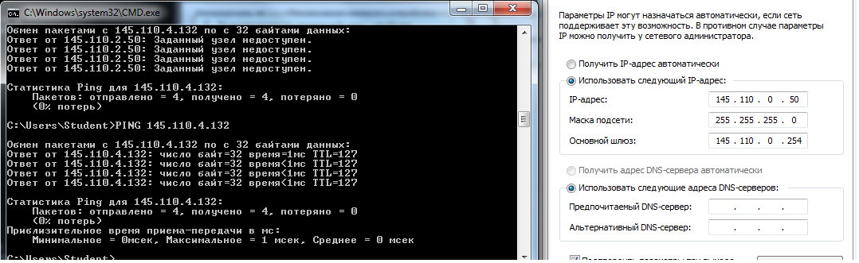

Эксперимент 2. Обмен данными между отделами 2 и 6 (запрещён)

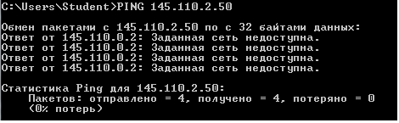

Эксперимент 3. Выход в WAN

8 отдел (разрешён)

