**Create Below Page using CSS:**

1. Pumpkin image is in images folder. You will be using float property, CSS fist-letter pseudo class/element, attribute selector for links.
2. Once the link has been visited make it black. When you hover your mouse on link make it green.
3. You will use CSS to make the text bold. Apply reset.css to reset browser added styles on this page.
4. You will use shadow property to make the Halloween store having black shadow.
5. Give the body element a double border but apply the bats.gif inside the “images” subfolder as background picture for html root element.

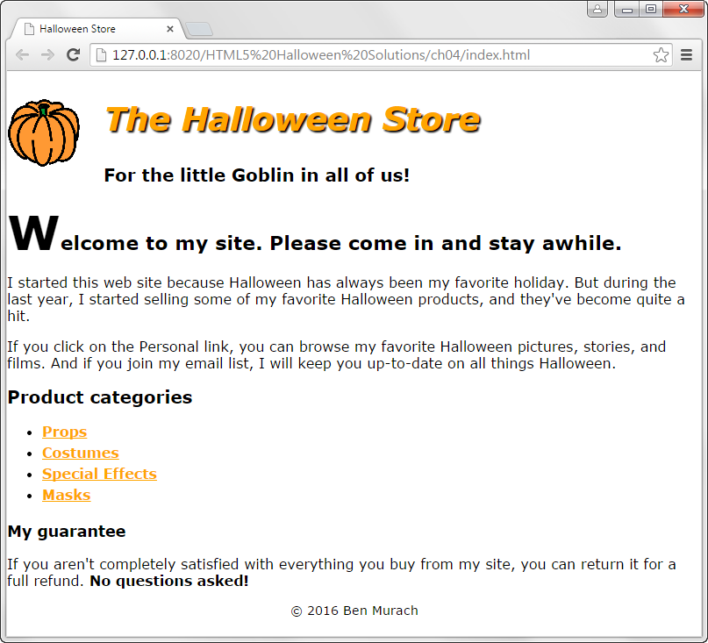

For the little Goblin in all of us!

Welcome to my site. Please come in and stay while.

I started this web site because Halloween has always been my favorite holiday. But during the last year, I started selling some of my favorites

**For the little Goblin in all of us!**

**Welcome to my site. Please come in and stay while.**

I started this web site because Halloween has always been my favorite holiday. But during the last year, I started selling some of my favorite Halloween products, and they've become quite a hit.

If you click on the Personal link, you can browse my favorite Halloween pictures, stories, and films. And if you join my email list, I will keep you up-to-date on all things Halloween.

**Product categories**

• Props

• Costumes

• Special Effects

• Masks

**My guarantee**

If you aren't completely satisfied with everything you buy from my site, you can return it for a full refund. **No questions asked!**