*CS7DS4 / CSU44065 Data Visualization 2019-20 Assignment 1.2*

**Submission 1.2**

Student Name: Yan Sen

Student No: 19315814

Declaration: "I have read and I understand the plagiarism provisions in the General Regulations of the University Calendar for the current year, found at [http://www.tcd.ie/calendar.](http://www.tcd.ie/calendar)

I have also completed the Online Tutorial on avoiding plagiarism ‘Ready Steady Write’, located at [http://tcd-ie.libguides.com/plagiarism/ready-steady-write.](http://tcd-ie.libguides.com/plagiarism/ready-steady-write)"

**Part A:**

I drew two rose charts for ‘deaths’ data from April 1854 to March 1855 twice for this task. The results could be seen in Figure1 and the code written in python with Jupyter Notebook could be also found in the attached files. In my work, NumPy was used to calculate the angles, areas and distances, Pandas was used to show and process the data in table, Matplotlib was used to draw the rose chart.

The first chart (i.e. the left one in Figure 1) is drawn in the author’s style while the other (i.e. the right one in Figure 1) is drawn in color in ‘TCD style’ (i.e. colors used in school badge) and it could be seen that the latter one is zoomed, repositioned and rotated differently with the former one.

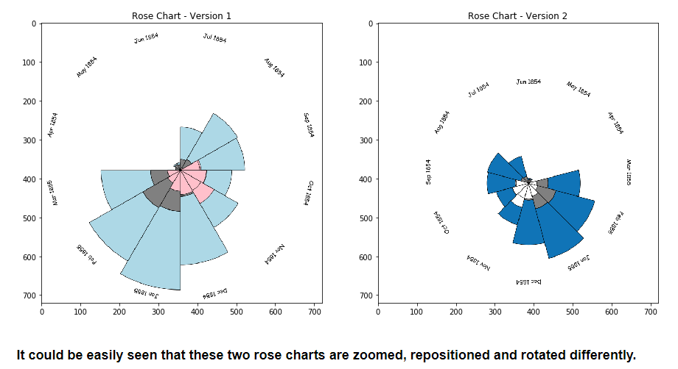

Figure

**Part B:**

I drew a Charles Joseph Minard’s map of Napoleon’s Russia campaign for this task. The results could be seen in Figure2 and the code written in python with Jupyter Notebook could be also found in the attached files. In my work, NumPy and Pandas were used to show and process the data in table, Matplotlib was used to draw the chart.

In the figure below, it could be seen that the map contains two parts (i.e. a map and a line chart). The map show the positions of cities (i.e. black points) and paths of army through them (i.e. different colors are used for each division of army in both attack and return directions) and the width of line represents the number of survivors. The line chart demonstrates the temperature during retreat (i.e. element – c).

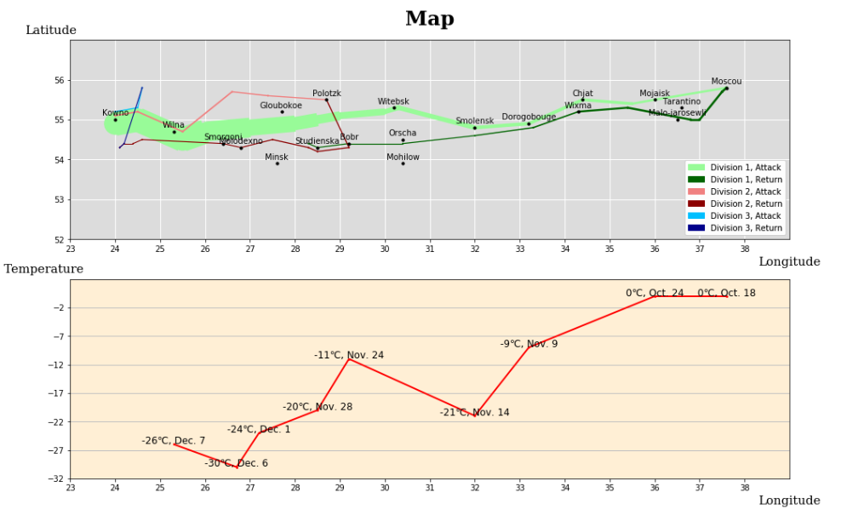

Figure