YanXuan NUID:001563047

**Program Structures & Algorithms**

**Fall 2021**

**Assignment No. 1**

* **Task (List down the tasks performed in the Assignment)**

1. **Completed RandomWalk.java and successfully passed the test.**
2. **Perform data simulation, change the number of steps and number of experiments, and make experimental data tables and graphs.**
3. **Analyze and summarize the experimental data, and get the relationship between d and n.**

* **Relationship Conclusion: (For ex : z = a * b)**

**The derivation process：**

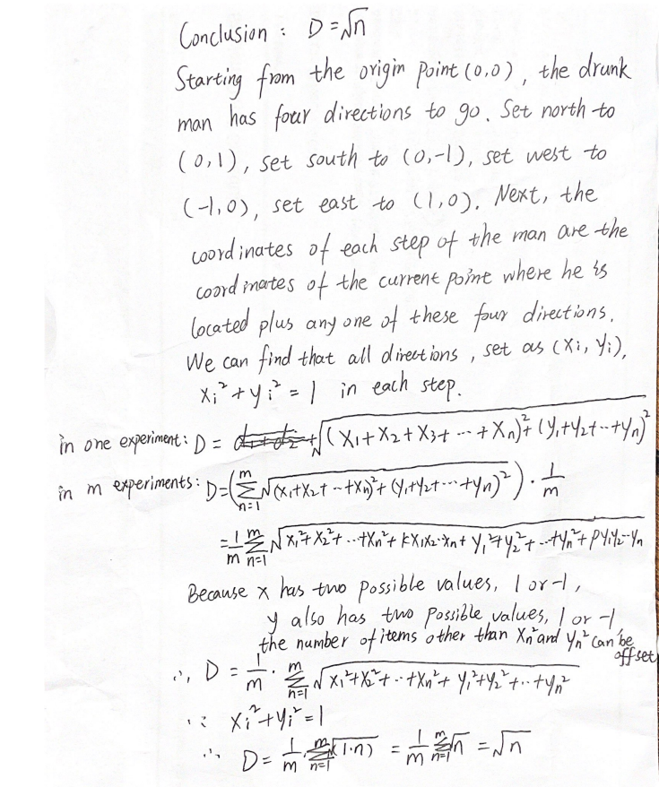

* **Evidence to support the conclusion:**

1. **Output (Snapshot of Code output in the terminal)**

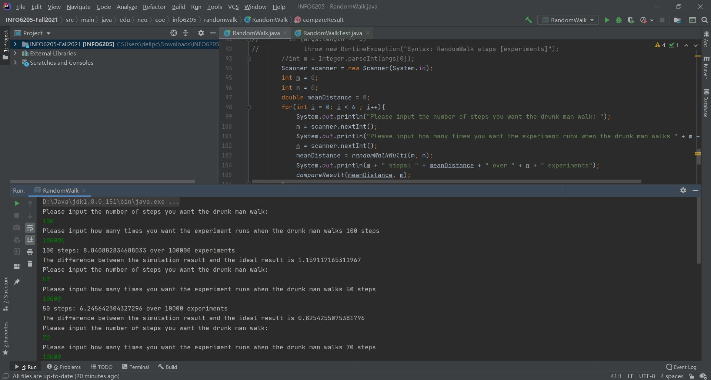

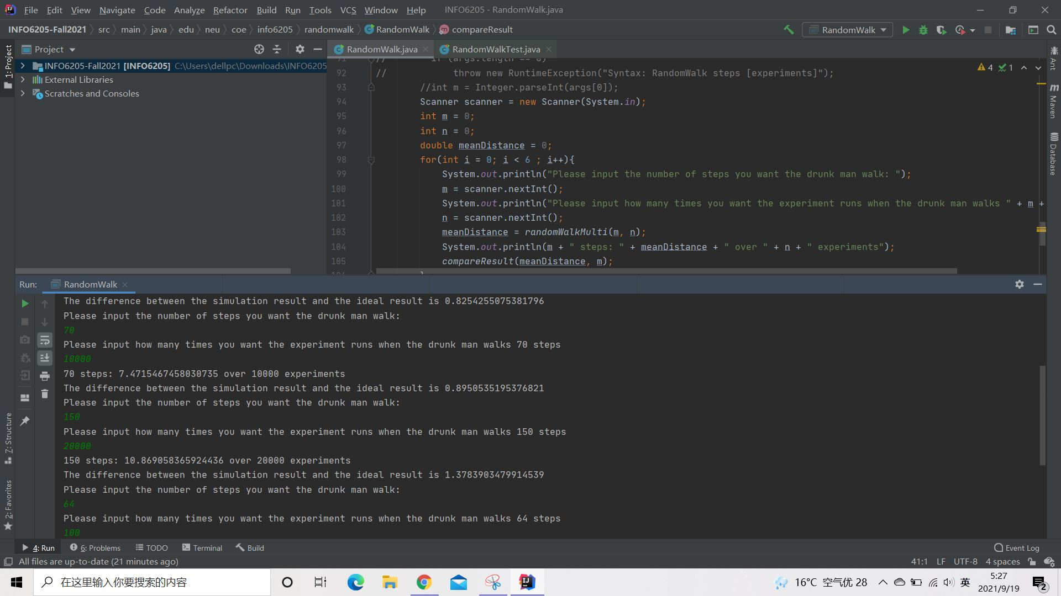

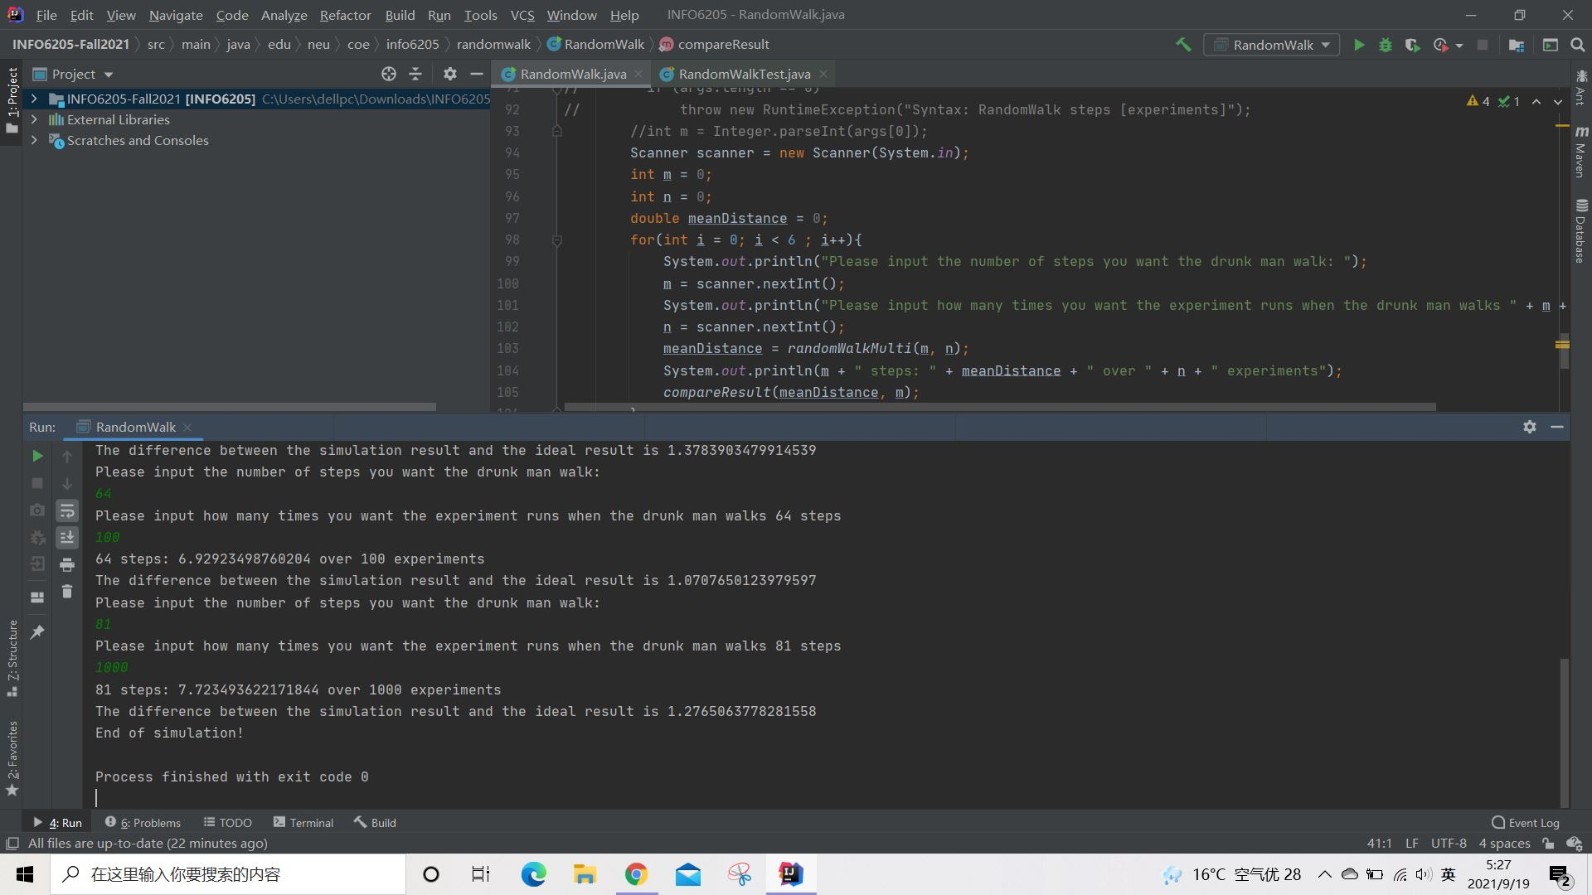

**Output text:**

|  |
| --- |
| Please input the number of steps you want the drunk man walk:  100  Please input how many times you want the experiment runs when the drunk man walks 100 steps  100000  100 steps: 8.840882834688033 over 100000 experiments  The difference between the simulation result and the ideal result is 1.159117165311967  Please input the number of steps you want the drunk man walk:  50  Please input how many times you want the experiment runs when the drunk man walks 50 steps  10000  50 steps: 6.245642304327296 over 10000 experiments  The difference between the simulation result and the ideal result is 0.8254255075381796  Please input the number of steps you want the drunk man walk:  70  Please input how many times you want the experiment runs when the drunk man walks 70 steps  10000  70 steps: 7.4715467458030735 over 10000 experiments  The difference between the simulation result and the ideal result is 0.8950535195376821  Please input the number of steps you want the drunk man walk:  150  Please input how many times you want the experiment runs when the drunk man walks 150 steps  20000  150 steps: 10.869058365924436 over 20000 experiments  The difference between the simulation result and the ideal result is 1.3783903479914539  Please input the number of steps you want the drunk man walk:  64  Please input how many times you want the experiment runs when the drunk man walks 64 steps  100  64 steps: 6.92923498760204 over 100 experiments  The difference between the simulation result and the ideal result is 1.0707650123979597  Please input the number of steps you want the drunk man walk:  81  Please input how many times you want the experiment runs when the drunk man walks 81 steps  1000  81 steps: 7.723493622171844 over 1000 experiments  The difference between the simulation result and the ideal result is 1.2765063778281558  End of simulation!  Process finished with exit code 0 |

1. **Graphical Representation(Observations from experiments should be tabulated and analyzed by plotting graphs(usually in excel) to arrive on the relationship conclusion)**



**The derivation process：**



* **Unit tests result:(Snapshot of successful unit test run)**

