API description template

Table of Contents

1. Class diagram 3

2. GET requests 4

3. POST requests 5

4. PUT requests 6

5. DELETE requests 7

# Class diagram

*Put your class diagram here. Also write some text that describes what is going on in your class diagram. For example, point out what the different unique identifiers are for each class and how the classes are related to each other.*

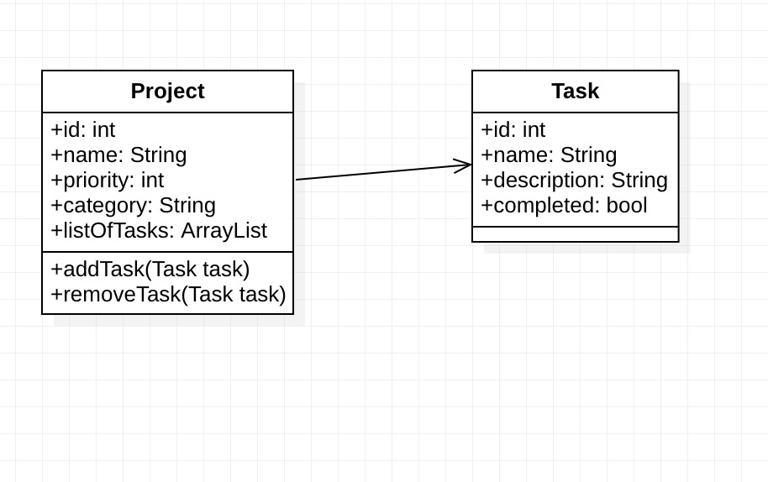

# GET requests

Template GET table:

|  |  |  |  |  |
| --- | --- | --- | --- | --- |
| **GET** | **/projects** | | | |
| Get a list of all projects | | | | |
|  | | | | |
| **Parameters:** | | **Name** | **Type** | **Description** |
|  | | category | query | Filter on category |
|  |  |  |
|  |  |  |
|  |  |  |
|  |  |  |
| **Responses:** | | **Code** | **Description / example if successful** | |
|  | | 200 | List of projects can be empty | |
|  |  | |
|  |  | |
|  |  | |
|  |  | |

|  |  |  |  |  |
| --- | --- | --- | --- | --- |
| **GET** | **/projects/{id}** | | | |
| Get one project, based on id | | | | |
|  | | | | |
| **Parameters:** | | **Name** | **Type** | **Description** |
|  | | id | path | ID of the project to find |
|  |  |  |
|  |  |  |
|  |  |  |
|  |  |  |
| **Responses:** | | **Code** | **Description / example if successful** | |
|  | | 200 | The found project based on ID | |
| 404 | Thrown if no project was found | |
|  |  | |
|  |  | |
|  |  | |

|  |  |  |  |  |
| --- | --- | --- | --- | --- |
| **GET** | **/projects/{id}/tasks** | | | |
| Get a list of tasks for a specific project, based on id | | | | |
|  | | | | |
| **Parameters:** | | **Name** | **Type** | **Description** |
|  | | id | path | ID of the project to find |
|  |  |  |
|  |  |  |
|  |  |  |
|  |  |  |
| **Responses:** | | **Code** | **Description / example if successful** | |
|  | | 200 | List of tasks for a specific project | |
| 404 | Thrown if no project was found | |
|
|
|

|  |  |  |  |  |
| --- | --- | --- | --- | --- |
| **GET** | **/tasks** | | | |
| Get a list of all tasks, independent of projects | | | | |
|  | | | | |
| **Parameters:** | | **Name** | **Type** | **Description** |
|  | | Completed | query | Filter on completed state, either true or false |
|  |  |  |
|  |  |  |
|  |  |  |
|  |  |  |
| **Responses:** | | **Code** | **Description / example if successful** | |
|  | | 200 | List of tasks, independent on projects. Can be empty | |
|  |  | |
|  |  | |
|  |  | |
|  |  | |

|  |  |  |  |  |
| --- | --- | --- | --- | --- |
| **GET** | **/tasks/{id}** | | | |
| Get one task, based on id | | | | |
|  | | | | |
| **Parameters:** | | **Name** | **Type** | **Description** |
|  | | id | path | ID of the task to find |
|  |  |  |
|  |  |  |
|  |  |  |
|  |  |  |
| **Responses:** | | **Code** | **Description / example if successful** | |
|  | | 200 | The found task, based on ID | |
| 404 | Thrown if no task was found | |
|  |  | |
|  |  | |
|  |  | |

# POST requests

*Add your requests here. Copy-paste the template for each different request.*

Template POST table:

|  |  |  |  |  |
| --- | --- | --- | --- | --- |
| **POST** | **/projects** | | | |
| Create a new project | | | | |
|  | | | | |
| **Parameters:** | | **Name** | **Type** | **Description** |
|  | | Project | body | The project that needs to be added |
|
|
|
|
| **Responses:** | | **Code** | **Description / example if successful** | |
|  | | 201 | Project created successfully | |
| 400 | Thrown when smth was wrong with project body | |
|  |  | |
|  |  | |
|  |  | |

|  |  |  |  |  |
| --- | --- | --- | --- | --- |
| **POST** | **/projects/{id}/tasks** | | | |
| Create new task and assign it to the project | | | | |
|  | | | | |
| **Parameters:** | | **Name** | **Type** | **Description** |
|  | | id | path | Id of project |
| task | Body | The task |
|
|
|
|
| **Responses:** | | **Code** | **Description / example if successful** | |
|  | | 201 | The task was created successfully | |
| 400 | Thrown when smth was wrong with task body | |
| 404 | Project id not found | |
|  |  | |
|  |  | |

# PUT requests

*Add your requests here. Copy-paste the template for each different request.*

Template PUT table:

|  |  |  |  |  |
| --- | --- | --- | --- | --- |
| **PUT** | **/projects/{id}** | | | |
| Update a project based on id | | | | |
|  | | | | |
| **Parameters:** | | **Name** | **Type** | **Description** |
| *Add a * to the name of required parameters.* | | id | path |  |
| project | body |  |
|  |  |  |
|  |  |  |
|  |  |  |
| **Responses:** | | **Code** | **Description / example if successful** | |
|  | |  |  | |
|  |  | |
|  |  | |
|  |  | |
|  |  | |

|  |  |  |  |  |
| --- | --- | --- | --- | --- |
| **PUT** | **/tasks/{id}** | | | |
| Update a task based on id | | | | |
|  | | | | |
| **Parameters:** | | **Name** | **Type** | **Description** |
| *Add a * to the name of required parameters.* | | id | path |  |
| task | body |  |
|  |  |  |
|  |  |  |
|  |  |  |
| **Responses:** | | **Code** | **Description / example if successful** | |
|  | |  |  | |
|  |  | |
|  |  | |
|  |  | |
|  |  | |

# DELETE requests

*Add your requests here. Copy-paste the template for each different request.*

Template PUT table:

|  |  |  |  |  |
| --- | --- | --- | --- | --- |
| **DELETE** | **/projects/{id}** | | | |
| [description here. Explain what the request does when executed successfully.] | | | | |
|  | | | | |
| **Parameters:** | | **Name** | **Type** | **Description** |
| *Add a * to the name of required parameters.* | | id | path |  |
|  |  |  |
|  |  |  |
|  |  |  |
|  |  |  |
| **Responses:** | | **Code** | **Description / example if successful** | |
|  | |  |  | |
|  |  | |
|  |  | |
|  |  | |
|  |  | |

|  |  |  |  |  |
| --- | --- | --- | --- | --- |
| **DELETE** | **/tasks/{id}** | | | |
| [description here. Explain what the request does when executed successfully.] | | | | |
|  | | | | |
| **Parameters:** | | **Name** | **Type** | **Description** |
| *Add a * to the name of required parameters.* | | id | path |  |
|  |  |  |
|  |  |  |
|  |  |  |
|  |  |  |
| **Responses:** | | **Code** | **Description / example if successful** | |
|  | |  |  | |
|  |  | |
|  |  | |
|  |  | |
|  |  | |