

**Report on Philautia**

# Submitted By: Submitted To:

## Yana Midha Mr. Lovish

G -21 Sir

## 2110992092

**Department of Computer Science & Engineering Chitkara University Institute of Engineering & Technology,**

**Rajpura, Punjab**

Report On Philautia

My Project is Philautia –“A Skincare Website”

At Philautia, we believe that self-love is the foundation of true beauty. Our mission is to empower you to embrace your natural beauty, enhance your self-confidence, and nurture your skin with the care it deserves. We are more than just a skincare brand; we are your partner in the journey towards self-love and self-care.

In a world that often emphasizes perfection and external standards, we encourage you to celebrate your uniqueness and cherish the skin you're in. We understand that self-love goes hand in hand with taking good care of your skin, which is why we offer a range of products designed to enhance your natural beauty while promoting self-confidence and well-being.

Our Commitment to Self-Love:

We prioritize clean, natural ingredients that respect your skin and the environment.

Our products are cruelty-free and sustainably sourced.

We celebrate diversity and inclusivity, recognizing that beauty comes in all forms.

We provide resources and support to help you on your self-love journey, from skincare tips to self-care practices.

Explore our collection of skincare products that cater to all skin types and concerns. Whether you're looking for hydrating moisturizers, rejuvenating serums, or gentle cleansers, we've got you covered. Each product is carefully crafted to make you feel beautiful in your skin and encourage a positive self-image.

Join our community of self-love advocates who are on a journey to radiant, confident skin, and a heart filled with love for oneself. Together, we embrace the mantra that self-love is not vanity; it is the ultimate act of self-respect.

Thank you for choosing [Your Skincare Brand]. Get ready to embark on a skincare journey that's all about you, your beauty, and your self-love. Explore our products, learn from our skincare experts, and let's celebrate the beauty of self-love together.

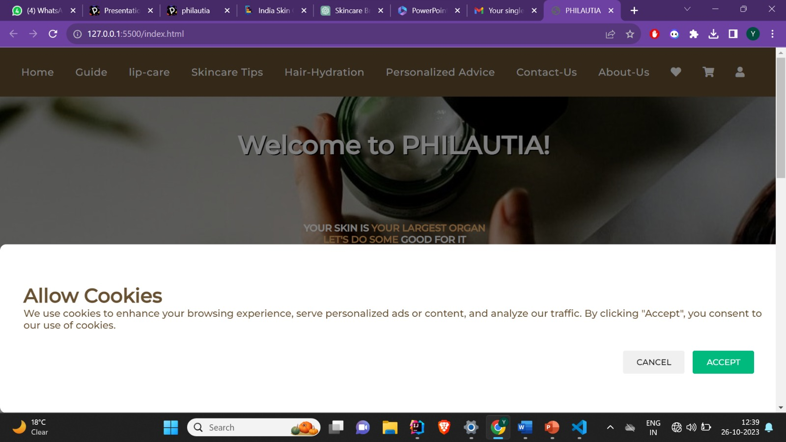

Page 1: Home page

Website Title: PHILAUTIA

General Impression:

The website presents itself as a platform related to skincare, with a strong focus on self-love. It has a warm and inviting feel with a feminine touch, and the content seems to be targeted at individuals interested in skincare and self-care.

Header Section:

The website has a well-structured header that includes navigation links, a logo, and several icons.

The navigation bar provides easy access to various sections, including home, guides, skincare tips, and more.

The use of Font Awesome icons in the navigation bar is a nice touch and adds visual appeal.

Cookie Consent Modal:

The cookie consent modal is a good addition, indicating that the website respects user privacy.

Users can either accept or cancel the use of cookies.

Home Page:

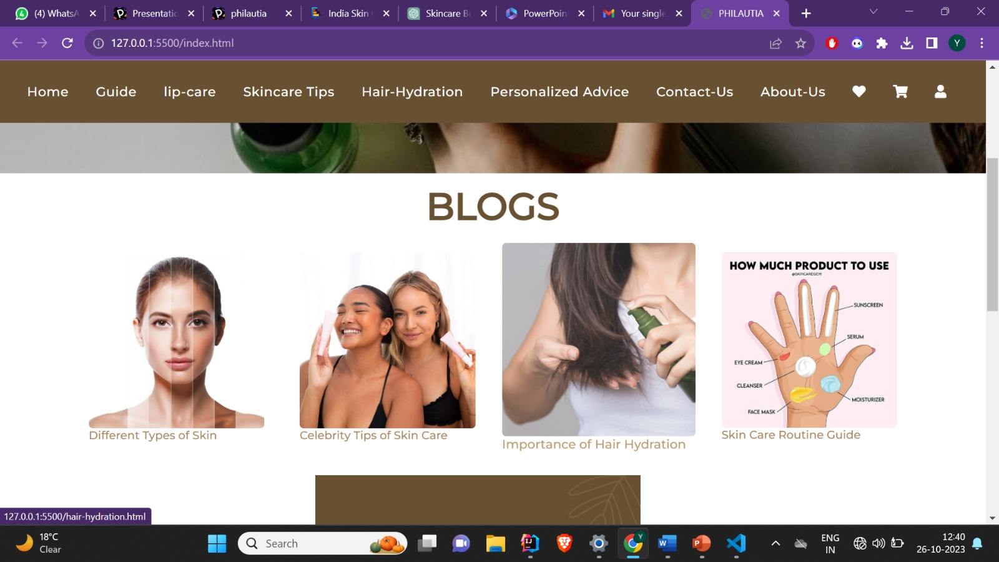

The homepage features a prominent title, "Welcome to PHILAUTIA," which effectively conveys the website's purpose.

The tagline emphasizes the importance of taking care of one's skin.

Blogs Section:

The website includes a "Blogs" section, which highlights different topics related to skincare.

Each blog post is represented by an image and a short description.

The images should be checked to ensure they are correctly linked.

About Section:

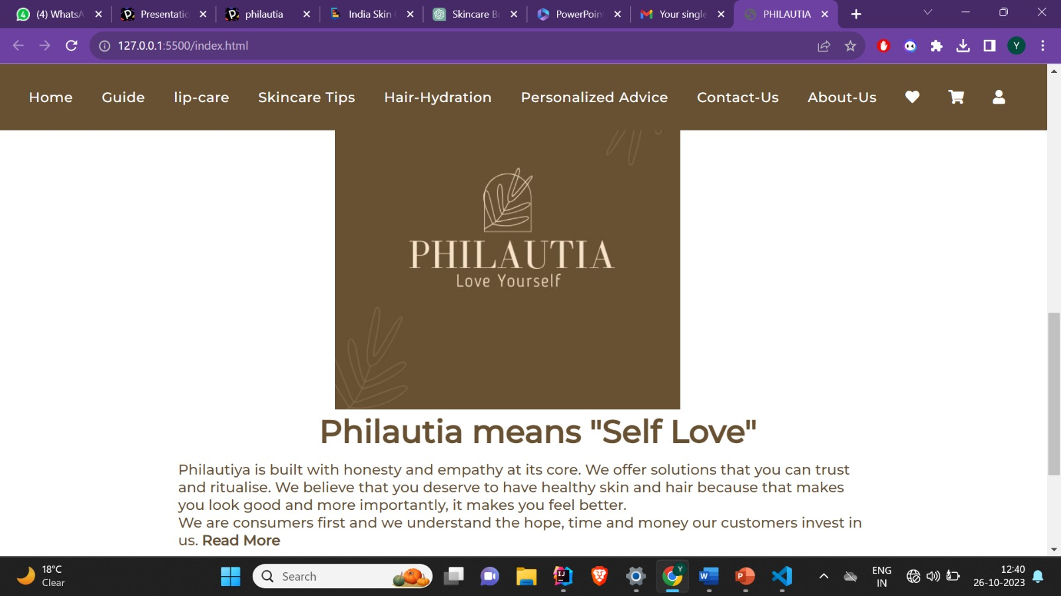

The "About Us" section provides information about the website's mission and values.

It mentions honesty and empathy, emphasizing a commitment to customers' well-being.

A "Read More" link provides an option for users to learn more about the brand.

Contact Section:

The contact section is well-structured and provides essential information.

Users can find a phone number and an email address for inquiries.

Quick Links:

The "Quick Links" section offers direct access to Home, Blogs, and About Us pages.

It provides an easy way for users to navigate the website.

Social Media Links:

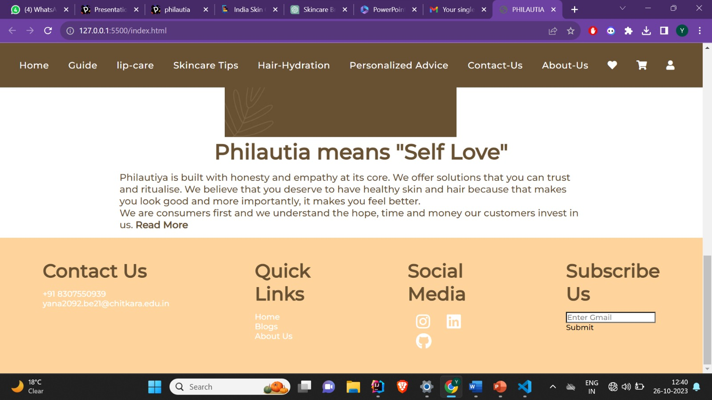

Social media links are available, with icons leading to Instagram and LinkedIn profiles. However, the GitHub link is currently inactive.

This is a good way to connect with the audience and build a social media presence.

Newsletter Subscription:

The website includes a section for users to subscribe via email.

The "Submit" button suggests that users can sign up for newsletters.

Page 2: Guide

The content on this page is a comprehensive guide to a daily skincare routine for both daytime and nighttime, covering various essential steps, including cleansing, toning, treatment, moisturizing, and sun protection. It is informative and well-structured to provide valuable information to users interested in maintaining healthy and radiant skin.

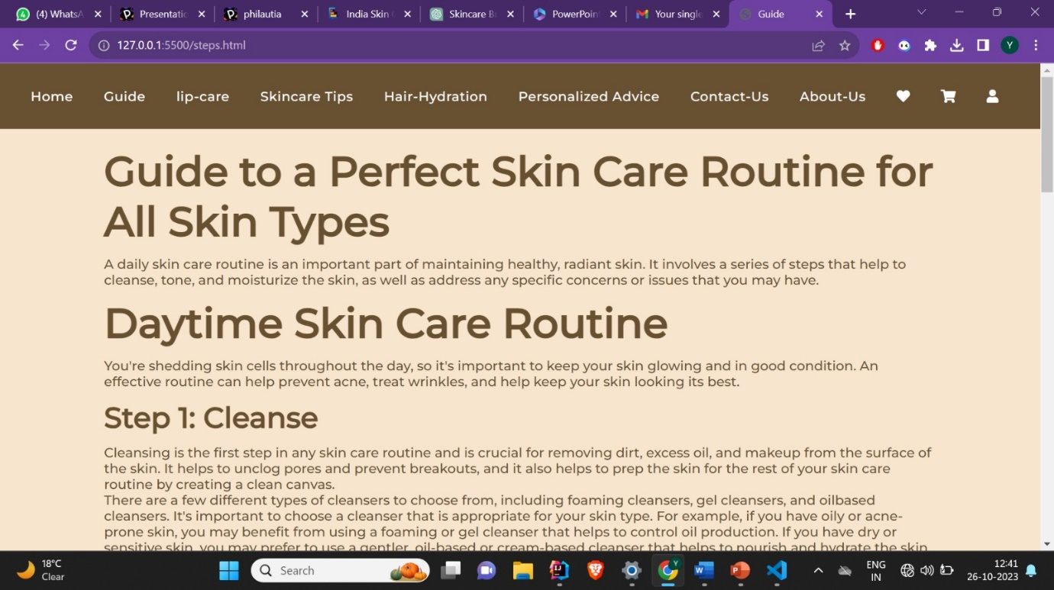

1. Introduction:

The page begins with an introduction emphasizing the importance of a daily skincare routine in maintaining healthy and radiant skin.

2. Daytime Skin Care Routine:

A dedicated section provides guidance on a daytime skincare routine.

A link is provided to learn more about the daytime routine.

3. Steps in Daytime Routine:

Each step in the daytime skincare routine is detailed, including cleansing, toning, treatment, moisturizing, and sun protection.

Clear explanations are given for each step, ensuring users understand the purpose and benefits of each.

Advice is provided for selecting products suitable for different skin types, such as oily, dry, or sensitive skin.

Tips on application techniques and the importance of avoiding hot water are included.

4. Nighttime Skin Care Routine:

A dedicated section offers guidance on a nighttime skincare routine.

A link is provided to learn more about the nighttime routine.

5. Steps in Nighttime Routine:

Similar to the daytime routine, the nighttime routine is explained in detail.

Steps include makeup removal and cleansing, toning, applying serum, using eye cream, and moisturizing.

The importance of using suitable products and techniques is emphasized.

Page 3: Lip-care

The content on this page provides valuable information about lip care, offering tips and guidance on keeping lips healthy and well-moisturized. It covers various aspects of lip care, including hydration, sun protection, the use of lip products, and the importance of cleaning and exfoliation.

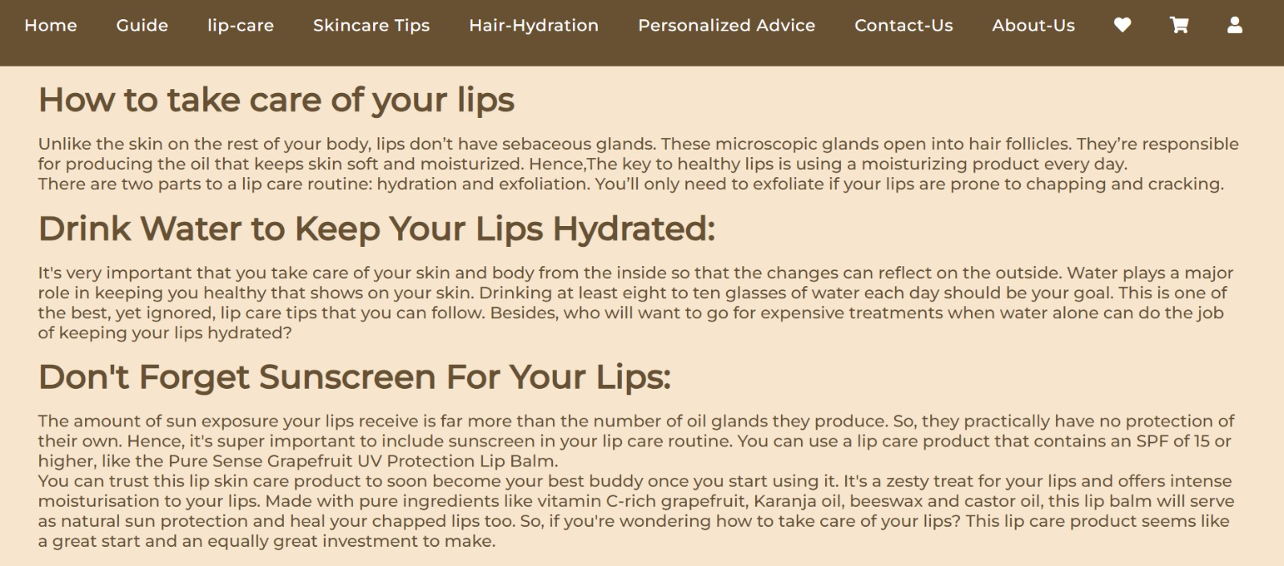

1. Introduction:

The page starts with an introductory image and text that emphasize the significance of lip care.

2. Lip Care Tips:

A section titled "Lip Care Tips" highlights the importance of taking care of your lips and introduces the topic.

3. How to Take Care of Your Lips:

The content provides an explanation about the unique characteristics of lip skin, emphasizing the absence of sebaceous glands and the importance of moisture.

It encourages the use of moisturizing products for lip care.

4. Lip Care Routine:

The content outlines a two-part lip care routine, focusing on hydration and exfoliation, based on individual needs.

5. Tips for Hydration:

The importance of drinking water to keep lips hydrated is discussed, linking internal hydration to external lip health.

The content recommends a daily water intake goal.

6. Sunscreen for Lips:

The section highlights the need for sun protection for lips, given their vulnerability to sun exposure.

A lip care product with SPF is recommended, and the benefits of specific products are mentioned.

7. Use of Lipstick or Lip Balm:

The content suggests that lipsticks made with natural ingredients can serve as a protective layer for lips.

The importance of lip balm in maintaining lip moisture and nourishment is emphasized.

A specific lip balm product is recommended.

8. Nighttime Lip Care:

The importance of including a lip care product in the nighttime routine is discussed.

A recommended lip balm product is mentioned for its hydrating properties.

9. Keeping Lips Clean:

Emphasizing the importance of cleaning lips daily to remove impurities and makeup.

Consistent cleanliness is recommended along with moisturization and hydration.

10. Exfoliation:

The content explains the significance of lip exfoliation for healthier, softer, and well-moisturized lips.

The importance of scrubbing or exfoliating lips once or twice a week is highlighted.

Page 4 : Skincare tips from celebrities

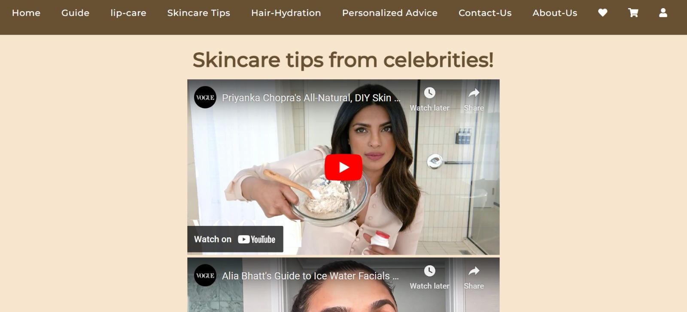

This webpage primarily consists of embedded YouTube videos featuring skincare tips from celebrities. It does not contain textual content or descriptions of the videos. The focus is on visual and video-based content.

1. Main Heading:

The page starts with a clear and concise main heading, "Skincare tips from celebrities!"

2. Video Embeds:

The main content of the page consists of six embedded YouTube video players. Each video appears to feature skincare tips provided by different celebrities.

The videos are of varying lengths. Users are expected to click on the videos to view the content.

Page 5 : Hair- Hydration

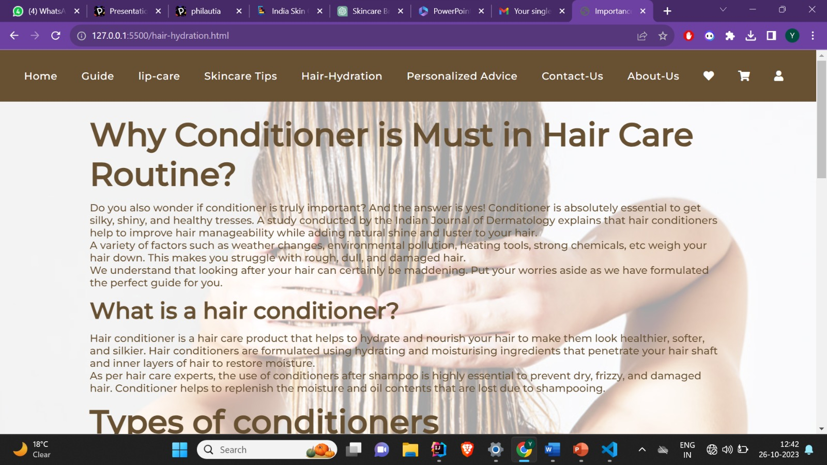

The content on this page highlights the significance of using a conditioner in a hair care routine. It explains the purpose of conditioners, their different types, and offers tips on how to use them effectively.

1. Introduction:

The page begins with a heading "Why Conditioner is Must in Hair Care Routine?" which immediately conveys the main topic.

The introductory text emphasizes the importance of conditioner for achieving silky, shiny, and healthy hair.

2. What is a Hair Conditioner:

This section defines what a hair conditioner is and explains its purpose.

It provides information on how conditioners work and why they are essential after shampooing.

3. Types of Conditioners:

The content introduces different types of conditioners, including Deep Conditioner, Cleansing Conditioner, Leave-In Conditioner, and Dry Conditioner.

Each type is explained, and some key ingredients associated with them are mentioned.

4. Proper Way to Use Conditioner:

This section offers practical tips on how to use conditioner effectively.

It covers key aspects such as application areas, the duration of application, and the recommended amount to use.

Page 6: Personalized advice

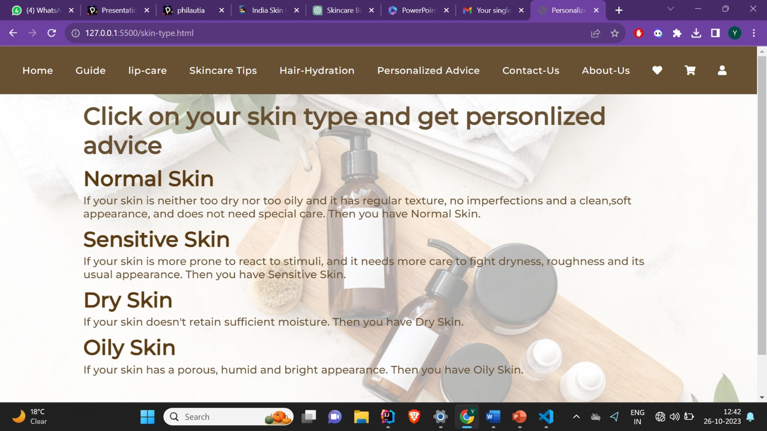

This webpage provides information and advice related to different skin types and encourages users to click on their specific skin type to access personalized skincare tips. The content is text-based and aims to assist individuals in understanding and caring for their unique skin type.

1. Main Heading:

The page begins with a main heading, "Click on your skin type and get personalized advice." This title clearly communicates the purpose of the webpage.

2. Skin Type Categories:

The webpage categorizes different skin types and provides information about each. Each skin type category includes the following elements:

A sub-heading (using the <h1> element) representing a specific skin type.

A hyperlink (<a>) that leads to a dedicated page for that skin type.

A brief description of the characteristics of that skin type (using the <p> element).

Skin Types and Descriptions:

The webpage discusses four primary skin types: Normal Skin, Sensitive Skin, Dry Skin, and Oily Skin.

Each skin type is briefly described, including its characteristics and potential concerns.

Page 7: Tips for Normal Skin

Introduction:

Normal skin is considered a lower-maintenance skin type. It usually doesn't require extensive efforts to manage oiliness, sensitivity, or dryness. While genetics play a significant role in determining skin type, factors like hormones, stress, sun exposure, and product usage can influence skin balance.

Tips for Normal Skin:

Less Is More: Maintaining balance is crucial. Avoid using products that strip the skin, as this can stimulate excess sebum production. Similarly, over-moisturizing can hinder the skin's natural moisture production.

Apply Sunscreen: Regularly apply sunscreen before going outdoors. It helps slow down skin aging and reduces the risk of skin cancer. Look for broad-spectrum protection with SPF 30 or higher and water resistance.

Manage Stress: Finding healthy ways to manage stress is beneficial for skin health. Stress can trigger skin conditions like psoriasis, eczema, acne, and rosacea.

Gentle Cleansing: Use a mild cleanser and gently cleanse your face. Start by wetting your face with lukewarm water, apply the cleanser in a circular motion with your fingertips, and rinse thoroughly. Gently pat your face dry with a clean towel.

Regular Skin Checks: Skin cancer is prevalent, and early detection is crucial. Regularly check your skin for new spots, unusual changes in existing spots, or moles that itch, bleed, or change color. If you notice suspicious spots, consult a board-certified dermatologist.

Page 8: Tips for Sensitive Skin

Introduction:

Dealing with sensitive skin can be challenging, as it often reacts negatively to various skincare products. This guide provides tips to soothe sensitive skin, ensuring it stays healthy and radiant.

Tips for Sensitive Skin:

Get Back to Basics: Keep your skincare routine simple, using products that soothe rather than harsh chemicals. Avoid overdoing it, as excessive skincare can have adverse effects. Choose products like micellar water for gentle cleansing and removing impurities without drying out your skin.

Handle Your Skin with Care: Be gentle when cleansing and removing makeup. Avoid rubbing or tugging, which can irritate sensitive skin. Use eye makeup remover to dissolve stubborn makeup, and opt for a more delicate approach to maintain your skin's health.

Cool Down Your Skin: Sensitive skin can be aggravated by excess heat. Use lukewarm water for face washing and avoid hot showers. You can soothe your skin by applying a damp, cool face cloth as a compress on irritated areas.

Protect Your Face Against Pollution: Airborne pollution can accumulate on your skin throughout the day, potentially leading to irritation. To prevent this, cleanse your skin regularly, both in the morning and evening. Consider carrying cleansing wipes for on-the-go cleansing.

Makeup Regime: You can still use makeup with sensitive skin. Opt for mineral powder or silicone-based foundation to reduce the risk of irritation. Avoid waterproof mascara, as it requires harsh removers. Choose pencil eyeliner over liquid, as liquids may contain irritants like latex. Maintain clean makeup brushes and discard old makeup products.

Page 9: Tips for Dry Skin

Introduction:

Dealing with dry skin can be challenging, as it often leads to discomfort and skin issues. This guide provides tips to help you maintain healthy and well-moisturized dry skin.

Tips for Dry Skin:

Gently Wash Your Face at Least Twice a Day: Use a gentle, alcohol-free, nonfoaming cleanser on your face both in the morning and evening. After sweating, it's also recommended to cleanse your face. Look for products with ingredients like stearic acid or linoleic acid, which can help repair your skin.

Use Warm Water and Limit Bath Time: Prolonged exposure to hot water during showers or baths can strip your skin's natural oils. Limit bathing to once a day and keep it short, ideally between 5-10 minutes. Use warm, not hot, water for bathing.

Use Allergen-Free Moisturizing Soap: When washing your hands, use fragrance-free, hypoallergenic moisturizing soap. Apply moisturizing cream while your skin is still damp. In the shower or bath, opt for non-soap cleansing cream or shower gel, reserving the use of soap for necessary areas. Avoid harsh exfoliating tools like loofahs and pumice stones.

Apply Moisturizer Immediately After Washing: Ointments, creams, and lotions work by trapping existing moisture in your skin. To do this effectively, apply a moisturizer within a few minutes of drying off after bathing, showering, or washing your face or hands.

Use a Humidifier: Dry skin benefits from increased moisture. You can achieve this by using a humidifier in your home. Some heating systems include built-in humidifiers, but you can also use portable humidifiers. Placing a portable humidifier in your bedroom and running it while you sleep can help maintain adequate humidity levels.

Avoid Sun and Tanning Beds: Both sunlight and indoor tanning equipment emit UV rays that can further dry the skin. Protect your skin by seeking shade when exposed to the sun and wearing protective clothing like wide-brimmed hats, long-sleeved shirts, and pants. Apply fragrance-free sunscreen with broad-spectrum protection and SPF 30 or higher to any exposed skin.

Wear Loose-Fitting Cotton Clothes: Tight-fitting clothing, such as leggings or body-hugging jeans, can rub against and irritate dry skin. Fabrics like wool or polyester can also be harsh on sensitive, dry skin. Opt for loose-fitting clothing made from breathable cotton to prevent irritation.

Page 10: Tips for Oily Skin

Introduction:

Oily skin can often lead to various skin issues, including breakouts and excessive shine. This guide provides valuable tips for managing and maintaining oily skin to achieve a healthier complexion.

Tips for Oily Skin:

Wash Your Face Twice a Day: The key to managing excess oil is to cleanse your face twice daily. Use gentle soap and warm water in the morning and evening. This routine helps remove accumulated dirt and oil, promoting cleaner and fresher skin.

Avoid Constantly Touching Your Face: Oily skin is prone to breakouts, and touching your face frequently can worsen the situation. It's essential to resist the temptation to pop or pick pimples to prevent further skin issues.

Maintain a Healthy Diet: A balanced diet plays a crucial role in managing oily skin. Avoid spicy, sweet, and fried foods, as well as processed foods and dairy products that can exacerbate skin issues. Focus on consuming fruits, vegetables, nuts, grains, lean proteins, eggs, and legumes.

Drink Plenty of Water: Staying well-hydrated is essential. Consume at least 7 to 8 glasses of water daily to flush out toxins and keep your skin hydrated. Sufficient hydration can help regulate sebum production and oiliness.

Moisturize Regularly: Contrary to common belief, even oily skin needs moisturizing. Opt for a lightweight, lotion-based moisturizer to keep your skin hydrated. Appropriate moisturization can prevent the skin from overproducing sebum.

Makeup Regime: When using makeup, choose non-comedogenic products that won't clog pores. Avoid heavy and chemical-laden skincare products. Use gentle cleansers and ensure that all makeup residue is thoroughly removed before bedtime.

Use a Facial Mask: Specific facial masks can be beneficial for managing oily skin. Ingredients like clay, raw honey, milk, oatmeal, and more can help control oiliness and promote clearer skin. Clay-based masks absorb excess oil, while honey and oatmeal can soothe and cleanse the skin.

Page 11: Contact Us

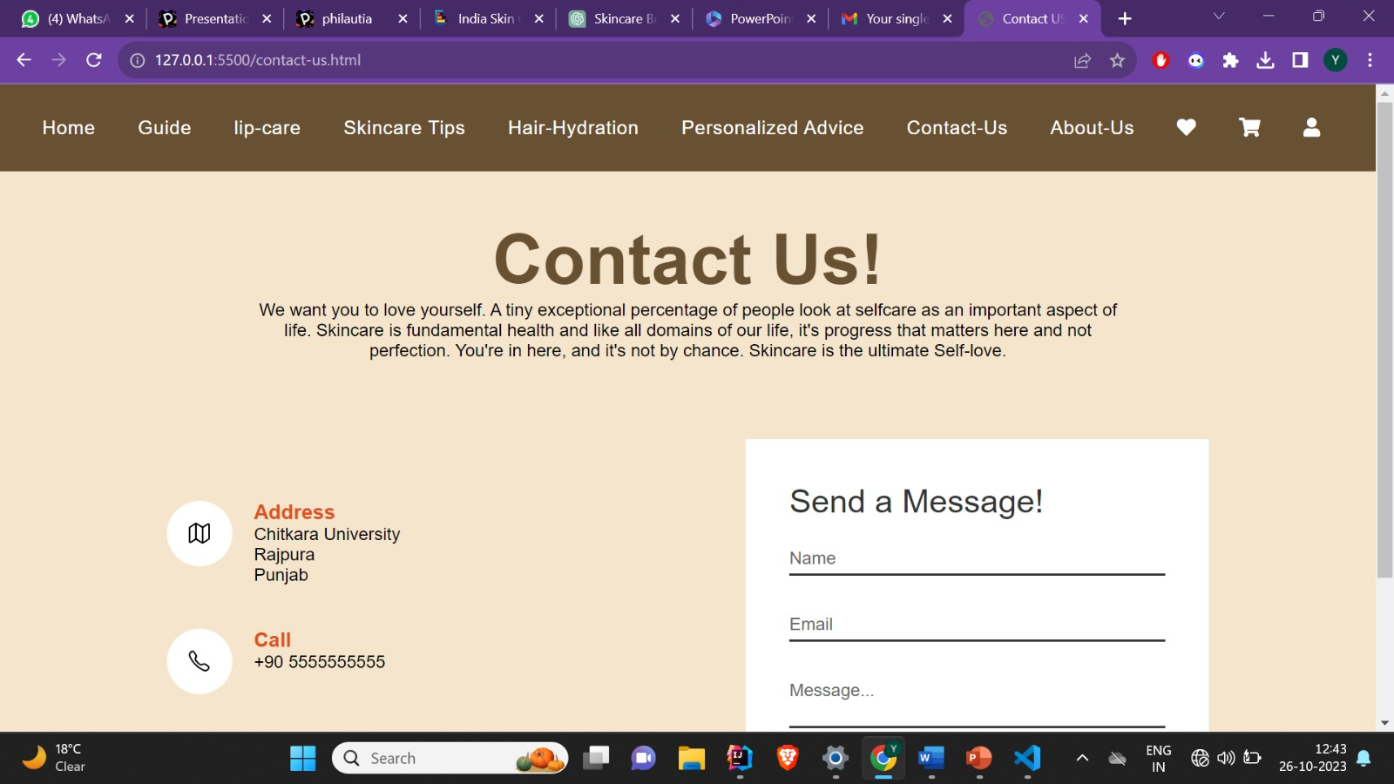

Introduction:

The "Contact Us" section of the website serves as a means for users to get in touch with the website administrators. It emphasizes the importance of self-care and skincare in one's life, promoting the idea that skincare is a form of self-love.

Contact Information:

Address:

Chitkara University, Rajpura, Punjab

Call:

Phone: +90 5555555555

Email:

Email Address: yana2092.be21@chitkara.edu.in

Contact Form:

The website offers a contact form that allows users to send messages. The form includes the following fields:

Name

Email

Message

Users can input their details and a message they want to convey to the website administrators.

Conclusion:

The "Contact Us" section provides essential contact information for users who wish to reach out to the website. It also conveys the website's message about self-care and skincare as a form of self-love. It encourages users to get in touch, ask questions, or provide feedback via the contact form. The provided contact details and form aim to facilitate communication between the website and its users.

Page 12: About Us

Introduction:

The website section introduces the concept of Philautia, which means "Self Love." It emphasizes the importance of self-care, particularly skincare, and conveys the idea that self-care is an essential aspect of life. The primary message is that skincare is a form of self-love.

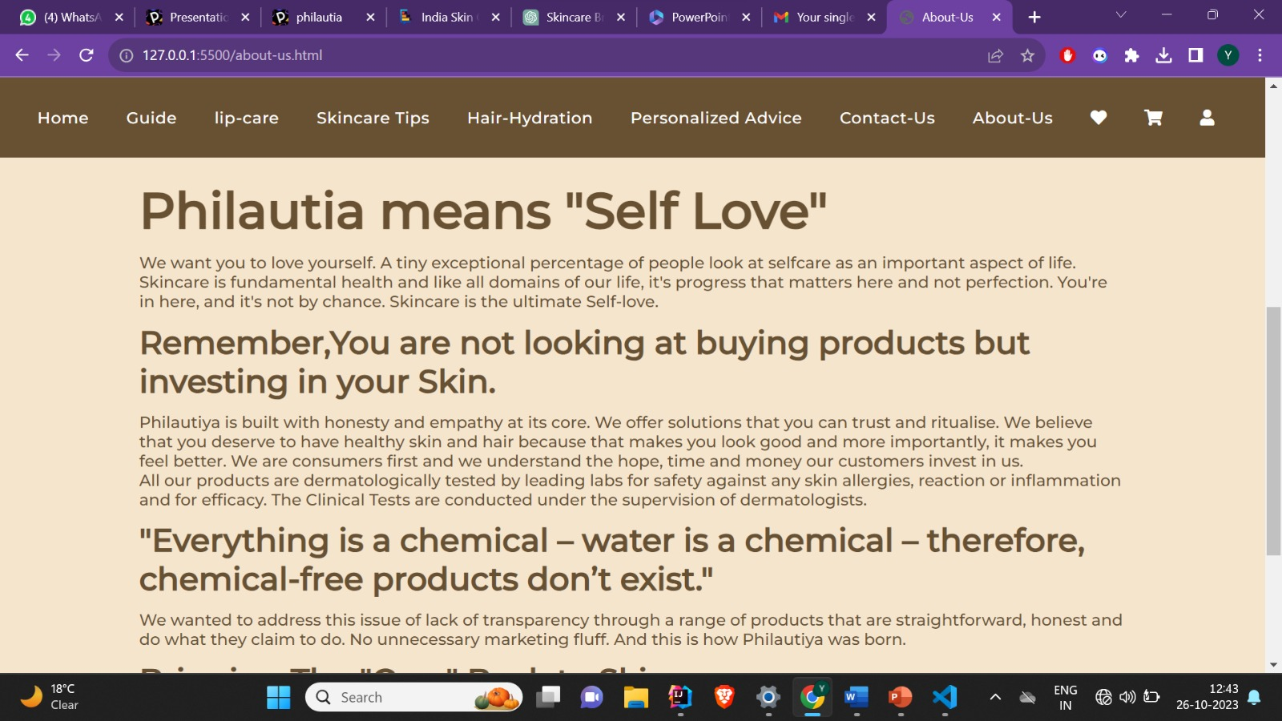

Website Logo:

The website includes an image/logo representing "Philautia."

Content:

The content further elaborates on the core philosophy of Philautia:

Emphasizes that skincare is vital for fundamental health, and perfection isn't the goal; progress and self-love are.

Invites visitors to the website, conveying that they are here for a purpose and not by chance.

Highlights the concept that skincare is the ultimate form of self-love.

Key Messages:

Investing in Your Skin:

Encourages visitors to view skincare as an investment in their skin's health rather than a mere purchase of products.

Conveys the brand's commitment to honesty, empathy, and trustworthiness in offering skincare solutions.

Expresses understanding of the time, hope, and financial investment made by customers.

Dermatologically Tested Products:

States that all products undergo dermatological testing for safety and efficacy.

These tests are supervised by dermatologists to ensure products are safe from allergies, reactions, or inflammation.

Transparency and Honesty:

Addresses the notion that everything is a chemical, including water, and asserts that "chemical-free products don't exist."

Promotes transparency, straightforwardness, and the avoidance of unnecessary marketing in skincare.

Nature-Forward Approach:

Expresses a commitment to a nature-forward approach in product formulation.

Ensures ingredients and actives are in their most natural, skin-friendly form.

Emphasizes the elimination of anything that could adversely affect the body and the environment.

Bringing Care to Skincare:

Advocates for bringing care back to skincare and maintaining dermatological safety.

Reiterates that every product is clinically tested to ensure safety.

Page 13: Self Love

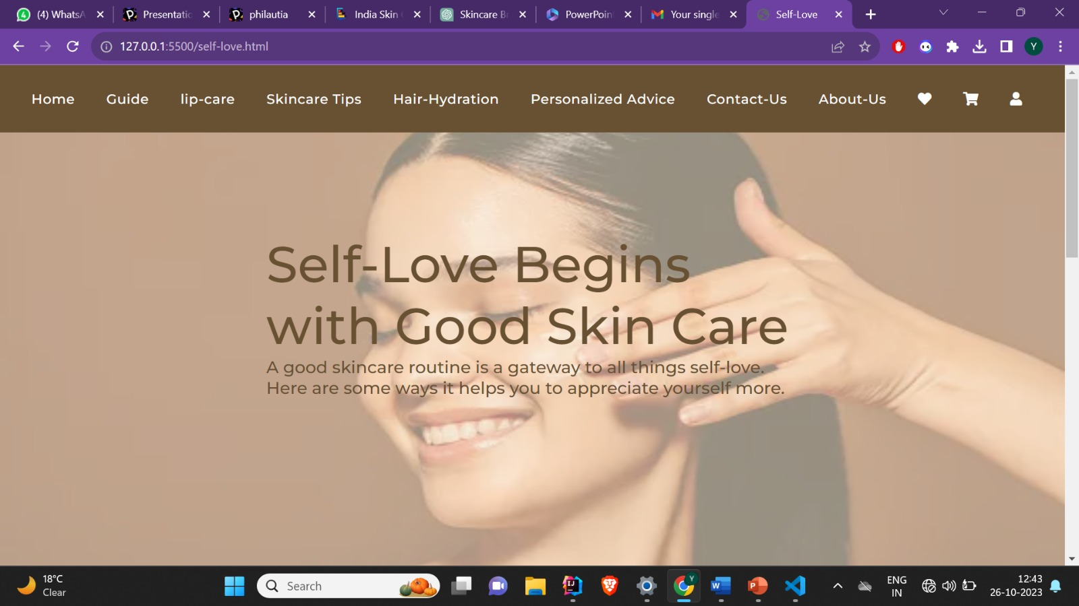

Introduction:

The website section emphasizes the connection between self-love and good skincare. It underscores that self-love is a personal journey, and skincare can be a gateway to appreciating oneself more.

Content:

The content explores the ways in which skincare and self-love are interconnected:

Skin Care as Self-Kindness:

Highlights how individuals turned to self-care and skincare as a form of self-kindness, especially during stressful times like lockdowns.

Shows that there has been an increased focus on products that promote skin health rather than solely beauty.

Reveals that people are choosing self-kindness by taking care of their skin.

Healthy Skin and Self-Confidence:

Discusses the emotional impact of skin issues on self-esteem.

Cites a study indicating that skin conditions, particularly severe acne, can lead to feelings of embarrassment and low self-worth.

Emphasizes that taking care of one's skin is an act of self-love that improves not only appearance but also self-confidence.

Acts of Self-Improvement and Mental Health:

Mentions the importance of setting goals and priorities for mental health improvement.

Explains how acts of self-improvement, such as maintaining a skincare routine, contribute to personal growth and mental well-being.

Stresses the significance of small daily acts in revealing one's potential.

Rituals and Routines for Wellbeing:

States the benefits of having routines for overall well-being, including structure, organization, and health.

Cites that individuals without routines may experience stress, poor sleep, malnutrition, procrastination, and lack of exercise.

Suggests that routines lead to relaxation, reduced anxiety, and improved quality of rest.

Self-Love Message:

Concludes the section with a simple message encouraging self-love.

Page 14: Menu of Product Pages

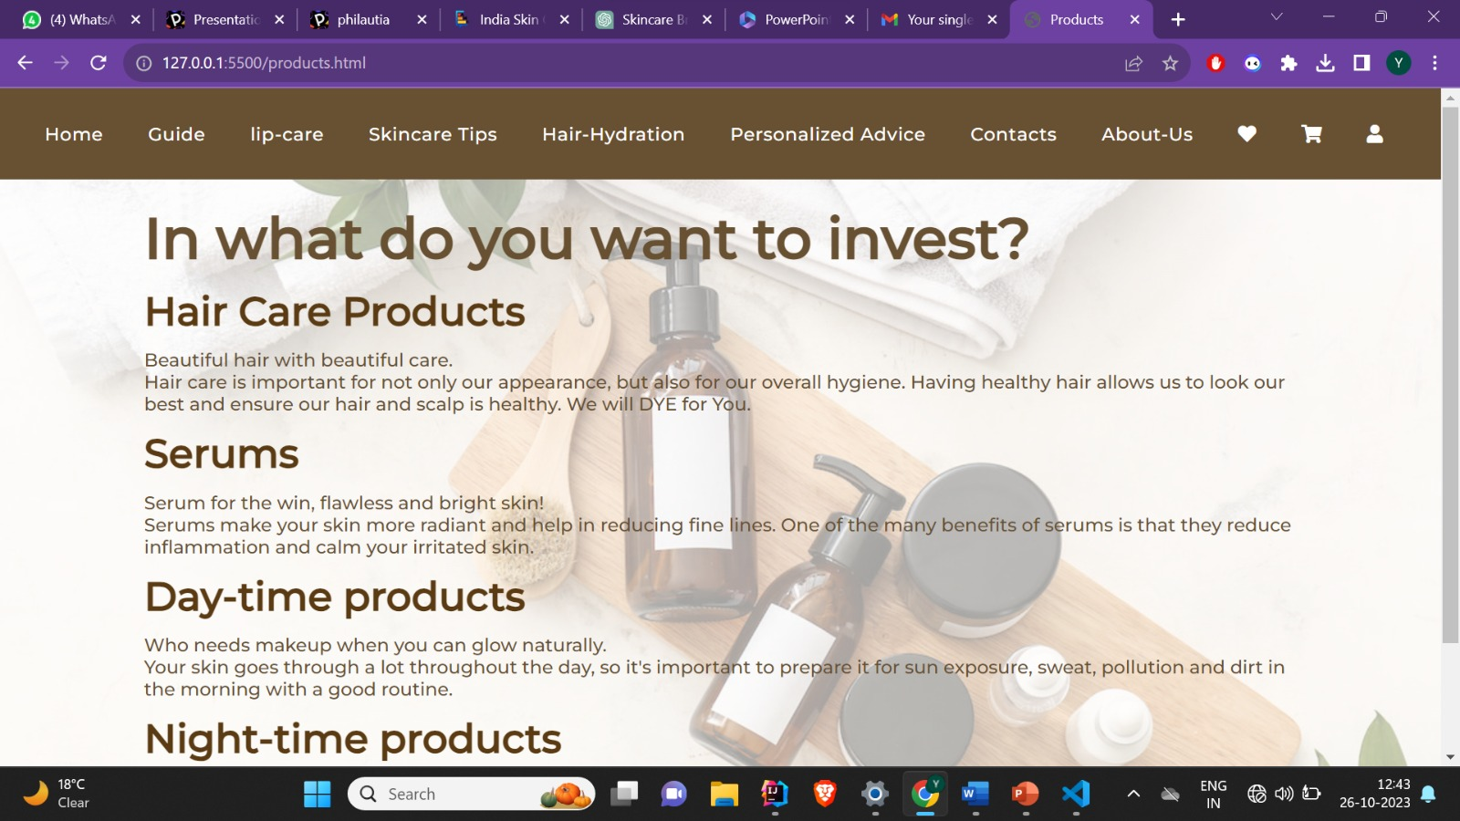

Introduction:

The website section presents various categories of products related to self-care and beauty. It encourages visitors to explore different investment options for their personal care needs.

Product Categories:

The content introduces four main product categories, each with its unique features and benefits:

Hair Care Products:

Highlights the importance of hair care for both appearance and hygiene.

Emphasizes that healthy hair contributes to a better overall look and ensures a healthy scalp.

Playfully suggests that visitors would be willing to "DYE" for the products.

Serums:

Promotes serums as a solution for achieving flawless and radiant skin.

Stresses the benefits of serums, such as reducing fine lines and inflammation.

Positions serums as a way to achieve healthier, more radiant skin.

Day-time Products:

Encourages visitors to embrace natural glow and minimize the need for makeup.

Highlights the importance of preparing the skin in the morning to face sun exposure, sweat, pollution, and daily challenges.

Suggests that a good morning skincare routine can lead to naturally glowing skin throughout the day.

Night-time Products:

Positions night-time products as the secret to beautiful skin.

Explains the benefits of nighttime product absorption, leading to glowing and plump skin in the morning.

Highlights the advantage of layering products without feeling sweaty or sticky during the day.

Page 15: Buy Day Time Skincare Routine

Introduction:

This website section offers a range of day-time skincare products for users to purchase. It provides information on various skincare products, including cleansers, toners, serums, moisturizers, and sunscreens. Each product is accompanied by an image, a brief description, price, and a "Buy Now" link.

Product Categories:

The website features the following product categories:

Cleansers:

Offers different cleanser options with images, descriptions, and prices.

Encourages users to consider purchasing these products for their skincare routine.

Toners:

Presents a variety of toners along with details and pricing.

Provides users with options to choose the right toner for their needs.

Serums:

Displays a selection of serums and outlines their benefits.

Promotes serums as a crucial part of a skincare routine.

Moisturizers:

Offers a range of moisturizers with descriptions and prices.

Encourages users to keep their skin well-hydrated with these products.

Sunscreens:

Provides different sunscreen options along with pricing.

Highlights the importance of sun protection as part of a skincare routine.

Conclusion:

The website segment is a one-stop destination for users looking to purchase day-time skincare products. It offers a variety of products with detailed information and prices, making it convenient for users to make informed choices for their skincare needs. The "Buy Now" links make the purchasing process straightforward, and the content encourages users to invest in quality skincare products to maintain healthy and radiant skin.

Page 16: Buy Night Time Skincare Routine

This section of the website offers a "Night Time Skincare Routine" with a variety of skincare products for users to purchase. The products include cleansers, toners, serums, eye creams, and moisturizers. Each product is presented in a visually appealing format with an image, product name, price, and a "Buy Now" button for easy purchasing.

Key Components:

Product Images: High-quality images of the skincare products are provided, allowing users to see the products.

Product Information: Each product is accompanied by a caption indicating its type (e.g., cleanser, toner, serum) and the price in Indian Rupees (Rs.).

"Buy Now" Button: A "Buy Now" button is available for each product, enabling users to easily make a purchase.

Categorization: The products are organized into categories for a clear and structured presentation, making it convenient for users to select the products they need for their night-time skincare routine.

Page 17: Buy Serums

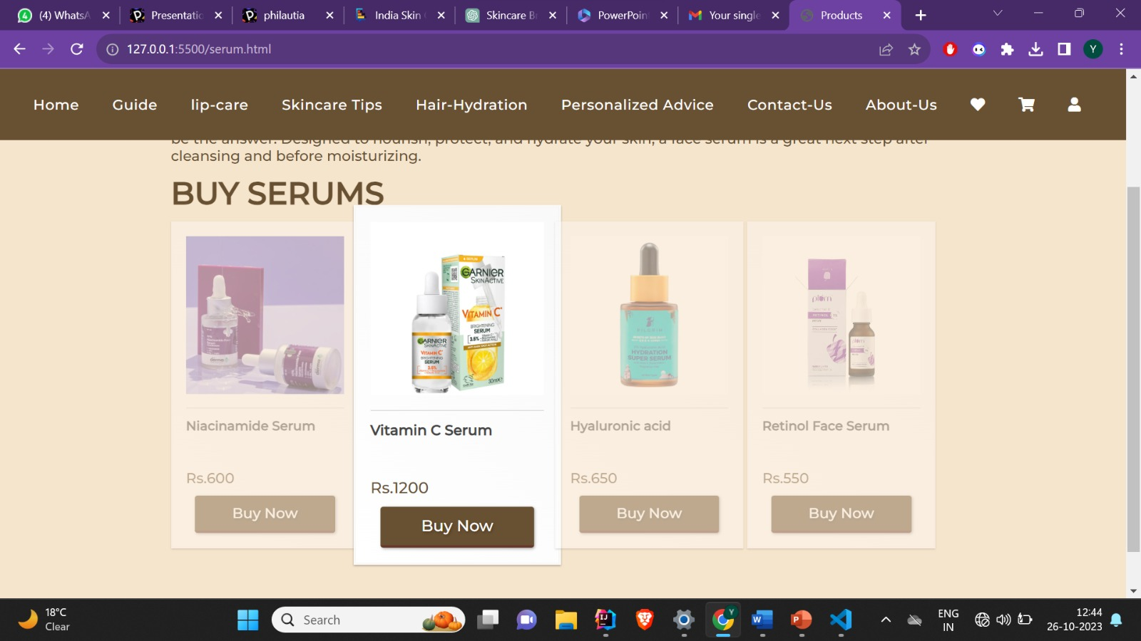

This section of the website provides information about the benefits of using a face serum and offers a selection of serums available for purchase. Here's a summary:

Benefits of Using a Face Serum:

Face serums can add moisture and deliver high concentrations of beneficial nutrients to the skin.

The specific benefits may vary depending on the formula chosen.

Face serums are designed to nourish, protect, and hydrate the skin.

They provide a powerful dose of active ingredients for enhanced skincare.

Available Face Serums for Purchase:

Niacinamide Serum: Priced at Rs. 600, this serum is designed to offer specific benefits associated with niacinamide.

Vitamin C Serum: Priced at Rs. 1200, this serum contains vitamin C and provides its associated skincare benefits.

Hyaluronic Acid Serum: Priced at Rs. 650, this serum is formulated with hyaluronic acid, which is known for its skin hydration properties.

Retinol Face Serum: Priced at Rs. 550, this serum features retinol, a popular ingredient known for its anti-aging properties.

Each serum is accompanied by a product image, a product name, price, and a "Buy Now" button, allowing users to easily purchase the desired serum.

Page 18: Buy Hair Care Products

T his section of the website provides information about various hair care products available for purchase. It includes a range of products, each designed to address specific hair care needs. Here's a summary:

Available Hair Care Products for Purchase:

Shampoo: Four different shampoos are offered, each designed for specific hair care needs. Prices range from Rs. 550 to Rs. 650.

Conditioner: Four different conditioners are available, each tailored to complement the shampoo selection. Prices range from Rs. 400 to Rs. 500.

Hair Mask: Four different hair masks are offered, designed to provide deep conditioning and treatment for various hair concerns. Prices range from Rs. 700 to Rs. 750.

Each product is presented with a product image, a product name, price, and a "Buy Now" button, allowing users to easily purchase the desired hair care product.

This section of the website serves as an informative and convenient platform for users to explore and purchase hair care products based on their specific needs. It provides clear information about the available products and their prices, making it user-friendly and encouraging informed decision-making in hair care.

Page 19: Login Page

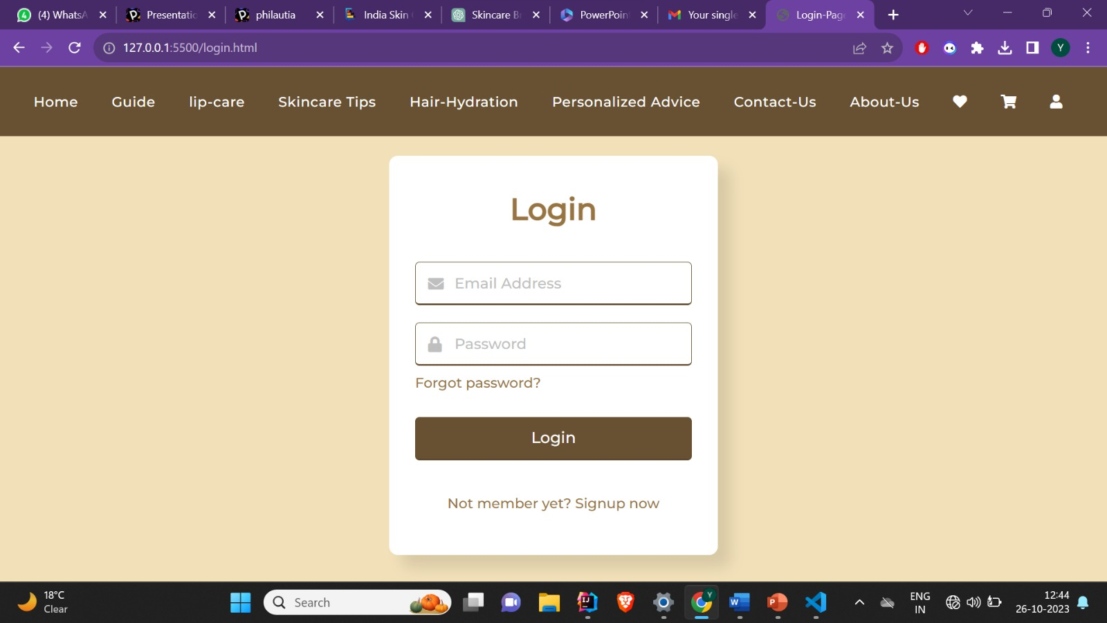

Header: The header displays "Login," indicating that this is a login form for existing users.

Form Fields:

Email Address Field:

Placeholder text: "Email Address"

Input area: Users can enter their email address.

Icon: A small envelope icon (fas fa-envelope) is displayed beside the email input field.

Error Icon: An exclamation circle icon (fas fa-exclamation-circle) is displayed, indicating an error.

Error Text: "Email can't be blank" is shown as an error message below the email input field.

Password Field:

Placeholder text: "Password"

Input area: Users can enter their password.

Icon: A padlock icon (fas fa-lock) is displayed beside the password input field.

Error Icon: An exclamation circle icon (fas fa-exclamation-circle) is displayed, indicating an error.

Error Text: "Password can't be blank" is shown as an error message below the password input field.

"Forgot Password?" Link:

A "Forgot password?" link is provided below the password field. Users can click on this link to potentially reset their password (the link itself, marked by "a href," does not have a specific destination in this provided code).

Submit Button:

Users can click the "Login" button to submit the form.

Additional Information:

Below the form, there is a text link that says "Not a member yet? Signup now." This link directs users to a signup page (signup.html) if they are not yet registered.

Page 20: Sign up Page

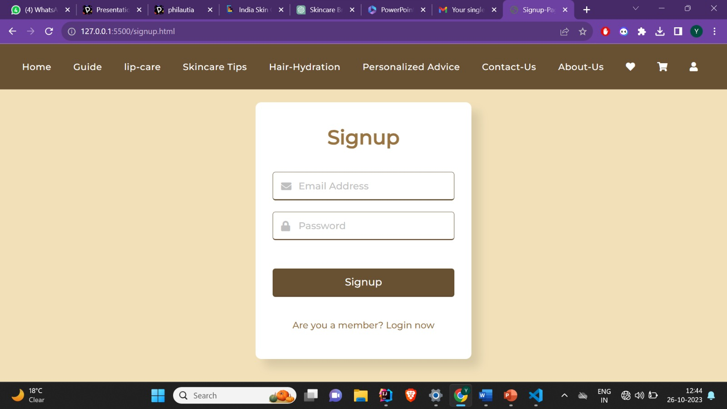

Header: The header displays "Signup," indicating that this is a signup form for new users.

Form Fields:

Email Address Field:

Placeholder text: "Email Address"

Input area: Users can enter their email address.

Icon: A small envelope icon (fas fa-envelope) is displayed beside the email input field.

Error Icon: An exclamation circle icon (fas fa-exclamation-circle) is displayed, indicating an error.

Error Text: "Email can't be blank" is shown as an error message below the email input field.

Password Field:

Placeholder text: "Password"

Input area: Users can enter their password.

Icon: A padlock icon (fas fa-lock) is displayed beside the password input field.

Error Icon: An exclamation circle icon (fas fa-exclamation-circle) is displayed, indicating an error.

Error Text: "Password can't be blank" is shown as an error message below the password input field.

Submit Button:

Users can click the "Signup" button to submit the form.

Additional Information:

Below the form, there is a text link that says "Are you a member? Login now." This link directs users to a login page (login.html) if they are already registered.

I’ve Created total 20 Webpages.

Yana Midha

2110992092