(1) (Catching Derived-Class Exceptions)

Use inheritance to create various derived classes of runtime_error.

Then show that a catch handler specifying the base class can catch derived-class exceptions.

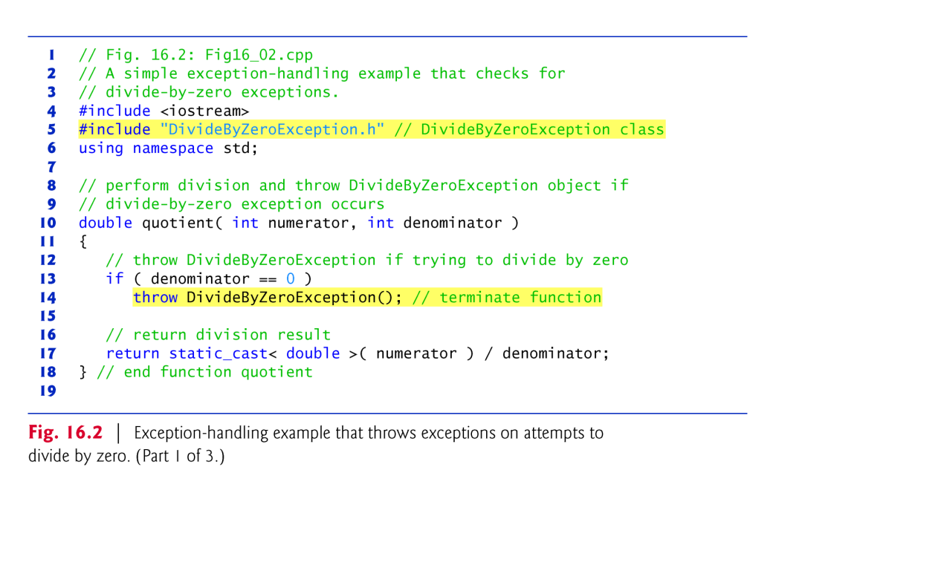

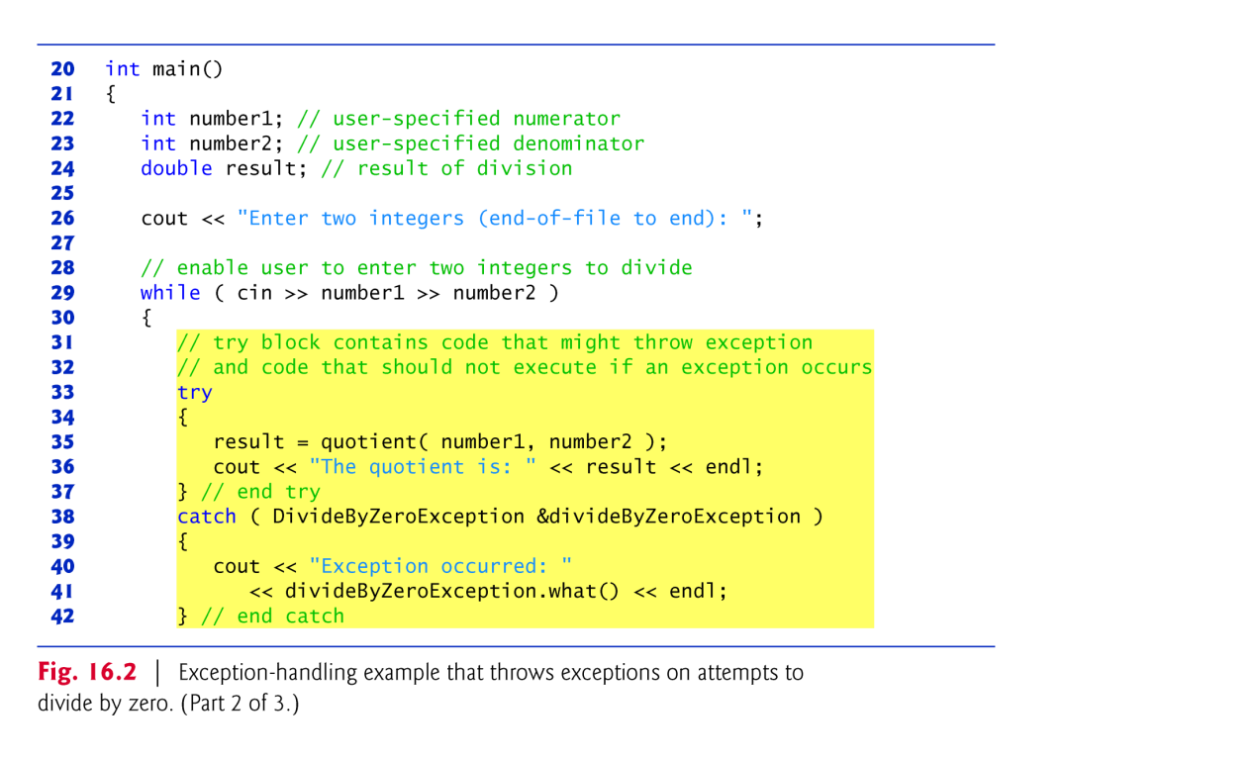

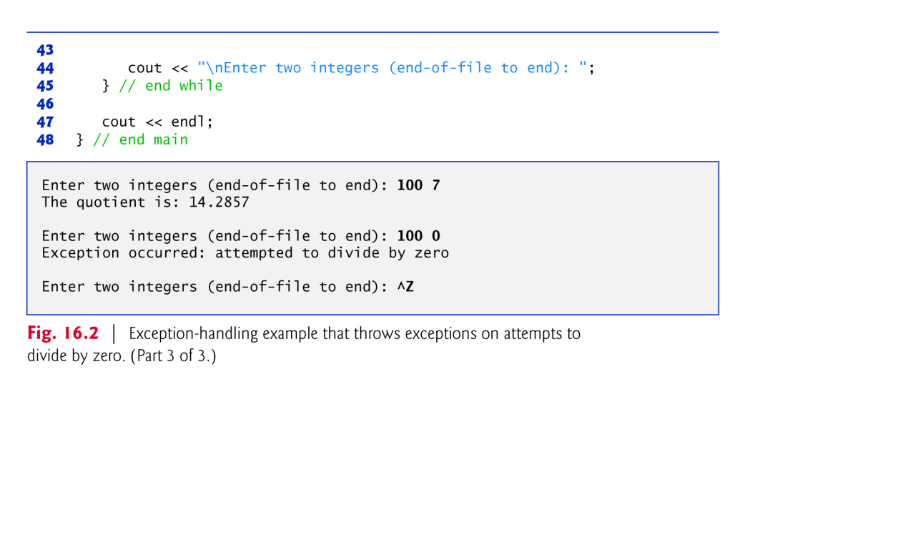

(2) Write program that demonstrates several exception types being

caught with the catch(...) exception handler.

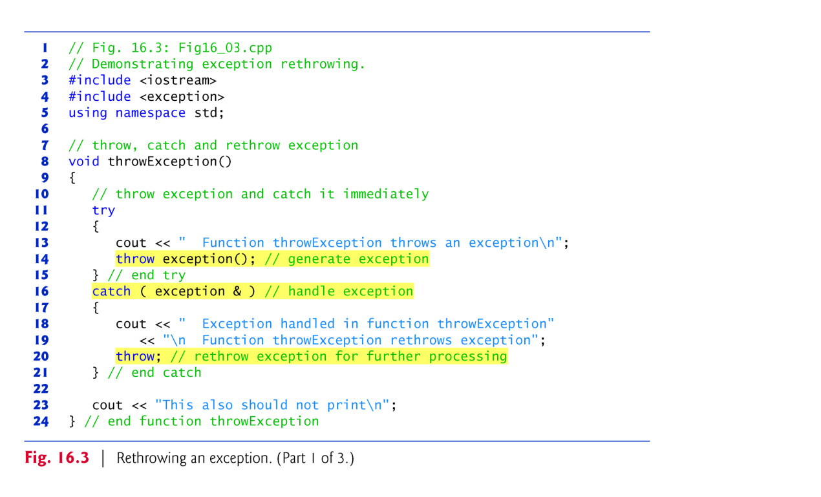

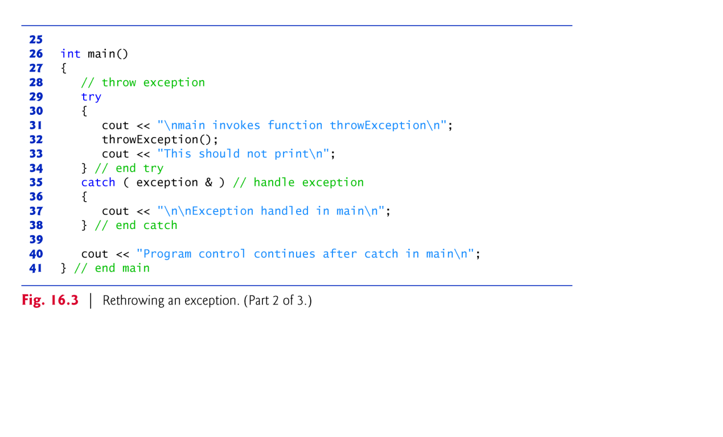

(3) Write a program that illustrates rethrowing an exception.

Write a program that illustrates that a function with its own try

block does not have to catch every possible error generated within the try.

Some exceptions can slip through to, and be handled in, outer scopes.

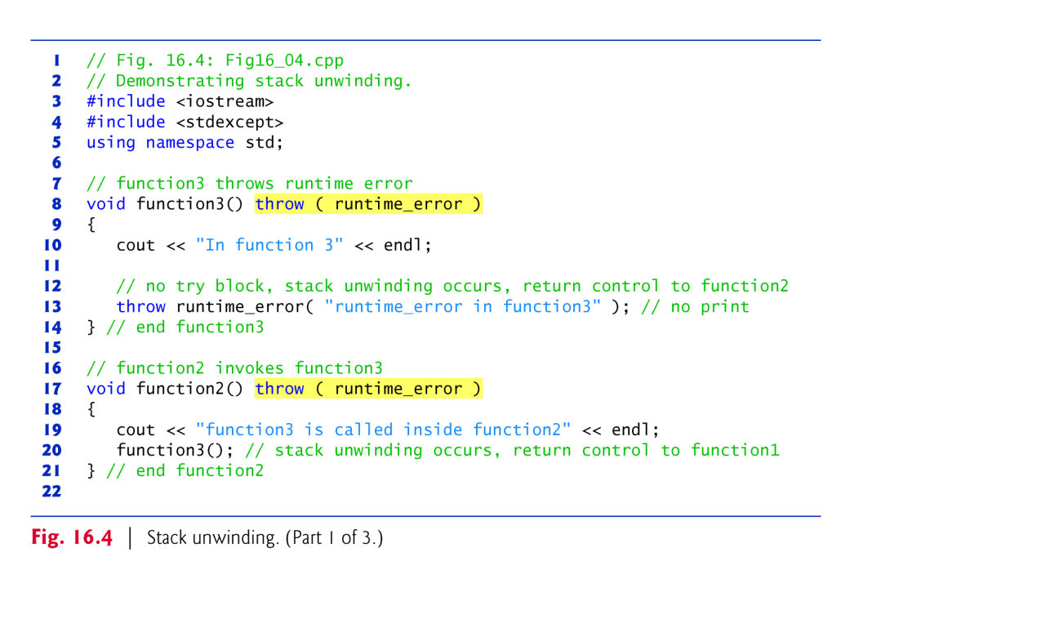

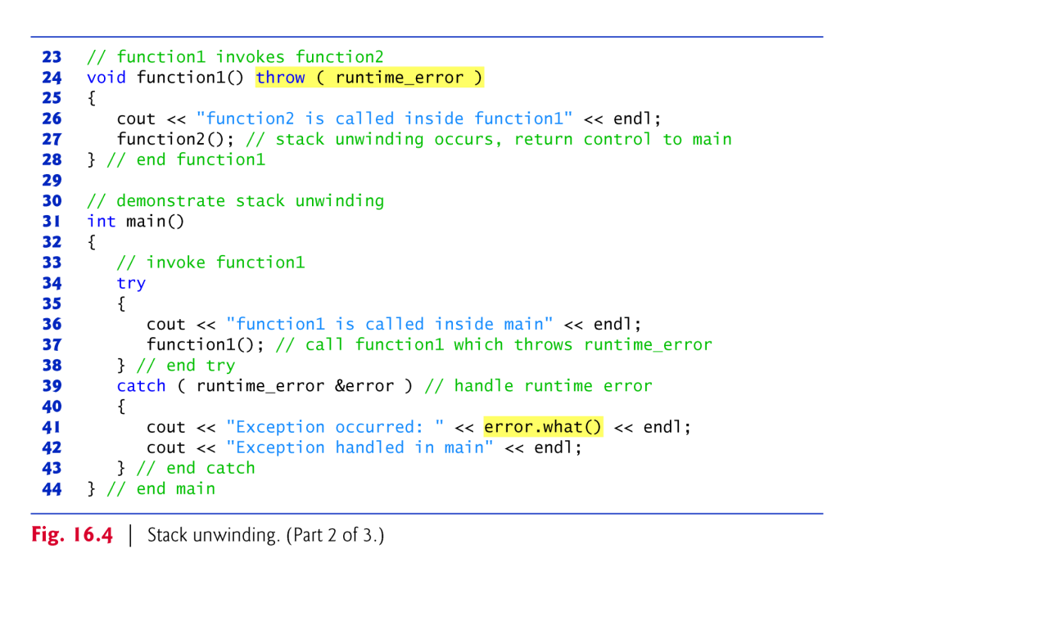

(4) Write a program that throws an exception from a deeply nested function

and still has the catch handler following the try block enclosing the call chain catch the exception.