Project 1
CIS 620

Name: Binu Joyce
Login Id: Bijoyce

Project 2 – Report

Introduction
This project is to familiarize ourselves with design and implementation of user-level thread package on Linux/PC.

Notice that I have added many explanations in the code.

There are two parts of this project.
- Part I
- Part II

Part I
Part I requires us to modify the non-preemptive DIY thread package and make it preemptive. For this we will be using SIGALRM interrupt instead. We will NOT be calling the xthread_yield() function.

The below code describes the way we have tried to set the timer of 0.02 secs using ualarm() and handler() function. We have called the Signal handler in main.c before the ctxsw(). This signal function will capture SIGALRM signal which is produced by ualarm(). When the current thread is running, if a alarm signal arrives, signal() function will capture it and let handler() function to handler it.

In handler function, firstly we will clear the the alarm signal in 32 bit-position, that is, change it from 1 to 0, if new alarm signal arrives, it will change the responding bit in 32 bit-position from 0 to 1. Then the current thread will stop and let next XREADY thread run. Notice that we should change the state of current thread from XRUN to XREADY before execute resched(), it means that the current thread will be not running.

Resched() function will search the xtab which is similar to PCB, and get next XREADY thread. And finally execute ctxsw() to let new thread run.

I created 3 applications for part 1:
- xmain1.c
- xmain2.c
- xmain3.c

I will show you the output and explain the reasons.

xmain1.c #define WAITING_TIME 10000
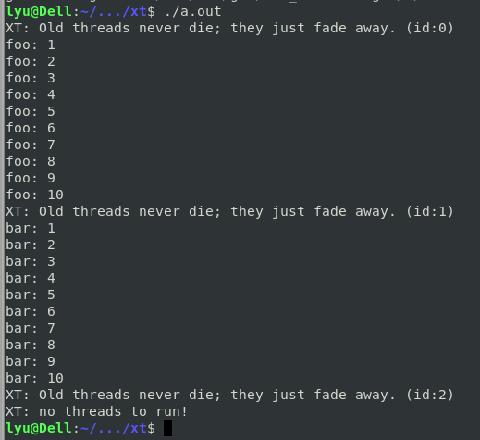
The waiting time is not big enough, so before the ALARM signal arrives, foo has run all of code and nature return. So we can’t see the preemptive situation.
So we set a larger number for busy waiting in xmain2.c

xmain2.c #define WAITING_TIME 5000000
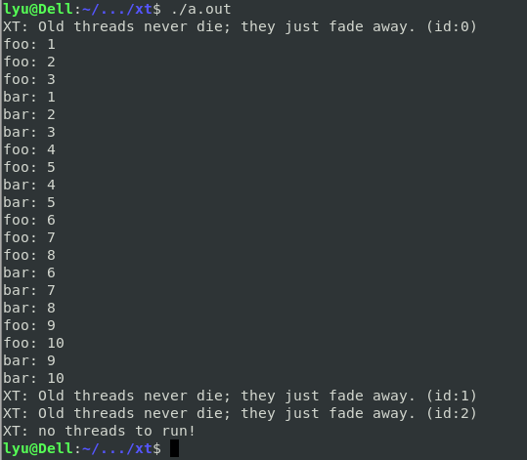
We use a larger number. As the above picture shows, before the ALARM signal arrives, foo thread had run 2 waiting loops and is running the third waiting loop. The bar thread get the control with a preemptive way when foo thread is running the third waiting loop.
Notice that it is not 3 foo and then 3 bar strictly. For example, foo:4, foo:5, and then bar:4. It depends on how much busy waiting time it remains when signal arrives.

xmain3.c #define WAITING_TIME 20000000
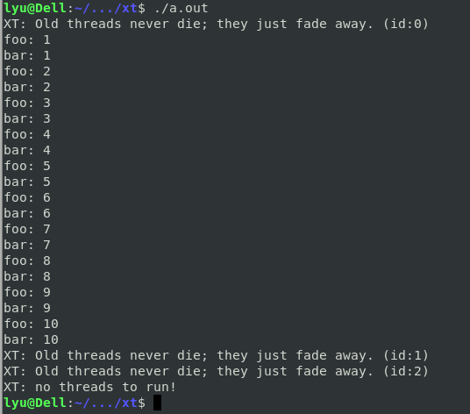
20000000 is big enough, so when foo thread is running the first busy waiting loop, the ALARM signal arrives, and foo thread's running(stack) information is stored to xtab. Then bar is switched to CPU and run.
As the above picture showed, it is strictly switch between foo and bar. It occurs by coincidence, the remaining of waiting time can’t last long enough time for waiting a new signal.
It is difficult to verify it by setting a proper waiting time. Because the busy waiting is so long.

I will add a printf(“context switch\n”) in reched() to explain it. And insert the screenshot on this report.
However, In order to make other xmain’s outputs neat, I will delete printf(“context switch\n”) when I turn in code.
Even context switch occurs, it didn’t print foo or bar, the reason is that the they are still in busy waiting loop when they are restored to CPU.
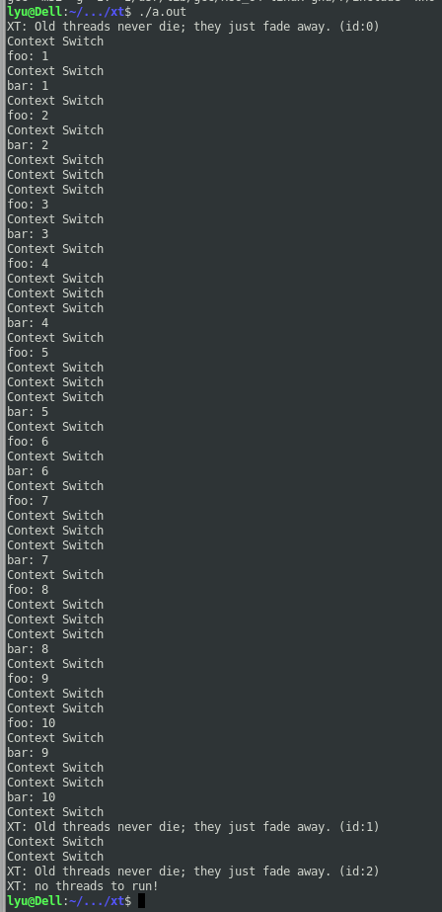

Part II
If OCCURRRED, the current thread will continue running and set it to be NOT_OCCURRED.
If NOT_OCCURRED, the current will be placed to Q and pick a next XREADY thread to run.

Part 2 of the project is regarding xthread library enhancement by adding the event mechanism. This feature has been implemented by using three functions (xthread_init_ev() xthread_wait_ev(), xthread_set_ev() ) and a struct datatype xthread_event_t.

The way it works is once the “event” (ep – event pointer) is initialised then if the event has “NOT OCCURED” then the active running thread’s state is changed from XRUN to XEVENT mimicking the WAIT state. After this, once the xthread_set_ev operation is performed by a thread then all the treads that were loaded to the “waiting queue” are allowed to continue processing for their slot times os 0.02 secs each and the xthread_event_t’s event indicator (a bool variable) is set to “NOT OCCURRED”

So, using this event mechanism we able to move a thread from “XRUN” state to “XEVENT” (wait state) and then to XREADY state.

These bellow applications are for part 2
- xmain4.c
- xmain5.c
- xmain6.c

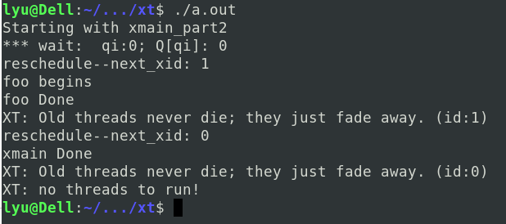
xmain4.c

Because xmain thread call xthread_wait_ev(&e), xmain thread will be inserted to Queue and foo thread is rescheduled to CPU. Foo thread call xthread_set_ev(&e), this function change the state of all threads in Q from XEVENT to XREADY. So when signal arrives, resched() pick the XREADY thread, in this test case, it is xmain thread to run. So then xmain Done.

xmain5.c
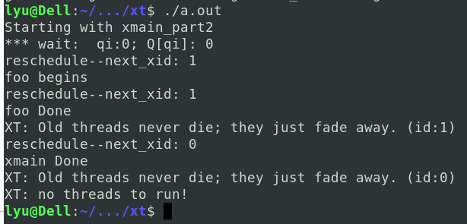
/* foo done before xmain done, because xmain thread is inserted to Queue
* and state is set as XEVENT. when foo is in busy waiting loop and a new
* signal arrives, xmain thread cannot run because it's in XEVENT state other than XREADY state.
* so xmain thread is still Done after foo Done
*/

xmain6.c
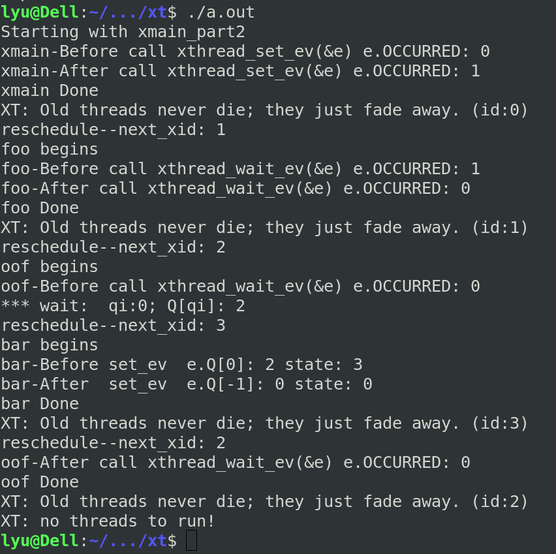
/* 1) xmain thread call xthread_set_ev()
* no process in Queue, so xmain will continue run and set e.occurred as OCCURRED(1)
* SO xmain is first done
* 2) foo thread will run after xmain nature return.
* Because e.occurred is OCCURRED(1) before calling xthread_wait_ev()
* the xthread_wait_ev() will set e.occurred as NOT_OCCURRED(0), and foo continue run.
* So foo Done and nature return
* 3) oof thread will run after foo nature return
* because e.occurred is NOT_OCCURRED(0) before calling xthread_wait_ev()
* So oof thead will be set as XEVENT, and resched() pick up next XREADY thread
* Therefore, oof is not done and no nature return
* 4) oof1 and oof2 will run and inserted to Q,
* like off, they are not Done and no nature return.
* 5) bar thread is picked up by resched() and will run
* it print the Q[qi]'s state(oof), which is XEVENT.
* Then call xthread_set_ev(), oof, oof1 and oof2 are in Queue, and e.occurred is NOT_OCCURRED,
* so all threads in Q are set as XREADY
* 6) Because the state of oof, oof1 and oof2 are XREADY now, so they will be Done and nature return
*/

Experience in debugging
Implementation of this project both part 1 and part 2 were tough. We struggled with the placement of Signal Handler function (signal(SIGALRM, handler) and were intially getting segmentation fault errors

The second issue was with the implementation of Part2. The way we had set the functionality was causing the thread that thread that calls the xthread_wait_ev got stuck in a continuous loop inside moving from reshed() to hadler() and back to resched(). The issue was with the while loop in the xthread_set_ev.

Inconsistent State (when not using SIGALRM)

???

Thread State Transition Diagram:

Ready (XREADY)

Rrunning
(XRUN)
Blocked
XEVENT
Thread terminates
New thread create (XFREE)

Schedular picks. Resched()

Xthread_wait_ev()
from event.c . (Threads wait in a queue)
Xthread_set_ev()
from event.c
Timer expires
Ualarm(), SIGALRM, resched()

