CIS 620 Advanced Operating System

HW1

First name: Yanan
Last name: Lyu

Student ID: 2725639
Login ID: yalyu

Photo:



Question5:
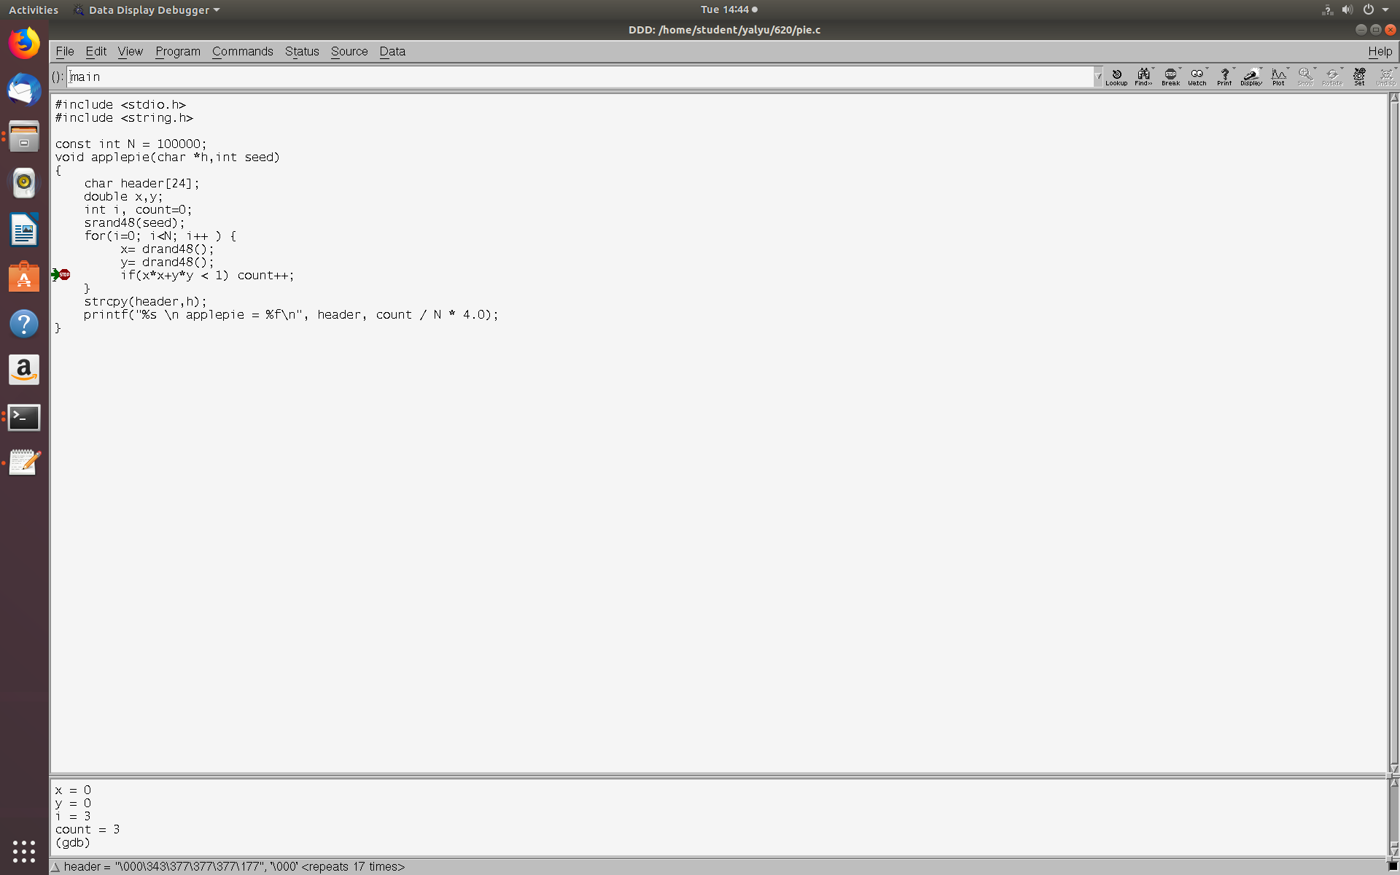
- what are the value of x and y?
The values of both x and y are always 0.
- Are they reasonable?
They are not reasonable. Because the values of both x and y are always 0. In order to calculate PI, we need calculate the section area firstly, so the value of both x and y should be region [0.0, 1.0).
I checked the function drand48() by “man drand48”, it also shows that the value should not be always 0 and should be in range [0.0, 1.0)
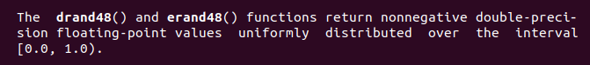

Question 7:
- Find and fix the first bug in the source files with ddd.
The bug is we did not include stdlib.h file, but both srand48(seed) and drand48() are functions. Therefore, I fixed it by add “#include <stdlib.h>”.
As the below picture shows, we get reasonable values of both x and y. So now I have fixed the first bug.
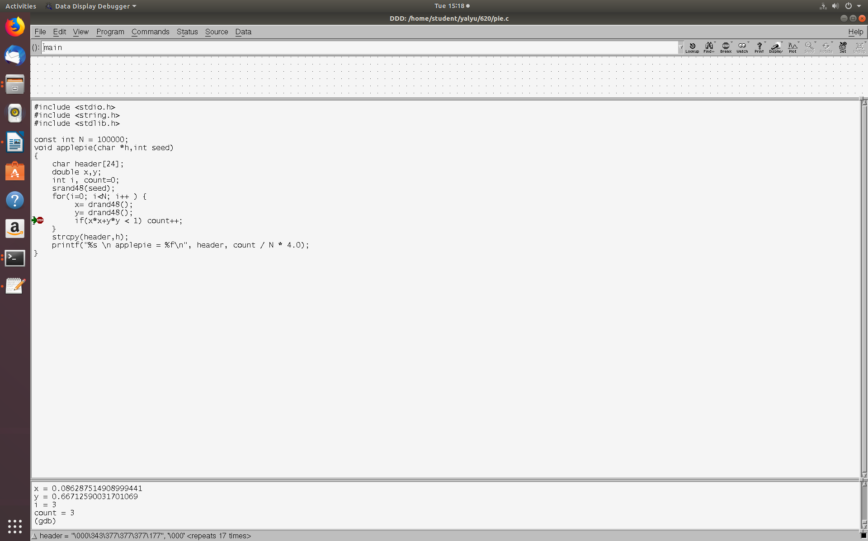
- What is the value of count?
The value of count is 78351 as bellow photo shows.
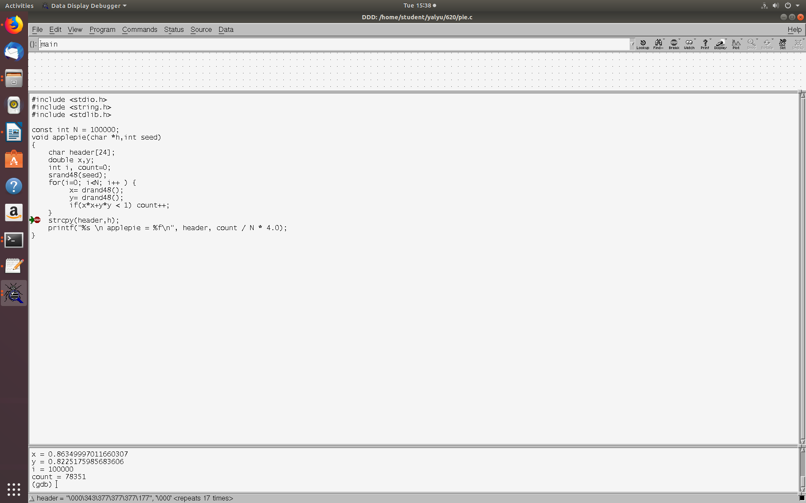

Question 8
- What is the value of count before printf?
78351
- Fix the second bug
Because it said stack smashing detected, I guess it is out of the range of certain variable. I have got the value of count and I, so they are not reasons.
Notice that strcpy(header, h), h is a pointer and header is an array whose length is 24. so I guess that the length of the string is greater than 24.
Therefore, I change the length of array from 24 to 50. As it showed, I fixed the second bug.
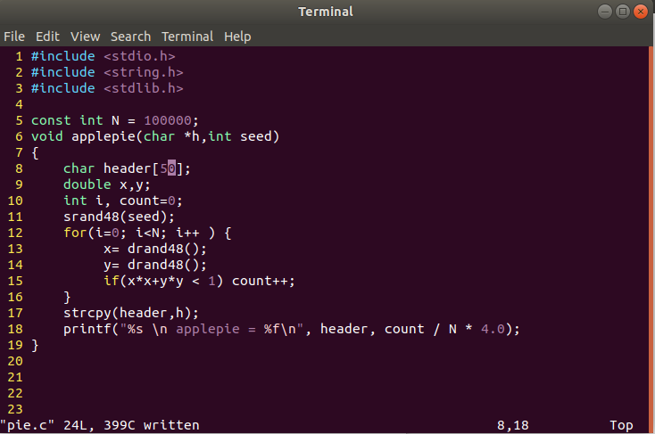

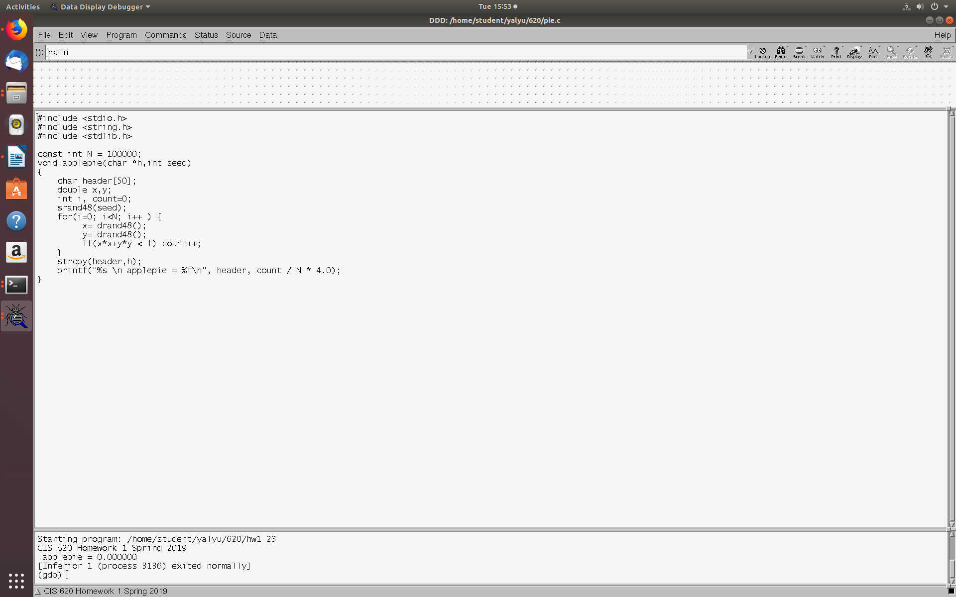

Question 9
- Find, fix and explain the third bug in the source files.
As the above picture showed, the value of pie is 0.00000, it is not reasonable.
I think the reason is the type of variable count and N. it will do int divide.
To fix it by cast them to double. Now we get the result which is 3.1314040.
