CIS 620 Advanced Operating System

HW#1

First name: Yanan
Last name: Lyu

Student ID: 2725639
Login ID: yalyu

Photo:

Part 1:

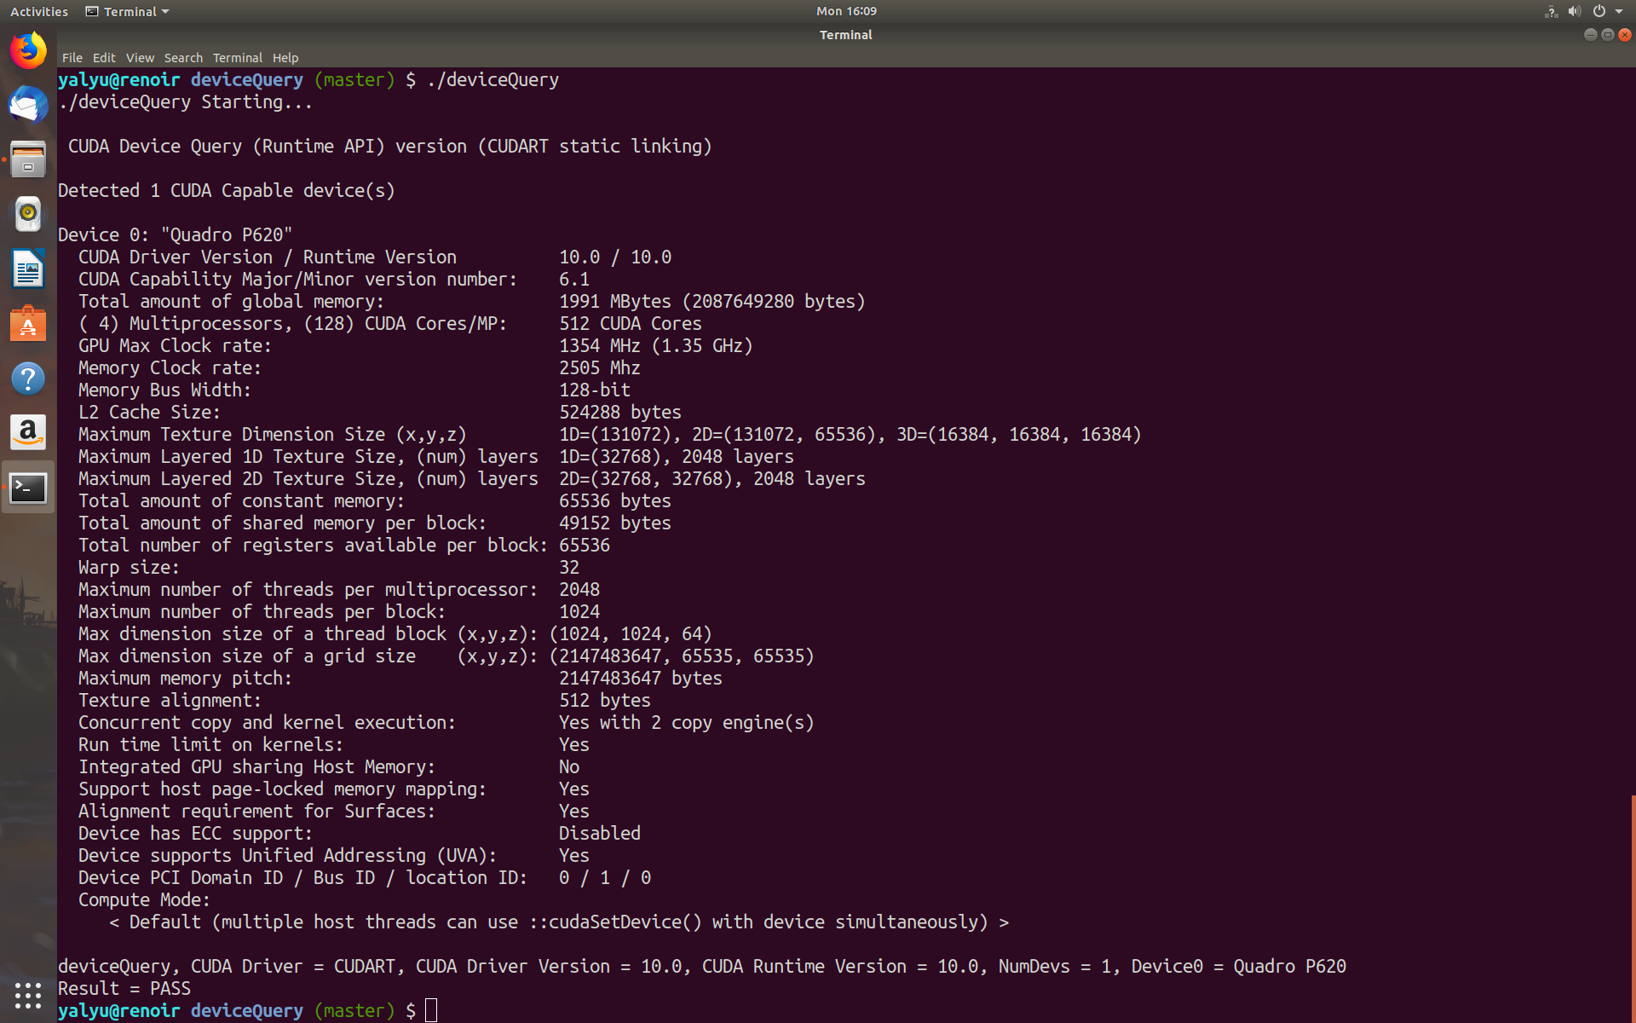
GPU clock rate: 1354 MHz(1.35 GHz)
CUDA cores: 512

Part2

