CIS 620 Advanced Operating System

HW#2



First name: Yanan
Last name: Lyu
First name:SRITEJ
Last name:DYAVARI SHETTY

Student ID: 2725639
Login ID: yalyu

Part 1:

The purpose is to introduce the CUDA GPU and MPI programming environment.

Here we create a makefile to get a executable file deviceQuery and run it to get the information about the GPU clock rate and find how many CUDA cores are used.

Output :

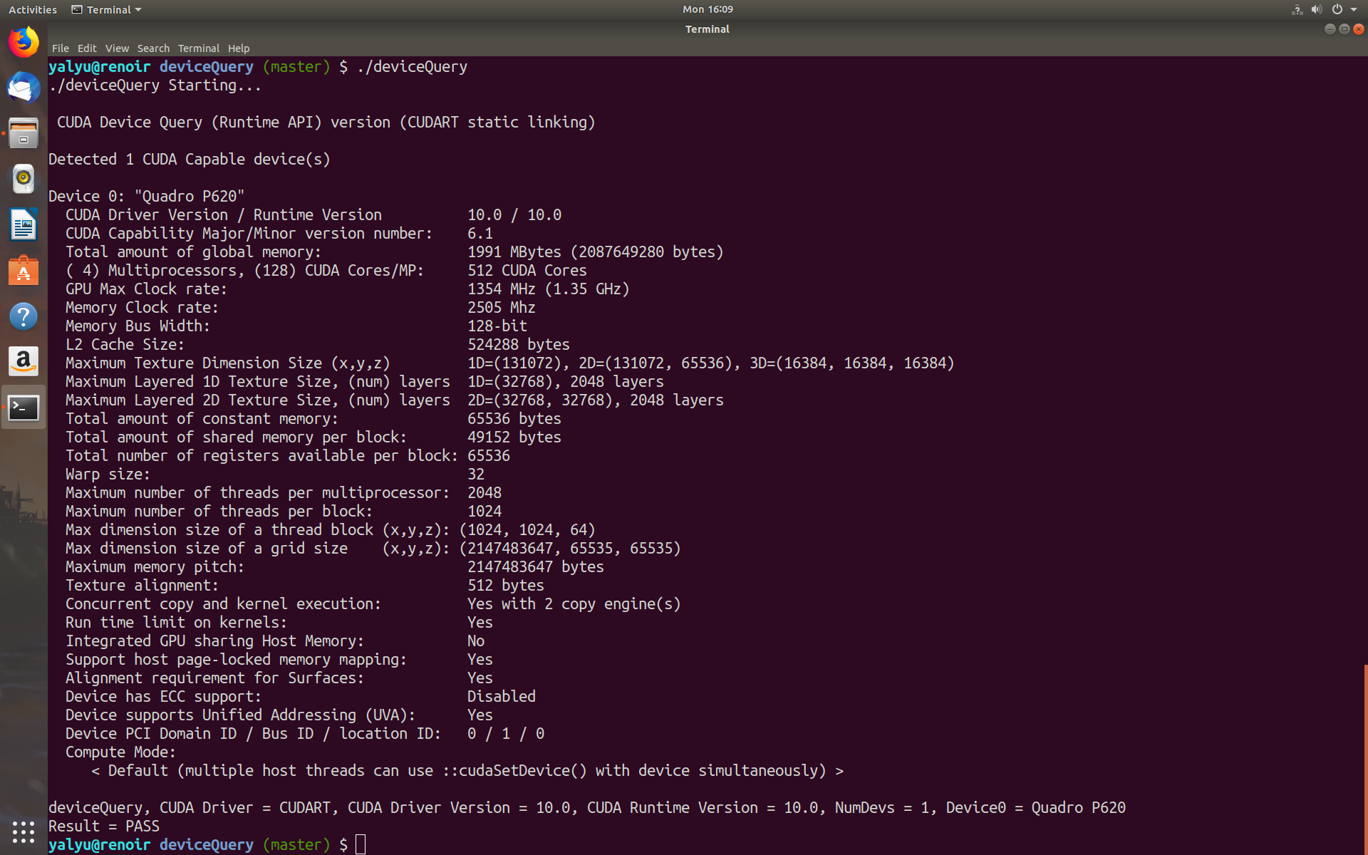
GPU clock rate: 1354 MHz(1.35 GHz)
CUDA cores: 512

Part2:

Here using different number of GPUs on MPI platform we calculate the average of Euclidean distance. Here we setup MPI in the system where you run the MPI program. We use different machines. We edit .cshrc file to add id_rsa through which we get access to the machines without using the passphrase every time we login or execute the program.

We add
- davinci
- renoir
- bach
- chopin
to machine file
We modify the simpleMPI.cpp and simpleMPI.cu files to add the two different arrays and allocate the memory to them to calculate the euclidean distance.

Now we run the file to get average of euclidean distance which is processed on the different machines.

Output :

