Delete Java temporary jar files, clear you’re the browser cache (delete cookies and temporary internet files), and then add the USRP link to trusted sites and try again..

Go to → start →control panel→Java
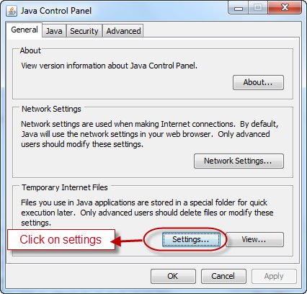

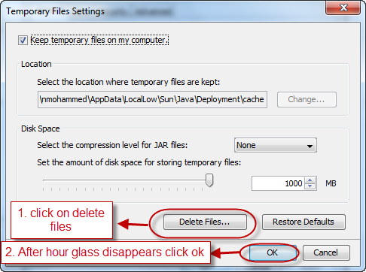
Go to → start →control panel→ internet options
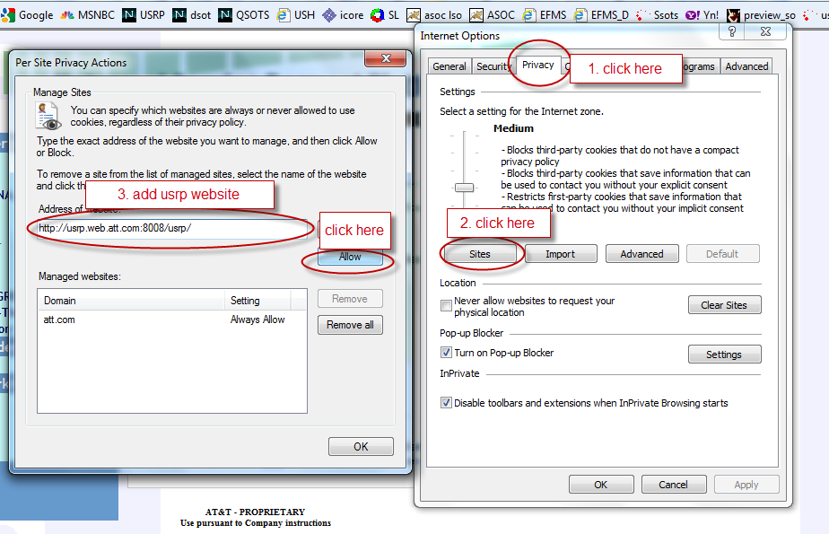

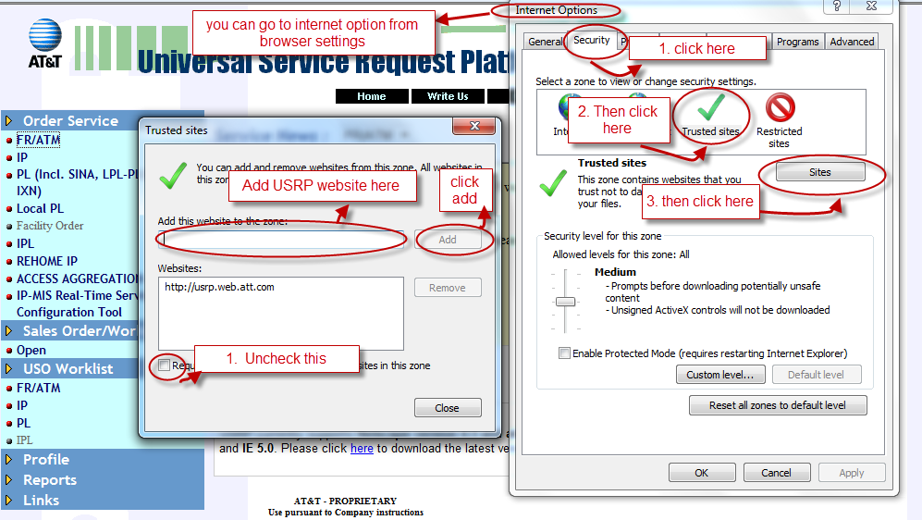

Thank You,
USRP FR/ATM PSO
 : 917.652.6786
 : nm9733@att.com
Q nm9733
Please use USH to report USRP FR/ATM troubles: Click Here
**Think Green - Please print responsibly**

Instructions for Clearing Browser Cache are as follows, depending on version:

HOW TO CLEAR YOUR BROWSER CACHE IE v. 8.xx:
- Open Internet Explorer. Do not login to USRP. From the Internet Explorer menu at the top of the window, click on 'Tools.'
- From the Tools menu, click on 'Internet Options.'
- This will generate a pop-up window. Look in the middle section of the window, for an area called 'Browsing history.' Click “Delete.”
- Please UNCHECK the box next to “Preserve Favorites website data,” and check the boxes next to “Temporary Internet Files” and “Cookies.”
- Within this area, you will see a button labeled 'Delete…' Click on this button.
- This may take as long as 2 minutes. Once the hourglass goes away, click 'OK' in the remaining 'Internet Options' open window.
- Restart your IE browser and login to USRP again

HOW TO CLEAR YOUR BROWSER CACHE IE v. 7.xx:
- Open Internet Explorer. Do not login to USRP. From the Internet Explorer menu at the top of the window, click on 'Tools.'
- From the Tools menu that opens, click on 'Internet Options.'
- This will generate a pop-up window. Look in the middle section of the window, for an area called 'Browsing history.'
- Within this area, you will see a button labeled 'Delete…' Click on this button.
- This will open another pop-up window. On this new window, click on the button labeled 'Delete files.' Now click on 'Yes' on the box that reads 'Are you sure you want to delete all temporary Internet Explorer Files?' The small window will close, and an hourglass icon may appear while your cache is cleared.
- This may take as long as 2 minutes if you have not cleared your cache in a while. Once the hourglass goes away, click 'Close' to close the 'Delete Browsing History' window, and then click 'OK' in the remaining 'Internet Options' open window.
- Restart your IE browser and login to USRP again

HOW TO CLEAR YOUR BROWSER CACHE IE v. 6.xx:
- Open Internet Explorer. Do not login to USRP. From the Internet Explorer menu at the top of the window, click on 'Tools.'
- From the Tools menu that opens, click on 'Internet Options.'
- This will generate a pop-up window. Look in the middle section of the window, for an area called 'Temporary Internet Files.'
- Within this area, you will see a button labeled 'Delete Files.' Click on this button.
- This will open a smaller pop-up window. On this new window, put a checkmark in the box to 'Delete all offline content.' Now click on OK. The small window will close, and the hourglass icon will appear while your cache is cleared.
- This may take as long as 2 minutes if you have not cleared your cache in a while. Once the hourglass goes away, click OK on the open pop-up window.
- Restart your IE browser and login to USRP again.

