**Basic Job Queue Actions**

* Job queues in eSign can be reached using the direct link –

<http://esign.marketing.att.com/esign/admin/jobQueueFailed.htm>

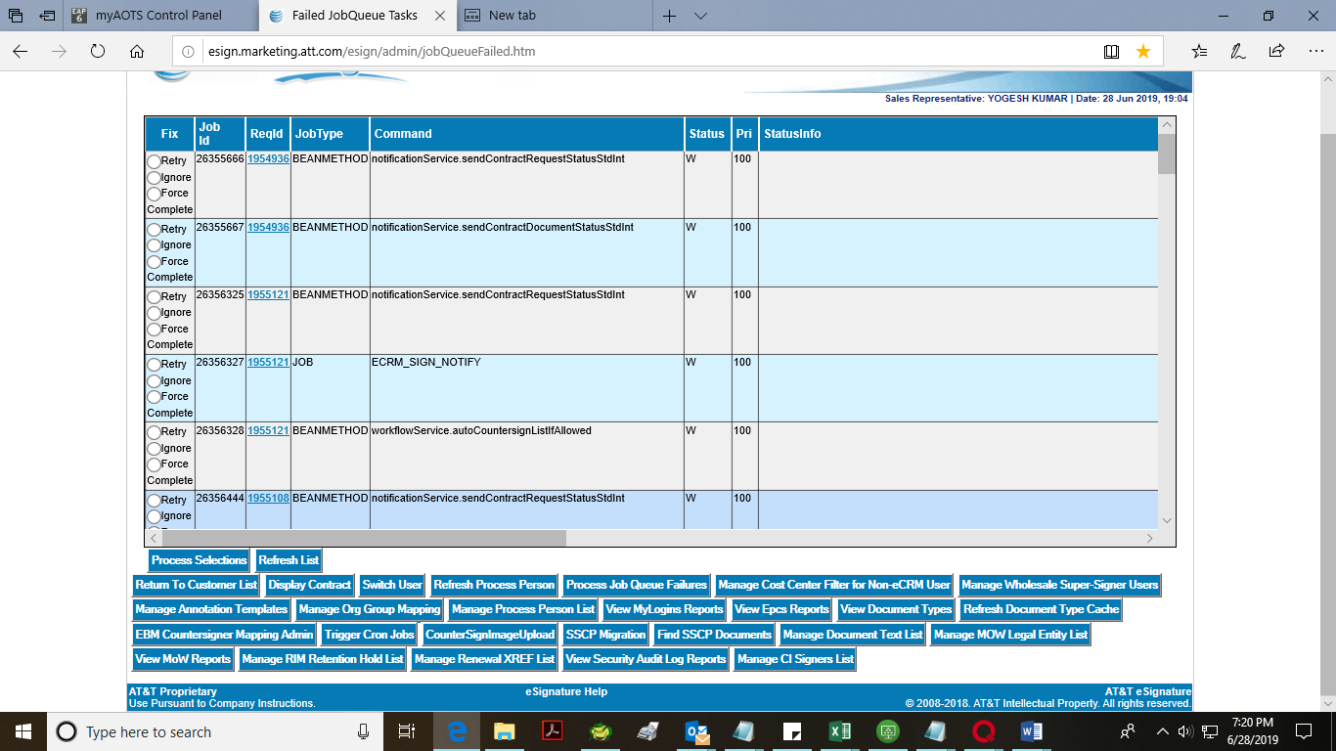

* Job queues has different **Status** like-

W- Waiting

R- Running

F- Failed

C- Completed

1. Awaiting

* There are 3 types of **actions** we can take on Job queues-

1. Retry
2. Ignore
3. Force Complete

We usually use Retry and Force close option according to the job failure, and not use ignore

* To implement the **action**, we have to select the option and Click on **Process selection** button. By clicking the button, action will be implemented.

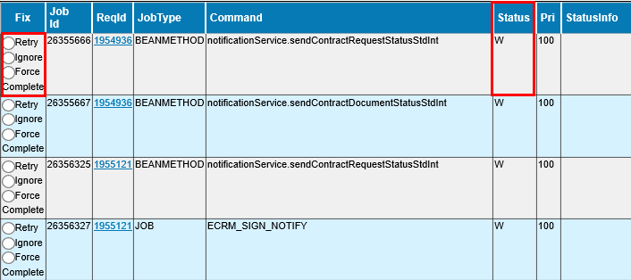

Snapshot represents the Fix/Action can be taken on job, Status of the job, Request id , Job id and other onformation.

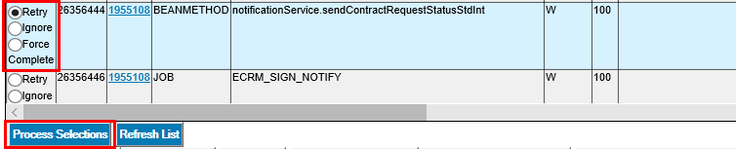

Snapshot shows the Process Selection button.

**Note-**

If the Job has status **Completed – C,** you **cannot** retry it from eSign admin, it needs to be done from eSign DB and run the update query.

1. Contact dev team at 'eSignDevSuppt@list.att.com' to run the query.

Or

1. Run the update query-

update esign.jobqueue  
set status = 'W' ,  
jobinitiatetime = sysdate + 1/86400,  
JOBSTARTTIME = sysdate + 1/86400  
where jobid = '203XXXXX' ;

-where job id can be obtained from job queues.