# **Production Logs**

Transactions of data between ADOPT and other applications are stored on two different sets of productions logs. These logs are the Catalina logs and the adopt.log logs.

1. GetALP (GetALPContractRepositoryQueryResponse)
2. CD (ContractInventoryDetailsReadRequest and ContractInventoryDetailsWriteRequest)
3. SIS (ServiceInventorySummaryRequest and ServiceInventorySummaryResponse)
4. SD (ServiceInventoryDetailReadRequest, ServiceInventoryDetailAcknowledgementResponse, and ServiceInventoryDetailsWriteRequest)
5. ASOC (BVOIPMultiSkinnySvcAvailResponse and BVOIPMultiSkinnySvcAvailRequest)
6. JSON logs
7. SetPSP (PricingScenarioPackageWriteRequest/PricingScenarioPackageWriteResponse )
   1. FileInfoWriteRequest/FileInfoWriteResponse triggered
8. SetSPP (SolutionProjectPackageWriteRequest/Response )/ ManageSalesOrderDetailsRequest/Response

### How to pull CD Log (ContractInventoryDetailsReadRequest and Response)

1. Get solution id from issue description.
2. Then use this query:-

*select * from adopt.ad_req_resp_correlation where lead_design_id in (select lead_design_id from adopt.ad_lead_Design where dbor_solution_id=22786233) ;*

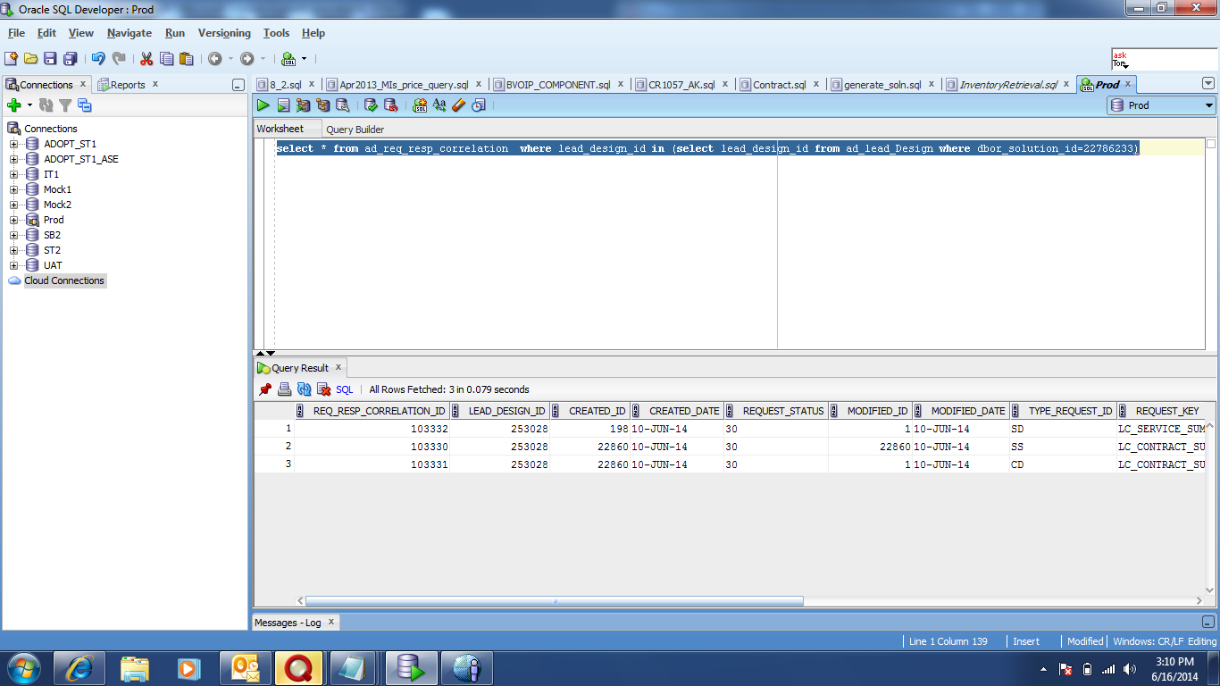

1. In Type_request_id column have 3 type of values:-

CD -- Contract Inventory details

SD-- Service Inventory Details

SS-- Service Summary

1. Pick Req_resp_correlational_id number for CD in this case.

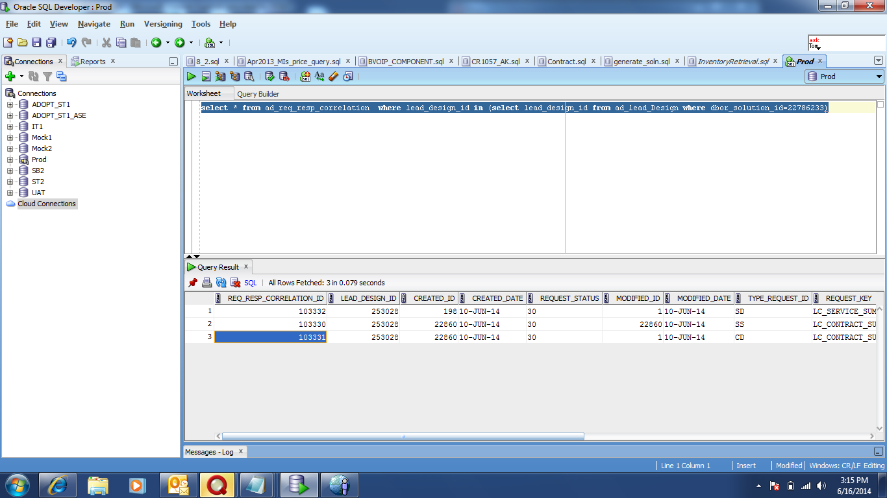

Example here Req_resp_correlational_id number is 103331

1. Now go to unix box [pstz0092.pedc.sbc.com](http://pstz0092.pedc.sbc.com)
2. Put att UID and pass code from token

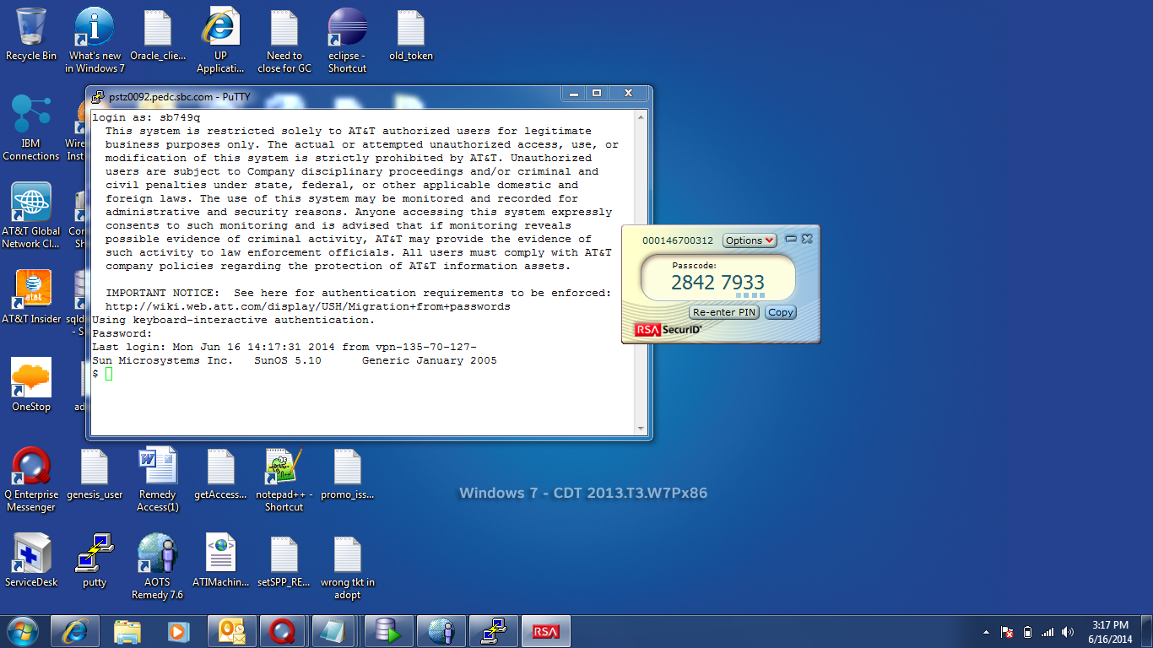

1. Change shell using ssh pstz0092.pedc.sbc.com.
2. Then again provide pass code from token.
3. Then change directory using cd command.

Example here: cd /usr/local/add-on/production_staging/prod_logs/bhdc/adopt

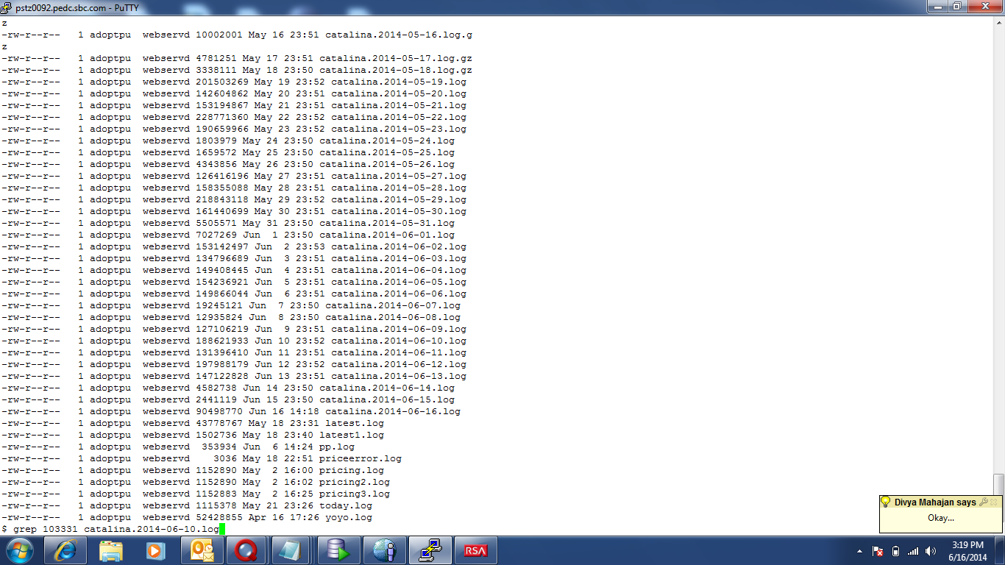

1. Now to fetch Log use grep command.

Example here: grep 103331 catalina.2014-06-10.log

1. **How to pull SD Log (ServiceInventoryDetailReadRequest and ServiceInventoryDetailAcknowledgementResponse)**
2. Get solution id from issue description.
3. Then use the below query:

*select * from adopt.ad_req_resp_correlation where lead_design_id in (select lead_design_id from adopt.ad_lead_Design where dbor_solution_id=22786233) ;*

1. Pick Req_resp_correlational_id or **MIS contract ID** number for SD in this case.
2. Now go to unix box [pstz0092.pedc.sbc.com](http://pstz0092.pedc.sbc.com)
3. Put att UID and pass code from token



1. Then cd /usr/local/add-on/production_staging/prod_logs/bhdc/adopt
2. Now to fetch Log use less command.Example here:- less catalina.log

### To Pull SS logs

SS Log stands for ServiceInventorySummaryRequest and ServiceInventorySummaryResponse.

1. Get solution id from issue description.
2. Open Solution and copy Contract Id. Example here it is MIS153362.
3. Now similarly fetch the log using grep command in Putty.

For example grep MIS153362 catalina.2014-07-25.log

1. But this command will not fetch ERROR logs as Error log will not contain Contract ID so in order to check error log use less command.

Example less catalina.2014-07-25.log

1. **To Pull SetSPP (solutionProjectPackageWriteResponse)**

This log is generated when user clicks on release project/Order Solution. So this log is generally used to check if Project is released.

1. Get solution id from issue description.
2. Then use the below query:

select sor.sor_project_id, sor.dbor_project_id dborSorId, sor.project_name projName, sor.status_id,sor.project_descr projDescr,

ld.dbor_solution_id solutionId, lk.description status, sor.created_date createDate, sor.project_number projectNumber,

ld.lead_design_id leadDesignId, ld.solution_type solutionType, al.ccid ccid

--ADOPT_SOR_UTILS.fn_has_custom_design(sor.sor_project_id) as customDesign

from adopt.ad_sor_lead_design_project sor, adopt.ad_lead_design ld, adopt.ad_lookup_data lk, adopt.ad_lead al

where sor.lead_design_id = ld.lead_design_id

and ld.lead_id = al.lead_id

and lk.dataset_name = 'SOR_STATUS'

and sor.status_id = lk.item_id

and ld.dbor_solution_id=92315678 ;

1. Copy DborsorId
2. Now similarly fetch the log using grep command in Putty.

### To Pull SetPSP Logs (PricingScenarioPackageWriteRequest and PricingScenarioPackageWriteResponse) EDF PSP

This log is generated when user clicks Generate Contract button. So this log is generally used to check if Contract was generated.

1. Get solution id from issue description.
2. Then use the below query:
3. select dbor_price_scenario_id from adopt.ad_lead_design_price_scenario where lead_design_id in (select lead_design_id from adopt.ad_lead_design where dbor_solution_id=23328555);
4. Copy dbor_price_scenario_id .
5. Now similarly fetch the log using grep command in Putty.