BPP-FACILITY: RESTART ORDERS

Generally -- the restart of orders in BPP-FACILITY is confined to REHOME/T1T3 orders. Why would we do this?

Answer: consider the following USH ticket:

-----------------------------------------------------------------------

Ticket #: 000000244414690

Application: BPP - FACILITY

PROBLEM_DESCRIPTION: REHOME PROJECT # 28CRVW071656. Please generate ESO and refer to BPP for TFAS creation. Thanks.

tm5859

-------------------------------------------------------------------------

Therefore we will work upon this Project/Order in BPP FACILITY using the Unix and sqlplus interface .

zlpv2226.vci.att.com

---------- BPP FAC - 2226 -----------------

ssh -l <attuid> zlpv2226.vci.att.com <--- ssh entry

sudo su - bppadm <------ needful sudo

bppSql <----- to invoke sqlplus

set linesize 2100

set pagesize 300

/* First we query by project number ('28CRVW071656') as given by user in the ticket. From there we discover the RH_ID (00096208) and all SQL going forward is done using that ID.

SELECT RH_ID, status, statustime, RECEIVEDATE, ESO_NO, TFAS_NO, CKT_TYPE

FROM WFM_REHOME where PROJ_NO in ('28CRVW071656');

RH_ID ST STATUSTIM RECEIVEDA ESO_NO TFAS_NO C

-------- -- --------- --------- -------- -------- -

00096208 ES 19-APR-18 19-APR-18

SQL>

We can see the SQL response is lacking ESO NO and TFAS. Something failed to happen in automation, it seems. We can fully appreciate the integrity of the user's USH ticket now. And, we have a manual work-around for this situation:

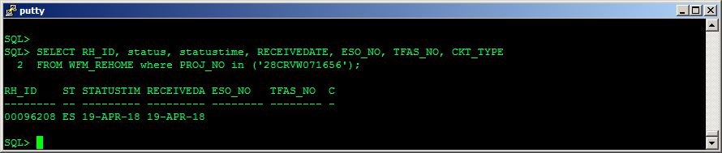

**1.) REMOVE FAILED ESO CREATION ROWS FROM CKTV TABLES**:

REHOME

TCIRCUIT- TIRKS Order Only

T1T3

RH_SIGNAL

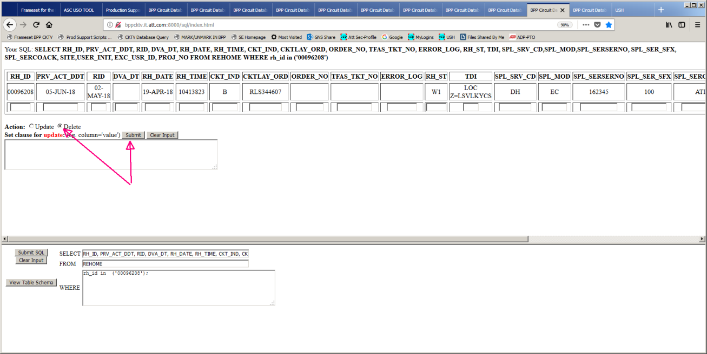

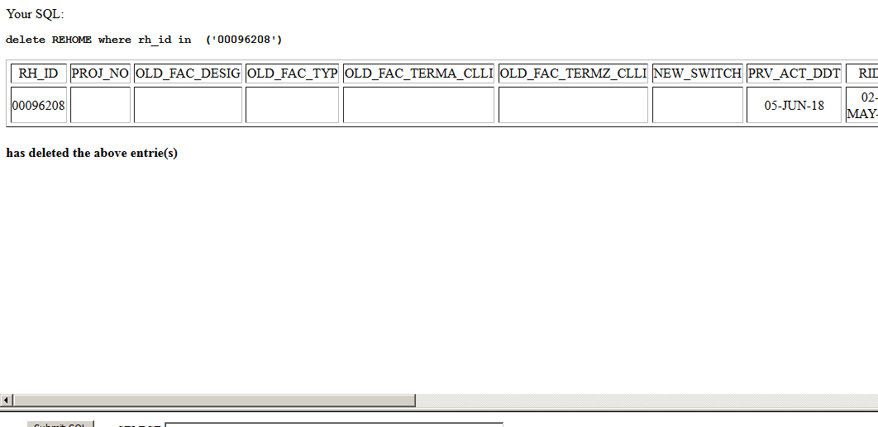

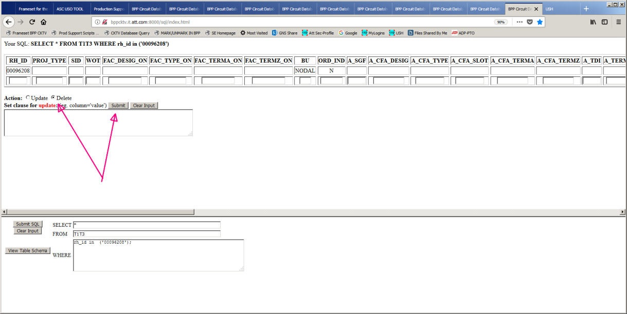

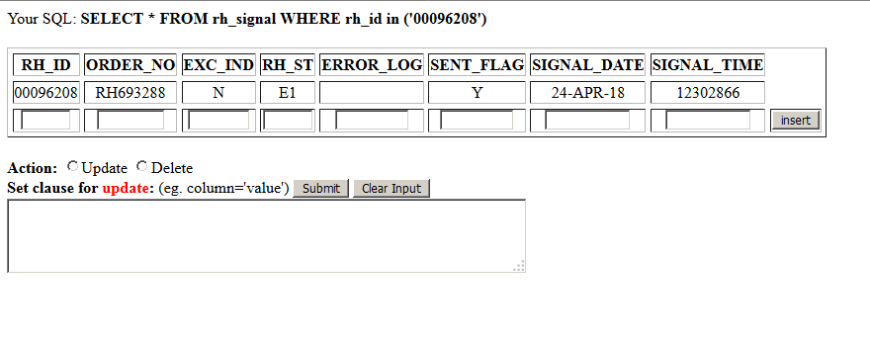

**2.) RESTART THE ORDER**

// We can use status 'RR' to restart this order -- see Status Code Chart at end of this doc.

Update WFM_REHOME set status = 'RR' where rh_id in ('00096208');

SELECT RH_ID, status, statustime, RECEIVEDATE, ESO_NO, TFAS_NO, CKT_TYPE

FROM WFM_REHOME where rh_id in ('00096208');

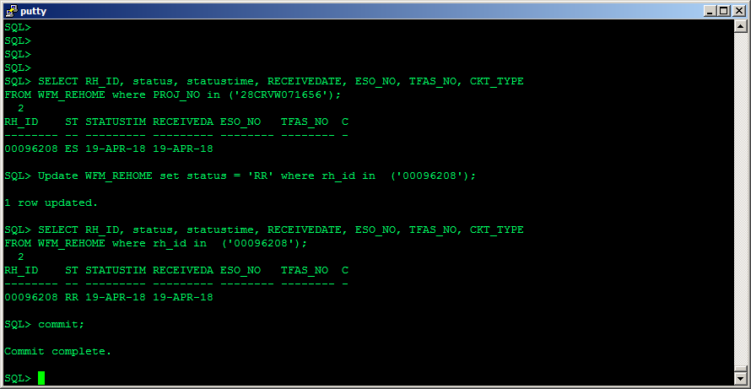

**3.) WATCH and QUERY:**

SELECT RH_ID, status, statustime, RECEIVEDATE, ESO_NO, TFAS_NO, CKT_TYPE

FROM WFM_REHOME where rh_id in ('00096208');

Soon we see status update to 'ES' in FACILITY: which takes few mins

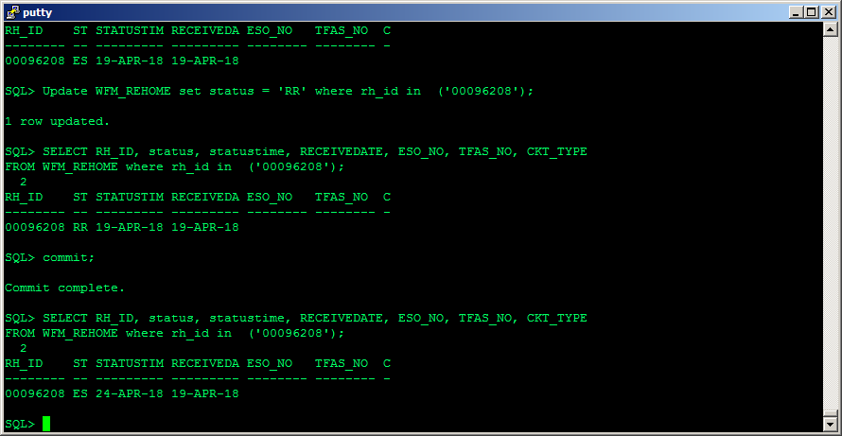

Soon after that we see the order data has come to CKTV REHOME table --- but we don't get an ESO or TFAS right away -- that takes time: sometimes it takes 30 mins

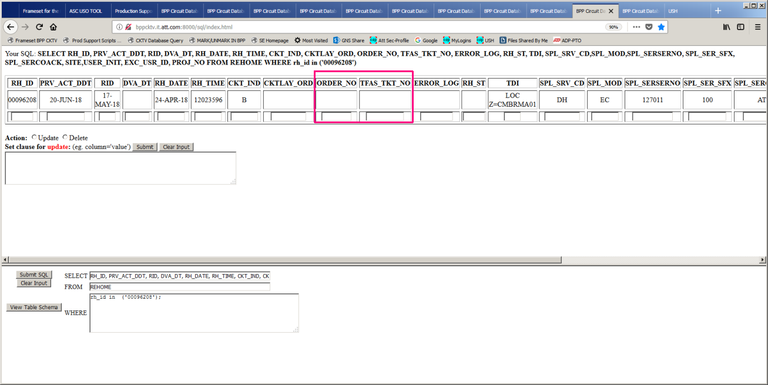

After a while we have ESO and TFAS. Note CKT_IND = 'B'. This order is landing on a BPP Circuit.

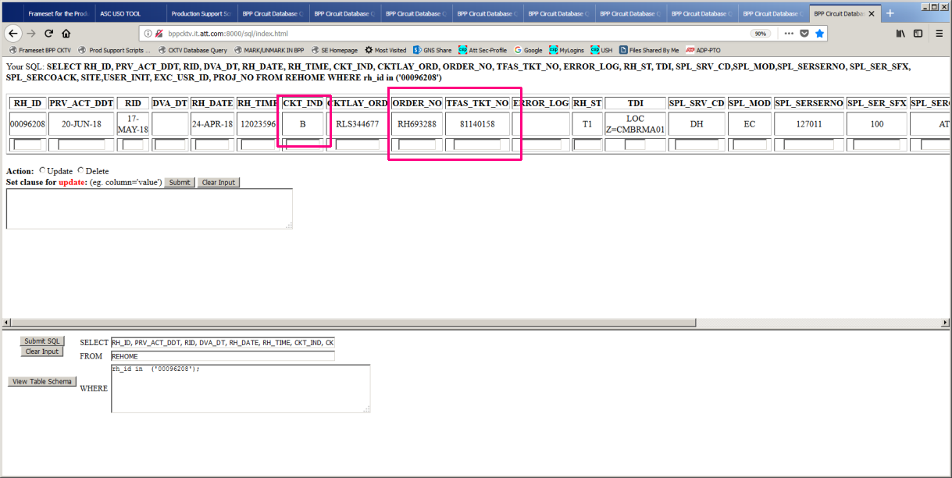

Because this order is landing on a BPP Circuit, we can see the order in getkeys too:

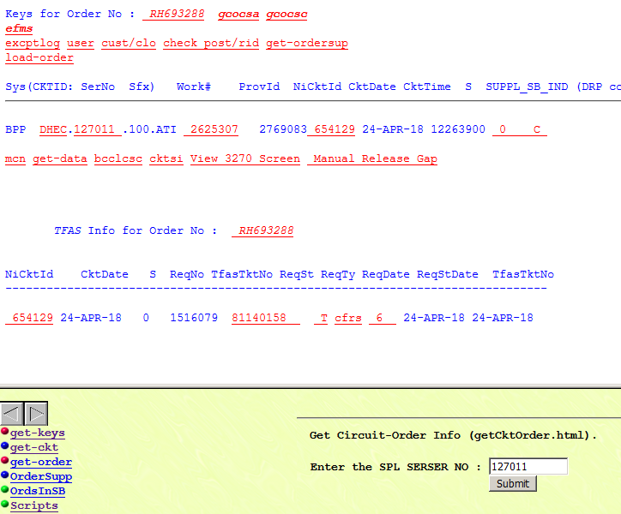

After a little while longer still -- we have ESO and TFAS in WFM_REHOME of FACILITY.

FACILITY finds out about ESO and TFAS generation later due to waiting on messaging from CKT VOICE:

SELECT RH_ID, status, statustime, RECEIVEDATE, ESO_NO, TFAS_NO, CKT_TYPE

FROM WFM_REHOME where rh_id in ('00096208');

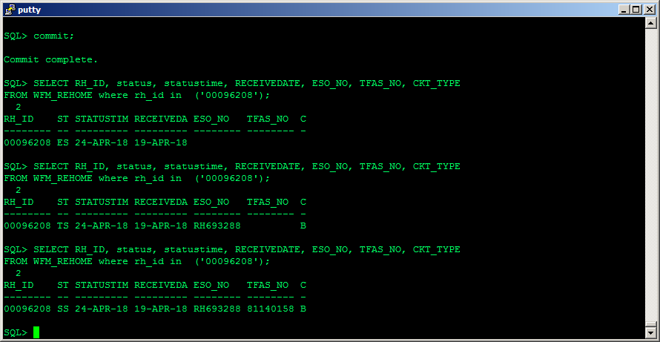

/* **We're finished --- update USH Ticket log like so ...** */

Restarted RH_ID 00096208 from BPP-FACILITY. ESO and TFAS generated:

SELECT RH_ID, status, statustime, RECEIVEDATE, ESO_NO, TFAS_NO, CKT_TYPE

FROM WFM_REHOME where rh_id in ('00096208');

RH_ID ST STATUSTIM RECEIVEDA ESO_NO TFAS_NO C

-------- -- --------- --------- -------- -------- -

00096208 SS 24-APR-18 19-APR-18 RH693288 81140158 B

////////////////////////////////////////////////////////////////////////////////////////////////

Status Code Chart

////////////////////////////////////////////////////////////////////////////////////////////////

<http://bppfacweb.it.att.com/bppwebreports/html/Statuscodes.html>

0E Exception in DS0 process

0R DS0 process re-started

0S DS0 process started

AE ASR Exception

AS ASR Creation Started

CE Circuit Roll Exception

CP Order completed by E-Prov

CS Order completed by Circuit Roll

DE DS1 Processing status sent to CKTV Failed

EE Exception in ESO Creation

ER Data Retrieval Exception

ES Data send for ESO generation

ET M24, Partial TFAS Created, Check Manually

FD Designer Exception found either in TFASProcessor or Facility Designer

FE FOC Exception

FS FOC Success

F2 D/N ASR, N ASR-FOC Success

FT Failed in TFAS Processor Process

FW Waiting FOC

GE Error Creating G2 File

GS G2 creation started

HC BPP CKTV DH completed BPP CKTV DH completed ready to sent to E-Prov

HD BPP CKTV DH completed and ready to send to Circuit Roll Process

HE Exception in DH processing

HR BPP CKTV DH process re-started

HS BPP CKTV DH process started

KC Send cancel message to Circuit Voice

KF T1T3 Order canceled

MT TFAS Manual Rehome Order

PE Partial TFAS sent to CKTV failed.

PS Partial TFAS signals send Successfully to CKTV

PT Partial TFAS will be created

RR Received and ready to send data to BPP CKTV

RS Received from E-Provisioning/Netmart successfully

SC DS1 Processing completed

SE DS1 Process Exception

SS DS1 Processing Started

SW Waiting for related 3U order to be complete

TE Exception in TFAS Ticket generation

TM TFAS Ticket generation Pulled to Custom Design

TR TFAS Ticket generation re-started

TS TFAS Ticket Generation Started

TW Waiting to check Duplicate TFAS

WR Waiting for RID to be posted

-----------------------------------------------------------------------------