**Customer Log 12/9/2019 14:27:08 Ticket #: 000000272087889 Functional Area: ATT_IT By: ma159u Owner Name: Phone: 000-000-0000 Owning Group: IT-ENTRPRS-SDEL**

Application: OT-USM  
Problem: OTHER TROUBLES  
RPT_SVC_LINE: NODAL  
RPT_SUB_SVC_LINE: OTHER  
ORG_GROUP_DDL: none  
DESCRIPTION_PROBLEM: Correction 9115554:1 / Disable All Voice Trunks failed for .DHEC.158707.100.ATI " So SR 9115554 can be released to the provisioning. Thank you

SQL> @getsrinfo

Please enter SRID: 9115554

SRID SR SMCREATIO O SDTC SRRELEASE S SERVICEREQUESTID CUSTOMERR ATTCAPABI

--------------- -- --------- - ---- --------- - ---------------- --------- ---------

SRREMARKS

--------------------------------------------------------------------------------------------------------------------------------------------------------------------------------------------------------------------------------------------------------------------------------------------------------------------------------------------------------------------------------------------------------------------------------------------------------------------------------------------------------------------

9115554 1 02-DEC-19 O QRD N 1565902 02-DEC-19

DDTS-2357841 HONEYWELL INTERNATIONAL, INC. Please Disconnect DHEC.158707.100.ATI and all associated Channels and subservices. This is a total TGP disconnect. Thank you

SQL> @getwl

Please enter SRID: 9115554

SRID SR WORKLISTITEMID REQUESTTYPE STATUS

--------------- -- -------------- -------------------- ----------

9115554 1 5932789 Release SR Open

9115554 1 5933441 QRD Confirmation Closed

9115554 1 5933442 Create Trouble Tkt Closed

9115554 1 5933443 CAD.DSA Status Closed

9115554 1 5933445 SR Correction Open

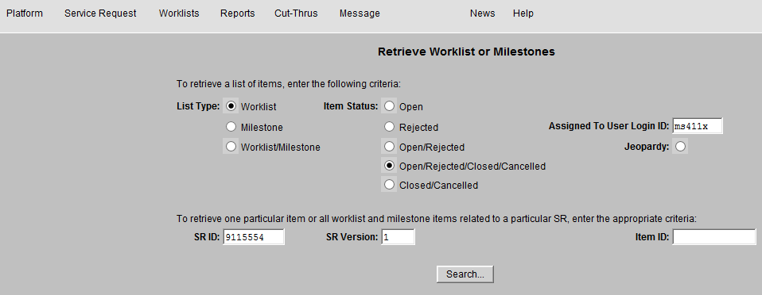

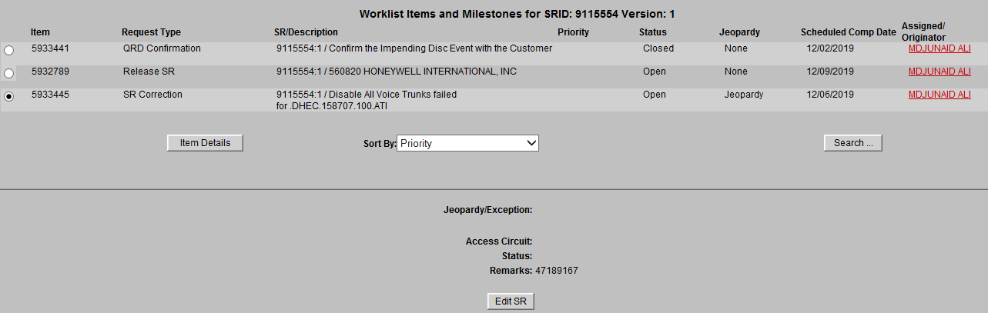

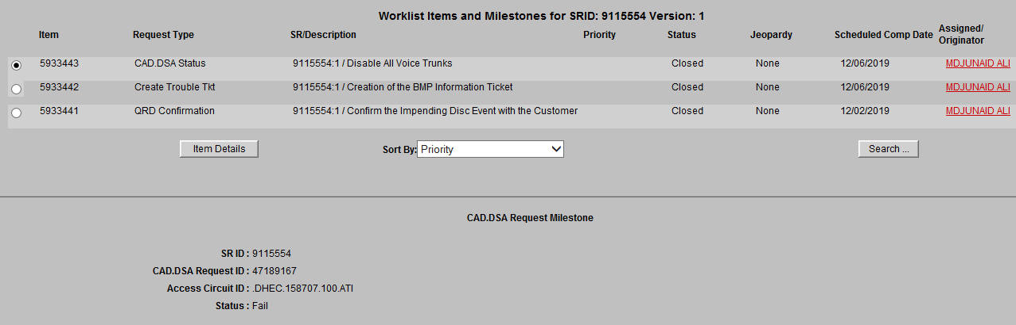

SQL> @closewl

Please enter Worklist item ID to manually close: 5933445

WORKLISTITEMID REQUESTTYPE STATUS J CREATEDAT ACTUALCOM REQUESTID STATE SRID SR S SRRELEASE

-------------- -------------------- ---------- - --------- --------- ---------- ---------- --------------- -- - ---------

5933445 SR Correction Open Y 05-DEC-19 47189189 CREATED 9115554 1 N

1 row updated.

1 row updated.

WORKLISTITEMID REQUESTTYPE STATUS J CREATEDAT ACTUALCOM REQUESTID STATE SRID SR S SRRELEASE

-------------- -------------------- ---------- - --------- --------- ---------- ---------- --------------- -- - ---------

5933445 SR Correction Closed Y 05-DEC-19 09-DEC-19 47189189 COMPLETED 9115554 1 N

SQL> @reopenwl

Please enter Worklist item ID to manually reopen: 5933441

WORKLISTITEMID REQUESTTYPE STATUS J CREATEDAT ACTUALCOM REQUESTID STATE SRID SR S SRRELEASE

-------------- -------------------- ---------- - --------- --------- ---------- ---------- --------------- -- - ---------

5933441 QRD Confirmation Closed 05-DEC-19 47189164 COMPLETED 9115554 1 N

1 row updated.

1 row updated.

WORKLISTITEMID REQUESTTYPE STATUS J CREATEDAT ACTUALCOM REQUESTID STATE SRID SR S SRRELEASE

-------------- -------------------- ---------- - --------- --------- ---------- ---------- --------------- -- - ---------

5933441 QRD Confirmation Open 47189164 CREATED 9115554 1 N

SQL> commit;

Commit complete.

