|  |  |  |
| --- | --- | --- |
|  | Name | Date |
| Created by | **Vivek** **Sawhney** | 11/13/2018 |
| Reviewed by | **Komaljeet kaur** | 11/14/2018 |
| Version Number | 1 |  |

**Ref Ticket**- 252641707

269169790

269168314

269087728

GIOM INTERNAL ERROR

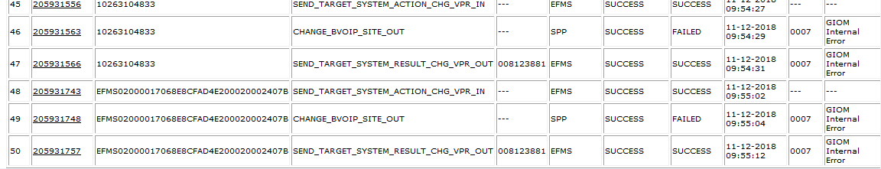

1. Get dial plan id with help of below query.

select dial_plan_identifier  
from iom_order o,voip_info v,dial_plan_info d  
where o.iom_order_id=v.iom_order_id and v.voip_info_id=d.voip_info_id  
and order_name='&order_name';

1. get generate_dial_plan entries based on dial plan id with help of below query.

select to_char(generate_dial_plan_id,'999999999') gdp_id,  
substr(site_id,1,9) siteid,to_char(fr_admin_data_contact_id,'999999999') fr_admin,  
to_char(vdna_admin_data_contact_id,'999999999') vdna_admin,fr_reservation_num,  
enhd_fea_ind,package_id,effs_package_source_ind,evas_package_source_ind,valid_ind  
from generate_dial_plan  
where dial_plan_id='&dial_plan_id'  
and site_id is not null  
/

1. Get voip_info_id with help of below query.

select voip_info_id,admin_data_contact_id from iom_order o,voip_info v where o.iom_order_id=v.iom_order_id and order_name='184151279';

1. update voip_info.admin_data_contact with the contact_id from step 2

update iomdbo.voip_info set admin_data_contact_id=22808409 where voip_info_id=11038110;

1. Ask user to complete the task .