**CKTV:  Stacked Orders**

Ticket Number **000000271781377**

|  |
| --- |
|  |
| Note added by USH on:  11/29/2019 15:40:39 ET for Ticket #: 000000271781377 | |
| Application: BPP - CKT VOICE  Problem: STACKED ORDER  RPT_SVC_LINE: OTHER  RPT_SUB_SVC_LINE: OTHER  ORDER_NUMBER_FOR_BPP: 60320243  CIRCUIT_ID: DHEC.211126 .500.ATI  TFAS_NUMBER:  PON:  DETAIL_PROBLEM_DESCRIPTIO:  SUBMITTER_ATTUID: gs829d  - Client Email: gregory.spears@genesisnet.com | |

STACKED - an order with more than one line on getkeys results -- even if same order number (different supps)

- a circuit with more than one active order on the same circuit block

**Look up order in get-keys page**

Determine if order is stacked, and if so the number of supps on the order (0, 1, 2, etc).

This is a stacked order -- note that is has multiple entries (Supp 0, 1, 2 ) all on one circuit:

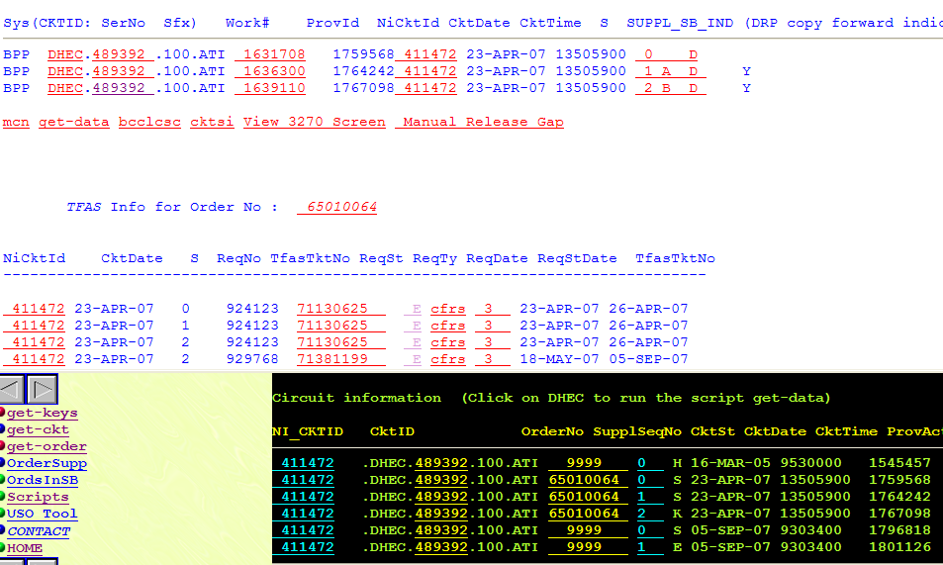

In the circuit database query page ( http://bppcktv.it.att.com:8000/sql/index.html ) you will run this query:

select * from ordstack where order_no='XXXX'

If there is an entry, you will need to UPDATE the STATUS field to 'S'

Select the Update button, and in the box type Status='S'

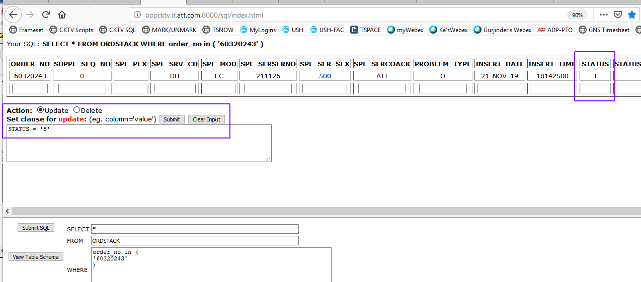

Then run the command (Submit) and you should see that it is updated.

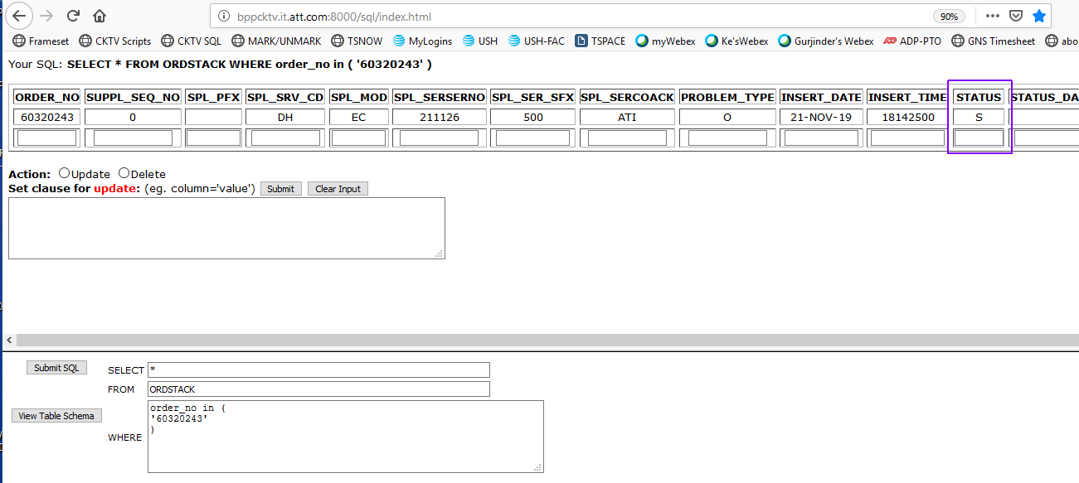

**DELETE the order** ....

Run sb2_dbcls.pl script on scripts page ( http://bppcktv.it.att.com:8000/prod-sup/wrapper/ps-index.html )

using:  Order# Supp#

 as the arguments. You will need to delete from the highest supp to the lowest supp (supp zero)

60320243 3

60320243 2

60320243 1

60320243 0

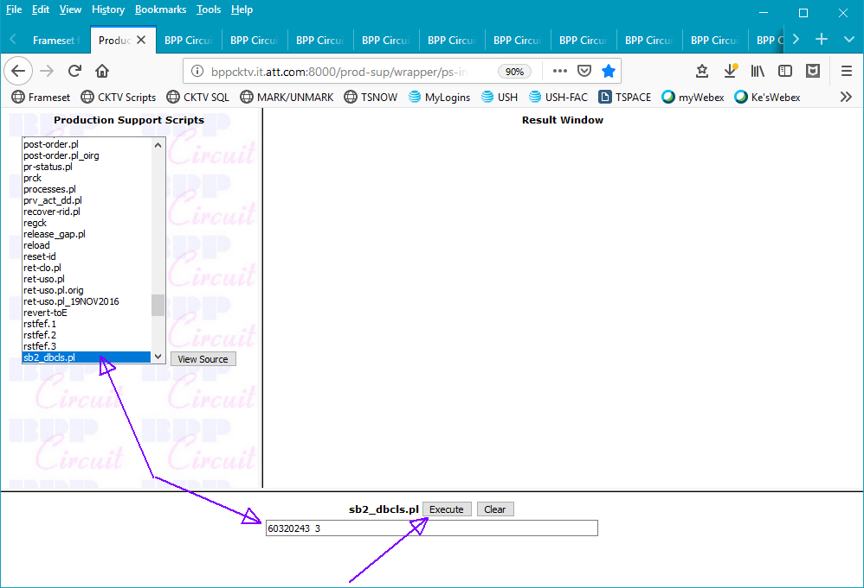

Verify that the order is removed from the get-keys page (refresh page, no order to see)

**RELOAD the order**...

On the scripts page, run the ret-uso.pl script with the

order# as the argument.

