**eSign BOA M&P**

**Convert Failure(Password Encryption)**

# Issue

CSIGN job failed because customer signed with some digital signature application, which is not supported by eSign and due to which document permissions do not allow altering.

**Error in Job description**: Caused by: java.lang.RuntimeException: You do not have sufficient permissions for: Change Document Check the document security. at com.qoppa.pdfProcess.PDFGraphics.drawImage(Unknown Source)

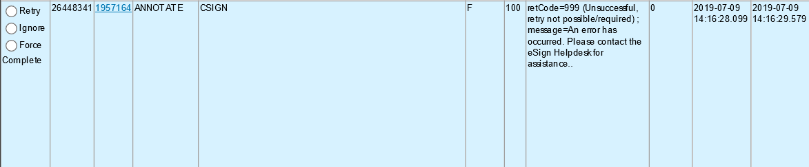

# Resolution Steps

1. Click on the request id in Job Q which has command as CSIGN

User will be directed to eSign admin page where all the information regarding request will be displayed.

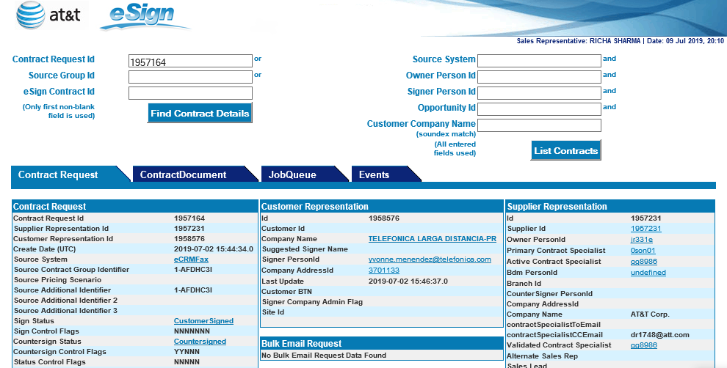

1. The Countersign status is “Countersigned” because the contract was countersigned by CM team.
2. Now go to the contract document Tab and look for the countersigned file.
3. Countersigned file will be missing.

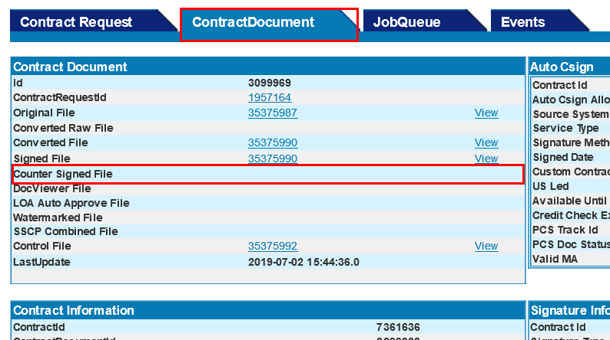

1. Download the signed file and save it by right click on View.

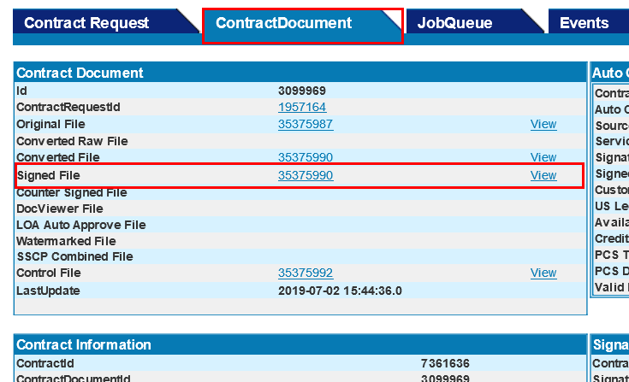

1. Open the password encrypted file, print the file to tif.

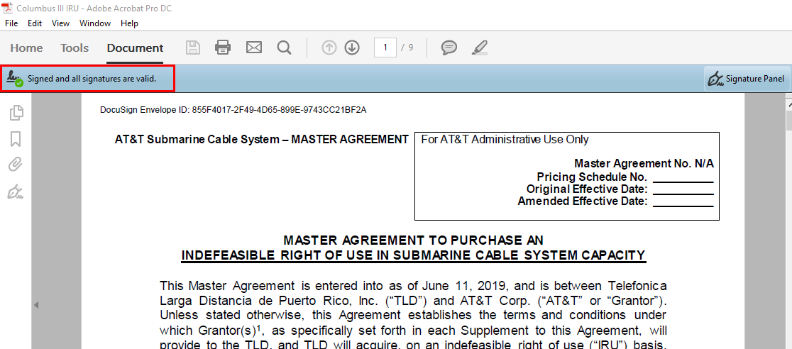

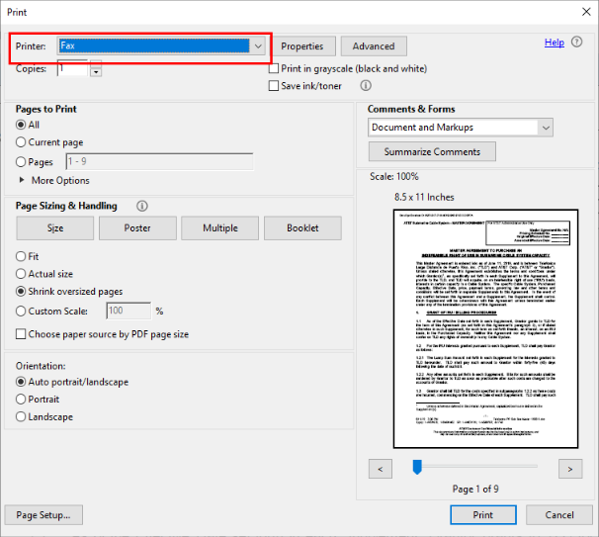

1. Now take the Tif file and print it back to pdf.

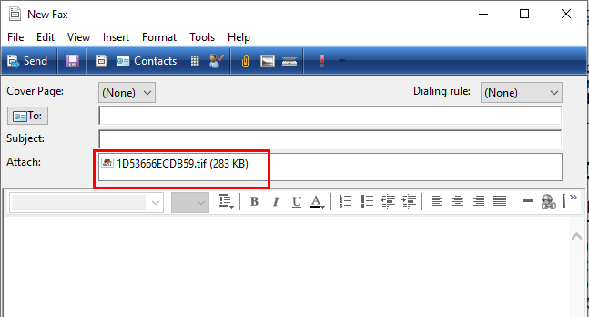

1. Now print the file back to PDF and save it in your system, which is required to replace file in eSign admin. 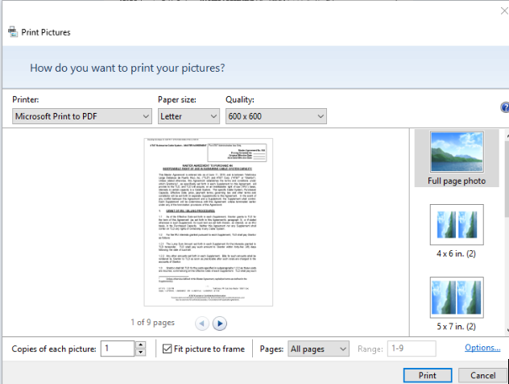
2. Now, replace the customer signed file with new password free file.

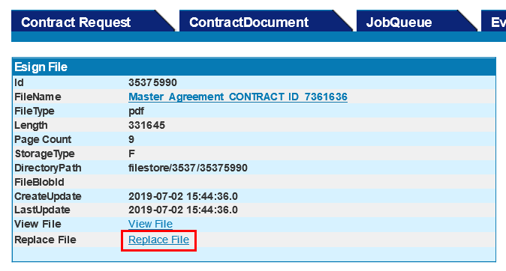

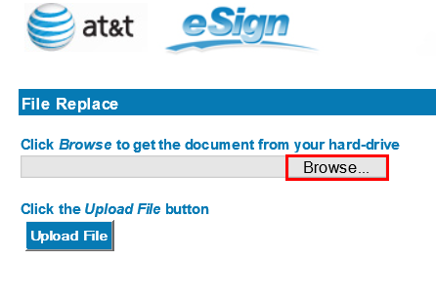

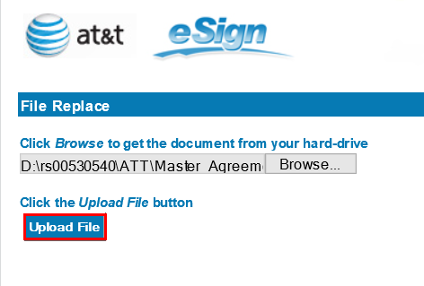

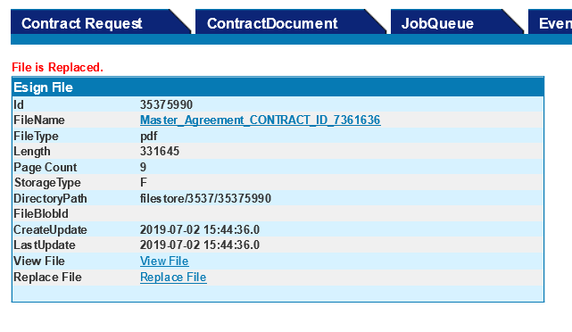

1. After customer signed file replace successfully. Retry the failed CSIGN job

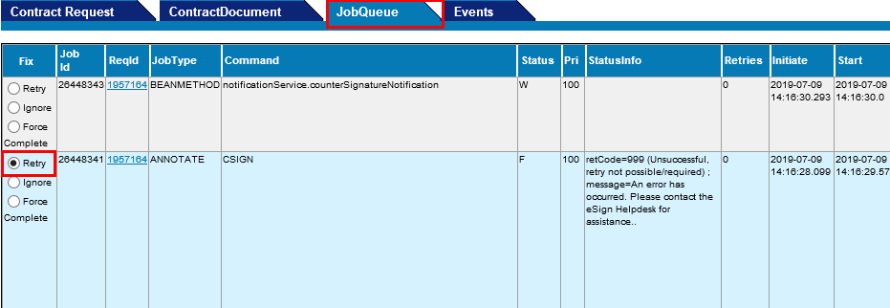

**Validation:**

Once the CSIGN job successfully completed, countersigned file arrived in eSign.