**CoS Service Option is missing the Egress Traffic**

**Sample Ticket**: 000000229095159

**Problem Description**: USRP ERROR:INSTAR Error: CoS Service Option is missing the Egress Traffic. I am unable to send out the order.

**Step:1)** Check with User to provide correct COS value to be updated in USRP.

**Step:2)** Check present value of COS in USRP GUI on page 4.

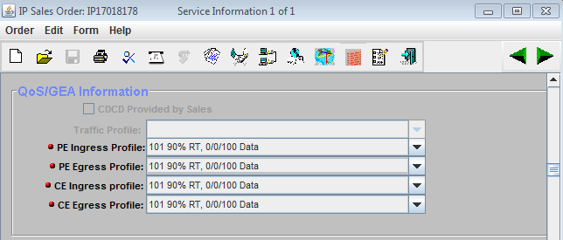

**Step:3)** If the value present in USRP GUI is different. Then update the correct value provided by user.

Below is the update statement:

*update ip_qos set ce_ingress_qos_profile_id=101,ce_egress_qos_profile_id=101,pe_ingress_qos_profile_id=101,pe_egress_qos_profile_id=101 where log_ip_id =1627292*

*** Check for log_ip_id in DSOTS(Display sales order tool)***

