**Customer Log 12/9/2019 14:16:42 Ticket #: 000000272086778 Functional Area: ATT_IT By: tm605r Owner Name: Phone: 000-000-0000 Owning Group: IT-ENTRPRS-SDEL**

Application: OT-USM  
Problem: OTHER TROUBLES  
RPT_SVC_LINE: NODAL  
RPT_SUB_SVC_LINE: OTHER  
ORG_GROUP_DDL: none  
DESCRIPTION_PROBLEM: Hi team, could you please check on SR 9112344? I receive validation error: RA,013,012,011,009,008,007 must be disconnected, however I doublechecked all ordered accounts and there are no RAs available anymore. Thanks!

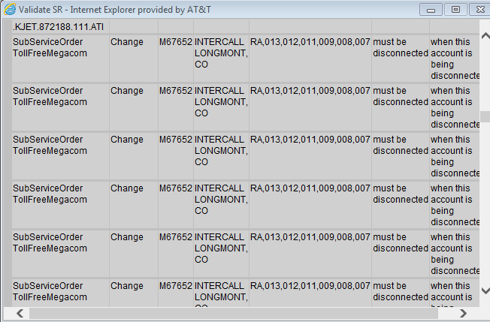

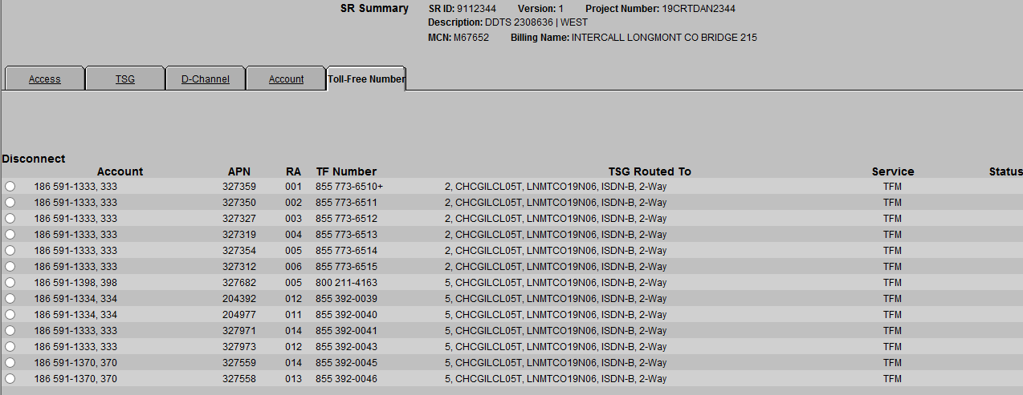

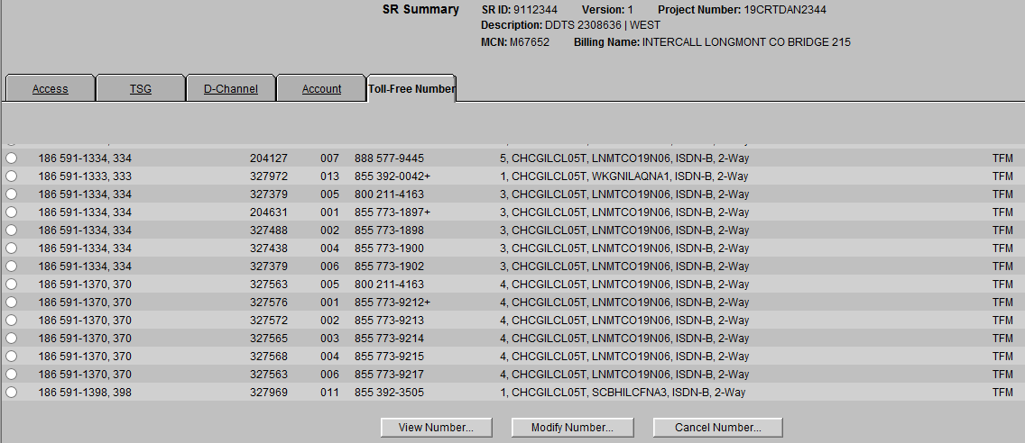

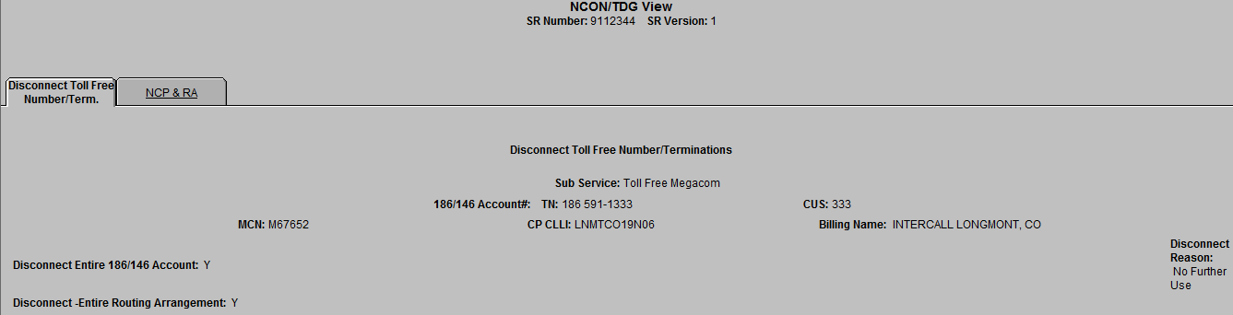

**Disconnect Entire 186/146 Account: and Disconnect -Entire Routing Arrangement:**

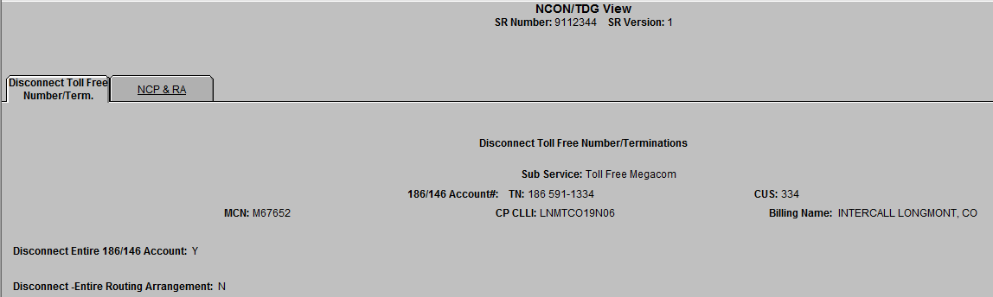



SQL> select ACCOUNTNUMBER, ACCOUNTCUSTOMERCODE,TOLLFREEKEYDATAID from u_tollfreekeydata where srid = '9112344';

ACCOUNTNUMBE ACC TOLLFREEKEYDATAID

------------ --- -----------------

186 591-1370 370 314730

186 591-1398 398 315406

186 591-1333 333 314129

186 591-1334 334 314131

SQL> select * from U_TFROUTINGARRANGEMENTS where TOLLFREEKEYDATAID in (314131);

WSR PRI PRI PRIM D TOLLFREEKEYDATAID TFROUTINGARRANGEMENTSID

--- --- --- ---- - ----------------- -----------------------

001 855 773 1897 Y 314131 926940

002 855 773 1898 Y 314131 926941

004 855 773 1900 Y 314131 926942

005 800 211 4163 Y 314131 926943

006 855 773 1902 Y 314131 926944

007 888 577 9445 N 314131 926945

008 855 489 0579 N 314131 926946

009 855 489 0580 N 314131 926947

011 855 392 0040 N 314131 926948

012 855 392 0039 Y 314131 926949

013 855 392 3813 N 314131 926950

WSR PRI PRI PRIM D TOLLFREEKEYDATAID TFROUTINGARRANGEMENTSID

--- --- --- ---- - ----------------- -----------------------

014 855 392 3812 Y 314131 926951

12 rows selected.

SQL> update U_TFROUTINGARRANGEMENTS set DISCONNECTRAINDICATOR='Y' where TFROUTINGARRANGEMENTSID in (926945,926946,926947,926948,926950);

5 rows updated.

SQL> commit;

Commit complete.