1. @faai updateorder "PO:8400388 Status:Cancel" @here

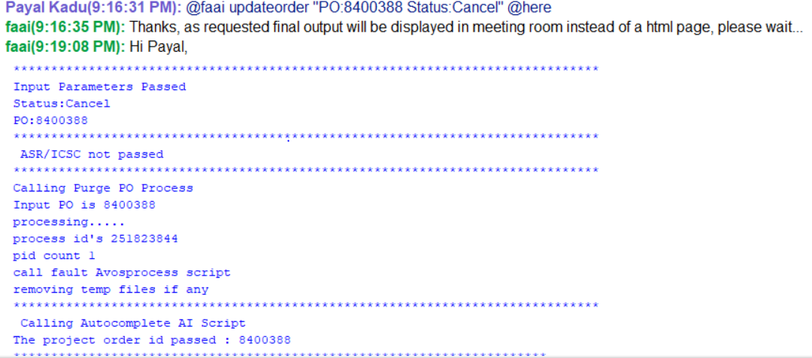

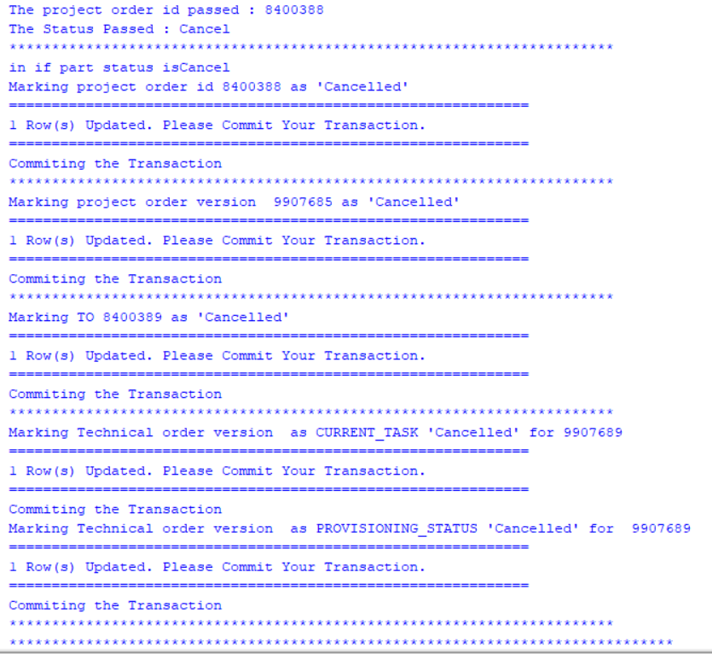

1. @faai fbsesmskip "A1/MCXF/006363//PT ENCNCA250AW ACTIVE" @here

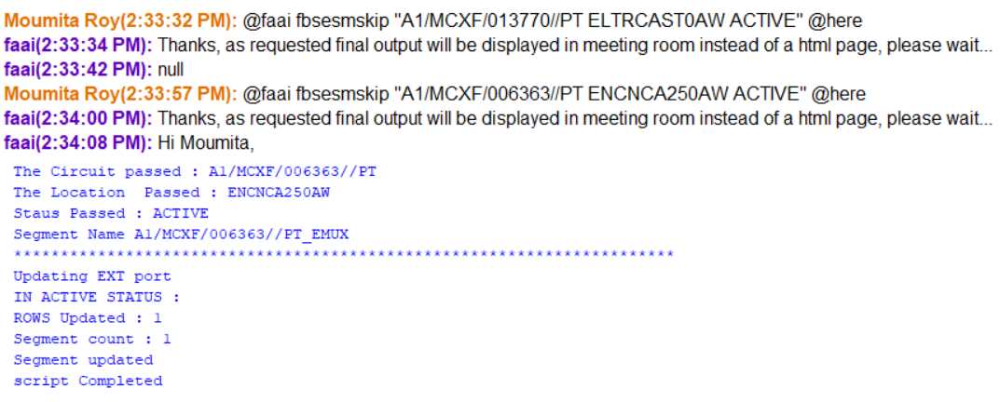

1. @faai unibanupdate "UNI:T4/KSFN/821233/SC BAN:901N010079 CUSID:079 ACNA:ZZW" @here

This use case will update BAN, ACNA, cuscode information to DB for given circuit.

1. @[faai](mailto:2.@faai) updatesegment "ACTIVE/DEACTIVE SEGMENTNAME" @here

This use case will update the segment for given order/circuit/service.

1. @faai updateorder "ASR:57867462534 ICSC:IB01 PO:655667 Status:Cancel/Complete" @here --OR –

This use case will cancel/complete the ASR provided by user in AOTS ticket.

1. @faai cnlcleanup "JU101/GE1N/ALBYGAMA1AW/LSBGGA340BW C" @here

This use case will clean CNL circuit/service as per given input.

1. @faai unicleanup "AS/KRGN/001650/PT C" @here

This use case will clean UNI circuit/service as per given input.

1. @faai status "AS/KRGN/001830/SB" @here

**Bhavesh Jain Kumar(9:31:21 PM):** @faai status "AS/KRGN/001830/SB" @here

**faai(9:31:27 PM):** Thanks, as requested final output will be displayed in meeting room instead of a html page, please wait...

**faai(9:33:03 PM):** Hi Bhavesh,

Input string is AS/KRGN/001830/SB  
 *-*-*-*-*-*-*-*-*-*-*-*-*-*-*-*-*-*-*-*-*-*  
 Service:  
 AS/KRGN/001830/SB - Active  
 *-*-*-*-*-*-*-*-*-*-*-*-*-*-*-*-*-*-*-*-*-*  
 Circuit:  
 AS/KRGN/001830/SB - In service  
 AS/KRGN/001830/SB_8852545037 - In service  
 *-*-*-*-*-*-*-*-*-*-*-*-*-*-*-*-*-*-*-*-*-*  
 Segments:  
 AS/KRGN/001830/SB_NTE - Active  
 *-*-*-*-*-*-*-*-*-*-*-*-*-*-*-*-*-*-*-*-*-*  
 Reserve Ports:  
 AS/KRGN/001830/SB_9028432674  
 *-*-*-*-*-*-*-*-*-*-*-*-*-*-*-*-*-*-*-*-*-*

**THANK YOU**