Find The Pending Order

Issue Description: Pending USRP Orders, When trying to cancel getting this error message: "It already has subsequent action on it.

Please use the below query and find the pending orders.

select * from logical_port where icore_site_id in (2841391)

select * from pvc where icore_pvc_id=12810631

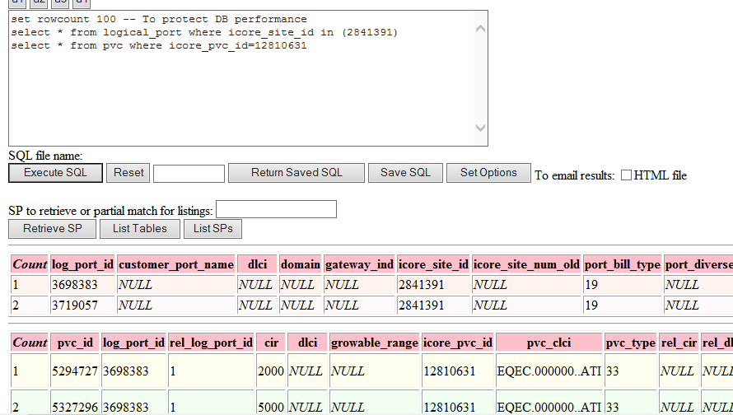

select * from acty_by_so where ntwk_entity_id in (3698383,3719057)

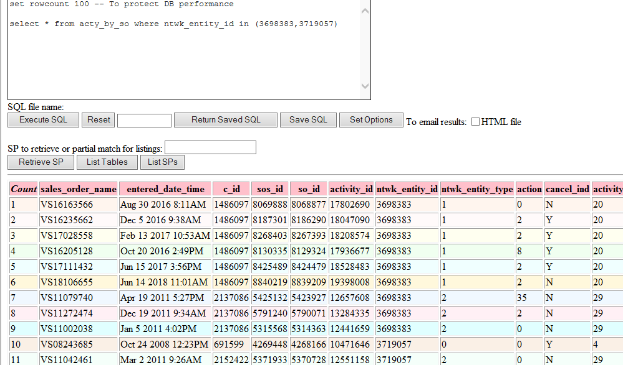

select * from acty_by_so where ntwk_entity_id in (5294727,5327296)

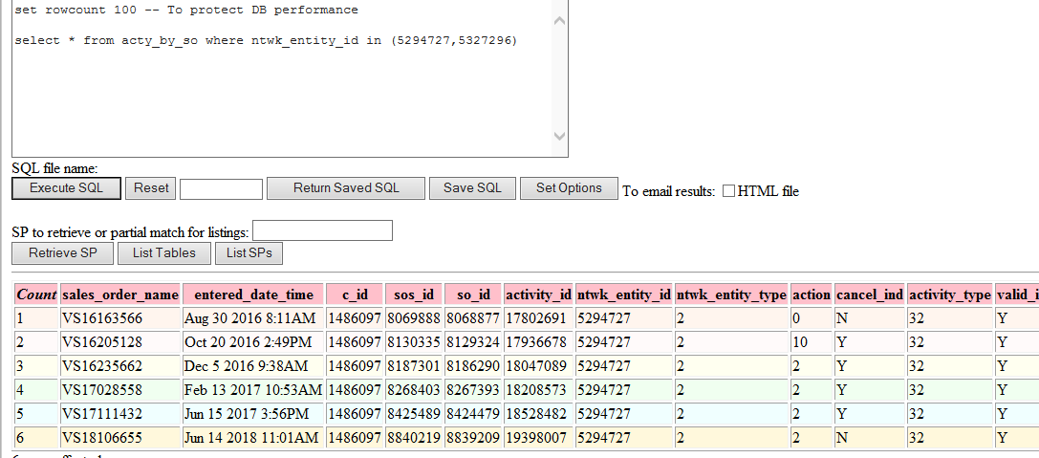

we need to check all sales_order to completed or cancelled,if it is not completed or cancelled,please inform user to complete ..