MnP- GIOM_ Order not in EFMS

# Issue

## Description:

Order released from GIOM, but not in EFMS.

Ticket will be created by users

Two Cases –

1. Invalid site name VOIP007742846 error code:309

# Order Detail

**Sample USH #**

242321375

260019717

254501265

**Sample Order Number-** 172824398

**Note- Order number will always be 9 digits.**

## UNIX Logs:

N/A

## Database:

GIOM DB : Host-p1gio1d6.sldc.sbc.com; Service Name - p1gio1d6; Port- 1524

EFMS DB : Host- p1efm1d7.aldc.att.com; Service Name - p1efm1d7; Port-1524

# Interfacing Applications:

EFMS

# Workaround Provided:

**Case 1: Invalid site name Error code?**

1. Validation step: Check if order has reached EFMS.

Query on order –

select * from ms_order where usrp_order_number = '172824398';

1. If order has reached EFMS, it will return a record for the order, drop the ticket and no need to go ahead with the following steps. (Do NOT close the ticket)
2. If no records are returned, Follow the below steps.
3. Open the order in BVoIP Order Status tool and check the error message.



Error message - Invalid site name VOIP007742846 error code:309

The site name - VOIP007742846 is in error.

select o.order_name, so.supplier_order_id, so.transaction_name, so.site_id, error_code, error_msg, transaction_status, DATETIME_UPDATED

from iomdbo.iom_order o, iomdbo.supplier_order so

where o.iom_order_id = so.iom_order_id

and o.order_name = ''

and transaction_name in (96, 221, 86, 43);

**ERROR MESSAGE - Invalid site name VOIP007728443 error code:309**

**ERROR CODE - 309**

**TRANSACTION_NAME – 96, 221, 86, 43**

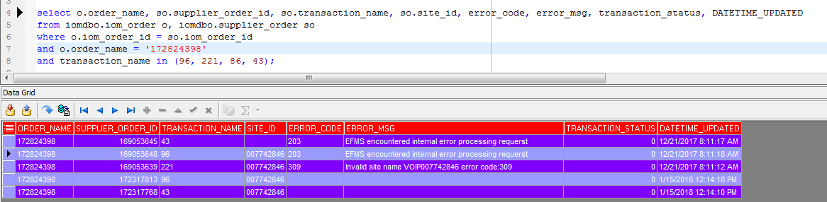

TRANSACTION_STATUS

Valid Values:

0 - Success

1 - Failed

2 - In Progress

5 - Error

24 - Created

26 - Timeout

40- System Down

1. Run the query to get the location id

select floor, room, state, street1, zip, city, street_num, street_dir_prefix, street_name,l.location_id ,site_name from iomdbo.iom_order o, iomdbo.voip_info v, iomdbo.location l

where o.iom_order_id=v.iom_order_id and v.location_id=l.location_id

and order_name='172824398';

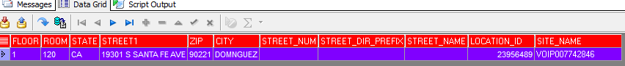

**Site_id = locationID ????**

1. Get the Site_id from Bvoip Tool ( query from Step 1)
2. Halo Site – Site starting with 999 is Halo site.

Example Site_ID – 999970900, 999935630

For Halo Site GOTO Step 5 and Skip step 6

1. BVoIP Site – All the other sites not starting with 999 are BVoIP sites

Example Site_ID – 006575824, 009405288

For BVoIP site GOTO Step 6 (skip Step5)

1. Update the site name with temporary site name

update iomdbo.location set site_name='9998DAL1675' where location_id='16810128';

(Location_id from Step 2)

1. Update the site name with temporary site name

update iomdbo.location set site_name='17' where location_id='23956489';

(Location_id from Step 2)

1. Trigger CreateCR to EFMS(OUT) through simulator

Mandatory attributes for transaction – **Package_Name, MCN, Customer Name**

**WSDL -** <http://elk.ims.att.com/~ra360w/EFMSBVOIP.wsdl>

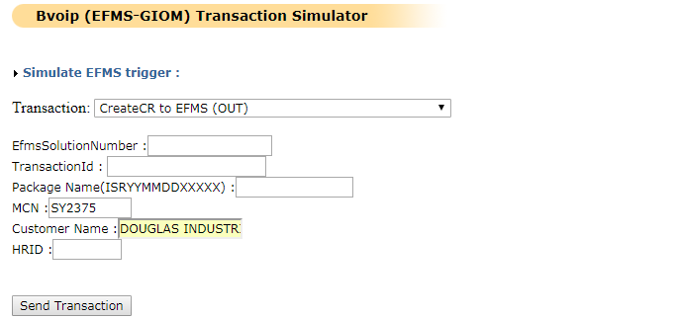

The mandatory attributes can be obtained with below query:

select p.PACKAGE_NAME, a.MCN, a.CUSTOMER_NAME

from iomdbo.iom_order o, iomdbo.account a, iomdbo.package p

where p.PACKAGE_ID = o.PACKAGE_ID

and a.ACCOUNT_ID = o.ACCOUNT_ID

and o.order_name = '172824398';

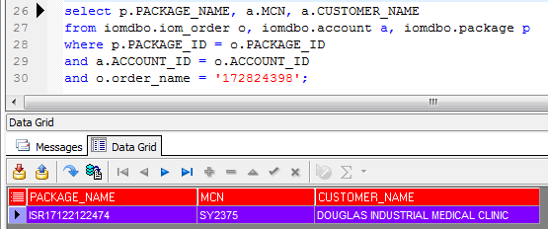

1. Once, Step 7 is success, trigger CreateSR to EFMS (OUT) through simulator.

Mandatory attributes for transaction – **Order Number**

**WSDL -** <http://elk.ims.att.com/~ra360w/EFMSBVOIP.wsdl>

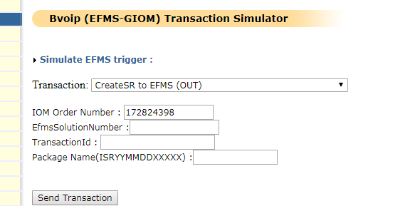

1. Next, check if order has reached EFMS.

Query on order –

select * from ms_order where usrp_order_number = '172824398';

It should return a record that means order has reached EFMS

1. Revert the changes on Site Name to original Site name.

update iomdbo.location set site_name='VOIP007742846' where location_id='23956489';

# Validation:

Validate the order in EFMS, it should reach EFMS after workaround.

================================================================================