**HOW TO UPDATE ASSET STATUS**

There will be file attached to the ticket download that file.

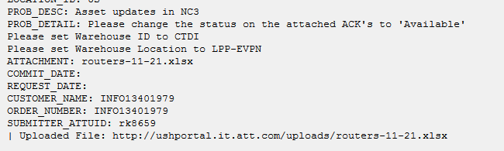

Example Ticket: 271509932

**Step 1.**

Login to database sever

gs282a@zlp12450.vci.att.com

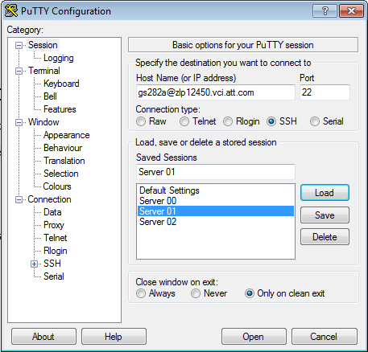

Enter the RSA token and enter

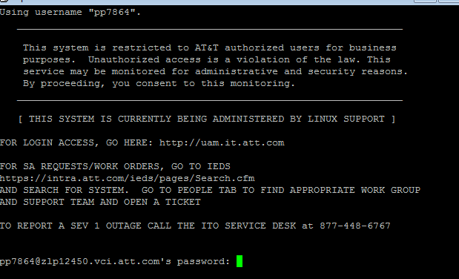

**Step 2:**

Enter to NC3 DB by command sudo su – nc3

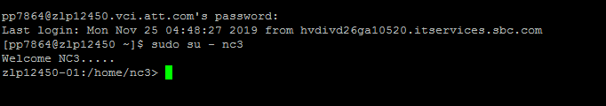

**Step 3:**

Now use the below command to enter SQL

/opt/app/nc3/sfw/oracle/product/11.2.0.4/bin/sqlplus [nc3/inte11nside345@p1c3d137.db.att.com](mailto:nc3/inte11nside345@p1c3d137.db.att.com)

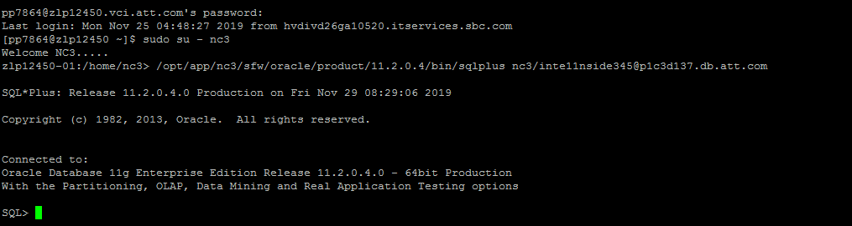

Note:

You can set the line and page size by following commands:

set linesize 5000;

set pagesize 5000;

**Step 4.**

Fetch the odbid’s of the assets by using below select command:

select odbid, asset_key, status, lastupduser, lastupdtran,WAREHOUSE_LOCATION ,STATUS_DATE from NC3.asset where asset_key in('','',’’);

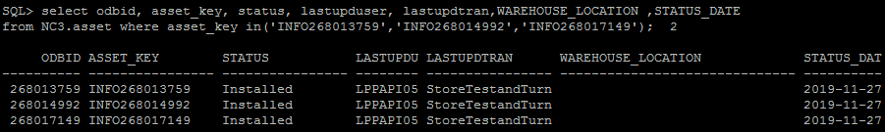

**Step 3.**

Use these odbid’s in update command, set status of the asset as per requirement.

update nc3.asset set status = 'Available', prev_status = status

,lastupduser = 'attuid', lastupdtran = 'Ticket no.', lastupdtmstmp = sysdate where odbid in ('','','');

Commit;

Execute query in the database server zlp12450.vci.att.com

**Step 4.**

Check for Asset status if it is successfully updated by using select command

select odbid, asset_key, status, lastupduser, lastupdtran,WAREHOUSE_LOCATION ,STATUS_DATE from NC3.asset where asset_key in('INFO268013759','INFO268014992','INFO268017149');



Similarly you can update the warehouse location and warehouse ID for example:

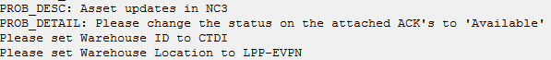

**Step 5.**

Search for the odbid of CTDI under Miscellaneous Data in Inventory Workcenter Notebook

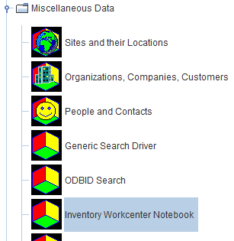

Search for CTDI

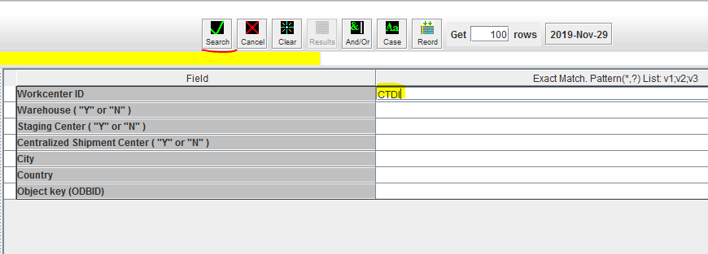

Search and return you will get the odbid on the bottom right of the page.



**Step 6.**

Use this odbid in below update command

update nc3.asset set status = 'Shipped',prev_status = status,WAREHOUSE_LOCATION = 'LPP-EVPN', odbid_warehouse = '83270852', lastupdtmstmp = sysdate, lastupduser = 'attuid', lastupdtran = 'Ticket no.' where odbid in ();

commit;

Execute the query in 01 server

Asset Notebook:

