**HOW TO UPDATE EOL STATUS & EOL LINES STATUS**

Example ticket number: 271673160



**Step 1.**

Login to database server gs282a@zlp12450.vci.att.com

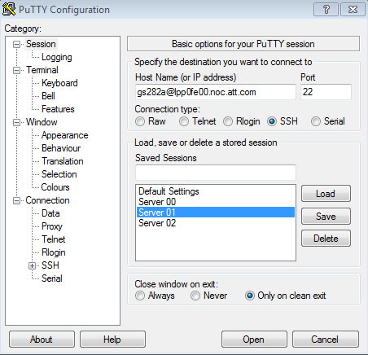

**Step 2.**

Fetch the order details by using select query:

select a.order_num, b.eol_num, b.version_num, b.status from nc3.orders a, nc3.eol b where b.odbid_order = a.odbid and a.odbid in (select odbid from nc3.orders where order_num = 'ISR18062702900-0001');

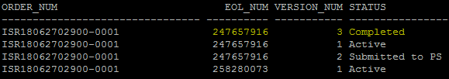

**Step 3.**

Pull the details from select query and then add them below in the update query and execute it:

update nc3.eol set lastupdtmstmp = sysdate, lastupduser = 'gs282a', lastupdtran = 'AOTS-271673160', status = 'Sent For Retrieval' where eol_num = 247657916 and version_num = 3;

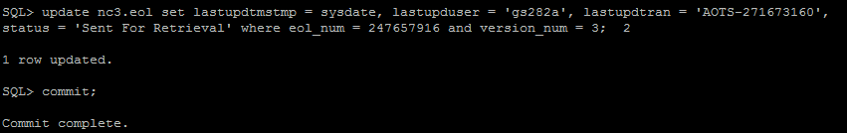

**EOL LINES STATUS UPDATE**

**Step 4.**

Use below command for updating EOL lines status

update nc3.eol_line_item set status = 'Sent for Retrieval',lastupdtmstmp = sysdate, lastupduser = 'gs282a', lastupdtran = 'AOTS-271673160' where eol_num = 247657916;

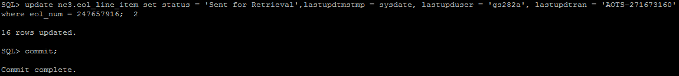

Note: Always use capital F while updating EOL status (Sent For Retrieval) & use small f while updating EOL lines status (Sent for Retrieval)

After updating the ticket logs kindly update the ticket logs as: EOL status & EOL lines status has been updated.

Close the ticket by filling below mandatory fields.

Trouble resolution text:

