**How to open Activity Logs in MS GUI**

**Step 1:** Copy and paste URL link in Browser.

<http://efmsms.it.att.com:8008/ms>

**Step 2:** Enter user ATTUID and Password in box as shown in image below.

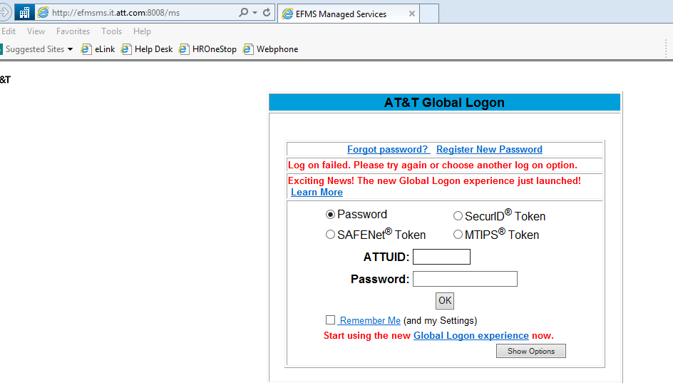

**Step 3:** After entering ATTUID and password in box, press OK button

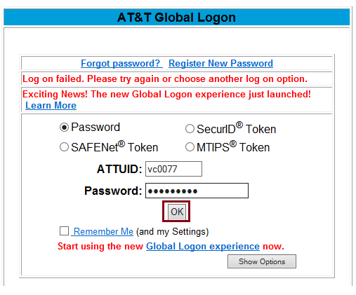

**Step 4:** Front interface of MS GUI will be displayed as shown in below image.

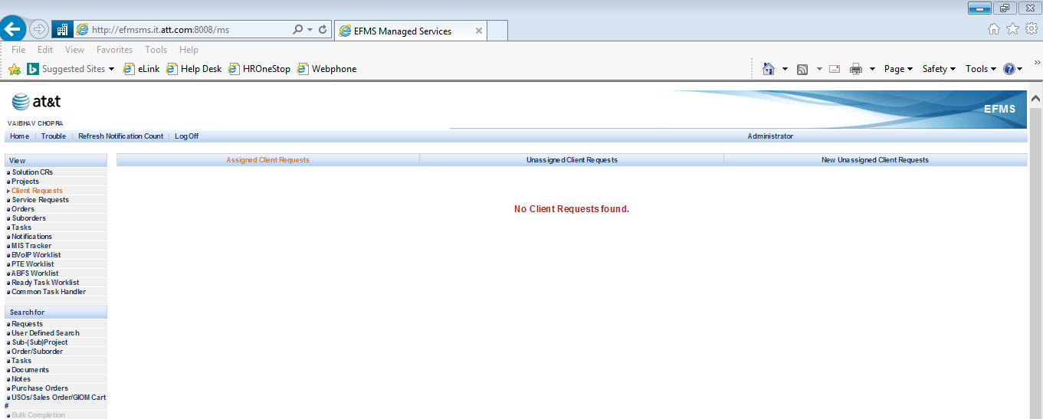

**Step 5:** Click on **Order/Suborder** tab as shown below:

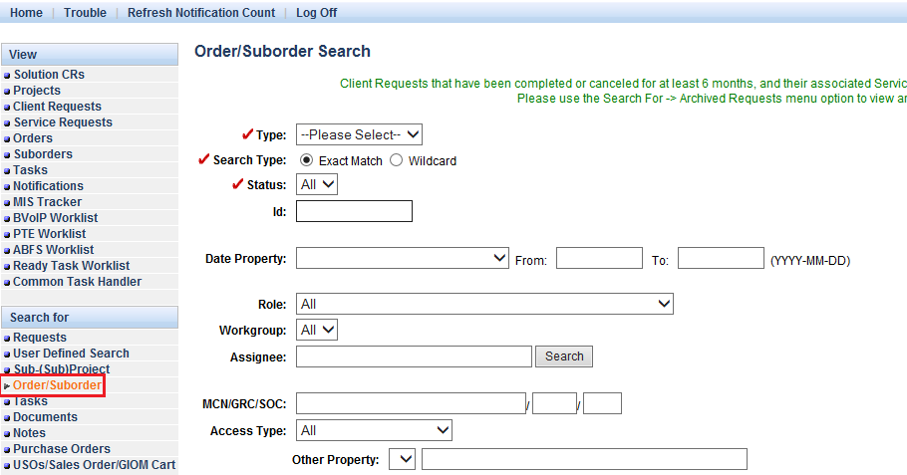

**Step 6:** Select **Suborder** as option in Type bar as shown below:

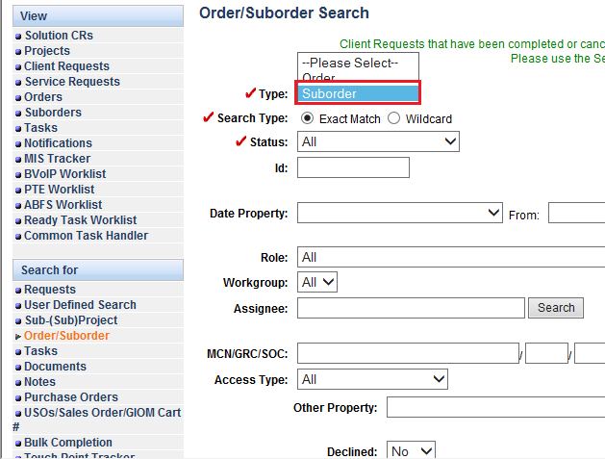

**Step 7:** Write order no. which you want to open at suborder level in **ID** option.

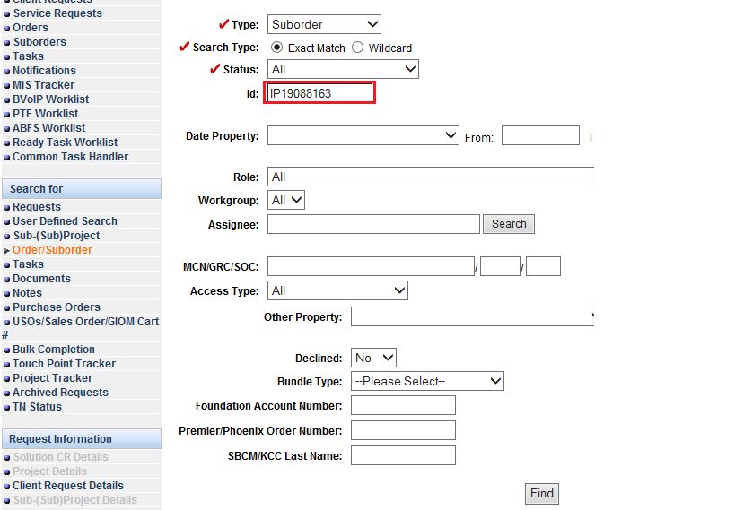

**Step 8**: Click on **Find** tab to open order.

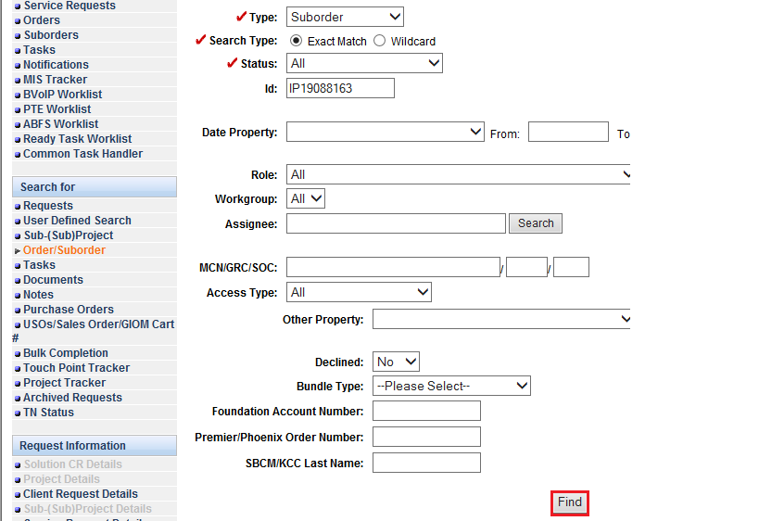

**Step 9:** Suborder search results will be displayed, click on **open** tab to open order.

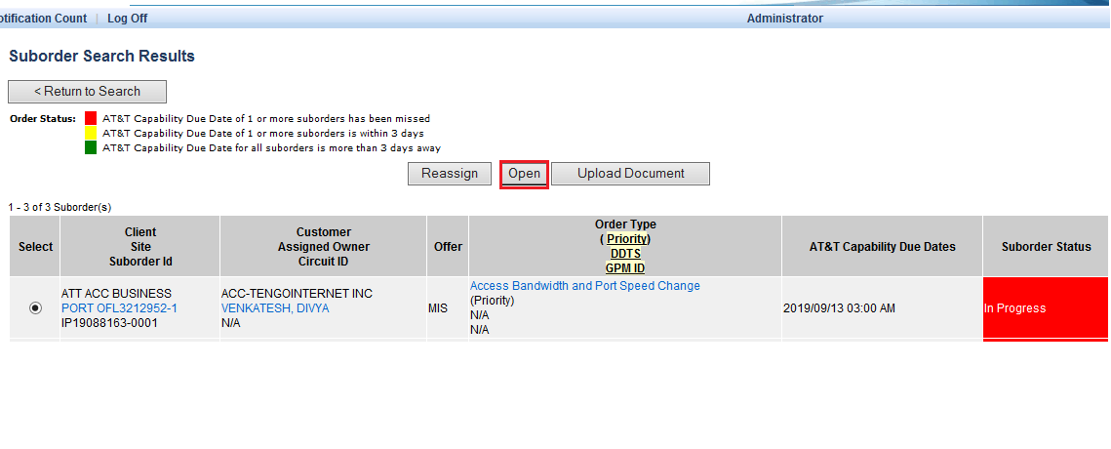

**Step 10:** Suborder will be displayed with all tabs and information.

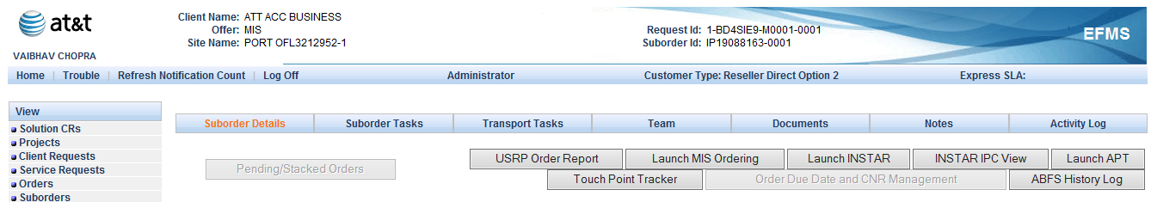

**Step 11:** **Activity log** will be displayed on bar, click it in order to view activities logs.

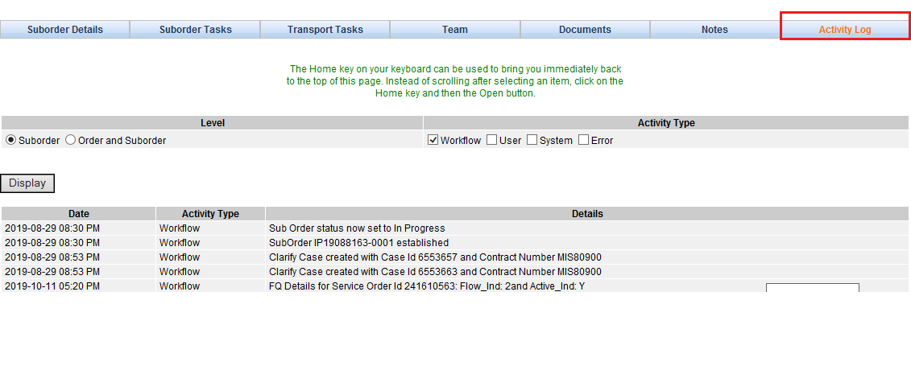

**Step 12:** Logs can be viewed according to type like user, error etc. by selecting the **check box** shown in image. After that click on **Display** button.

