**How to open order at order level in MS GUI**

**Step 1:** Copy and paste URL link in Browser.

<http://efmsms.it.att.com:8008/ms>

**Step 2:** Enter user ATTUID and Password in box as shown in image below.

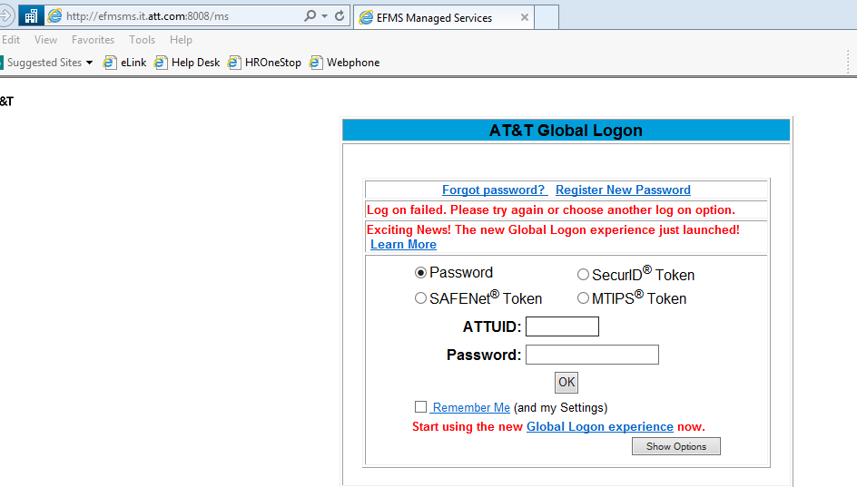

**Step 3:** After entering ATTUID and password in box, press OK button

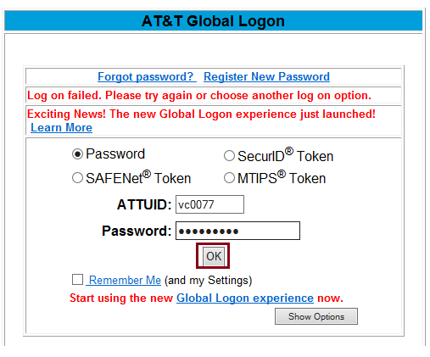

**Step 4:** Front interface of MS GUI will be displayed as shown in below image.

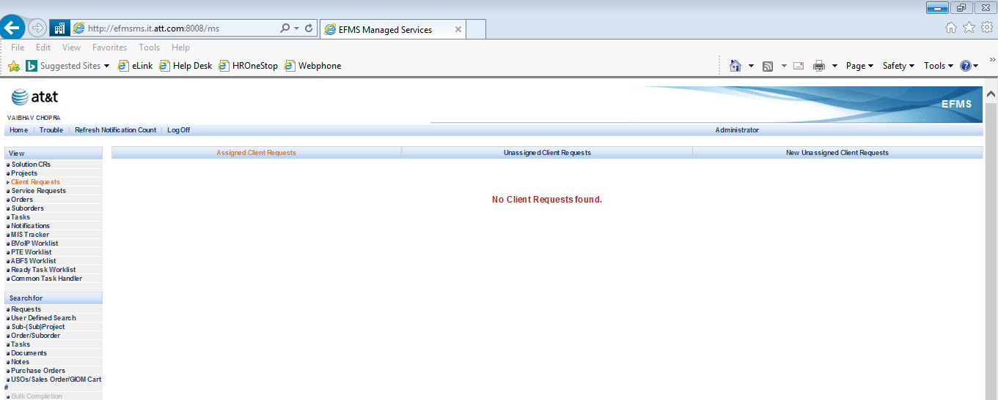

**Step 5:** Click on **Order/Suborder** tab as shown below:

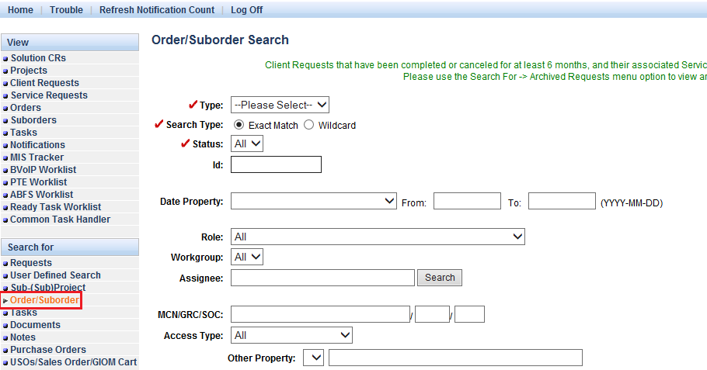

**Step 6:** Select **Orde**r as option in Type bar as shown below:

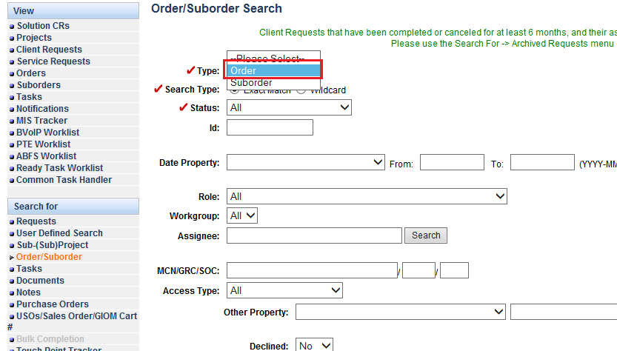

**Step 7:** Write order no. which you want to open in **ID** option.

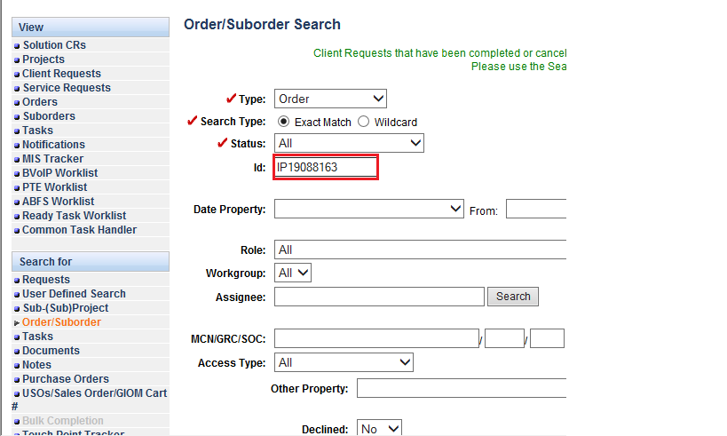

**Step 8**: Click on **Find** tab to open order.

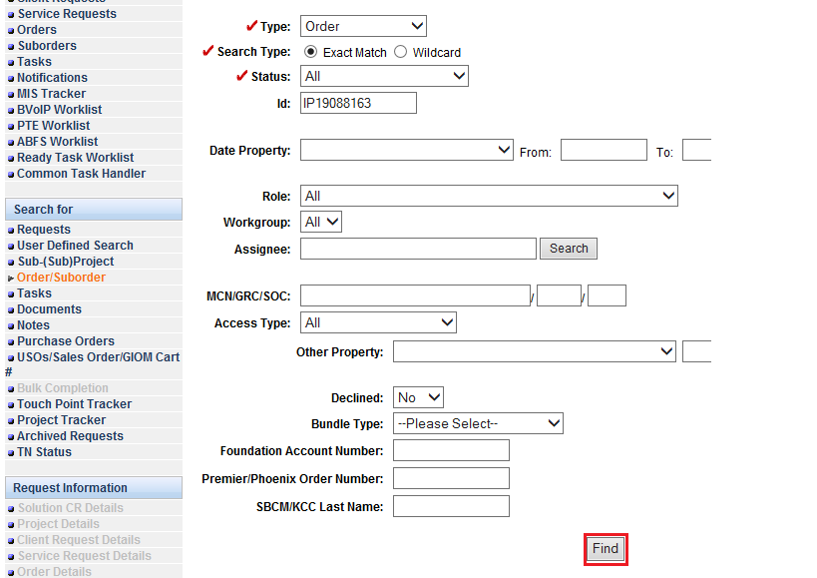

**Step 9:** Order search results will be displayed, click on **open** tab to open order.

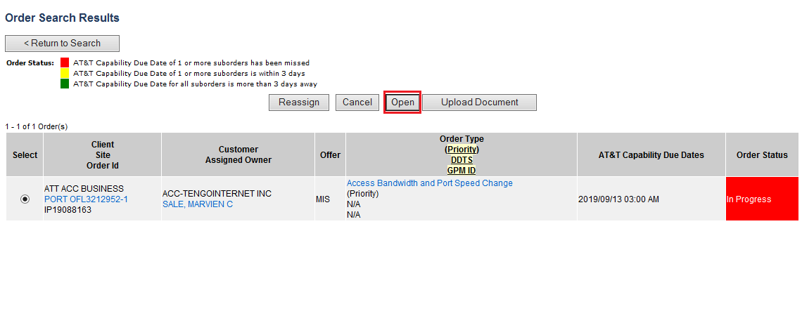

**Step 10:** Order will be displayed with all tabs and information.

