1. **INR Overview:**

Sales user retrieves the inventories for active circuits so the users can design an effective plan for customers there are multiple ways users can try ,the known ways are INR or Manual gather (from other systems)

Below flow chat brings the clear idea of INR (Inventory retrieval):

1. **Flow :**

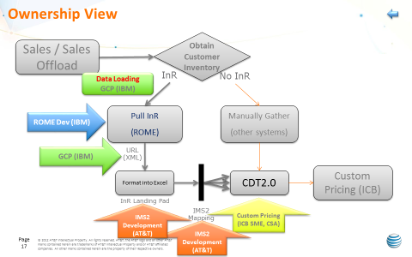

1. INR Ticketing Process :



1. ROME Server Access :



1. INR (ROME) Servers and Logs checking :



1. Billing Month mismatch issue :

