## **LIVE-LINE WITH SAME NPA-NXX IN NUMBER EXISTS.**

|  |  |  |  |
| --- | --- | --- | --- |
| **Heavy Load BOTS** | **On Demand/ Scheduled/Both** | **BOA Estimate how much time it takes** | **Comments on Estimated time** |
| **No** | **Scheduled** | **20 mins** | **Estimates are made considering following steps:**   1. **BOT will pull the orders from AOTS ticketing system** 2. **Check the lines in CADM** 3. **Retrigger Billing, if required.** 4. **Update and close the ticket for success.** |

**Sample USH –**

268251906

267912025

1. USH to get the order information. User will provide order number in the USH/AOTS ticket .

User need to provide to CRDD as well (Mandatory)

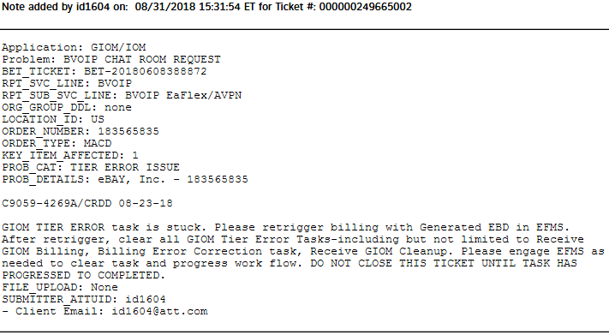

1. Using the order details in the BVOIP GUI .Find the Line Number error .

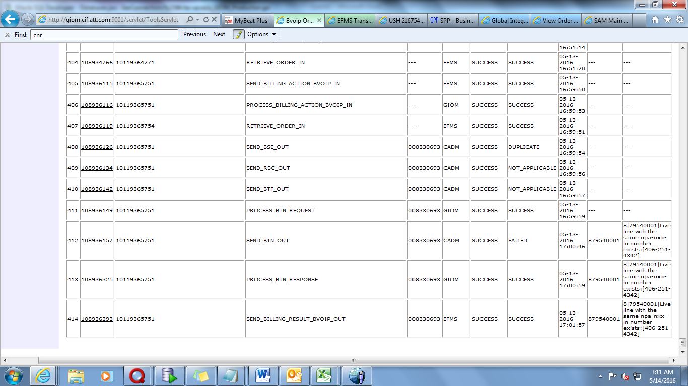

1. Go to CADM(**EUAM GUI)** Provide the Below Inputs –

Inventory Type:-Line.

Inventory ID:-Paste the line number

Go to Search option and click. As shown in below screenshot.

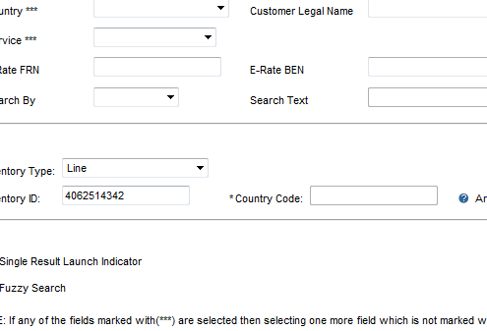

### CASE1:-LINE IS PRESENT IN CADM.

#### Step1:-Check the sub-account (SA):-

* If sub account start with 82900 or 83100.

Then skip the GTE and close the USH/AOTS ticket

* If sub account start with 124.

Ask user to create BET and disconnect line from WATSOP.

Add the Comments in USH/AOTS Ticket Comment notes asking user to create BET and disconnect line from WATSOP usingCRDD 2 days before current test and turn up date on the order.

* If sub account starts with 0.

BOT should send message “Please work on issuing a disconnect order as Line :[608-265-4931] exists under Sub account [0160310512003] in CADM.”

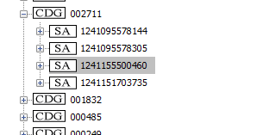

### CASE 2- IF LINE IS NOT PRESENT IN CADM.

**Step1:**Billing Date=Billingeffectivedate(CRDD mentioned in ticket)+1.

**Step2:** Update the EFMS DB with Billing date from Step1 for order.

DB Details –

Host Name- p1efm1d7.aldc.att.com

Port – 1524

update ms_order set billing_effective_date = todate('06-FEB-19','DD-MON-YY') where usrp_order_number = ‘ordernumber’;

**Step3:** Force Complete the GIOM Tier Error task

If there are multiple GTEs, the all GTEs need to be force completed.

1. cd /opt/app/home/prodsupp/complete  
  
 2. fc.run (script name)

Please refer below M&P for FC



*Reference to Mnp where task are skipped and fcd*

**Note - Once task is force completed, it can’t be undone.**

#### 

1. Need to re-validate from BVOIP for success or failure for error. If it is a success go to Step5.

Check below transaction if they are successful

SEND_BSE_OUT

SEND_RSC_OUT

SEND_BTF_OUT

PROCESS_BTN_REQUEST

SEND_BTN_OUT

PROCESS_BTN_RESPONSE

SEND_BILLING_RESULT_BVOIP_OUT

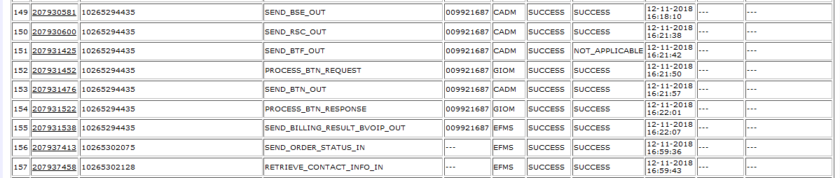

In case of failure and same error_code is same then start from step2, else mark it as RED in USH/AOTS.

1. If billing is success and GTE are still present in EFMS, Iskip GTE.

Please Refer Below M&P for Iskip

**Note - Once task is iskipped, it can’t be undone.**

Issue Resolved